Weather App

Eric Johnston

CST-451 Capstone Project Proposal

Grand Canyon University

Instructor: Professor Jeff Stucker

Revision: 2.0

Date: September 29, 2024

**ABSTRACT**

For my senior project, I plan to create a workout tracking web application. This application will allow users to create workout routines. Within each routine, the user can select specific days to target different muscle groups and perform certain exercises. For example: Monday – chest, shoulders, triceps. Tuesday – legs and lower back. For each day, the user will then assign exercises and the numbers of sets and reps per exercise, as well as the weight. Users can select from existing exercises or create new exercises to use. When a user begins a routine, they can log the weights used and if they failed or completed a set. Users can also write notes for each exercise in a routine or for the entire day. Data will be displayed to the user in a way that allows them to see their progress over time.

|  |
| --- |
| History and Signoff Sheet |

**Change Record**

|  |  |  |
| --- | --- | --- |
| **Date** | **Author** | **Revision Notes** |
| ~~03/03/2024~~ | ~~Eric Johnston~~ | ~~Initial draft for review/discussion~~ |
| ~~03/24/2024~~ | ~~Eric Johnston~~ | ~~Final project proposal~~ |
| 9/11/2024 | Eric Johnston | Project change and new proposal |
| 9/29/2024 | Eric Johnston | Final project proposal |

|  |
| --- |
| **Overall Instructor Feedback/Comments** |

|  |
| --- |
| **Overall Instructor Feedback/Comments** |

**Integrated Instructor Feedback into Project Documentation**

Yes  No

**Project Approval**

Professor Jeff Stucker

**TABLE OF CONTENTS**

Project Overview and Project Objectives 4

Project Scope 5

Project Success Measures 6

Project High-Level Solution 7

Project Controls 8

Project Cost and Schedule 10

Appendix A – References 11

Appendix B – Copyright Compliance 12

Project Overview and Project Objectives

**State the Problem and Background**

As a weekly weightlifter, I find that many of the applications (both web and mobile) currently available for tracking weight-lifting progress don’t have all of the features that I want available to me. With this application, I plan to address the features I find missing in certain applications and add them all to this single application.

**Christian Worldview**

In the context of a workout logging application, a Christian worldview perspective can influence various aspects.

**Ethical Perspective:** A Christian ethical framework encourages developers to prioritize honesty, transparency, and integrity in collecting and presenting data. Upholding the principles of fairness in data representation aligns with the Christian emphasis on truthfulness (Ephesians 4:25).

**Social Responsibility:** A Christian worldview emphasizes caring for one's neighbor and community. In the context of a workout logging application, this could translate into features that provide tools for better taking care of one’s body so they can better provide for their community. This resonates with the Christian call to love and care for others (Matthew 22:39).

**Project Objectives**

List objectives that will be used to measure project success.

Users should be able to create routines, add workouts to them, and be able to measure their progress within the routine over a period of time (weeks, months).

**Challenges**

List the known challenges that will be used to measure project success.

User satisfaction. Safeguarding user data. Data visualization that effectively conveys data trends to the user.

Project Scope

The scope of this workout log application project encompasses the development and deployment of a user-centric platform designed to allow users to create routines, log exercises, and track their progress. Key features include intuitive user interfaces for routine creation, exercise logging, data trends, and exercise planning.

|  |  |  |
| --- | --- | --- |
| Stakeholder Name | Role(s) | Responsibilities |
| Eric Johnston | Lead Developer | Project planning, development, implementation. |

1. List the work breakdown required to satisfy the project objectives. Identify teams and other resources that may be required to successfully complete the project.

|  |  |  |  |  |  |  |  |  |  |  |
| --- | --- | --- | --- | --- | --- | --- | --- | --- | --- | --- |
| Work Breakdown Structure | | | | | | | | | | |
| ID | Task | Dependencies | Status | Effort Hours | Cost | Start Date | Planned Completion | Estimate to Completion | Actual Completion | Resource |
| 1 | Account creation |  | Complete | 2 |  | 7/15/24 | 7/20/24 |  | 7/20/24 | ASP.NET Identity |
| 2 | Basic hmtl / view in place |  | Complete | 2 |  | 7/15/24 | 7/24/24 |  | 7/24/24 | Bootdrap |
| 3 | EF Core Implementation |  | Complete | 4 |  | 7/30/24 | 8/7/24 |  | 8/7/24 | Entity Framework Core |
| 4 | Basic routine creation |  | Complete | 8 |  | 8/7/24 | 8/15/24 |  | 8/15/24 |  |
| 5 | Basic exercise creation |  | Complete | 3 |  | 8/7/24 | 8/15/24 |  | 8/15/24 |  |
| 6 | Routine display and navigation |  | Complete | 4 |  | 8/19/24 | 8/26/24 |  | 9/15/24 |  |
| 7 | Routine Editing |  | Complete | 8 |  | 9/9/24 | 9/22/24 |  | 9/22/24 |  |
| 8 | Exercise logging (entering weight added) |  | Complete | 8 |  | 9/10/24 | 9/15/24 |  | 9/15/24 |  |
| 9 | Rework routine creation |  | Complete | 10 |  | 9/10/24 | 9/22/24 |  | 9/22/24 |  |
| 10 | Fix "Create new exercise" within the 'Add Exercise' modal |  | Complete | 5 |  | 9/22/24 | 9/29/24 |  | 9/27/24 |  |
| 11 | Fix exercise logging for exercises added on "StartRoutine" view |  | Complete | 3 |  | 9/22/24 | 9/27/24 |  | 9/27/24 |  |
| 12 | Populate Database with boilerplate exercises |  | Complete | 2 |  | 9/22/24 | 9/29/24 |  | 9/25/24 |  |
| 13 | Create detailed README |  | Complete | 1 |  | 9/29/24 | 9/29/24 |  | 9/29/24 |  |
| 14 | ILogger Implementation |  | Complete | 3 |  | 9/25/24 | 9/27/24 |  | 9/27/24 |  |
| 15 | Fix adding newly created exercises to routine |  | Complete | 4 |  | 9/27/24 | 9/27/24 |  | 9/27/24 |  |
| 16 | Add privacy policy page |  | Complete | 1 |  | 9/26/24 | 9/26/24 |  | 9/26/24 |  |

Project Success Measures

1. Describe what measures will be used to calculate project success.
2. Use the template to list the project completion criteria.

|  |
| --- |
| Project Completion Criteria |
| 1 – Users will be able to create routines, add workouts to them, and be able to measure their progress within the routine over a period of time (weeks, months). |
| 2 – Display data in easy-to-read format |

1. Use the template to list the project assumptions and constraints, if applicable. An assumption is an educated guess that a likely condition or circumstance is presumed to be true. A constraint is a limiting condition or circumstance that defines the project boundaries. Assumptions allow the project to succeed. Constraints restrict or limit the project execution.

|  |  |  |  |  |  |
| --- | --- | --- | --- | --- | --- |
| Assumptions and Constraints | | | | | |
| ID | Description | Comments | Type | Status | Date Entered |
| 1 |  |  | Assumption |  | 3/3/24 |
| 2 | Time constraints |  | Constraint |  | 3/324 |

Project High-Level Solution

**Introduction**

The project aims to tackle the challenge of allowing the user to create workout routines for tracking progress over a period of weeks and months. The objective is to create a user-friendly platform where user interaction is intuitive, and data is easy to read and comprehend. This solution considers cross-platform compatibility and data security.

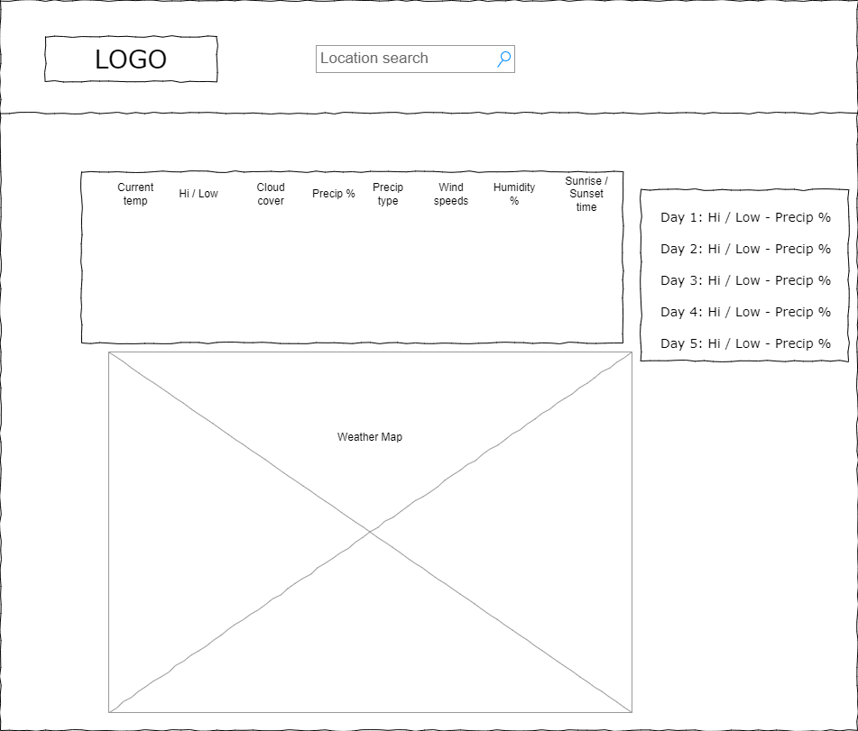

**Solution**

Employ HTML, CSS, and JavaScript for a responsive and intuitive UI. Utilize APIs from established meteorological services to fetch real-time data. Develop features using technologies such as Bootstrap, jQuery, ASP.NET, EntityFramwork Core, and ASP.NET Identity.

**Project Controls**

1. Use the template to define the risk and list the steps to prevent the risk from occurring or the steps to minimize the chances of it happening. The contingency plan describes alternative solutions to reduce the impact of the risk. An example of a contingency plan is to provide the customer a temporary web server if there are delays in delivery/completion. If the risk has already happened then provide an entry in the issue log.

|  |  |  |  |  |
| --- | --- | --- | --- | --- |
| Risk Management | | | | |
|  | **Risk Probability** | **Risk Impact** |  |  |
| **Event Risk** | **(high, medium, low)** | **Risk Mitigation** | **Contingency Plan** |
| Deadline crunch | High | Poor grade | Plan out project step-by-step. Proper time management | Reduce procrastination |
|  |  |  |  |  |
|  |  |  |  |  |

|  |  |  |  |  |  |  |  |  |
| --- | --- | --- | --- | --- | --- | --- | --- | --- |
| Issues Log | | | | | | | | |
| **ID** | **Description** | **Project Impact** | **Action Plan/Resolution** | **Owner** | **Importance** | **Date Entered** | **Date to Review** | **Date Resolved** |
| 1 | What is the issue? | How will this impact scope, schedule & cost? | How do you intend to deal with this issue? | Who manages this issue? |  |  |  |  |
| 2 |  |  |  |  |  |  |  |  |
| 3 |  |  |  |  |  |  |  |  |

1. All projects have either anticipated and planned or unexpected changes. Describe any issues in management or change management due to the anticipated and planned or unexpected changes. Use the template to list anticipated and planned or unexpected changes.

|  |  |  |  |  |  |  |  |  |  |
| --- | --- | --- | --- | --- | --- | --- | --- | --- | --- |
| Change Control Log | | | | | | | | | |
| **ID** | **Change Description** | **Priority** | **Originator** | **Date Entered** | **Date Assigned** | **Evaluator** | **Status** | **Date of Decision** | **Included in Rev. #** |
| 1 |  |  |  |  |  |  |  |  |  |
| 2 |  |  |  |  |  |  |  |  |  |

1. Use the template to describe how the end user is involved in the software development, if applicable. Include relevant information about meetings, reviews, presentations, etc.

|  |  |  |  |
| --- | --- | --- | --- |
| Roles and Responsibilities | | | |
| Name | Team | Project Role | Responsibility |
| Eric Johnston | Development | Lead developer | Design, development, implementation |
|  |  |  |  |

Project Cost and Schedule

1. Project will not require any cost calculations.

Week 1 – Project planning

Week 2 – Requirement analysis, basic website structure begun. Basic API calls working

Week 3 – High level diagrams (architecture diagrams, ER diagrams, UML class diagrams, etc.)

Week 4 – Website functionally complete

Appendix A – References

*List all references using APA style*

Appendix B – Copyright Compliance

For each external technical tool or code used, provide a reference to its copyright policy, clearly showing your right to use it. For each external technical tool or code used, detail how you used it, how you adapted it, how you modified it (if permitted), and why did you use it as opposed to write your own. Only a small portion of your project may rely on external code. When code libraries/packages are used, explain why this was necessary/required/recommended. Seek instructor approval for using external resources prior to beginning to work on the project.