Group 22

Author: Yuxin Miao

SOFTWARE REQUIREMENTS

Elevator Control System

Table of Contents

System Objective 2

Domain Analysis 2

System Architecture 4

Use Cases 5

Software Requirements 5

R1: ControlPanelUI 6

R2: DisplayUI 6

R3: Elevator Core 6

R4: Controller Core 6

## System Objective

Develop a system which is used for elevator control, including Control panel, Elevator controller and a coordinating system. By applying this system, we can improve the transportation efficiency and reduce the total waiting time of passengers.

## Domain Analysis

The participants of activities in a elevator control system can be categorized into Machine and Passenger.

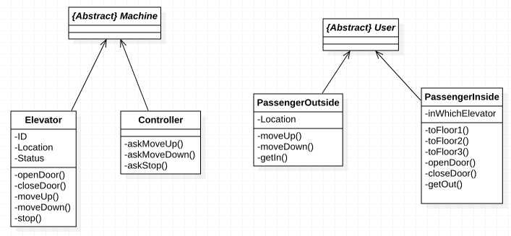

Here is the sequence of events for using an elevator:

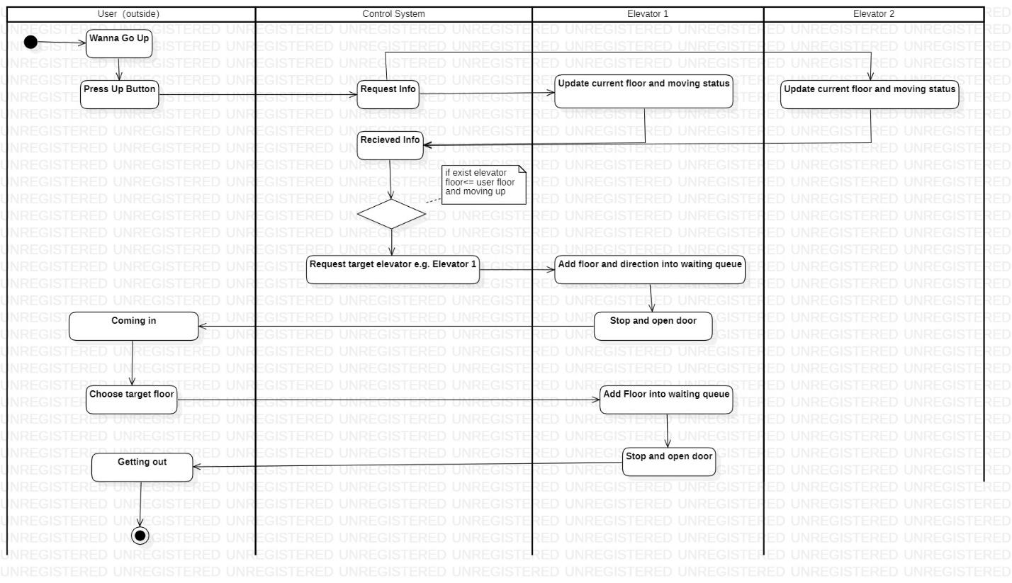

Here is the sequence of events for using a elevator

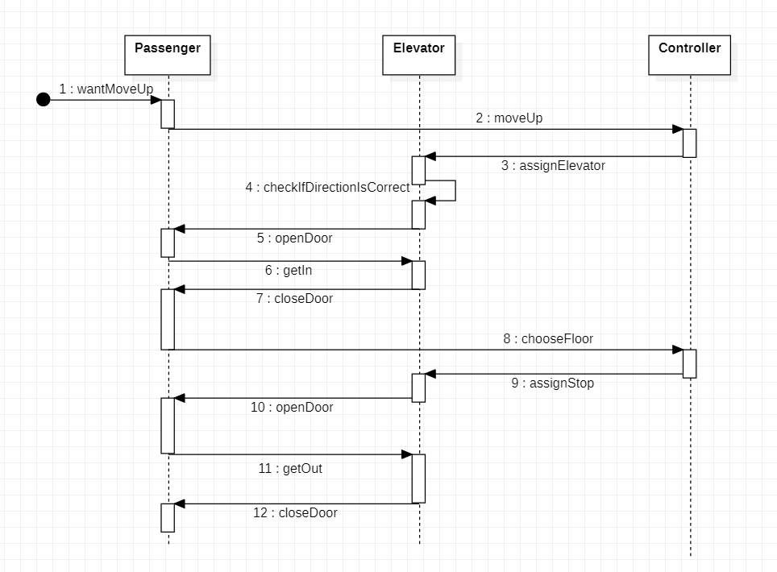:

## System Architecture

The elevator control system can be built up by finishing the following modules. The whole system contains both UI and core functions, which will coordinate with each other to realize the system functions.

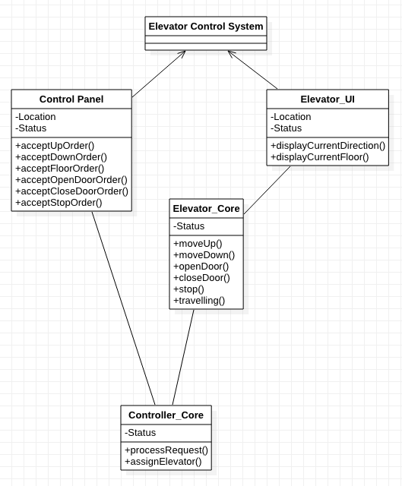

## Use Cases

The elevator control system should be able to fulfill the following features which is asked by passengers.

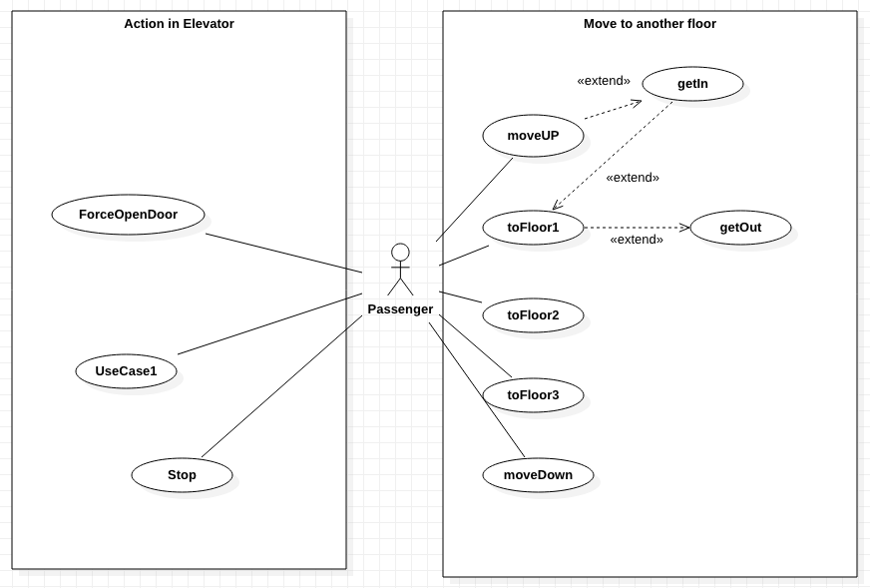

## Software Requirements

### R1: ControlPanelUI

* R1.1: Control panel UI should be able to provide functions according to its location
  + R1.1.1: The Control panel located in the outside of elevator should has two functions, move up and move down (available according to its floor, e.g. the top floor only has one button which is move down)
  + R1.1.2: The Control panel located inside the elevator should have 6 buttons which contains 3 floor buttons, Open and close door buttons and a stop button.
* R1.2: Control panel UI should be responsive
  + R1.2.1: All of the button should have two status: light up and dim down, which is used to indicate the finishing state of functions.

### R2: DisplayUI

* R2.1: Control panel should have display to provide information
  + R2.1.1: The Control panel should have one display indicates the current floor of elevator (expressed in numbers), and the moving status of elevator (moving up, moving down, stop)

### R3: Elevator Core

* R3.1: Elevator core should be able to detect and share its location and moving status
  + R3.1.1: The Elevator Core should be able to use sensors to get its own location(in number) and moving status((moving up, moving down, stop)
  + R3.1.2: The Elevator Core should be able to share its location and moving status to both UI and Controller Core
* R3.2: Elevator core should be able to receive order from Controller Core
  + R3.2.1: The Elevator core should only receive order from Controller Core except for Open and Close door functions
* R3.3: Elevator core can control the physical change of elevator:
  + R3.3.1: Elevator Core can pass order directly to motor
  + R3.3.2: Elevator Core can not Open and Close door when it is not in Stop state
  + R3.3.3: Elevator Core cannot execute move up function when in top floor
  + R3.3.4: Elevator Core cannot execute move down function when in bottom floor

### R4: Controller Core

* R4.1: Controller core should be able to receive order from control panel and assign order to Elevator Core
  + R4.1.1: The Controller Core should only receive order from Control panel
  + R4.1.2: The Controller Core should pass the suitable order to suitable Elevator Core