Group 22

Author: Yuxin Miao

User Manual

Elevator Control System

Table of Contents

System Architecture 2

Passenger Manual 2

## System Architecture

The system architecture of elevator Core in shown as below.

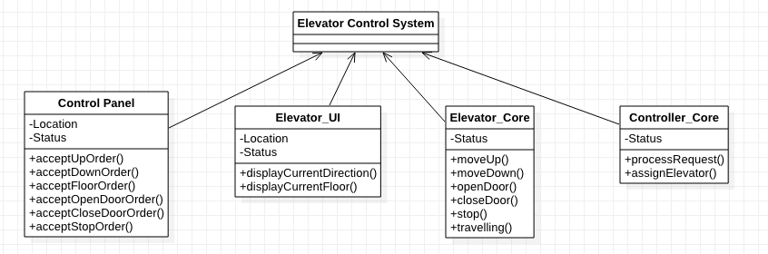

## Passenger Manual

Passenger can access the UI as below

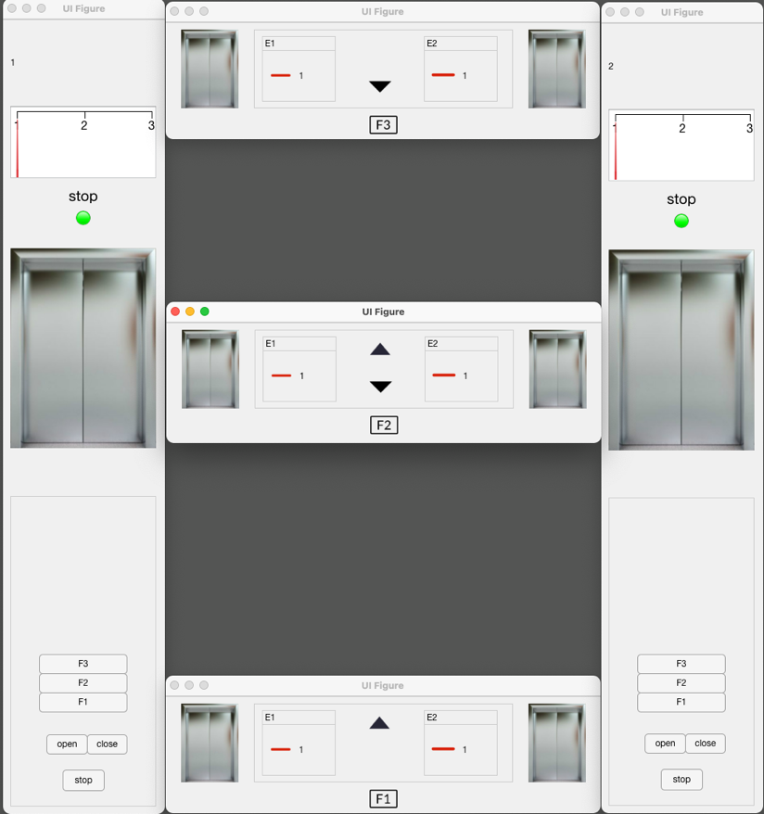

#### When passenger is at the outside of the elevator

In the outside, passenger can access the outside Control Panel. There are basically two Buttons on it (number of buttons may differ according to your current floor i.e. Ground floor has no ‘Up’ button)

* Up Button: The Up Button should be pressed when you want to go upstairs. Once pressed, the Up button will light up ( )until your elevator comes. Passengers Can enter the elevator as soon as your button dims down().
* Down Button: The Down Button should be pressed when you want to go downstairs. Once pressed, the Down button will light up ( )until your elevator comes. Passengers Can enter the elevator as soon as your button dims down( ).

Except for buttons, passengers can also get information of elevator through a display. The display contains two parts: The floor number and The elevator direction.

* Floor number: The Number indicates current location of the Elevator
* Elevator direction: The moving direction of elevator is expressed by target symbol
  +  means elevator is moving up
  +  means elevator is moving down
  +  means elevator is not operating or now move

#### When passenger is at the inside of the elevator

In the inside, passengers can choose the floor they would like to go and open or close the door, or, for emergency situation only, they are able to let the elevator stop at the nearest floor and keep the door open. The control panel contains 5 buttons.

* Floor Buttons(‘F1’,’F2’,’F3’): Once pressed, the button will light up . Elevator will stop at selected floor and keeps door open for 1.5 seconds. (for convenient). Once door is opened at target floor , the button will dim down to normal ().
* Open door Button: Only response when elevator is not moving. Every time this button is pushed, the door will keep open for the following 1.5 seconds.
* Close door Button: Only response when elevator is not moving. Every time this button is pushed, the door will close immediately.
* Stop: Only for emergency situation. Once Pushed, all of other button will be disabled, Elevator will stop at the nearest floor and keeps door open until this status is ended. In this status, elevator will not response to any request except ‘exit this status’. This status can be ended by re-Push the Stop button.