Group 22

Author: Yuxin Miao

Traceability Report

Elevator Control System

Table of Contents

System Architecture 2

Software Traceability 3

## System Architecture

The system architecture is shown below:

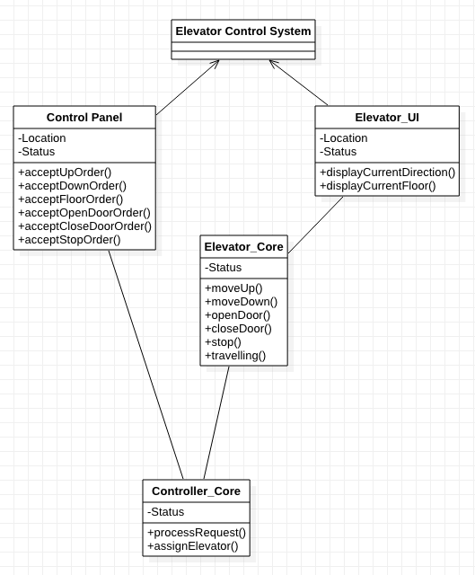

## Software Traceability

|  |  |  |
| --- | --- | --- |
|  | Is implemented by | Is validated by |
| R1.1.1 | S1.1.1 | T1.2.1, T1.2.2 |
| R1.1.2 | S2.4 | T1.2.3, T1.2.4,T1.2.5, T1.2.6 |
| R1.2.1 | S1.2.1 | T1.2 |
| R2.1.1 | S1.1.3 | T1.1.1, T1.1.2 |
| R3.1.1 | S2.1.4 | T1.1.1, T1.1.2, T1.1.5 |
| R3.2.1 | S2.1.3 | T2.1 |
| R3.3.1 | S2.2.2 | T2.1.2 |
| R3.3.2 | S2.2.3 | T1.2.5 |
| R3.3.3 | S2.2.4 | T3.1.1 |
| R3.3.4 | S2.2.4 | T3.1.2 |
| R4.1.1 | S2.1.2 | T2.1 |
| R4.1.2 | S2.1.1. | T2.1.2 |