## Step 1: Understand and Define the problem (Analyse)

1. **Problem statement:**

* The system should automatically dispense food for cats and dogs at scheduled times, using a real-time clock.
* Based on the weight sensor and infrared sensor, the system can detect the consumption status, such as checking the food bin level or whether food has been eaten. Therefore, it can alert staff if something goes wrong ( no food dispensed, pets didn’t eat)

1. **Limitations/ Assumptions:**

* The system uses simple sensors for low cost.
* Only accessed for 1 type of pet food ( dry food, food bag, etc.) or particular pet (dogs, cats).
* Limited storage capacity and space for many pets at the same time.
* Electric power could be required.
* External problem is that without supervision or protective measures, pets may interfere with the food, disrupting the feeding process and monitoring.

1. Inputs/ Outputs:

# Input:

* **Food bin level sensor** – using an infrared sensor to check the percentage of food remaining.
* **Bowl weight sensor** – using a weight sensor to check the weight of bowl after and before feeding.
* **Real-time clock** – to check current time with the feeding scheduled time daily.

# Output:

* **Servo motor** – open/close the gate to dispense food into the bowl based on scheduled times and consumption.
* **Alert signal** – sends warnings for staff when storage is empty or food is not eaten.
* **Message log display** – store feeding processing, issues.

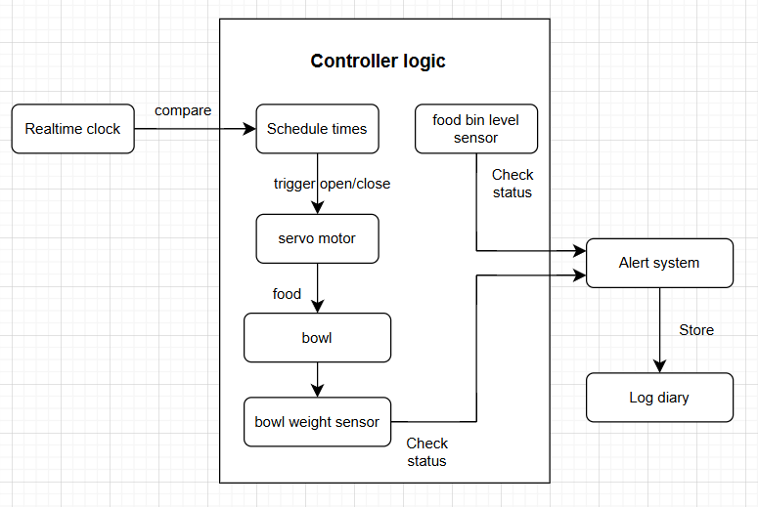

Figure 1: Simple sketch of an Automated pet feeder system

## Step 2: Organise and Describe the data

|  |  |  |  |
| --- | --- | --- | --- |
| Name | Type | Sample values | Operational constrain |
| Real-time clock | Input - Timestamp | 6:00, 18:00 | * trigger the feeding process if it matches with feeding time. |
| Bowl weight | Input - integer | 0-500 (g) | * Store food from a food container |
| Bowl weight sensor | Input - integer | 500 (g) | * Scale based on bowl weight * Decrease when they have a food consumption * Increase when adding food. * If food weight does not decrease within a set period (e.g., 30 minutes) throw the weight sensor 🡪 trigger alert. * Trigger the stop automated feed process when the bowl weight gets full. |
| Food bin sensor | Input - Boolean | True/false | * If bin is empty → sensor = False → trigger alert |
| Servo motor | Output - Boolean | True/false | * True = open / false = close * Open when on schedule time * Close when the bowl gets full |
| Log | Output - String | “Feeding process is starting” | * Store all activities during the feeding process |
| Alert signal | Output - string | “storage empty”,  “food not eaten” | * Trigger the notification process when getting issues |