Zachary Jones

CS 110

13 December 2020

**Overview and Summary of Project**

Global Poker Tool is a web scraping program that provides users with real-time pot odds and custom bet sizes. It also converts the pot size and player balances into a poker unit of measurement known as big blinds.

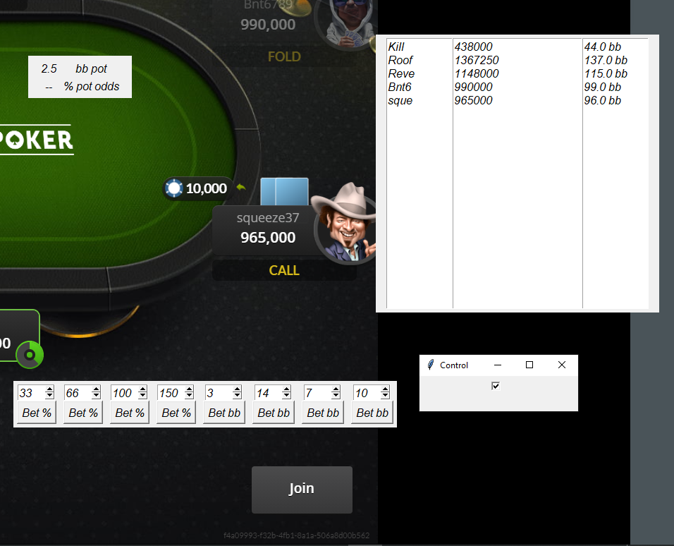

The user interface encompasses four windows. The root window is titled the “Control” window, and it has a checkbox. When the user checks the box, the other three windows override all redirects. This means that the user can no longer minimize, maximize, or exit the other three windows. However, the control window is always readily available for redirect. The next window is the pot window (top left), which displays the pot size in big blinds and the percentage pot odds. The player window (top right) has 3 textbox columns. The first column scrapes the player names at the table and displays the first four characters in their username. The second column scrapes the player’s balances, and the last column converts the player balances into big blinds. Lastly, there is a custom bet size window with eight custom bet slots. The first four bet slots are percentage-based bets relative to the size of the pot. The last four bet slots are big blind based bets relative to the size of the big blind at the table.

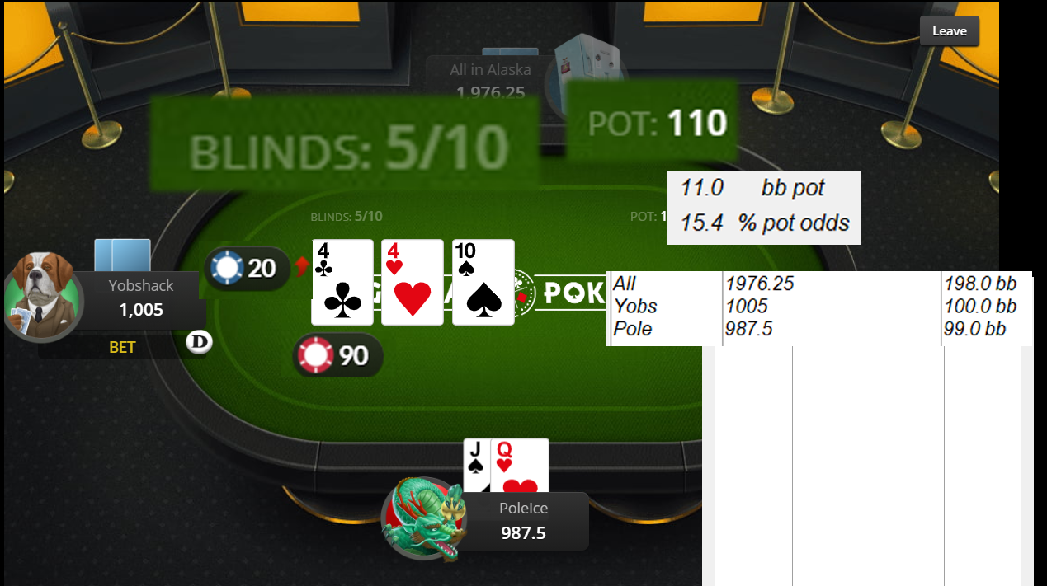

In the following sample input, the big blind is 10 (the big blind is the number after “/” in blinds), and the pot size is 110. 110 divided by 10 outputs an 11 big blind pot. Player Yobshack bet 20 into a pot of 90. To calculate the user’s pot odds, first, find the final pot size if you were to hypothetically call. In this case, the final pot size if the user calls is 130 (90 + 20 + 20). Then, divide the size of the call by the final pot size and multiply by 100. 20 divided by 130 equals about 0.154.

**Target Audience**

Global Poker Tool is for poker grinders who play on Global Poker and are looking for an edge over their competition. With real-time pot odds, big blind conversions, and custom bet sizes, competitive poker players will benefit most from my program.

**Specific Programming Techniques Used**

I used selenium to scrape the web elements, and I coded class Scrape. Scrape’s functions include get_pot(self), get_potodds(self), get_players(self), and get_bigblind(self). I stored the webdriver elements in variables, lists, and dictionary lists. I manipulated some of the variable types for calculations and conversions.

For the user interface, I used tkinter and coded class Display. Display is the root window, and for the other additional windows I constructed classes that initialized toplevel windows. The Display class contains PotWindow, PlayersWindow, and BetsWindow. PotWindow and PlayersWindow have an update function which constantly updates the values of the labels and textboxes, respectively. The BetsWindow contains an inner class, CustomBet, which creates a canvas and adds a spinbox and button, essentially creating a custom bet slot. In class CustomBet, there is a function called custom_bet which scrapes for the “bet-input” class name element, clears the element, and sends the keys to the element, finalizing the bet with the return key. Lastly, I coded a procedural oriented function called isFloat. The user inputs a string, and isFloat either returns true or false through a try and except ValueError block.

**Challenges**

I had no previous experiences with tkinter and selenium, but I watched tutorials on Youtube and troubleshooted every error I encountered on Stack Overflow. The first challenge I encountered was finding a way to constantly update the scraped information. I troubleshooted the issue on Stack Overflow and found the solution was using root.after to create a constantly looping function. The next challenge I encountered was getting the button commands to properly work. When the program would boot up, the button commands would run instantly and not work when pressed. To fix this issue, I troubleshooted again using Stack Overflow and I found the solution was to use lambda.

**Future Extensions**

In a future version of Global Poker Tool, I would improve the design of the user interface by changing the fonts, font sizes, colors, background colors, and I would make the user interface transparent through a toggle. I would also want to support players who want to play multiple tables at a time. Currently, Global Poker Tool only works on one table.