**Course Project**

*Subject*: Web Programming

**Web site creation**

Students' Names:

ERIC YOUNGOUA

ZENGANG NGAPMEN

2024/2025 summer semester

(Erasmus+)

**Table of Contents**

Introduction 3

Goal 3

Site map / Architecture 5

[Database ] 5

Site Structure 7

Conclusion 8

References 8

**Introduction**

The main purpose of our website is to present our beautiful country, Cameroon. Before, all our websites were very basic, styleless and didn’t have any interactive elements.

We took the opportunity given by this project to create our first professional and attractive website.

**Goal**

**Comparison** of different ways:

* Website builders: WIX.com; UKIT.com; SITE123.com; WEEBLY.com; JIMDO.com
* HTML, CSS, JavaScript, PHP
* CMS (Contents Management System) – WordPress; Drupal; Joomla

**Way 1**: online website creator (wix.com; weebly.com; site123.com; jimdo.com; ukit.com; etc.), open-source, free only

**Way 2**: html, css, javascript

**Way 3**: CMS (Wordpress, WooCommerce or Magento)

**Motivation** of your choice: Promote my country to maybe attract visitors.

The web application is just a simple site to where we can find basic information about Cameroon, it has 5 principal parts that are *Presentation*, *Tourism*, *Lang*, *Celebrities* and *Quiz*. You can see the main page below (Figure 1).

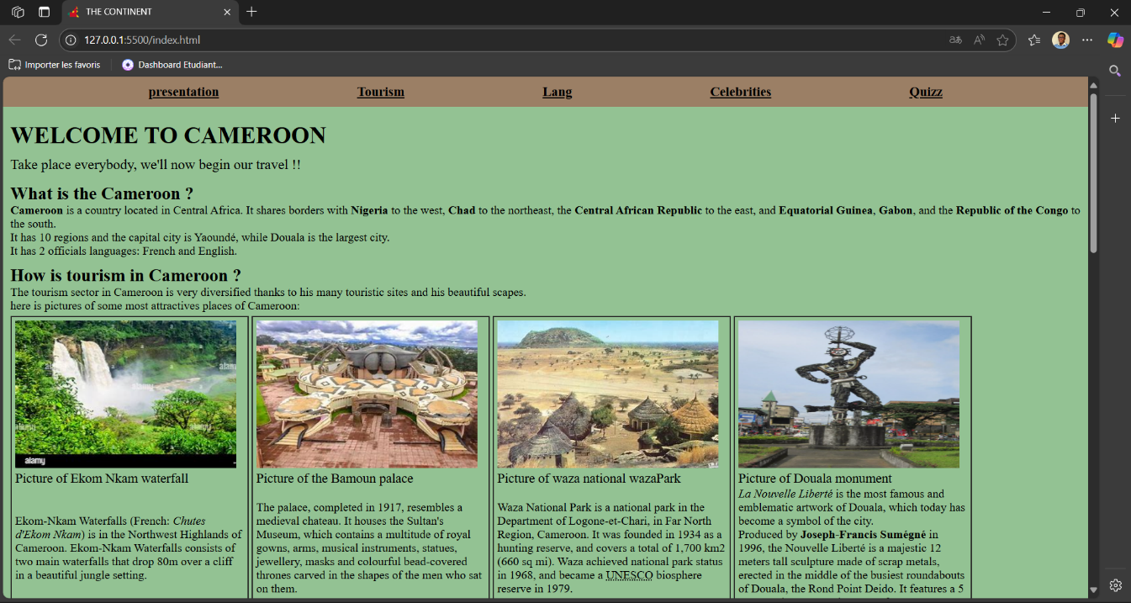

**Fig. 1**. *Home page*

For the developing process I used the last version of Visual Studio Code, this version contains the necessary stuffs for web development, a link functionality with GitHub making the group working easier and a Copilot integrated menu.

After this, I created my project main folder within I put the index.html file, the readme and an assets folder where there are all the other files (images, fonts, videos, styles, scripts, etc.). My work was done with HTML5, CSS3 and JavaScript.

In the head section of the html, we added links to connect ours html, css and javascript parts.

**Site map / Architecture**

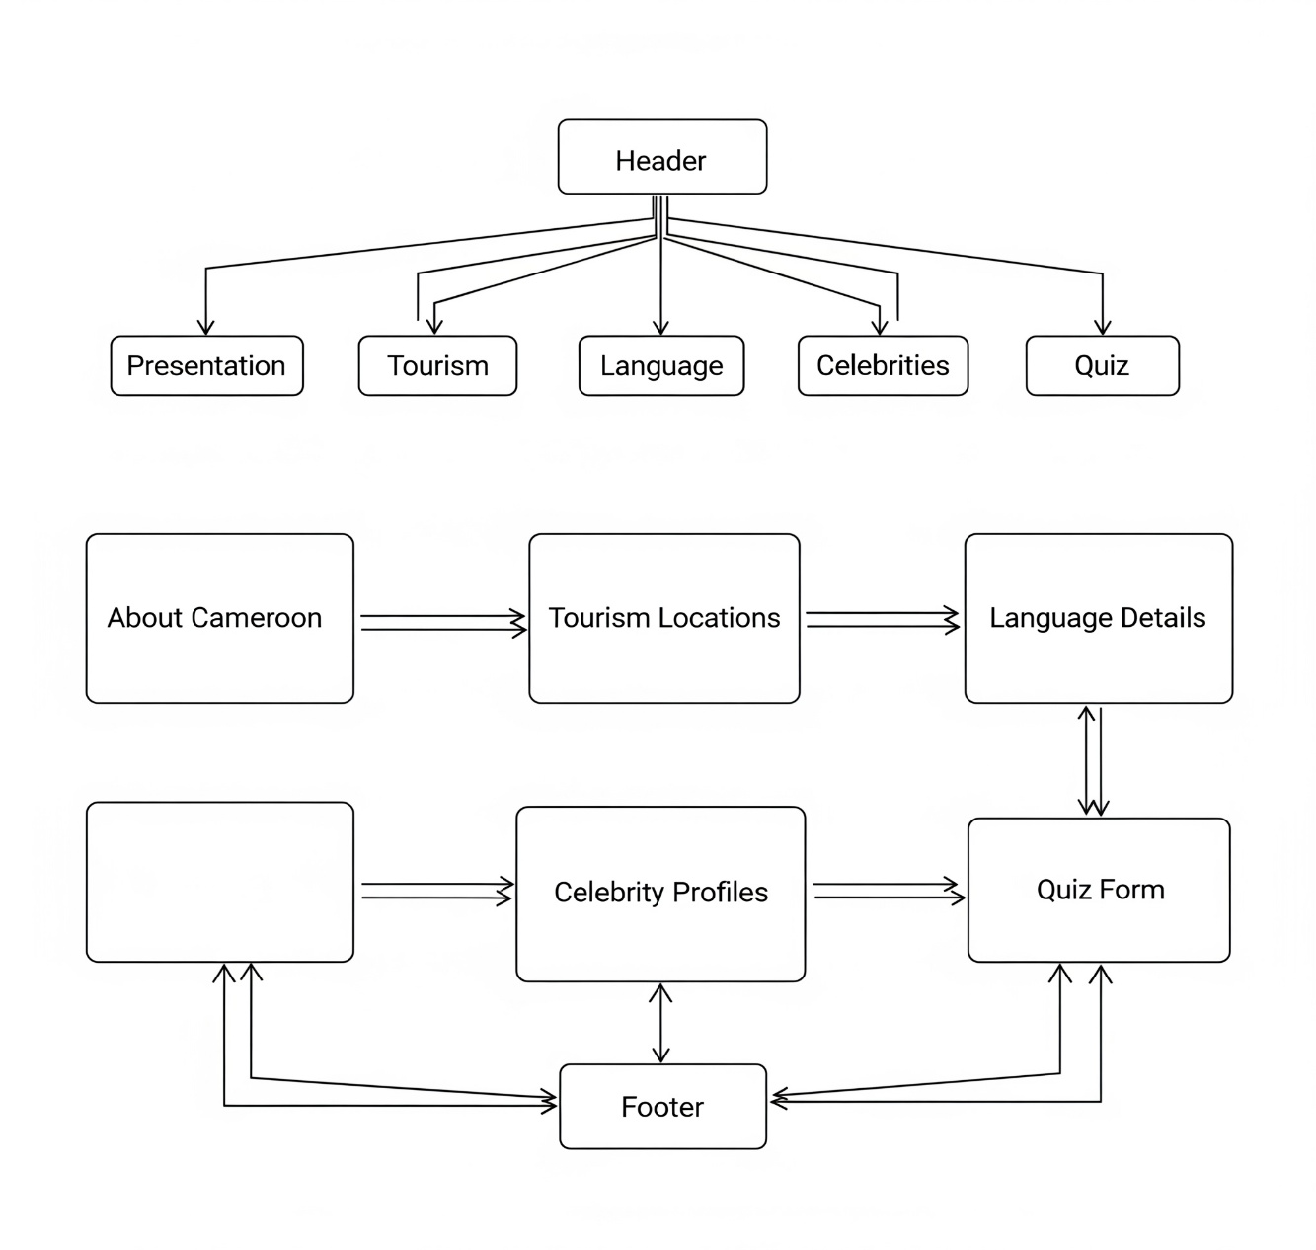

**Fig. 2**. *Site architecture*

**Site Structure**

Our website consists of following pages:

* Home
* Presentation
* Tourism
* Language
* Celebrities
* Quiz

**Screenshots of different pages**

* **“Language”**

In this page, we talked about what “Camfranglish” is, we created a table to show the translate of some Camfranglish words in English.

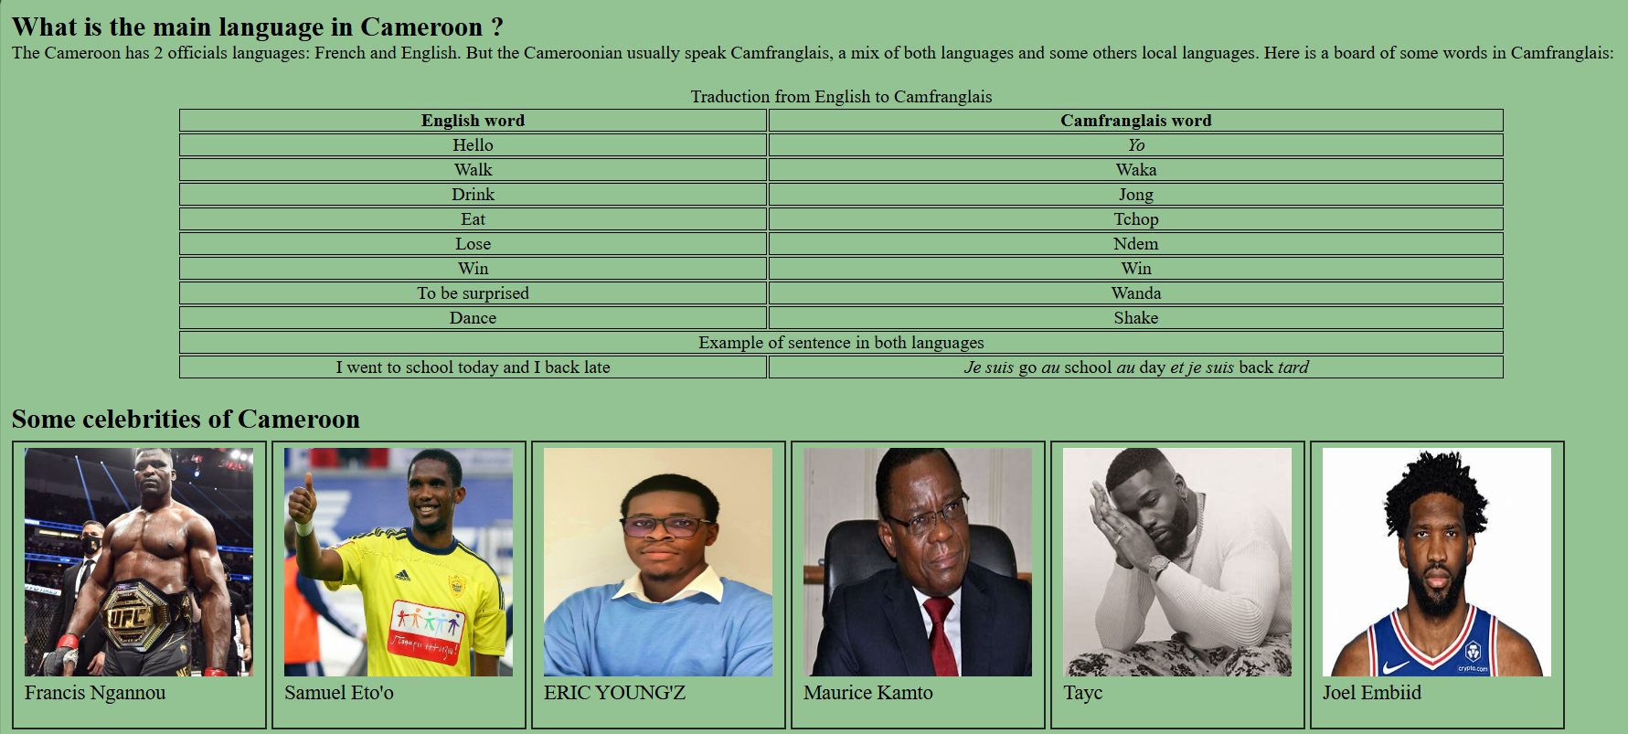

**Fig. 8**. *“Language” page of the website*

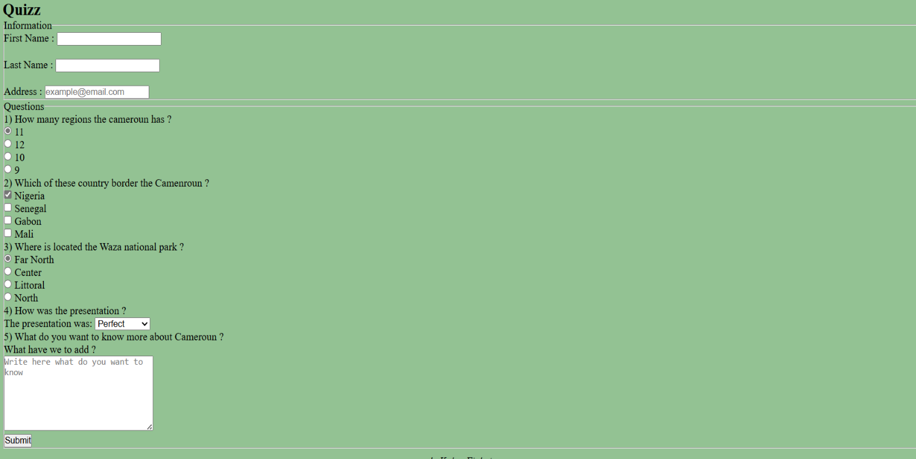

**Fig. 9**. *Quiz’s part picture*

**Conclusion**

HTML, CSS and JavaScript are good languages to create webpages, mastering, they allow us a very large flexibility and the freedom to personalize the site as we want. Despite the vast possibilities that these languages give to us, we still have a lot of limits. To bypass these limitations, we have to use other tools like databases, programming languages, JavaScript frameworks, etc…

**References**

1. **Gauchat, J. D.** (2017). *Html5 for Masterminds*, 3rd Edition.
2. <https://www.freecodecamp.org/>
3. <https://www.youtube.com>/
4. <https://www.chatGPT.com/>