**National Spectral Database General Guide**

Eric Hay, Spectral data quality officer

DEA, Geoscience Australia

Last updated: 10/06/2021

The Australian National Spectral Database (“NSD”) utilises a client called Specchio to access the database. The following information is a general introduction to some of Specchio’s functionality. For more detailed information please refer to Specchio documentation on the Specchio website (https://specchio.ch). Note that the service offered by Geoscience Australia differs from the main Specchio deployment.

You may first receive access to the public server, permitting the viewing and downloading of existing data campaigns.

If you wish to upload data, please contact the NSD manager for further information:

[NSDB_manager@ga.gov.au](mailto:NSDB_manager@ga.gov.au)

**Installing Specchio**

Requirements: Java Runtime Environment (JRE) 8 or higher

Download the Specchio client at:

<https://jenkins.specchio.ch/job/SPECCHIO/lastSuccessfulBuild/artifact/src/client/build/distributions/specchio-client.zip>

or

<https://specchio.ch/downloads/>

Install and run the Specchio client on your system.

It might be useful to start the client from the command line. This way, if there are any errors, there is a little more information on the error printed in the command window. To start from the command line, change into the specchio-client directory and type: java -jar specchio-client.jar

**Logging in and getting access – Specchio NSDB application**

New user:

* Click “Database”, located at the top left of the Specchio client, and select “create a new user account”.

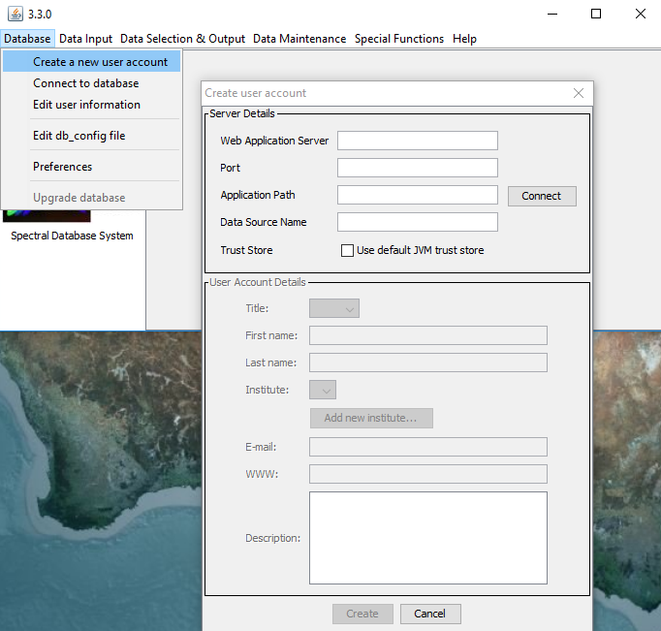

**­­**Existing user:

* Select “Database”, then ‘Connect to database”. After creating an account your credentials are stored by Specchio, and you can login without needing to re-enter these.

**NSD server details**

Web Application Server: app-sec.specchio.dev.dea.ga.gov.au

Port: 443

Application Path: /specchio_service

Data Source Name: jdbc/specchio

Select the tick box "Use default JVM trust store".

If server credentials were entered correctly you should now be able to enter your user account details, please specify your name, institute and email. Please provide details for all the fields. Please specify a new institute for new accounts. If you have collected your own field data and don’t belong to any company or institute, please enter your name as the institute, otherwise specify your company/institute. For the Description field, please state your intended use of the NSD (ie research data source, student with a need for raw data, spectral scientist with a wealth of high-quality data etc).

**Password Requirements**

Minimum password strength requirements: 14-character, 2 mixed-case plus minimum 1 number & 1 special character. You should not need to alter your password. It is set and automatically saved. If you lose access to your account please contact the NSD manager.

**Navigating the Specchio NSDB application**

Once connected, you should have access to the selected database.

To get an overview of the database, start by browsing the current data structure:

* Select “data Selection & output”, and “browse data hierarchy”

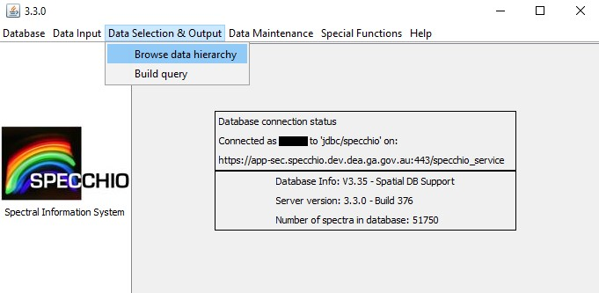

This will open a new window with the current file sub-structure, and allows you to open and select folders and sub-folders down to the base files. There are options on the RHS of the window, with “show report” being the most useful to initially explore data.

* Navigate to the sub-folder you desire. If you want a full campaign, select the top level folder. This will generate a report for all of the sub-folders and spectra contained (be cautious doing this as large folders will take time to load!).
* Geoscience Australia field data are organised into dated folders within each field site, specifying a date that a field study was undertaken. Selecting “show report’ with a date folder selected will generate a new window with a spectral plot at the top, and metadata fields relating to that particular measurement. This allows you to view each spectrum individually, from a specific sub-folder, or groups of spectra as needed, to whichever folder level is desired.

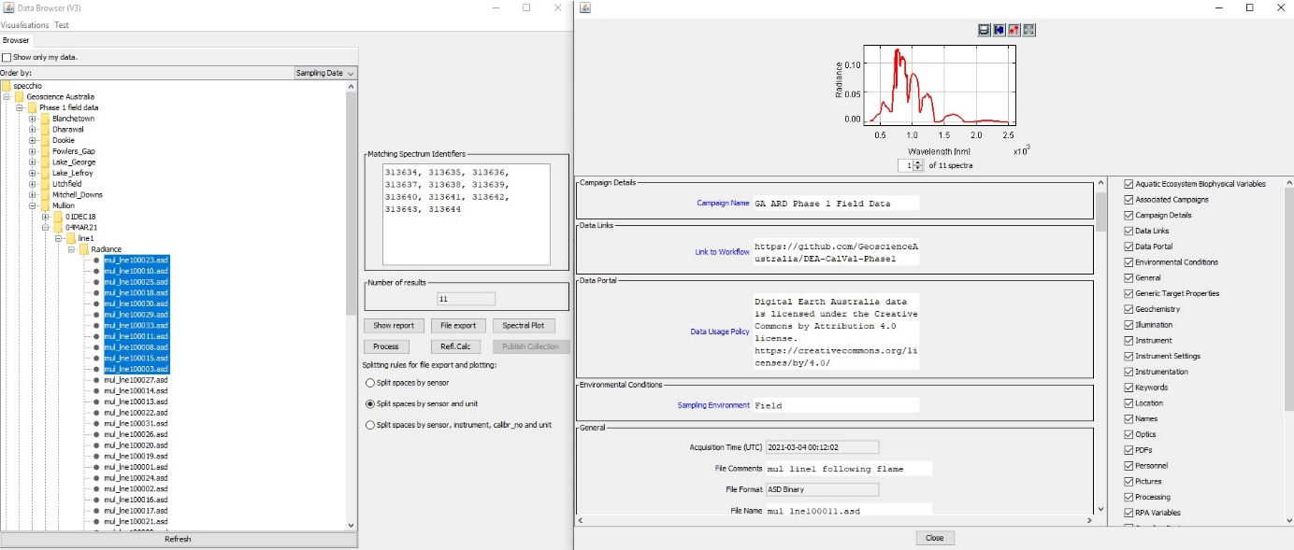

* Selecting “spectral plot” will plot everything in the selected folder, and is a good way to get an overview of the spectral signal for a given site / field campaign / study. You can also export the selected data here with the “file export” button.

**Querying the NSD**

Besides navigating the existing folder structure within Specchio, you may be interested in downloading all available spectra for a certain area or time period (or by any metadata parameter which is populated in the database). This can be achieved by selecting “data selection & output”, “build query”. You can specify the parameters you want to find all matching spectra, and output summaries / .csv’s similar to the functionality of the data browser. A current full list of metadata fields can be obtained from the main client window, and selecting Help > List available Metadata Elements located at the top right hand side.

**Downloading data**

Selecting “file export” will allow you to download the selected folder. I would recommend doing this at the folder level containing raw spectra files as sub-folder information is lost otherwise (such as the info contained in folder names- dates, field site name etc). It is possible to download a whole campaign this way but you lose the sub-folder structure.

The resulting .csv will have header information which is the text-based metadata for each file (you can specify to split header and body info when exporting the data). Data is exported in long format, rows are generated for each data point or file name. Raw measurement data sits below the header information with wavelength on the left hand side.

If you require further information or would like to contribute data please contact the NSD manager:

NSDB_manager@ga.gov.au