**接口文档**

说明：

1. 返回参数时间格式统一：yyyy-MM-dd HH:mm:ss；
2. 参数小写开头；
3. 传参时间格式：yyyy-MM-dd；
4. 多个id用半角逗号隔开；

### 1添加 （查询设备数据）

***资源URL：***<http://iot.chntek.com:3410/api/Terminal/HistoryData?searchDate=2020-10-17&ids=00017,00018>

这个接口地址 绑定IP和端口，是指向新网云服务器IP和端口，

URL地址：指云服务器IP和端口(**新网云服务器IP是：117.50.119.238 端口：3411)**

注：给接口的这个地址用的端口是3411

|  |  |  |
| --- | --- | --- |
| ***资源URL：http://iot.chntek.com:3410/api/Terminal/HistoryData*** | | |
| ***HTTP协议：****GET* | | |
| **参数名** | **说明** | **是否必须** |
| TerminalNum | 终端编号 | 是 |
| TerminalAddress | 位置信息 | 是 |
| pressure | 压力值 | 是 |
| temper | 温度值 | 是 |
| electricity | 电池电量 | 是 |
| flow | 累计流量 | 是 |
| conductivity | 流量差值 | 是 |
| rssi | 信号强度 | 是 |
| MonitorsTime | 监测时间 | 是 |
| Longitude | 设备精度 | 是 |
| Latitude | 设备纬度 | 是 |
|  |  |  |

**成功返回ok,失败返回error**

**调用方式，示例：**

http:// iot.chntek.com:3410/api/Terminal/HistoryData?searchDate=2020-10-17&ids=00017,00018

<http://localhost:52042/api/Terminal/HistoryData?searchDate=2020-10-17&ids=00017,00018>

{"err":null,"val":{"00017":[{"customerunit":"长沙银行镇头支行","longitude":"E113.33542228","latitude":"N28.007142","productTerID":"CP000010117","terminalNum":"00017","pressure":"0.329","temper":"18.0","electricity":99,"flow":"0.0","conductivity":"7.4","rssi":15,"monitorsTime":"2020-10-17 23:24:00"},{"customerunit":"长沙银行镇头支行","longitude":"E113.33542228","latitude":"N28.007142","productTerID":"CP000010117","terminalNum":"00017","pressure":"0.330","temper":"18.1","electricity":99,"flow":"0.0","conductivity":"7.4","rssi":16,"monitorsTime":"2020-10-17 19:25:14"}],"00018":[{"customerunit":"长沙银行浏阳分行","longitude":"E113.6360389","latitude":"N28.1428291","productTerID":"CP000010118","terminalNum":"00018","pressure":"0.112","temper":"16.3","electricity":99,"flow":"0.0","conductivity":"7.4","rssi":13,"monitorsTime":"2020-10-17 22:48:47"},{"customerunit":"长沙银行浏阳分行","longitude":"E113.6360389","latitude":"N28.1428291","productTerID":"CP000010118","terminalNum":"00018","pressure":"0.114","temper":"16.5","electricity":99,"flow":"0.0","conductivity":"7.4","rssi":14,"monitorsTime":"2020-10-17 20:49:58"},{"customerunit":"长沙银行浏阳分行","longitude":"E113.6360389","latitude":"N28.1428291","productTerID":"CP000010118","terminalNum":"00018","pressure":"0.111","temper":"16.2","electricity":99,"flow":"0.0","conductivity":"7.4","rssi":13,"monitorsTime":"2020-10-17 18:50:07"},{"customerunit":"长沙银行浏阳分行","longitude":"E113.6360389","latitude":"N28.1428291","productTerID":"CP000010118","terminalNum":"00018","pressure":"0.110","temper":"17.1","electricity":99,"flow":"0.0","conductivity":"7.4","rssi":11,"monitorsTime":"2020-10-17 16:50:17"},{"customerunit":"长沙银行浏阳分行","longitude":"E113.6360389","latitude":"N28.1428291","productTerID":"CP000010118","terminalNum":"00018","pressure":"0.112","temper":"17.3","electricity":99,"flow":"0.0","conductivity":"7.4","rssi":12,"monitorsTime":"2020-10-17 14:51:23"},{"customerunit":"长沙银行浏阳分行","longitude":"E113.6360389","latitude":"N28.1428291","productTerID":"CP000010118","terminalNum":"00018","pressure":"0.112","temper":"17.3","electricity":99,"flow":"0.0","conductivity":"7.4","rssi":12,"monitorsTime":"2020-10-17 12:51:32"},{"customerunit":"长沙银行浏阳分行","longitude":"E113.6360389","latitude":"N28.1428291","productTerID":"CP000010118","terminalNum":"00018","pressure":"0.110","temper":"17.1","electricity":99,"flow":"0.0","conductivity":"7.4","rssi":12,"monitorsTime":"2020-10-17 10:51:41"},{"customerunit":"长沙银行浏阳分行","longitude":"E113.6360389","latitude":"N28.1428291","productTerID":"CP000010118","terminalNum":"00018","pressure":"0.116","temper":"17.7","electricity":99,"flow":"0.0","conductivity":"7.4","rssi":13,"monitorsTime":"2020-10-17 06:52:53"},{"customerunit":"长沙银行浏阳分行","longitude":"E113.6360389","latitude":"N28.1428291","productTerID":"CP000010118","terminalNum":"00018","pressure":"0.111","temper":"17.2","electricity":99,"flow":"0.0","conductivity":"7.4","rssi":13,"monitorsTime":"2020-10-17 04:53:02"},{"customerunit":"长沙银行浏阳分行","longitude":"E113.6360389","latitude":"N28.1428291","productTerID":"CP000010118","terminalNum":"00018","pressure":"0.110","temper":"17.1","electricity":99,"flow":"0.0","conductivity":"7.4","rssi":13,"monitorsTime":"2020-10-17 02:53:12"},{"customerunit":"长沙银行浏阳分行","longitude":"E113.6360389","latitude":"N28.1428291","productTerID":"CP000010118","terminalNum":"00018","pressure":"0.113","temper":"17.4","electricity":99,"flow":"0.0","conductivity":"7.4","rssi":12,"monitorsTime":"2020-10-17 00:53:21"}]}}

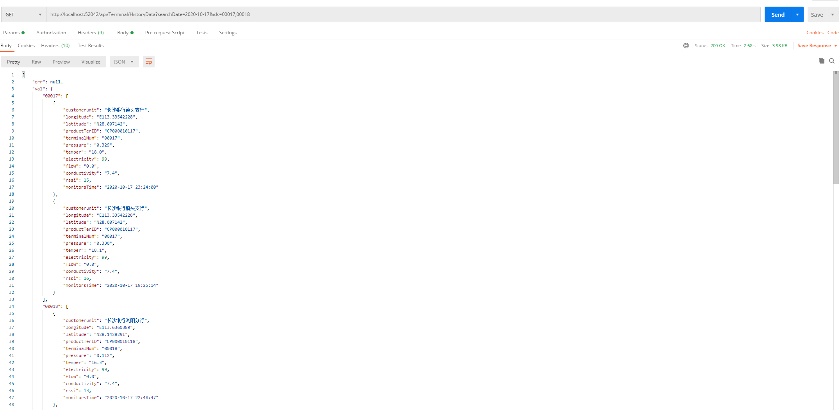

**2. 添加 查询告警信息接口**

|  |  |  |
| --- | --- | --- |
| ***资源URL：***http:// iot.chntek.com:3410/api/Terminal/RealTimeData | | |
| ***HTTP协议：****GET* | | |
| **参数名** | **说明** | **是否必须** |
| ProductTerId | 传感器ID编号 | 是 |
| TerminalNum | 设备终端ID号 | 是 |
| warnName | 告警类型 | 是 |
| MonitorsTime | 最近告警时间 | 是 |
| Prefecturecity | 告警城市 | 是 |
| Distriancounty | 告警区县 | 是 |
| Customerunit | 告警位置 | 是 |
| Longitude | 设备精度 | 是 |
| Latitude | 设备纬度 | 是 |
|  |  |  |

**成功返回ok,失败返回error**

**调用方式，示例：**

[http:// iot.chntek.com:3410/api/Terminal/RealTimeData?ids=00017,00018](http://117.50.119.238:3410/api/Terminal/RealTimeData?ids=00017,00018)

<http://localhost:52042/api/Terminal/RealTimeData?ids=00017,00018>

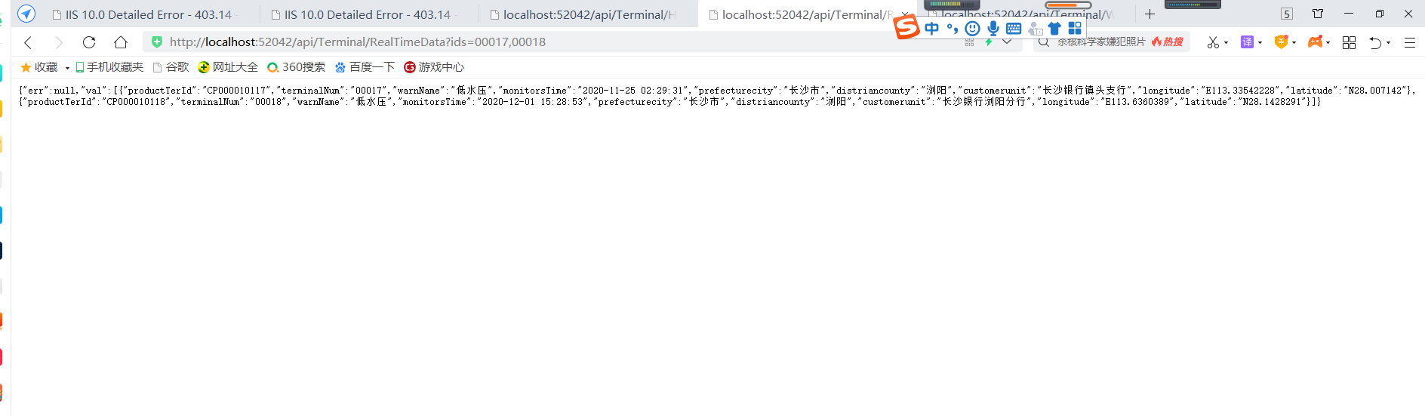

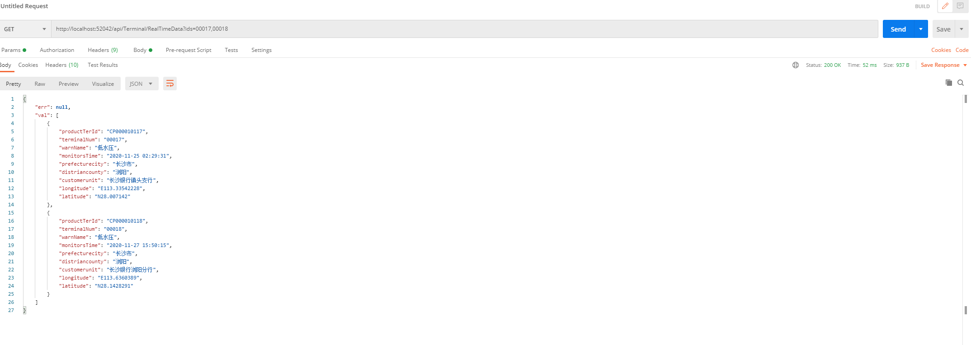

**3. 添加查询设备告警统计**

|  |  |  |
| --- | --- | --- |
| ***资源URL：***http:// iot.chntek.com:3410/api/Terminal/WarningList | | |
| ***HTTP协议：****GET* | | |
| **参数名** | **说明** | **是否必须** |
| ProductTerId | 传感器ID | 是 |
| TerminalNum | 终端设备ID | 是 |
| pressure | 压力值 | 是 |
| MonitorsTime | 报警时间 | 是 |
| warn | 告警类型 | 是 |

**成功返回ok,失败返回error**

**示例：**

http:// iot.chntek.com:3410/api/Terminal/WarningList?ids=00017,00018

<http://localhost:52042/api/Terminal/WarningList?ids=00017,00018>

