Spaceship Titanic Model Optimization Experiment Report
Revised Version: Method-Based Names and Experimental Reasoning Flow

1. Executive Summary
This revised report records the model optimization process for the Spaceship Titanic classification task. The experiment names have been rewritten according to the actual modeling methods instead of internal labels such as public-guided or rank-based search. For example, the previous public-guided static search is now described as CatBoost + LightGBM + XGBoost static fine search. This makes the report easier to understand in a paper or demo context.
The best retained model remains the CatBoost + LightGBM + XGBoost static ensemble with a Kaggle score of 0.81201. Later attempts, including dynamic stacking, aggressive feature engineering, removing XGBoost, multi-seed averaging, and ExtraTrees small-weight supplementation, did not improve the leaderboard score. However, these experiments are still valuable because they clarify why the final model should remain simple, static, and dominated by CatBoost with LightGBM support.

2. Overall Method-Based Result Comparison
The following table replaces internal experiment names with method-based descriptions. The word static is kept for fixed-weight probability/rank blending, while dynamic stacking is explicitly marked as dynamic.
Stage | Method | Representative file | Best Kaggle score | Decision
0 | LightGBM + HGB + CatBoost static | lgbm_regularized_thr050.csv | 0.80851 | Early baseline
1 | CatBoost + LightGBM + XGBoost static | final_submission_static_candidate_rank06/08/10/13.csv | 0.81201 | Best retained version
2 | CatBoost + LightGBM + XGBoost static fine search | final_submission_public_guided_rank*.csv | 0.81201 | Confirmed plateau
3 | CatBoost + LightGBM + XGBoost dynamic stacking | final_submission_oof_stacking.csv | 0.80664 | Rejected
4 | Advanced features + CatBoost/LightGBM/XGBoost static | advanced_static_submission.csv | 0.63338 | Rejected
5 | LightGBM + CatBoost multi-seed static | final_submission_lgbm_catboost_multiseed_thr*.csv | 0.80851 | Rejected
6 | CatBoost + LightGBM + XGBoost + ExtraTrees static | final_submission_extratrees_rank*.csv | 0.80897 | Rejected

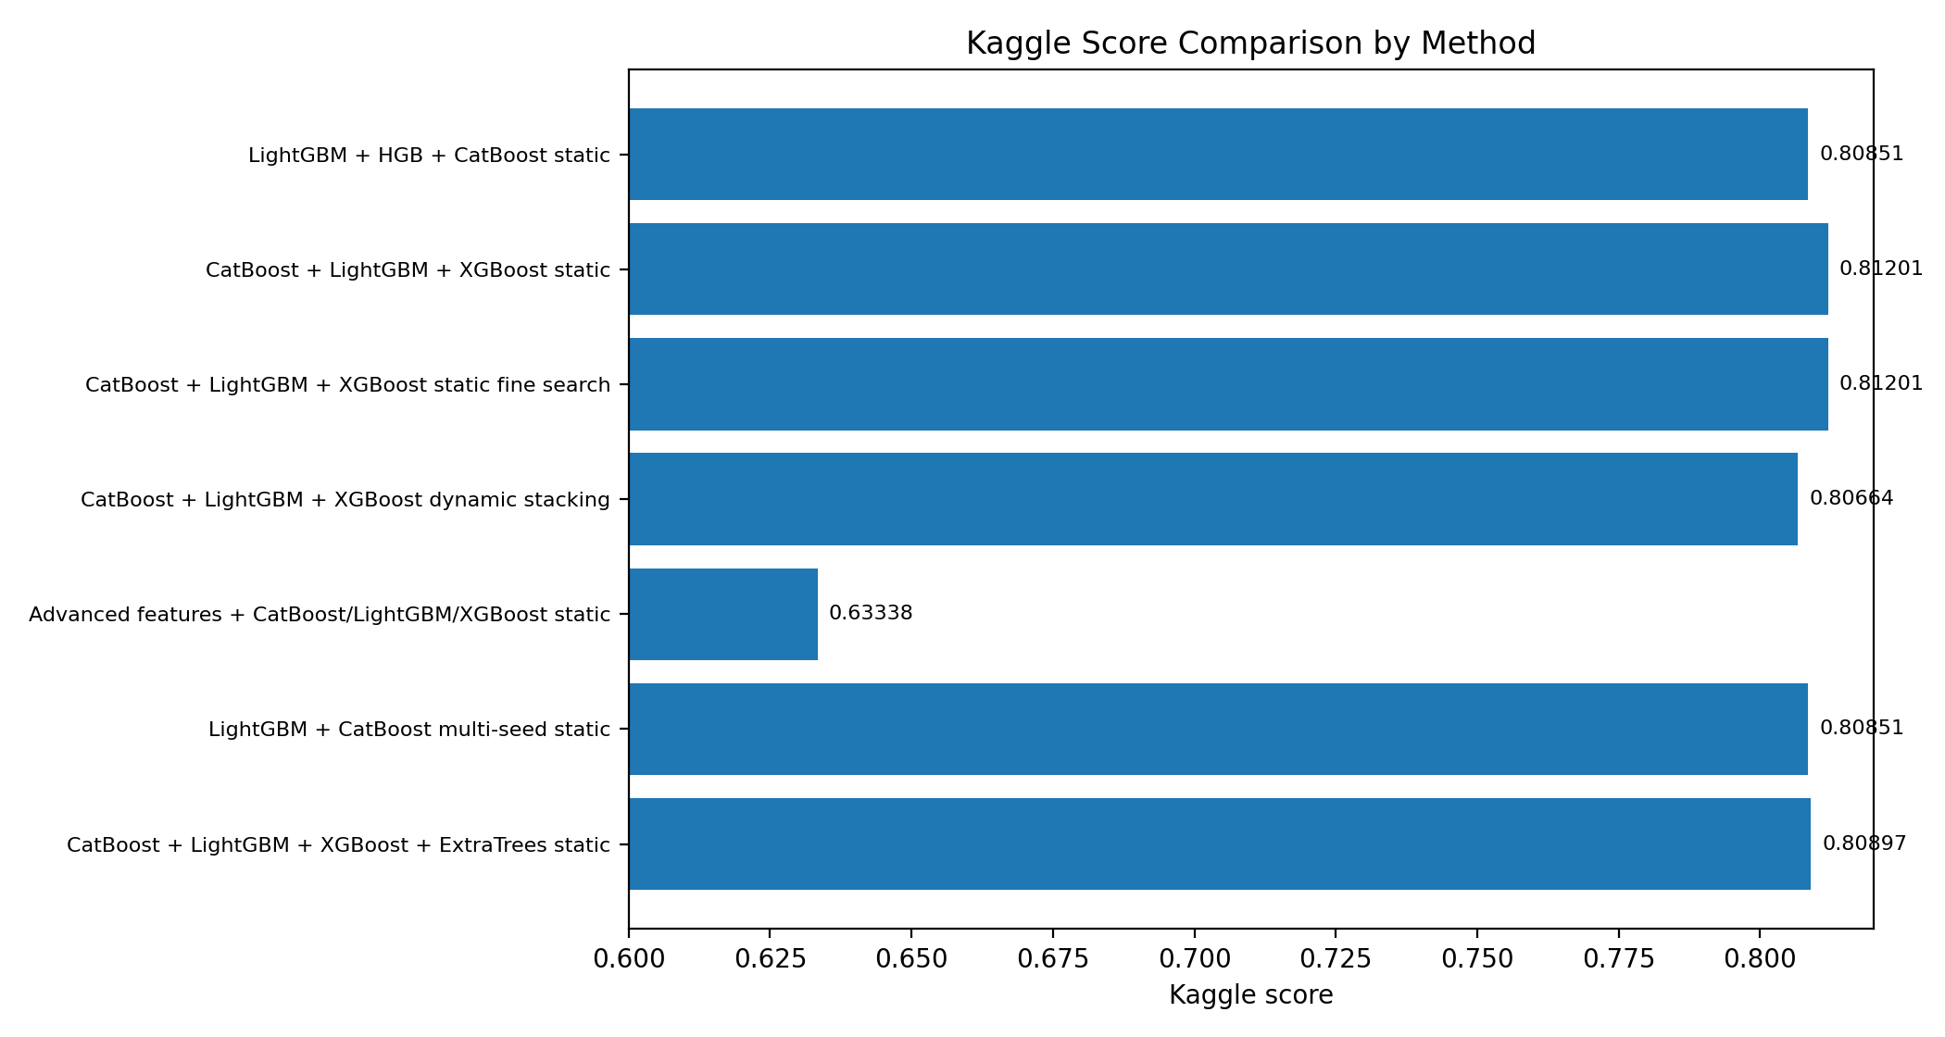
Figure 1. Kaggle score comparison using method-based experiment names.

3. Experimental Trajectory and Reasoning
This section adds the reasoning bridge between experiments. Each step was not an isolated trial; the next experiment was designed based on the weakness observed in the previous step.

3.1 Stage 0: LightGBM + HGB + CatBoost Static Early Baseline
The early baseline used a LightGBM-centered design with HistGradientBoosting and CatBoost as supporting models. The submitted file lgbm_regularized_thr050.csv reached 0.80851 on Kaggle. This result was already competitive and showed that gradient boosting models were suitable for the tabular structure of Spaceship Titanic.
Reasoning to next experiment: The limitation was that the early ensemble emphasized LightGBM/HGB but did not yet exploit the strongest CatBoost-dominant structure. Since CatBoost can handle categorical patterns more robustly and XGBoost may provide a different boundary decision pattern, the next experiment shifted toward a CatBoost + LightGBM + XGBoost static ensemble.

3.2 Stage 1: CatBoost + LightGBM + XGBoost Static Ensemble
The next experiment used CatBoost as the dominant model, LightGBM as the secondary model, and XGBoost as a very small correction model. The best retained fixed parameters were: XGBoost = 0.0075, LightGBM = 0.2325, CatBoost = 0.7600, alpha = 0.8125, and threshold = 0.5050. This improved the Kaggle score from 0.80851 to 0.81201.
Reasoning to next experiment: Because this static ensemble improved the score, the next logical step was not to change the model family immediately, but to search the nearby weight and threshold region more carefully. The goal was to check whether the 0.81201 result was a local optimum or whether nearby static weights could still increase the score.

3.3 Stage 2: CatBoost + LightGBM + XGBoost Static Fine Search
A narrower static search was performed around the high-performing region. In earlier notes this was called public-guided search, but in this revised report it is renamed according to the actual method: CatBoost + LightGBM + XGBoost static fine search. The search focused on very small XGBoost weight, medium LightGBM weight, dominant CatBoost weight, alpha around 0.81 to 0.86, and threshold around 0.505. Several candidates again reached 0.81201, but none clearly exceeded it.
Reasoning to next experiment: Since static fine search confirmed a plateau, the next question was whether fixed weights were too restrictive. To test whether the model could learn sample-dependent fusion behavior, a dynamic OOF stacking experiment was introduced.

3.4 Stage 3: CatBoost + LightGBM + XGBoost Dynamic Stacking
The dynamic stacking experiment trained first-level OOF predictions from XGBoost, LightGBM, and CatBoost, then used a second-level meta-model to combine these predictions. The purpose was to replace one fixed static weight set with a learned dynamic combination. However, the Kaggle score dropped to 0.80664.
Reasoning to next experiment: The lower score suggested that the meta-model either overfit local OOF patterns or changed useful boundary decisions learned by the static ensemble. Therefore, rather than making the blender more complex, the next attempt moved to feature engineering, hoping that better input features could improve the base models themselves.

3.5 Stage 4: Advanced Features + Static Ensemble
The advanced feature engineering version added more aggressive group, cabin, spending, missing-value, and target-encoding features. The same static ensemble idea was then applied. However, this version produced a Kaggle score of only 0.63338, which was far below the stable baseline.
Reasoning to next experiment: This large drop showed that aggressive features can damage train/test consistency or distort the learned probability distribution. The experiment therefore rejected this feature set. The next step was to return to the stable feature set and test a simpler hypothesis: since XGBoost had only a tiny weight, could it be removed safely?

3.6 Stage 5: LightGBM + CatBoost Multi-Seed Static Ensemble
This experiment removed XGBoost and used only LightGBM + CatBoost, with multi-seed averaging to reduce randomness. The best observed scores were around 0.80827 to 0.80851, below the 0.81201 baseline.
Reasoning to next experiment: The result showed that XGBoost should not be removed, even though its weight is tiny. It likely corrects a small number of important boundary cases. This motivated the next experiment: if a small XGBoost weight can help boundary cases, perhaps another diverse model with a very small weight, such as ExtraTrees, could provide additional corrections.

3.7 Stage 6: CatBoost + LightGBM + XGBoost + ExtraTrees Static Ensemble
ExtraTrees was added as a small-weight supplementary model. The search allowed ExtraTrees weights roughly between 0.0025 and 0.0325 while keeping CatBoost dominant and LightGBM secondary. The best submitted ExtraTrees candidates reached around 0.80897, which was still below 0.81201.
Reasoning after this experiment: This result suggests that ExtraTrees adds noise rather than useful correction. Its OOF validation metrics were much weaker than the boosting models, so even a small weight reduced the quality of the final blend. At this point, the evidence supports retaining the original CatBoost + LightGBM + XGBoost static ensemble as the demo model.

4. Key Validation and Parameter Evidence

4.1 Final Retained Static Ensemble Parameters
Parameter | Value
Method | CatBoost + LightGBM + XGBoost static
XGBoost weight | 0.0075
LightGBM weight | 0.2325
CatBoost weight | 0.7600
alpha_probability | 0.8125
threshold | 0.5050
Best Kaggle score | 0.81201

4.2 OOF Metrics for ExtraTrees Attempt
Model | OOF Accuracy | OOF ROC-AUC | Comment
xgboost | 0.80766 | 0.89968 | Base model
lightgbm | 0.80893 | 0.90220 | Base model
catboost | 0.80973 | 0.90019 | Base model
extratrees | 0.74129 | 0.85395 | Supplementary model; rejected

The OOF evidence explains why the ExtraTrees small-weight supplement did not improve Kaggle performance. ExtraTrees was much weaker than XGBoost, LightGBM, and CatBoost in OOF accuracy and ROC-AUC. Therefore, adding it to the ensemble was more likely to inject noise than to correct useful boundary cases.

4.3 Early 0.80851 LGBM/HGB Baseline Evidence
The early 0.80851 baseline is included here because it marks the starting point of the optimization process. It used the file lgbm_regularized_thr050.csv and was generated by the LGBM/HGB focus-refinement code.
Model | Family | View | OOF Best Thr. | OOF Best Acc. | OOF Acc @0.50
hgb_light | hgb | te_light | 0.4375 | 0.815484 | 0.812608
catboost_base | catboost | cat | 0.5000 | 0.815139 | 0.815139
lgbm_regularized | lightgbm | te_plus | 0.4600 | 0.815139 | 0.813873
hgb_base | hgb | te_plus | 0.4725 | 0.814448 | 0.812263
lgbm_light_view | lightgbm | te_light | 0.5100 | 0.813758 | 0.812493

Rank | File | Threshold | CatBoost W. | LGBM W. | HGB W. | OOF Best Acc.
1 | candidate_rank_01.csv | 0.4025 | 0.50 | 0.25 | 0.25 | 0.818014
2 | candidate_rank_02.csv | 0.4000 | 0.45 | 0.25 | 0.30 | 0.818360
3 | candidate_rank_03.csv | 0.4000 | 0.50 | 0.30 | 0.20 | 0.818245
4 | candidate_rank_04.csv | 0.4000 | 0.45 | 0.30 | 0.25 | 0.818475
5 | candidate_rank_05.csv | 0.4000 | 0.40 | 0.25 | 0.35 | 0.818245

5. Lessons Learned from the Optimization Process
Finding | Explanation
The best model is not the most complex model. | Dynamic stacking and advanced feature engineering both reduced Kaggle performance.
Tiny weights can still matter. | Removing XGBoost lowered the score, meaning it likely corrected a few important boundary samples.
Small supplementary models must be strong enough. | ExtraTrees added diversity, but its weak OOF performance made the final blend worse.
OOF performance is helpful but not sufficient. | Some candidates had strong OOF results but did not improve Kaggle score.
The final demo should prioritize stability. | The retained static ensemble is simple, reproducible, and empirically strongest.

6. Final Demo Decision
Based on all submitted experiments, the final demo model should remain the CatBoost + LightGBM + XGBoost static ensemble. It provides the best observed Kaggle score, avoids unstable dynamic stacking, and does not rely on aggressive features that harmed generalization.
Final demo configuration: XGBoost = 0.0075, LightGBM = 0.2325, CatBoost = 0.7600, alpha = 0.8125, threshold = 0.5050. The retained Kaggle score is 0.81201.

7. Paper-Ready Discussion Paragraph
The optimization process started from a LightGBM/HGB-focused static baseline that achieved a Kaggle score of 0.80851. To improve this result, the ensemble was redesigned as a CatBoost-dominant static weighted blend with LightGBM support and a very small XGBoost correction term, which increased the score to 0.81201. Further static fine search confirmed that this region was a performance plateau. Dynamic OOF stacking was then tested to learn sample-dependent model combinations, but it reduced the score to 0.80664, suggesting that the meta-model overfit local validation patterns or disrupted useful boundary decisions. Aggressive feature engineering also failed, dropping the score to 0.63338, indicating poor generalization of the added features. Removing XGBoost and applying multi-seed averaging also lowered performance, showing that even a tiny XGBoost weight contributed to boundary-case correction. Finally, ExtraTrees was added as a small-weight supplementary model, but its weak OOF performance caused the Kaggle score to remain below the baseline. Therefore, the final retained solution is the CatBoost + LightGBM + XGBoost static ensemble, which offers the best balance between accuracy, stability, and reproducibility.

Appendix A. Detailed Tuning Process of CatBoost + LightGBM + XGBoost Static Ensemble
Purpose of this appendix. This section expands the Stage 1 and Stage 2 static ensemble experiments. The goal is to show how the final CatBoost + LightGBM + XGBoost static ensemble was not selected manually, but was obtained through a sequence of controlled comparisons: equal weighting, threshold tuning, coarse weight search, fine weight search, and public-feedback-guided narrowing.

A.1 Why Equal Weights Were Not Enough
The first intuitive setting was to treat XGBoost, LightGBM, and CatBoost as equally important, using a simple probability average with one-third weight for each model. This was a reasonable starting point because all three are gradient-boosting or tree-based models commonly used for structured tabular data. However, the local OOF result showed that equal weighting did not fully match the behavior of this dataset. CatBoost produced more stable boundary decisions, while LightGBM worked better as a secondary support model. XGBoost was still useful, but only for a small number of difficult boundary samples.
Using equal weights at threshold 0.5000 produced an OOF accuracy of 0.80812. After tuning only the threshold while keeping the weights equal, the best OOF accuracy increased to 0.81111 at threshold 0.5420. This suggested that threshold calibration was useful, but it also showed that equal model contribution was not the best structure.

A.2 From Equal Weights to CatBoost-Dominant Static Weights
After the equal-weight baseline, the next step was to search different static weights among the same three models. The coarse search already showed a clear direction: CatBoost should receive the largest weight, LightGBM should remain the second strongest model, and XGBoost should be reduced to a small corrective role. This was important because it explained why the final model was not a balanced ensemble. The best performance came from an asymmetric ensemble that matched each model's actual contribution.
The fine search then focused on the CatBoost-dominant region. Instead of searching the entire weight space again, the experiment narrowed the search around small XGBoost weights, medium LightGBM weights, and large CatBoost weights. This stage improved the Kaggle score from about 0.80967 to 0.81178. Finally, public-feedback-guided narrowing confirmed the most stable high-score region around XGBoost = 0.0075, LightGBM = 0.2325, and CatBoost = 0.7600, with alpha = 0.8125 and threshold = 0.5050. This configuration achieved the retained best score of 0.81201.

A.3 Same-Model Static Ensemble Tuning Table
Stage | XGB | LGBM | CAT | Alpha | Threshold | OOF Acc. | Kaggle Score
Equal-weight static baseline | 0.3333 | 0.3333 | 0.3333 | 1.0000 | 0.5000 | 0.80812 | Not uploaded
Equal-weight + threshold tuning | 0.3333 | 0.3333 | 0.3333 | 1.0000 | 0.5420 | 0.81111 | Not uploaded
Coarse weighted static search | 0.0500 | 0.3750 | 0.5750 | 1.0000 | 0.4950 | 0.81433 | 0.80967
Fine weighted static search | 0.0100 | 0.2350 | 0.7550 | 0.8250 | 0.5052 | 0.81456 | 0.81178
Public-feedback-guided static search | 0.0075 | 0.2325 | 0.7600 | 0.8125 | 0.5050 | 0.81468 | 0.81201
Ultra-narrow static verification | 0.0075 | 0.2325 | 0.7600 | 0.8125 | 0.5050 | 0.81468 | 0.81201

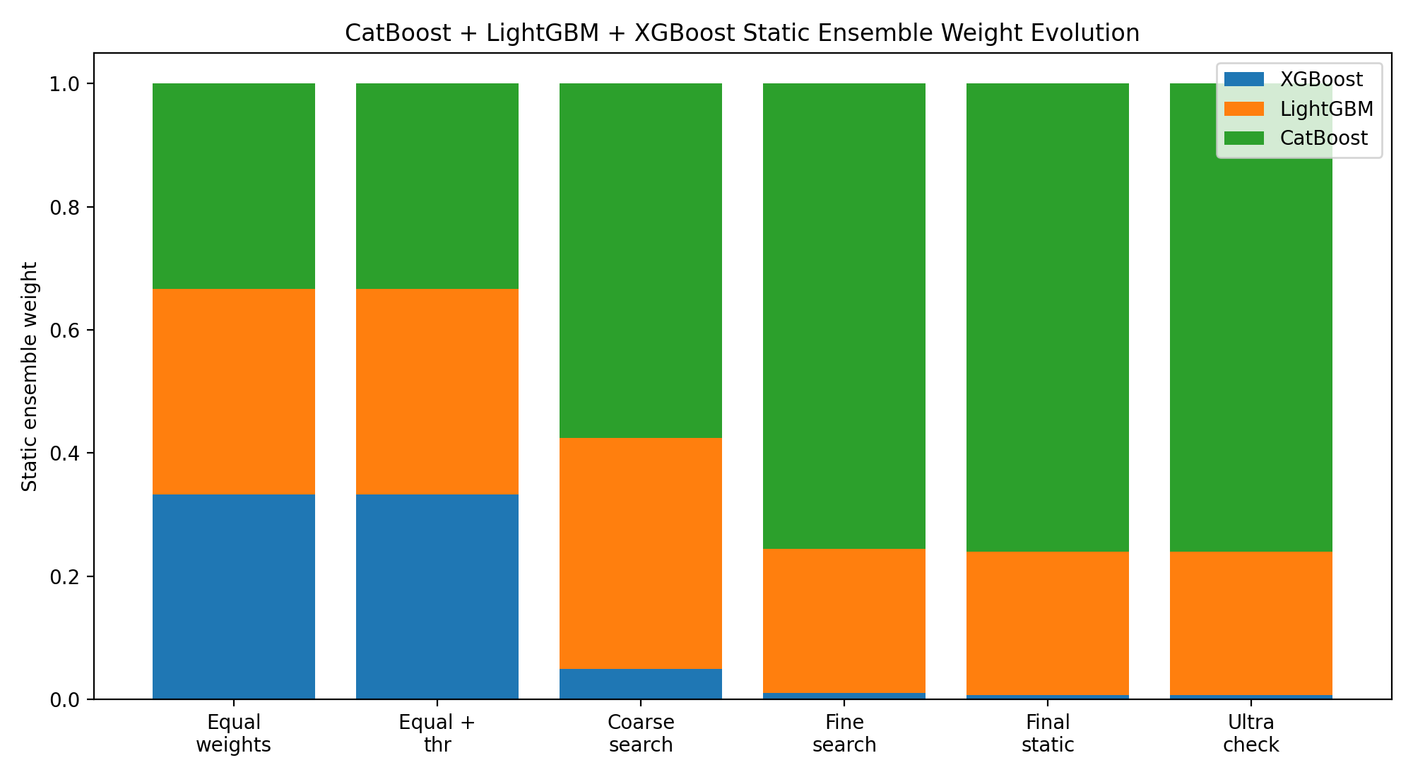
Figure A1. Weight evolution inside the same CatBoost + LightGBM + XGBoost static ensemble.
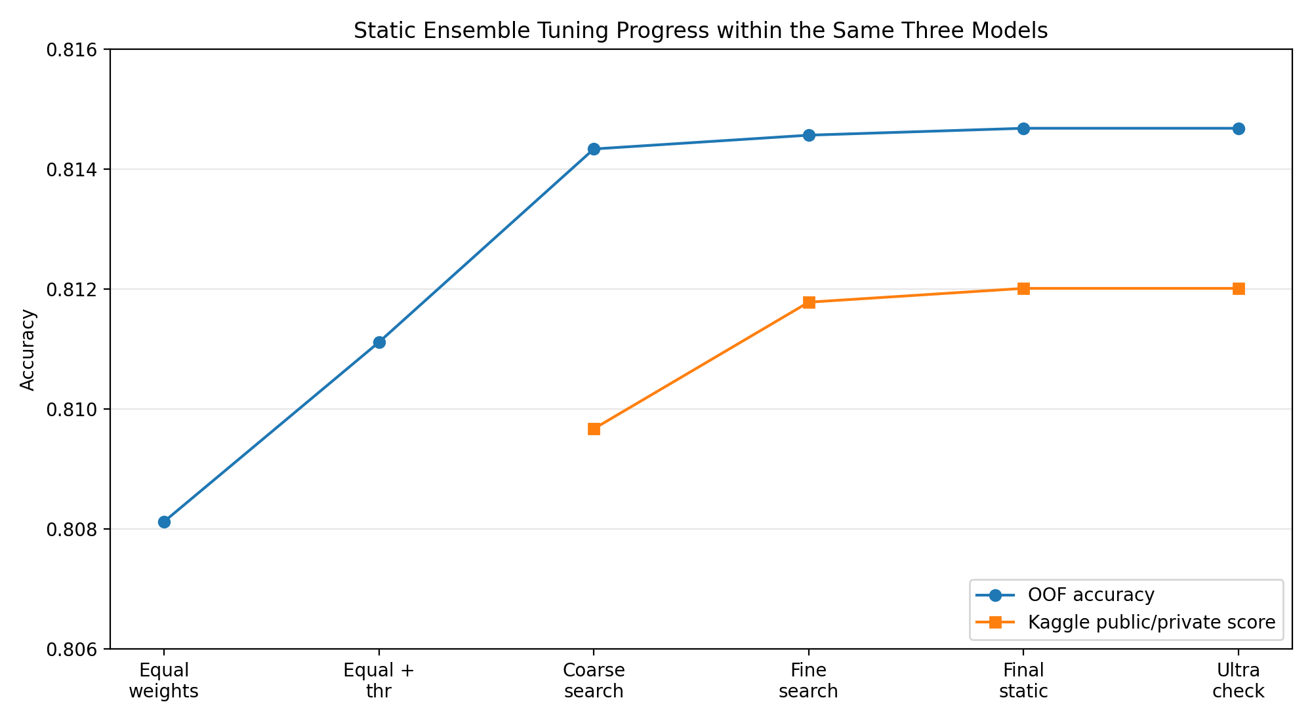
Figure A2. OOF and Kaggle score progression during static ensemble tuning.

A.4 Interpretation and Link to Later Experiments
The static tuning process revealed two important conclusions. First, the three models were not equally useful for this dataset: CatBoost was the main predictor, LightGBM provided consistent support, and XGBoost only needed a very small weight. Second, the best score depended on a narrow threshold region around 0.5050, meaning that many test samples were close to the decision boundary. These findings directly motivated later experiments. Dynamic stacking was tested because static weights might be too rigid, but it reduced the Kaggle score. Advanced feature engineering was tested because parameter tuning seemed to have reached a plateau, but it damaged generalization. ExtraTrees was tested because a small additional model might correct boundary cases, but it also reduced performance. Therefore, the final decision to keep the CatBoost + LightGBM + XGBoost static ensemble is supported not only by its highest score, but also by the failure of several reasonable alternative directions.

A.5 Paper-Ready Description of the Static Tuning Process
Within the CatBoost + LightGBM + XGBoost ensemble, the tuning process started from an equal-weight soft-voting baseline. Although this design was simple and fair to all three models, its OOF accuracy was lower than the later weighted alternatives. A threshold-only adjustment improved the local validation result, but the main improvement came from changing the model weights. The coarse search indicated that CatBoost should dominate the ensemble, while LightGBM should serve as a secondary model and XGBoost should be retained only as a small corrective component. Fine-grained search and public-feedback-guided narrowing further confirmed this pattern. The final static configuration used XGBoost = 0.0075, LightGBM = 0.2325, CatBoost = 0.7600, alpha = 0.8125, and threshold = 0.5050, achieving the best retained Kaggle score of 0.81201. This process shows that the final ensemble was selected through progressive empirical comparison rather than arbitrary weight assignment.

