Spaceship Titanic Passenger Transport Prediction
with Feature Engineering and Gradient-Boosted Ensembles
Team: Nova@MLW
Zhentao LUO 2430034048 Zihao CHEN 2430034007 Zhuangtao XIONG 2430034081 Zirui SU 2430034058
AI3023 Machine Learning Workshop Course Project
May 2026
Abstract—This article presents our solution for the Kaggle Spaceship Titanic binary classification task. The objective is to predict whether each passenger was transported to an alternate dimension using demographic, travel, cabin, and spending information. We build a complete machine-learning workflow in stages. First, we conduct exploratory data analysis and construct features from booking groups, cabin strings, spending behavior, age, and travel categories. Then, we train Logistic Regression and SVM as baseline models. Because these baselines have limited ability to capture nonlinear interactions, we further evaluate Random Forest, XGBoost, LightGBM, and CatBoost. The strongest models make different types of errors, so the final demo script combines their predicted probabilities, adds rank blending, and tunes the decision threshold. The final static ensemble weights are XGBoost 0.0075, LightGBM 0.2325, and CatBoost 0.7600, with a probability-rank blending coefficient of 0.8125 and a decision threshold of 0.5050. The official-files-only demo submission reaches a public Kaggle leaderboard accuracy of 0.81201. Because the final model was selected after comparing local validation and public leaderboard feedback, this score should be interpreted as a selected public result rather than an unbiased estimate of private-test performance. Overall, for this mixed tabular dataset, careful feature engineering combined with a lightweight gradient-boosted ensemble performs better than any single classifier tested in this project.
Index Terms—Kaggle Spaceship Titanic, Feature Engineering, Binary classification, CatBoost, LightGBM, Random Forest, XGBoost, Model ensemble
I. INTRODUCTION
Spaceship Titanic is a typical tabular machine-learning problem. Each passenger record contains demographic information, travel options, cabin information, service-spending fields, and the binary target Transported. The dataset includes several common challenges in tabular modeling: mixed numerical and categorical variables, missing values in multiple columns, useful structured information hidden in PassengerId and Cabin, strongly right-skewed spending fields, and important interaction effects such as CryoSleep combined with spending behavior. Directly applying off-the-shelf classifiers is not sufficient; the task requires feature construction, reliable validation, and comparison across multiple model families.
Our goal is to build a workflow that can produce a Kaggle submission and can also be clearly explained in the final report and demo. Starting from exploratory data analysis (EDA), we engineer features related to passenger groups, cabin position, spending behavior, age, and travel patterns. We then train Logistic Regression and SVM baselines. After identifying their limitations, especially on nonlinear interactions, we evaluate Random Forest, XGBoost, LightGBM, and CatBoost. Finally, we combine the best-performing boosted models and tune the decision threshold.
The workflow has three main stages: feature engineering from identifiers, cabin strings, and spending fields; stratified validation across several model families from Logistic Regression to gradient boosting; and a conservative final static ensemble using CatBoost, LightGBM, and XGBoost with probability-rank blending and threshold tuning. This official-files-only demo pipeline reaches a public Kaggle leaderboard score of 0.81201.
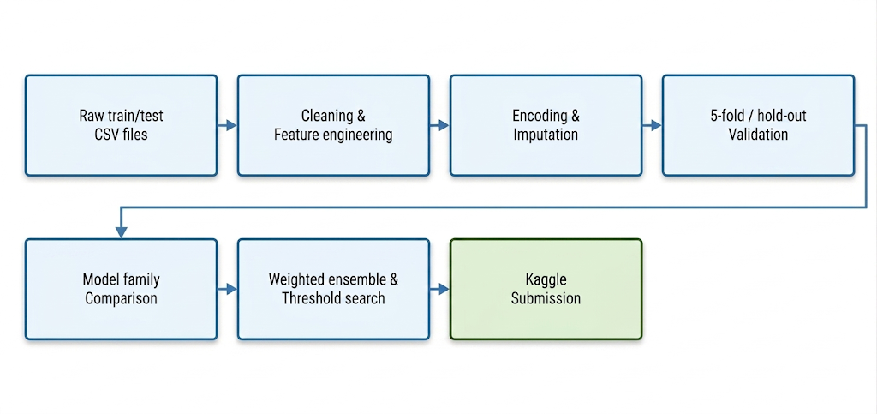
Fig. 1. Project pipeline: CSV data is cleaned, feature engineering, encoded and imputed, stratified validation and evaluation, and multi-model comparison, and finally submitted through weighted integration and threshold optimization.
II. RELATED WORK AND EXISTING TECHNIQUES
Spaceship Titanic is a mixed-type tabular classification task. Logistic Regression is an efficient starting point because it is fast, stable, and interpretable after one-hot encoding. However, its linear decision boundary cannot easily capture interaction effects among CryoSleep, spending, cabin side, HomePlanet, and Destination. SVM can introduce nonlinear decision boundaries through kernel functions, but training speed and probability estimation become more expensive as the dataset and parameter grid grow.
Tree-based models are well suited to this structured dataset. They do not require feature scaling and can learn thresholds and interactions automatically. Random Forest provides a strong nonlinear bagging baseline by averaging many independently trained decision trees. XGBoost, LightGBM, and CatBoost further improve on this idea through sequential boosting and regularization. XGBoost uses regularized gradient boosting with second-order loss information; LightGBM uses histogram-based leaf-wise growth for efficiency; and CatBoost handles categorical variables natively with ordered boosting, which is useful for fields such as HomePlanet, Destination, Deck, and Side.
When different models make different errors, ensemble learning can improve stability. Weighted probability averaging is usually more robust than relying on a single classifier, especially near the decision boundary. Threshold tuning is also important for Kaggle accuracy: although 0.5 is a common default threshold, the best threshold can shift when probabilities are imperfectly calibrated or when the public leaderboard distribution differs slightly from local validation.
III. DATASET AND EXPLORATORY DATA ANALYSIS
A. Dataset Overview
The training set contains 8,693 samples and the test set contains 4,277 samples. The training set has 14 columns, including PassengerId and the target Transported, while the test set does not contain the target label. The original features are HomePlanet, CryoSleep, Cabin, Destination, Age, VIP, RoomService, FoodCourt, ShoppingMall, Spa, VRDeck, and Name. Transported is a Boolean target and is converted into an integer label for scikit-learn models.
TABLE I
Dataset summary and Modeling Inspiration.
Field group | Examples | Modeling implication
Identifiers | PassengerId, Cabin, Name | Split into lower-cardinality group, cabin, and family features
Categorical travel features | HomePlanet, Destination, CryoSleep, VIP | One-hot encoding for sklearn/LightGBM; native categorical handling for CatBoost
Numeric features | Age and five spending columns | Median imputation, log transformation, spending totals and ratios
Target | Transported | Binary label; evaluated mainly by accuracy
Dataset size | Train 8,693; test 4,277 | Small-to-medium tabular dataset; suitable for cross-validation and boosted trees

B. Target Balance and Numeric Distributions
The target classes are almost balanced, so accuracy is a reasonable main evaluation metric. Age is concentrated around young and middle-aged passengers, while children and elderly passengers are relatively fewer. The spending variables are strongly right-skewed: most passengers have zero or low spending, while a small number have very high spending. Therefore, we use log1p transformations, zero-spending indicators, total spending, and spending ratios instead of relying only on the raw spending columns.
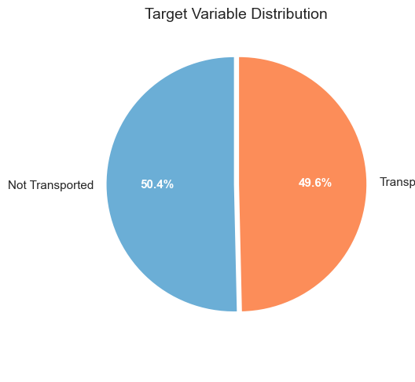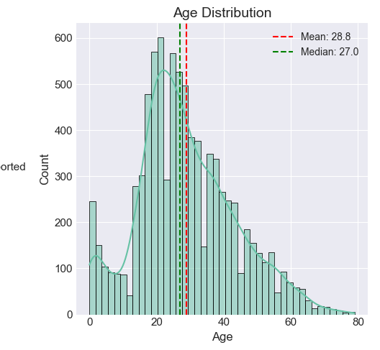
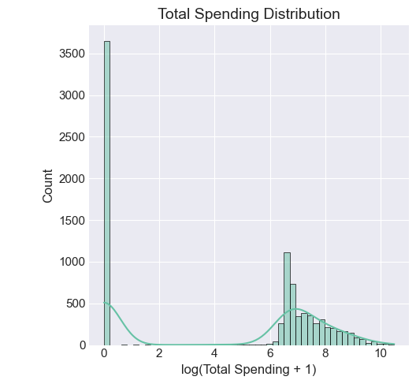
Fig. 2. Overview of EDA: the top is the target class balance (49.6% transported) and the age distribution (the mean is 28.8); the bottom is the total spending after logarithmic transformation, and there are a large number of zero-spending groups and medium-spending groups. The balanced target makes the accuracy a reasonable main indicator.
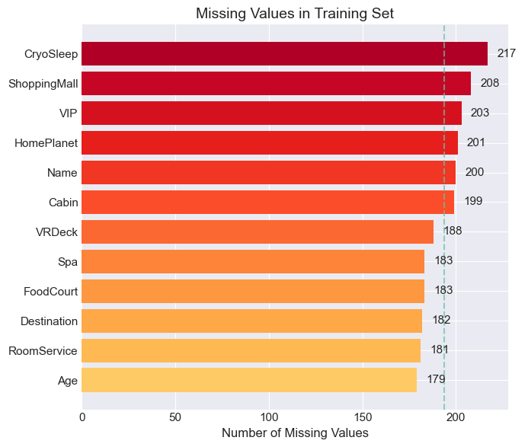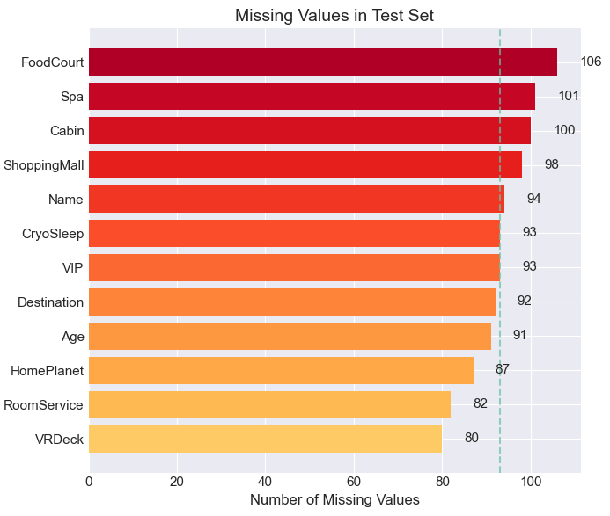
Fig. 3. Statistics of missing values of training sets and test sets. Most of the features are missing, and about 180-217 are missing in each column of the training set. Numerical features are filled with medians; CryoSleep, HomePlanet and other category features are filled with mode or constants according to the needs of the model.
C. Categorical Trends
Visualization shows clear categorical patterns. Europa passengers have a higher transported rate than Earth passengers; Destination is also related to the target; and CryoSleep is the strongest single feature, with frozen passengers having a much higher transported rate than non-frozen passengers. These findings guide the construction of interaction features such as CryoAndNoSpend, CryoAndSpend, HomePlanet-Destination combinations, and group-count features.
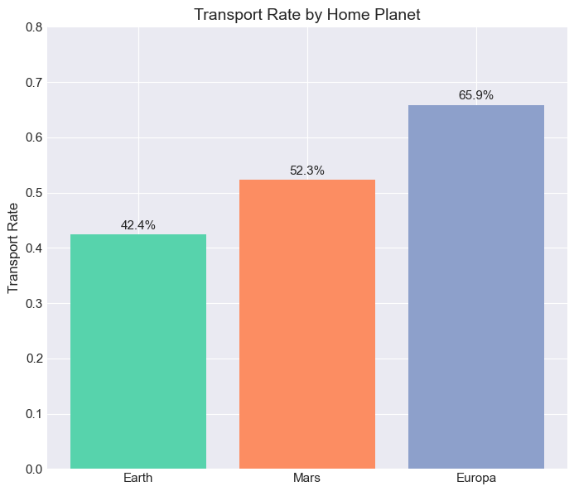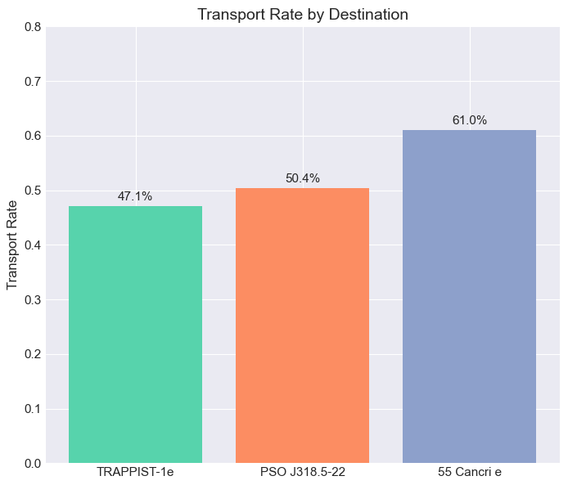
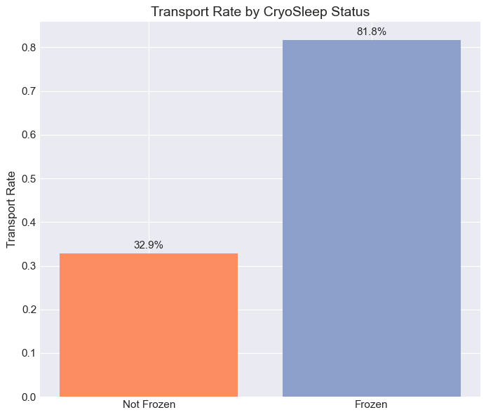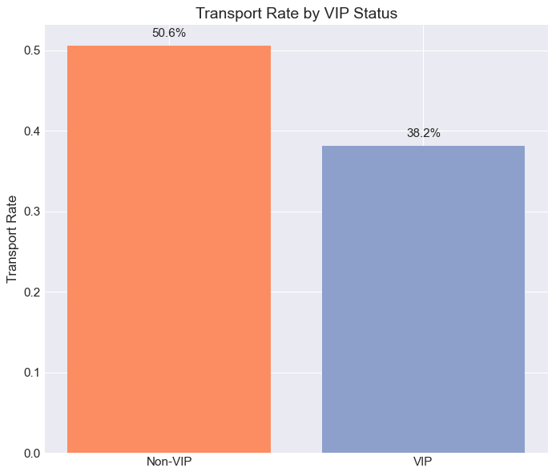
Fig. 4. Categorical feature transported rate: Europa 65.9% vs Earth 42.4%; 55 Cancri e destination 61.0%; frozen passengers 81.8% vs non-frozen 32.9%; VIP is 38.2%. These findings guide the construction of key interaction features.
D. Outliers and Spending Behavior
The total-spending boxplot and violin plot show many high-spending outliers. We do not delete these values because high spending may be related to passenger status, CryoSleep, and transport probability. Instead, the pipeline retains the original values and adds logarithmic transformations and aggregate spending indicators. This keeps the high-spending signal while reducing the impact of scale on models that are sensitive to numerical magnitude.

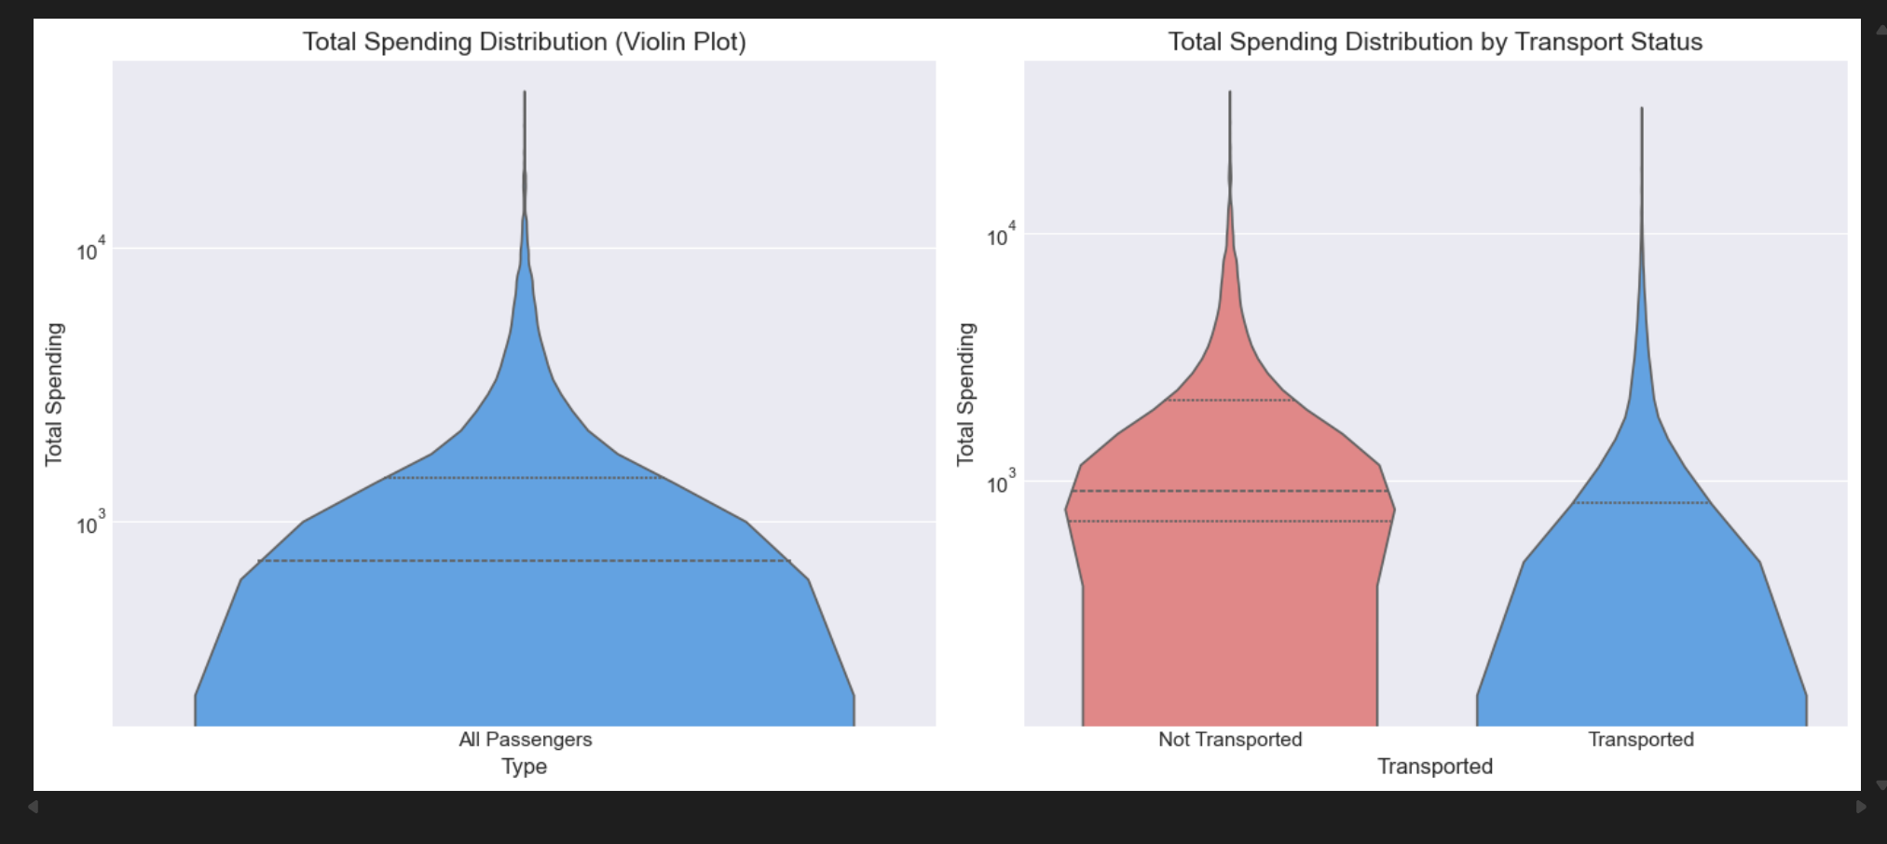
Fig. 5. TotalSpend of violin plot
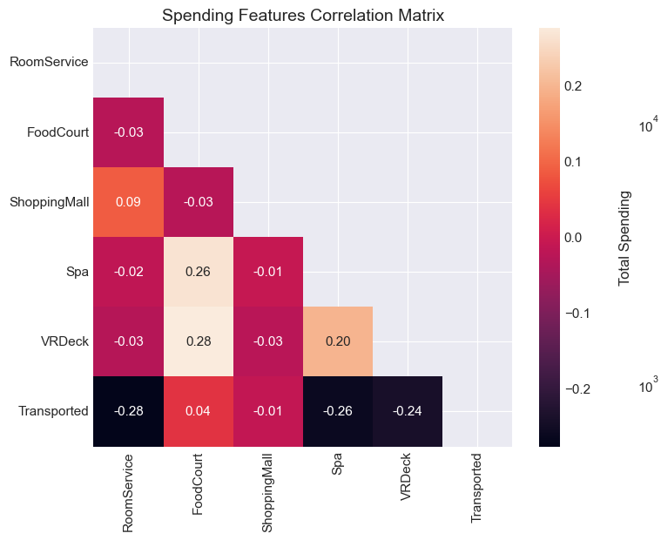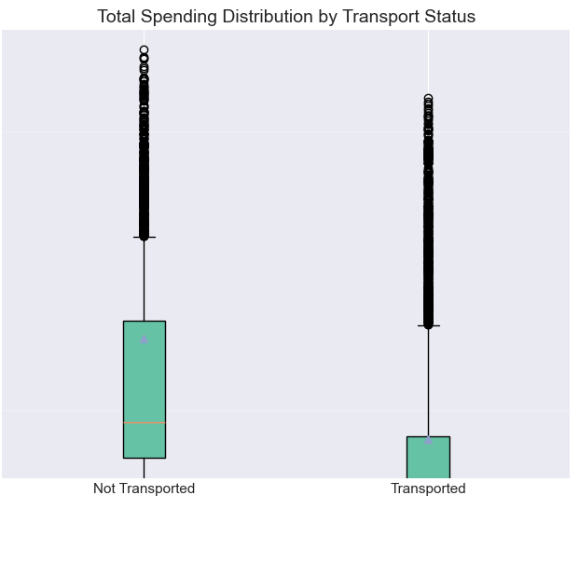
Fig. 6. Spending characteristic correlation heatmap and logarithmic total spending distribution according to transport status: RoomService (-0.28) and Spa (-0.26) are the strongest spending predictors and negatively related to transport; the overall spending of transported passengers is lower, supporting the characteristics of zero spending and LuxurySpendRatio .
IV. METHODOLOGY
A. Data Cleaning and Feature Engineering
Preprocessing first converts the Boolean target into an integer label and separates the target from the feature matrix. Training and test features are combined only during deterministic feature construction so that group-size and count features are calculated consistently across both datasets. No test labels are used, so no supervised information is leaked.
PassengerId is split into GroupId and PassengerNo, and GroupSize and IsSolo are derived from the booking group. Cabin is split into Deck, CabinNum, and Side to capture cabin-position information. Name is used to extract Surname and NameLength as approximate family and completeness signals. The original high-cardinality identifiers are dropped after their useful derived features are created.
The five spending columns are converted into numeric values and expanded into TotalSpend, NoSpend, LuxurySpend, BasicSpend, LuxuryRatio, and log1p-transformed spending features. CryoSleep and VIP are treated as categorical or Boolean signals, and important interaction features such as CryoAndNoSpend and CryoAndSpend are added. This design helps the model distinguish true zero-spending passengers from passengers with missing or irregular spending records.

TABLE II
Feature Engineering Design.
Feature family | Constructed variables | Rationale
Group features | GroupId, PassengerNo, GroupSize, IsSolo | Passengers in the same booking group may have related outcomes
Cabin features | Deck, CabinNum, Side | Cabin position can correlate with passenger type and transported rate
Family features | Surname, FamilySizeApprox, NameLength | Approximate family grouping plus name-completeness signal
Spending features | TotalSpend, log1p columns, NoSpend, LuxurySpend, ratios, bins | Handle skewed expenses and separate true zero-spenders from rows with missing spending data
Age features | AgeMissing, AgeBin, IsChild, IsTeen | Non-linear age effects and missingness signals
Interaction features | CryoAndNoSpend, CryoAndSpend, GroupSize, IsSolo | Capture non-linear combinations observed in EDA
Target encoding | TE_* categorical encodings in sklearn view | Add smoothed category-level signal from out-of-fold estimates; used in notebook exploration, not in final demo script
B. Encoding, Imputation, and Validation
The project uses two feature views. For CatBoost, categorical columns are cleaned and passed directly to the model, while numeric columns are median-imputed. For XGBoost and LightGBM, numeric columns are imputed with the median, and categorical columns are filled with "Missing", converted to strings, and one-hot encoded with unknown-category handling.
Baseline notebooks use a stratified 20% hold-out set and cross-validation for Logistic Regression and SVM. A broad SVM grid is not included in the final tuning because of its computational cost. The final demo script uses five-fold StratifiedKFold for CatBoost, LightGBM, and XGBoost, saves out-of-fold probabilities, and performs threshold and ensemble selection without evaluating on the training predictions directly.
C. Logistic Regression Baseline
Logistic Regression provides a fast and interpretable baseline. The default model (max_iter=1000) reaches a five-fold cross-validation accuracy of 0.8018±0.0055 and a hold-out accuracy of 0.8033. Grid search selects C=1, l1_ratio=1.0, and solver=liblinear, improving cross-validation accuracy to 0.8057 and hold-out accuracy to 0.8154.
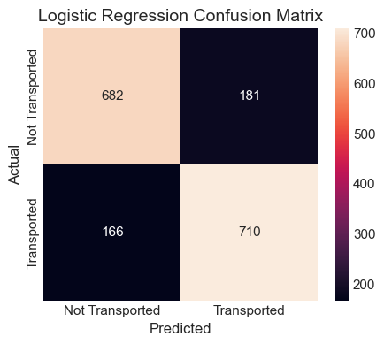
Fig. 7. After tuning, the Logistic Regression confusion matrix, the false positive and false negative are basically balanced, and the linear baseline is well calibrated.
D. Support Vector Machine Baseline
SVM provides a nonlinear boundary comparison. In the retained experiment, its five-fold cross-validation accuracy is 0.7869±0.0094 and its hold-out accuracy is 0.7982. The confusion matrix shows that SVM recalls more transported passengers, but it also produces more false positives. Because wide tuning over C, gamma, and kernels is computationally expensive, SVM is used as a baseline rather than as part of the final ensemble.
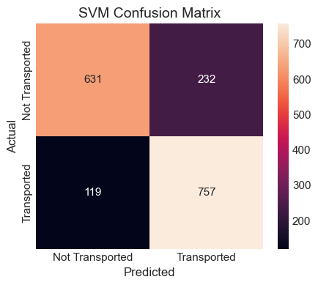
Fig. 8. Confusion matrix for the SVM baseline
E. Random Forest Model
Random Forest is the first nonlinear tree ensemble tested between the SVM baseline and gradient boosting models. Through bootstrap sampling and random feature subsets, it trains multiple decision trees and averages their predictions. It does not require feature scaling and can handle the different scales of age and spending after imputation. We use 500 trees, min_samples_leaf=2, random seed 42, and five-fold stratified validation. Its accuracy is competitive, but the boosted models perform better because they correct residual errors sequentially.
F. CatBoost Model
CatBoost is highly suitable for this task because it can directly use cleaned categorical features. The final script uses 650 iterations, learning rate 0.025, depth 5, l2_leaf_reg=5.0, Logloss as the objective, Accuracy as the evaluation metric, random seed 42, and verbose output disabled. The CatBoost feature view drops raw high-cardinality identifiers after extracting derived group, cabin, family, and interaction features.
G. LightGBM Model
LightGBM is trained on the scikit-learn feature view after one-hot encoding categorical variables. The final parameters are 650 trees, learning rate 0.022, 24 leaves, min_child_samples=35, subsample 0.85, column sampling 0.85, L1 regularization 0.08, L2 regularization 2.0, and random seed 42. Its leaf-wise growth and histogram-based training provide a useful complement to CatBoost.
H. XGBoost Model
XGBoost provides another gradient-boosted tree perspective with explicit L1/L2 regularization and second-order loss information. The final parameters are 500 trees, maximum depth 3, learning rate 0.025, subsample 0.85, column sampling 0.85, min_child_weight=2, gamma=0.02, L2 regularization 2.5, L1 regularization 0.08, and random seed 42. Although XGBoost has only a small final weight of 0.0075, ablation experiments show that it can still correct some boundary cases missed by CatBoost and LightGBM.
I. Weighted Ensemble and Threshold Search
The final script integrates the probability of three models and adopts the normalized weighted average:
Final score = α × probability blending + (1−α) × rank blending
Probability blending = w_CB・p_CB + w_LGBM・p_LGBM + w_XGB・p_XGB
Rank blending uses the same weight to act on the percentile ranking.
Satisfy w_CB + w_LGBM + w_XGB = 1

The weight selection adopts a coarse-to-fine search strategy based on out-of-fold predictions. The first search shows that CatBoost should dominate the ensemble, so later searches focus on CatBoost-biased combinations. The final weights are XGBoost=0.0075, LightGBM=0.2325, and CatBoost=0.7600. The fusion coefficient α=0.8125 means that 81.25% of the final score comes from probability blending and 18.75% comes from rank blending. The threshold is searched between 0.48 and 0.53, and 0.5050 is selected. The resulting out-of-fold accuracy is about 0.81468, while the official public Kaggle score of the conservative demo submission is 0.81201. Since public leaderboard feedback influenced the final selection, this score should be treated as a selected public result rather than a private-test guarantee.

TABLE III
Model Performance Summary (Notebook Verification).
Model | Accuracy | Precision | Recall | F1-score | ROC-AUC
Logistic Regression | 0.7871 | 0.7684 | 0.8262 | 0.7963 | 0.8717
SVM | 0.7878 | 0.7531 | 0.8607 | 0.8033 | 0.8283
Random Forest | 0.7960 | 0.8035 | 0.7876 | 0.7955 | 0.8779
Gradient Boosting | 0.7906 | 0.8034 | 0.7736 | 0.7882 | 0.8840
Extra Trees | 0.7875 | 0.8077 | 0.7588 | 0.7825 | 0.8700
XGBoost | 0.8065 | 0.8020 | 0.8177 | 0.8098 | 0.8985
LightGBM | 0.8109 | 0.8261 | 0.7910 | 0.8082 | 0.9025
CatBoost | 0.8135 | 0.8069 | 0.8278 | 0.8172 | 0.9026
Probability-rank ensemble | 0.8124 | 0.8131 | 0.8148 | 0.8139 | 0.9041

TABLE IV
Note: Tables III and IV report local validation and notebook-based results, while the final Kaggle score is measured on the public leaderboard. Therefore, the validation values and the Kaggle public score are related but not identical metrics.
Five-fold cross-validation stability.
Model | 5-fold CV accuracy | Std. dev. | Validation interpretation
Logistic Regression | 0.7879 | 0.0056 | Fast linear benchmark
SVM | 0.7876 | 0.0096 | Kernel baseline
Random Forest | 0.7936 | 0.0084 | Non-linear bagging baseline
Gradient Boosting | 0.7982 | 0.0097 | Sequential tree baseline; improves over Random Forest.
Extra Trees | 0.7872 | 0.0060 | Strong variance reduction but underfits some transported cases.
XGBoost | 0.8064 | 0.0103 | Regularized boosted trees
LightGBM | 0.8059 | 0.0080 | Fast leaf-wise boosting; strong accuracy/runtime trade-off.
CatBoost | 0.8092 | 0.0085 | Best single CV model; categorical handling fits this dataset.

V. EXPERIMENTAL STUDY AND RESULTS ANALYSIS
A. Evaluation Metrics
Kaggle evaluates submissions by accuracy, so accuracy is the main metric. Additional metrics such as precision, recall, F1-score, ROC-AUC, confusion matrices, training time, inference time, and memory usage are used to interpret model behavior. Because the target is close to balanced, accuracy is suitable, but the confusion matrix is still important for understanding whether a model is more conservative or more likely to predict Transported.
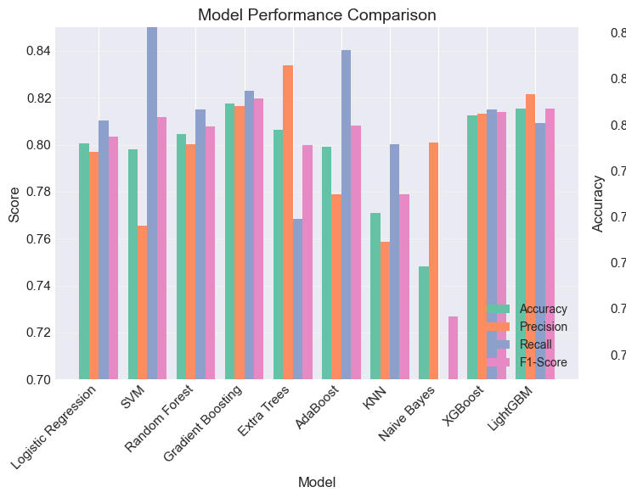

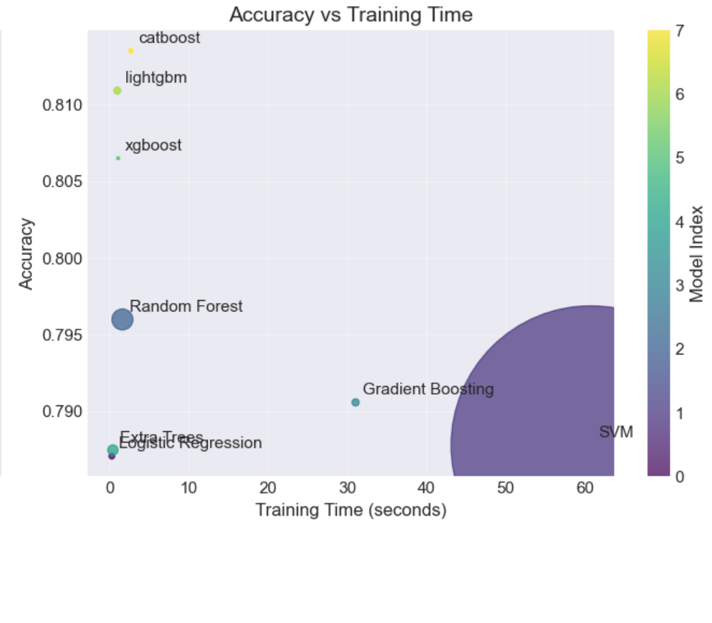
Fig. 9. Comparison of model performance

B. Baseline Model Interpretation
Tuned Logistic Regression is a strong baseline, showing that one-hot encoding and engineered features capture many useful signals. Tuning improves cross-validation from 0.8018 to 0.8057. However, Logistic Regression cannot automatically learn high-order interactions unless they are manually constructed. Random Forest provides a nonlinear tree baseline, but gradient boosting performs better. XGBoost, LightGBM, and CatBoost reach stronger validation results because they learn interactions among CryoSleep, spending, cabin, and HomePlanet more effectively.
The SVM baseline has lower accuracy than tuned Logistic Regression, but it recalls more transported passengers. Its error mode is different: it is more likely to predict Transported, reducing false negatives but increasing false positives. This difference is useful for analysis, although the cost of probability estimation and large-scale tuning makes it less suitable for the final ensemble.
C. Why the Final Submission Uses Gradient Boosting
The dataset contains many strong interaction patterns. CryoSleep is strongly related to the target, but its effect is tied to spending because frozen passengers usually have zero spending, while non-frozen passengers show more variation in luxury and basic spending. HomePlanet, Destination, cabin deck, and cabin side also interact in ways that are difficult for linear models to capture. Tree ensembles can directly learn these thresholds and interaction effects.
CatBoost, LightGBM, and XGBoost differ in categorical handling, tree growth strategy, and regularization. CatBoost uses ordered boosting and native categorical processing; LightGBM uses efficient leaf-wise growth; and XGBoost applies L1/L2 regularization in the split objective. Because their error patterns are not identical, probability blending can reduce residual errors compared with a single model.
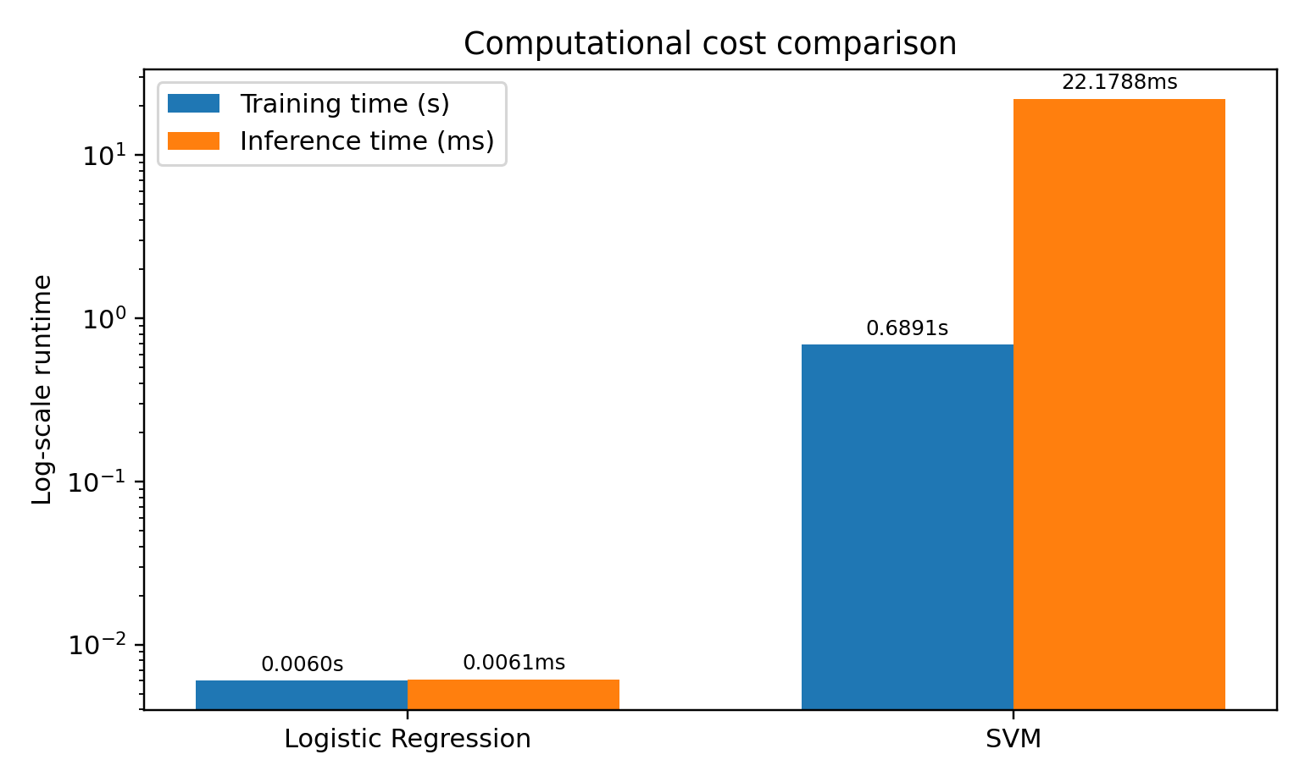
Fig. 10. Computational cost comparison between training time and inference time.
D. Computational Cost
Notebook runtime measurements show that Logistic Regression is the fastest model, while SVM is much more expensive for inference and broad parameter search. Gradient boosting requires more training time than Logistic Regression but remains practical for this dataset and captures tabular interactions more flexibly. The final demo script also records fold-level validation and runtime summaries to support reproducibility.

TABLE V
Comparison of computational costs
Model | Train time (s) | Inference time (ms) | Memory alloc. (MB) | Cost conclusion
Logistic Regression | 0.2111 | 1.29 | 0.01 | Best for quick iteration and sanity checks.
SVM | 55.6952 | 3409.97 | 48.95 | Too expensive for broad grid search on this dataset.
Random Forest | 1.6689 | 22.58 | 0.40 | Moderate training cost; slower inference from many trees.
Gradient Boosting | 78.3971 | 5.31 | 0.10 | Accurate but slowest training among tested models.
Extra Trees | 0.6994 | 12.95 | 0.27 | Fast training; accuracy does not match boosted models.
XGBoost | 2.1268 | 0.54 | 0.02 | Efficient boosted baseline with strong ROC-AUC.
LightGBM | 4.5768 | 2.49 | 0.04 | Good accuracy with practical runtime.
CatBoost | 4.6912 | 1.96 | 0.04 | Best single accuracy while remaining practical.

E. Error Analysis and Key Findings
The confusion matrices show how different models balance false positives and false negatives. Tuned Logistic Regression has 154 false positives and 167 false negatives on the hold-out set, which is relatively balanced. SVM has 232 false positives and 119 false negatives, explaining its higher recall but lower accuracy. This contrast supports the use of probability-level integration: conservative and aggressive models can compensate for each other after blending.

EDA and ablation experiments lead to several key findings. The target is balanced, so the model cannot improve much simply by favoring one class. CryoSleep is the strongest single feature, and its relationship with spending motivates CryoAndNoSpend and CryoAndSpend. Spending fields are heavily right-skewed, making log transformations and zero-spending indicators important. HomePlanet, Destination, cabin deck, and cabin side encode passenger-group information that tree models can exploit. Although the XGBoost weight is only 0.0075, removing it lowers the Kaggle score. Dynamic OOF stacking decreased to 0.80664, and excessive feature engineering decreased to 0.63338, suggesting that the conservative static ensemble with original engineered features generalizes better on the hidden test set.
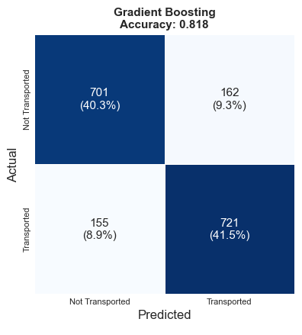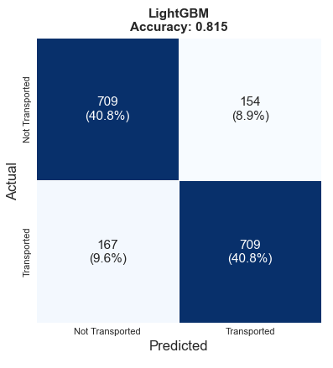
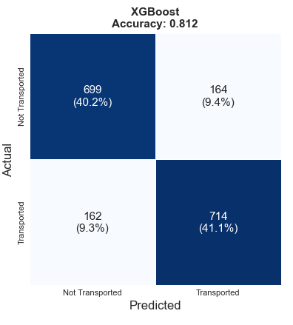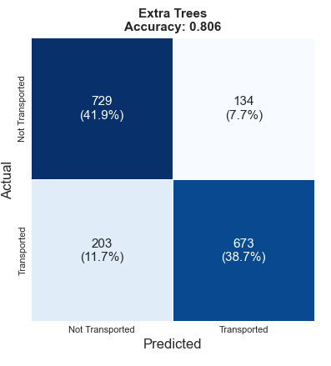
Fig. 11. Upgrade Model Confusion Matrix

TABLE VI
Boosted-model feature-importance evidence
Model | Top evidence from notebook | Interpretation for final model
XGBoost | NoSpend, CryoSleep_True, CryoAndNoSpend, HomePlanet_Earth, TotalSpend | The strongest split-level signals are zero spending and CryoSleep interactions.
LightGBM | CabinNum, Age, VRDeck, Spa, FoodCourt, TotalSpend, SurnameSize | Leaf-wise boosting uses fine-grained cabin, age, and spending thresholds.
CatBoost | BasicSpend, LuxuryRatio, RoomService, Age, NameLength, CryoAndNoSpend | Native categorical handling benefits from mixed spending and group-derived features.

F. Reproducibility and Output Files
The final demo script is a reproducible command-line process. It reads train.csv and test.csv from the same folder as the script, trains XGBoost, LightGBM, and CatBoost with five-fold StratifiedKFold, saves out-of-fold probabilities, saves fold-level validation and runtime summaries, and writes the final Kaggle submission. The demo uses a fixed static ensemble and does not rely on manual row-index corrections.
python spaceship_demo.py

TABLE VII
Files generated by the final demo script.
Output file | Purpose
demo_final_submission.csv | Final Kaggle submission generated by the conservative static ensemble.
demo_test_base_predictions.csv | Test-set base probabilities from XGBoost, LightGBM, and CatBoost.
demo_oof_predictions.csv | Out-of-fold base probabilities, final ensemble score, final OOF prediction, and true labels.
demo_validation_summary.csv | Model-level OOF accuracy and final ensemble OOF accuracy.
demo_fold_validation_summary.csv | Fold-by-fold validation accuracy and runtime for each base model.
demo_model_runtime_summary.csv | Training-time summary and OOF accuracy for each base model.

VI. FINAL KAGGLE SUBMISSION, RANKING, AND GITHUB LINK
The final presentation script spaceship_demo.py implements a fixed CatBoost+LightGBM+XGBoost static ensemble and outputs demo_final_submission.csv. The conservative official-files-only submission reaches an accuracy of 0.81201 on the public Kaggle leaderboard. Because the final weights and threshold were selected after comparing local validation and public leaderboard feedback, the score should be regarded as a selected public leaderboard result rather than a guaranteed value for the private test set.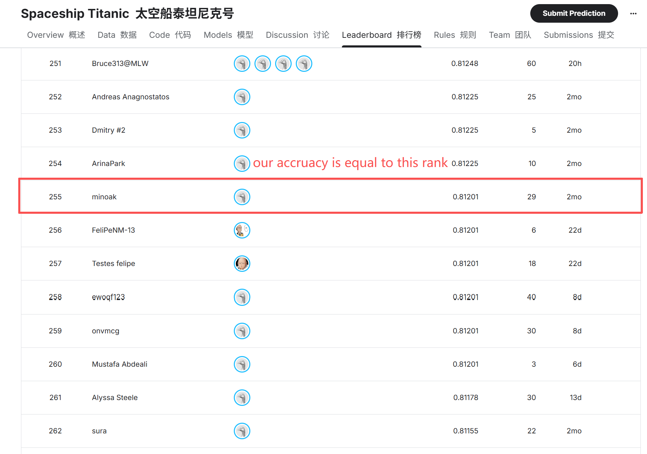

TABLE VIII
Final Submission Record
Item | Value
Kaggle team name | Nova@MLW
Final public leaderboard score | 0.81201 (confirmed public leaderboard score)
Final Kaggle ranking | 255
Selected final submission file | demo_final_submission.csv
GitHub repository link | https://github.com/Eric-xiong1/Nova-MLW

VII. FUTURE WORK AND CONCLUSION
A. Future Work
Expandable direction: Missing value filling can add more context: CryoSleep is related to spending logic, which can be filled according to CryoSleep, HomePlanet and passenger grouping conditions; Replace grid tuning with Bayesian optimization, especially for LightGBM and CatBoost; Probability calibration is done before threshold search to make the selected model more stable between cross-validation folding and public/private division;
Add interpretable tools such as replacement importance or SHAP to quantify the engineering characteristics that drive the final integration; A more rigorous ablation experiment, remove a group of features each time, and measure the value of cabin disassembly, group characteristics, spending transformation, age compartment, and target code; Reduce or accelerate the SVM grid search and incorporate it into the tuned SVM within a reasonable operating time.
B. Conclusion
This project builds a reproducible machine-learning workflow for the Spaceship Titanic competition. Through EDA, we identify balanced labels, strongly right-skewed spending fields, a powerful CryoSleep signal, and clear differences in transported rates across HomePlanet, Destination, cabin deck, and cabin side. These findings guide the feature-engineering decisions. Logistic Regression and SVM establish the initial baselines: tuned Logistic Regression reaches 0.8057 cross-validation accuracy and 0.8154 hold-out accuracy, while the retained SVM baseline reaches 0.7869 cross-validation accuracy and 0.7982 hold-out accuracy with a high-recall error mode. Tree models better handle the interactions that linear models cannot capture. Random Forest provides a nonlinear transition, while CatBoost is the strongest single boosted model and LightGBM and XGBoost provide complementary predictions. Weighted probability-rank blending and threshold optimization raise the public Kaggle score from the earlier LightGBM baseline of 0.80851 to the conservative final demo score of 0.81201. Overall, feature engineering contributes most of the improvement, and the final ensemble further refines performance.

VIII. CONTRIBUTION STATEMENT
Table IX summarizes each team member's main responsibility and the concrete model or report components completed.
TABLE IX
Contribution statement.
Member | Main responsibility | Concrete contribution
Zirui SU  2430034058 | Baseline models and visualization | Built baseline models, ran model comparison experiments, and prepared result visualizations.
Zhentao LUO  2430034048 | Random Forest, ensemble learning, and final demo | Implemented Random Forest, gradient-boosted ensemble learning, final prediction, and Kaggle submission generation.
Zhuangtao XIONG  2430034081 | Progress report, final report, and PPT | Drafted and organized the progress report, final report, and presentation materials.
Zihao CHEN  2430034007 | Data preprocessing and evaluation | Implemented data cleaning, missing-value handling, categorical encoding, validation summaries, and evaluation metrics.

IX. GITHUB AND RUNNING INSTRUCTIONS
GitHub link: https://github.com/Eric-xiong1/Nova-MLW. The repository should contain the notebook, final demo script, requirements.txt or environment.yml, this report, and a README with running instructions. The README should tell users to place train.csv and test.csv in the same folder as spaceship_demo.py; install numpy, pandas, scikit-learn, xgboost, lightgbm, catboost, matplotlib, seaborn, and psutil; run the notebook for EDA and baselines; run the final demo script for the ensemble submission; and upload demo_final_submission.csv to Kaggle.

Example environment setup:

python -m venv .venv
source .venv/bin/activate # Windows: .venv\Scripts\activate
pip install numpy pandas scikit-learn xgboost lightgbm catboost matplotlib seaborn psutil
python spaceship_demo.py
X. REFERENCES
[1] Kaggle, “Spaceship Titanic,” Kaggle competition page, 2022. [Online]. Available: https://www.kaggle.com/competitions/spaceship-titanic/overview
[2] F. Pedregosa et al., “Scikit-learn: Machine learning in Python,” Journal of Machine Learning Research, vol. 12, pp. 2825-2830, 2011.
[3] L. Breiman, “Random forests,” Machine Learning, vol. 45, no. 1, pp. 5-32, 2001.
[4] T. Chen and C. Guestrin, “XGBoost: A scalable tree boosting system,” in Proc. ACM SIGKDD, 2016, pp. 785-794.
[5] G. Ke et al., “LightGBM: A highly efficient gradient boosting decision tree,” in Advances in Neural Information Processing Systems, 2017, pp. 3146-3154.
[6] L. Prokhorenkova, G. Gusev, A. Vorobev, A. V. Dorogush, and A. Gulin, “CatBoost: unbiased boosting with categorical features,” in Advances in Neural Information Processing Systems, 2018, pp. 6638-6648.
[7] C. Cortes and V. Vapnik, “Support-vector networks,” Machine Learning, vol. 20, no. 3, pp. 273-297, 1995.

