CS 4310 Operating Systems
Project #1 Simulating Job Scheduler and Performance Analysis

(Total: 100 points)

Student Name: Eric La

Date: October 29, 2026

Important:
- Please read this document completely before you start coding.
- Also, please read the submission instructions (provided at the end of this document) carefully before submitting the project.

Project #1 Description:
Simulating Job Scheduler of the Operating Systems by programming the following four scheduling algorithms that we covered in the class:

- First-Come-First-Serve (FCFS)
- Shortest-Job-First (SJF)
- Round-Robin with Time Slice = 2 (RR-2)
- Round-Robin with Time Slice = 5 (PR-5)

You can use either Java or your choice of programming language for the implementation. The objective of this project is to help student understand how above four job scheduling algorithms operates by implementing the algorithms, and conducting a performance analysis of them based on the performance measure of their average turnaround times (of all jobs) for each scheduling algorithm using multiple inputs. Output the details of each algorithm’s execution. You need to show which jobs are selected at what times as well as their starting and stopping burst values. You can choose your display format, for examples, you can display the results of each in Schedule Table or Gantt Chart format (as shown in the class notes). The project will be divided into three parts (phases) to help you to accomplish above tasks in in a systematic and scientific fashion: Design and Testing, Implementation, and Performance Analysis.

The program will read process burst times from a file (job.txt) – this file will be generated by you. Note that you need to generate multiple testing cases (with inputs of 5 jobs, 10 jobs and 15 jobs). A sample input file of five jobs is given as follows (burst time in ms):

[Begin of job.txt]
Job1
7
Job2
18
Job3
10
Job4
4
Job5
12
[End of job.txt]

Note: you can assume that

- There are no more than 30 jobs in the input file (job.txt).
- Processes arrive in the order they are read from the file for FCFS, RR-2 and RR-5.
- All jobs arrive at time 0.
- FCFS uses the order of the jobs, Job1, Job2, Job3, …

You can implement the algorithms in your choice of data structures based on the program language of your choice. Note that you always try your best to give the most efficient program for each problem. The size of the input will be limited to be within 30 jobs.

Submission Instructions:
- turn in the following @Canvas after the completion of all three parts, part 1, part 2 and part 3
        - (1) four program files (your choice of programming language with proper documentation)
(2) this document (complete all the answers)

Part1
Design & Testing (30 points)

  - Design the program by providing pseudocode or flowchart for each CPU scheduling algorithm.

a) FCFS
FCFS(jobs[1..n]):
time = 0
for i = 1 to n: // jobs processed in file order
start[i] = time
finish[i] = time + burst[i]
turnaround[i] = finish[i] // arrival time is 0 for all jobs
time = finish[i]
avgTurnaround = sum(turnaround[1..n]) / n
return schedule, avgTurnaround
b) SJF (non-preemptive)
SJF(jobs[1..n]): // non-preemptive, all jobs arrive at time 0
order = sort jobs by burst time ascending
(ties broken by original file order)
time = 0
for each job in order:
start = time
finish = time + job.burst
turnaround = finish // arrival time is 0
time = finish
avgTurnaround = sum(turnaround) / n
return schedule, avgTurnaround
c) & d) Round-Robin (shared logic; q = 2 for RR-2, q = 5 for RR-5)
RoundRobin(jobs[1..n], quantum q): // q = 2 for RR-2, q = 5 for RR-5
queue = FIFO queue of jobs in file order
remaining[i] = burst[i] for all i
time = 0
while queue is not empty:
job = queue.dequeue()
run = min(q, remaining[job])
start = time
time = time + run
remaining[job] -= run
if remaining[job] > 0:
queue.enqueue(job) // not finished, go to back of queue
else:
finish[job] = time
turnaround[job] = time // arrival time is 0
avgTurnaround = sum(turnaround) / n
return schedule, avgTurnaround

  - Design the program correctness testing cases. Give at least 3 testing cases to test your program, and give the expected correct average turnaround time (for each testing case) in order to test the correctness of each algorithm.

Testing case # | Input  (table of jobs with its job# and length | Expected output for FCFS  (√ if Correct after testing in Part 2) | Expected output for  SJF  (√ if Correct after testing in Part 2) | Expected output for  RR-2  (√ if Correct after testing in Part 2) | Expected output for  RR-5  (√ if Correct after testing in Part 2)
1  (5 jobs) | Job1=7, Job2=18, Job3=10, Job4=4, Job5=12 | 31.40 ✓ | 24.00 ✓ | 36.40 ✓ | 36.00 ✓
2  (10 jobs) | Job1=7, Job2=18, Job3=10, Job4=4, Job5=12,  Job6=3, Job7=15, Job8=9, Job9=6, Job10=20 | 54.60 ✓ | 41.60 ✓ | 70.00 ✓ | 68.10 ✓
3  (15 jobs) | Job1=7, Job2=18, Job3=10, Job4=4, Job5=12,  Job6=3, Job7=15, Job8=9, Job9=6, Job10=20,  Job11=11, Job12=2, Job13=17, Job14=8, Job15=5 | 80.07 ✓ | 55.13 ✓ | 97.07 ✓ | 95.80 ✓

  - Design testing strategy for the programs. Discuss about how to generate and structure the randomly generated inputs for experimental study later in Part 3.
Hint 1: To study the performance evaluation of the four job scheduling algorithms, this project will use three different input sizes, 5 jobs, 10 jobs and 15 jobs. It is the easiest to use a random number generator for generating the inputs. Note that you need to decide the maximum value of job length (use at least 20). However, student should store each data set in various sizes and use the same data set for each job scheduling algorithm.
The performance of average Turnaround Time of each input data size (5 jobs, 10 jobs and 15 jobs) can be calculated after an experiment is conducted in 20 trail (with 20 input sets of jobs). We can denote the results as the set X which contains the 20 computed Turnaround Times of 20 trails, where X = {x₁, x₂, x₃ … x₂₀}, from the simulator.
For each data size (5 jobs, 10 jobs and 15 jobs):

Average Turnaround Time = $\frac{\sum_{i=1}^{20}{Xi }}{20 }$

The student should decide the maximum value of the job length (at least 20).

Three input sizes are used: 5, 10, and 15 jobs. For each size, 20 random job sets ("trials") are generated, with each job's burst time drawn uniformly from 1 to 20 ms (maximum job length = 20, the minimum allowed by the assignment). A fixed random seed (42) is used so the experiment is reproducible. Each of the 20 generated job sets per size is written to its own input file and is reused unchanged across all four scheduling algorithms (FCFS, SJF, RR-2, RR-5), ensuring a fair, apples-to-apples comparison within a trial. For each trial, each algorithm computes its own average turnaround time across that trial's jobs; those 20 per-trial averages (X = {x1, ..., x20}) are then averaged using the formula given above to produce the final "average of average turnaround times" reported in the Part 3(a) table. This process is implemented in analysis/experiment.py, which drives the four compiled Java programs and collects their output automatically.

Part 2
Implementation (30 points)

- Code each program based on the design (pseudocode or flow chart) in Part 1(a).
Four standalone Java programs were created, one per algorithm, each independently compilable and runnable: FCFS.java, SJF.java, RR2.java, and RR5.java (submitted alongside this document).

- Document the program appropriately.

Each of the four files begins with a header comment documenting the algorithm, its assumptions (all jobs arrive at time 0, FCFS/RR process jobs in file order), and usage instructions (e.g. "javac FCFS.java" then "java FCFS [path-to-job-file]"). Class and method names are self-descriptive (readJobs, printGanttChart, printTable, etc.).
- Test you program using the designed testing input data given in the table in Part 1(b), Make sure each program generates the correct answer by marking a “√” if it is correct for each testing case for each program column in the table. Repeat the process of debugging if necessary.

All four testing cases were run against the four compiled programs; computed average turnaround times matched the expected values in the table in Part 1(b) exactly, so each cell above is marked with a checkmark.

- For each program, capture a screen shot of the execution (Compile&Run) using the testing case in Part 1(b) to show how this program works properly
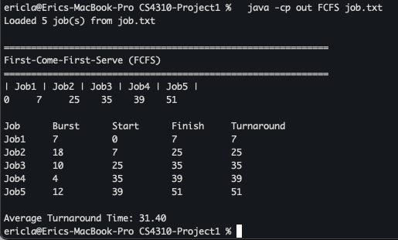
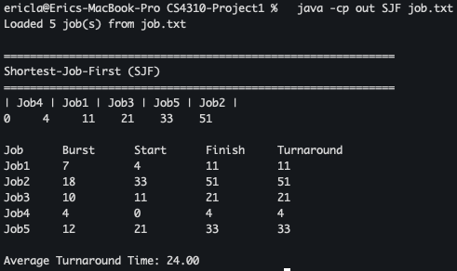
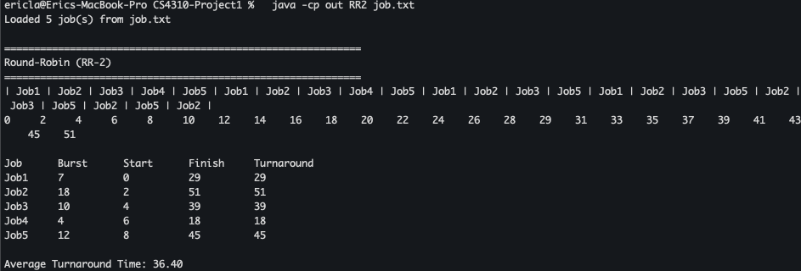
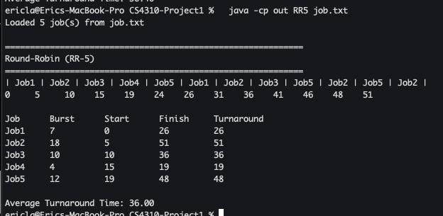

By now, four working programs are created and ready for experimental study in the next part, Part 3.

Part 3
Performance Analysis (40 points)

- Run each program with the designed randomly generated input data given in Part 1(c). Generate a table for all the experimental results for performance analysis as follows.
Input Size  n jobs | Average of average turnaround times  (FCFS Program) | Average of average turnaround times  (SFJ Program) | Average of average turnaround times  (RR-2) | Average of average turnaround times  (RR-5)
5 jobs | 28.63 | 22.52 | 34.25 | 33.74
10 jobs | 55.48 | 41.11 | 68.87 | 68.15
15 jobs | 81.47 | 63.2 | 111.16 | 107.3

- Plot a graph of each algorithm, average turnaround time vs input size (# of jobs), and summarize the performance of each algorithm based on its own graph.

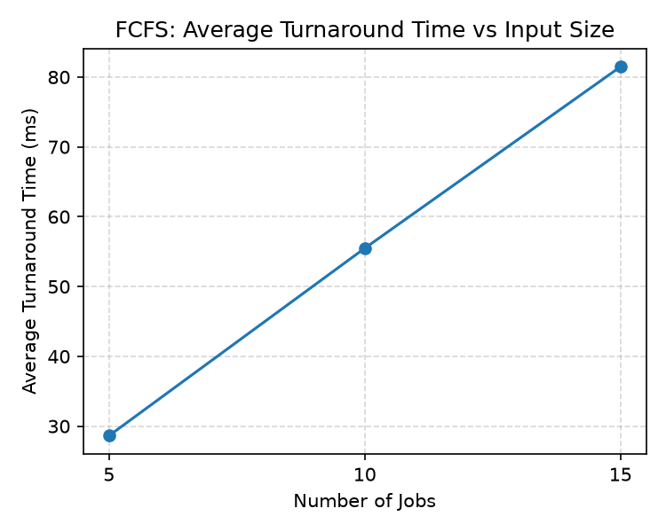
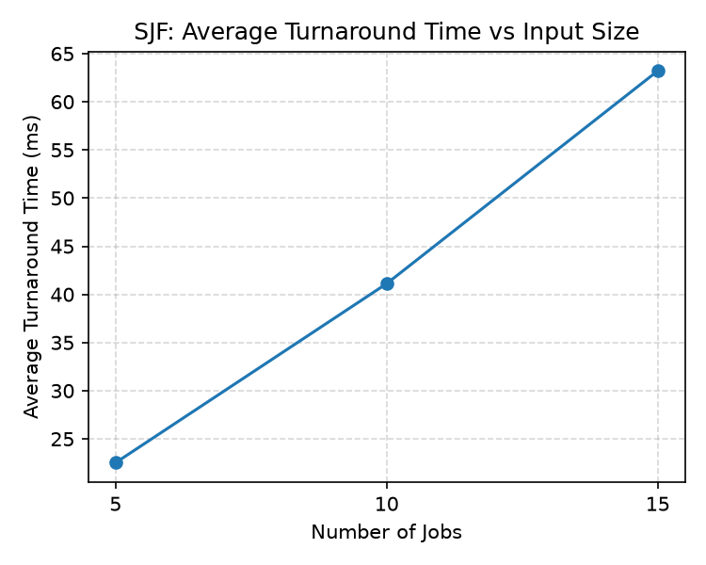
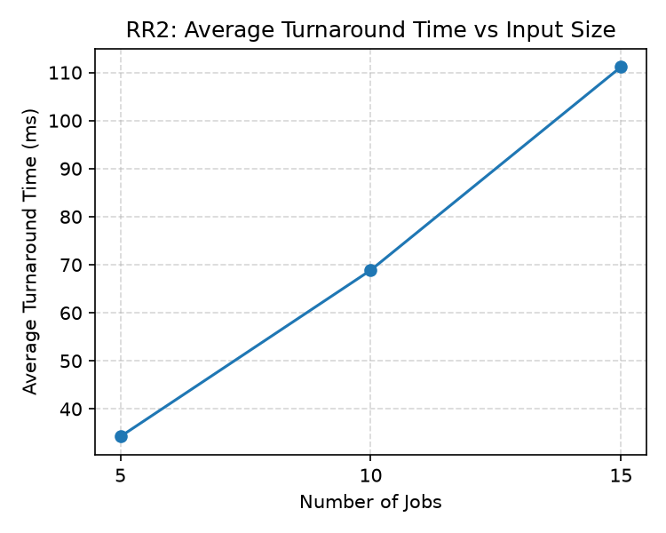
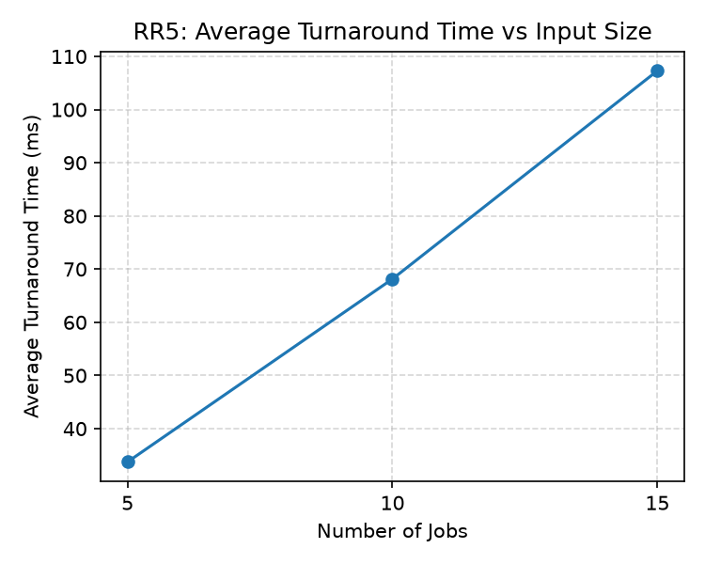

FCFS: average turnaround grows roughly linearly with input size, driven by the convoy effect — long jobs early in file order delay every job behind them. SJF: consistently the lowest average turnaround time at every input size, and the gap between it and the other algorithms widens as job count increases, since it always clears short jobs before they can be stuck waiting behind long ones. RR-2: the highest average turnaround time at every size; the small 2 ms quantum forces many context switches, so jobs cycle through the queue many times before finishing. RR-5: consistently slightly better than RR-2 but still worse than FCFS and SJF; the larger quantum lets jobs finish in fewer trips through the queue, trending RR-5's behavior closer to FCFS.

Plot all four graphs on the same graph and compare the performance of all four algorithms. Rank four scheduling algorithms. Try giving the reasons for the findings.
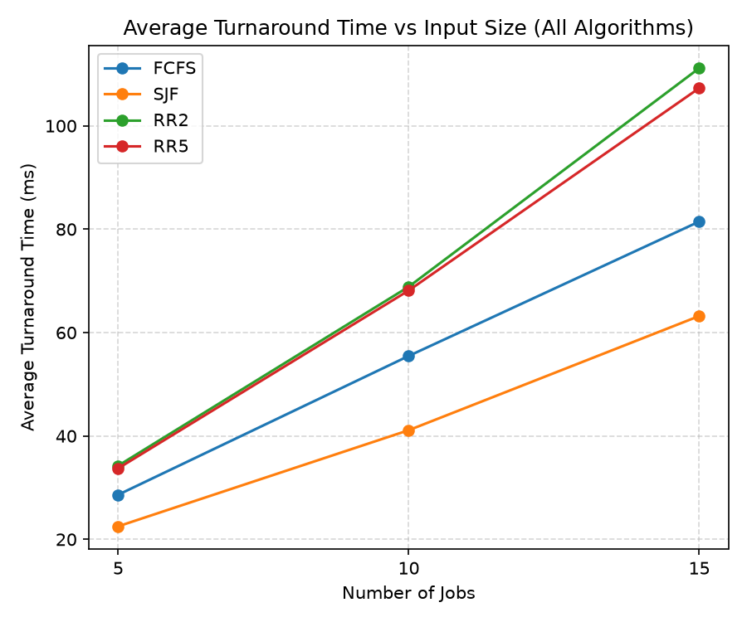

Ranking from best (lowest average turnaround) to worst: 1) SJF, 2) FCFS, 3) RR-5, 4) RR-2. SJF wins because it is provably optimal for minimizing average turnaround time when all jobs arrive simultaneously — running the shortest jobs first keeps the average number of jobs waiting in the system as low as possible. FCFS is simple and performs reasonably, but a single long job placed early in the file delays every job behind it (the convoy effect), which SJF avoids entirely. Round-Robin is designed to optimize fairness and responsiveness (every job gets the CPU quickly and repeatedly), not turnaround time, so both RR variants trail FCFS and SJF; RR-5 edges out RR-2 because its larger time slice means fewer context switches and jobs complete in fewer trips through the queue, pushing its behavior closer to FCFS as the quantum grows.

- Conclude your report with the strength and constraints of your work. At least 100 words.
(Note: It is reflection of this project. If you have a change to re-do this project again, what you like to keep and what you like to do differently in order get a better quality of results.)

This project's main strength is that the four scheduling algorithms were implemented as fully independent, documented programs sharing the same input format, which made it straightforward to automate a 20-trial randomized experiment (analysis/experiment.py) on top of them without modifying the submitted files. The results matched textbook expectations — SJF minimized average turnaround time while Round-Robin, optimized for fairness rather than turnaround, consistently trailed — which gave good confidence in the implementations' correctness. The main constraint is that the simulation assumes all jobs arrive at time 0 and burst times are known in advance, which is unrealistic for a live operating system; a more complete simulator would model staggered arrival times, preemption based on priority, and I/O-bound waiting. If redone, I would keep the standalone-program design and the automated trial harness, but I would add preemptive SJF (shortest-remaining-time-first) and variable arrival times to make the comparison more representative of real scheduling behavior, and I would collect waiting time and response time alongside turnaround time to get a fuller picture of each algorithm's trade-offs.

