***TMVPR：The most valuable paper reading***

**每周最有价值论文阅读表**

2020/04/05

1. 双路动态增强网络对于真实世界的**图像超分辨率**

《DDet: Dual-path Dynamic Enhancement Network for Real-World Image Super-Resolution》

<https://arxiv.org/pdf/2002.11079.pdf>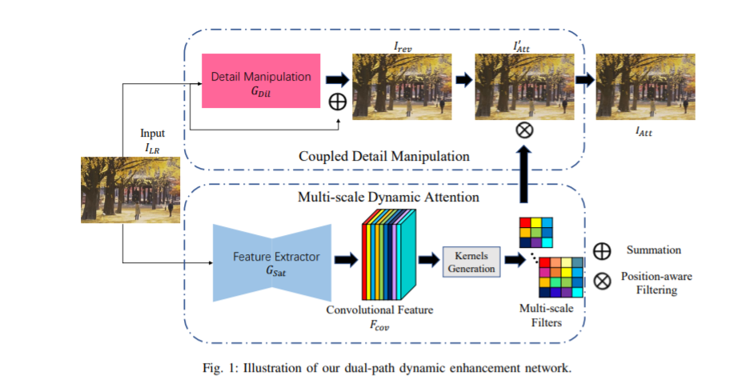

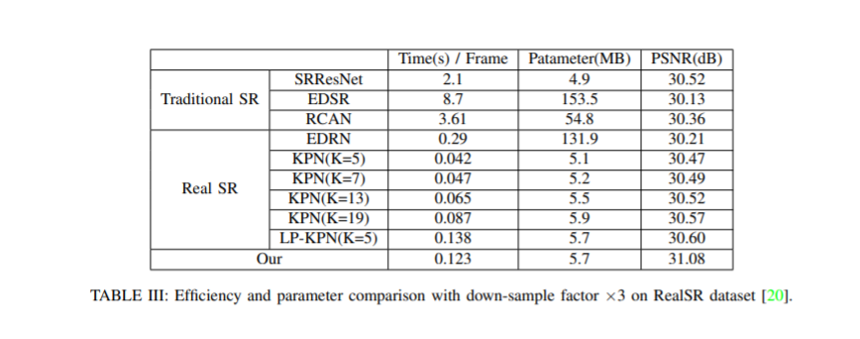

02、基于排序网络Ranking_CNN的图像去雾

《Single Image Dehazing Using Ranking Convolutional Neural Network》，北航。

<https://arxiv.org/pdf/2001.05246.pdf>