The UNIVARIATE Procedure

Variable: logsize

Subfamily=NOTERIDA

| **Moments** | | | |
| --- | --- | --- | --- |
| **N** | 2 | **Sum Weights** | 2 |
| **Mean** | 0.61362189 | **Sum Observations** | 1.22724378 |
| **Std Deviation** | 0.0559896 | **Variance** | 0.00313483 |
| **Skewness** | . | **Kurtosis** | . |
| **Uncorrected SS** | 0.75619848 | **Corrected SS** | 0.00313483 |
| **Coeff Variation** | 9.12444567 | **Std Error Mean** | 0.03959062 |

| **Basic Statistical Measures** | | | |
| --- | --- | --- | --- |
| **Location** | | **Variability** | |
| **Mean** | 0.613622 | **Std Deviation** | 0.05599 |
| **Median** | 0.613622 | **Variance** | 0.00313 |
| **Mode** | . | **Range** | 0.07918 |
|  |  | **Interquartile Range** | 0.07918 |

| **Tests for Location: Mu0=0** | | | | |
| --- | --- | --- | --- | --- |
| **Test** | **Statistic** | | **p Value** | |
| **Student's t** | **t** | 15.49917 | **Pr > |t|** | 0.0410 |
| **Sign** | **M** | 1 | **Pr >= |M|** | 0.5000 |
| **Signed Rank** | **S** | 1.5 | **Pr >= |S|** | 0.5000 |

| **Quantiles (Definition 5)** | |
| --- | --- |
| **Level** | **Quantile** |
| **100% Max** | 0.653213 |
| **99%** | 0.653213 |
| **95%** | 0.653213 |
| **90%** | 0.653213 |
| **75% Q3** | 0.653213 |
| **50% Median** | 0.613622 |
| **25% Q1** | 0.574031 |
| **10%** | 0.574031 |
| **5%** | 0.574031 |
| **1%** | 0.574031 |
| **0% Min** | 0.574031 |

| **Extreme Observations** | | | |
| --- | --- | --- | --- |
| **Lowest** | | **Highest** | |
| **Value** | **Obs** | **Value** | **Obs** |
| 0.574031 | 98 | 0.574031 | 98 |
| 0.653213 | 97 | 0.653213 | 97 |

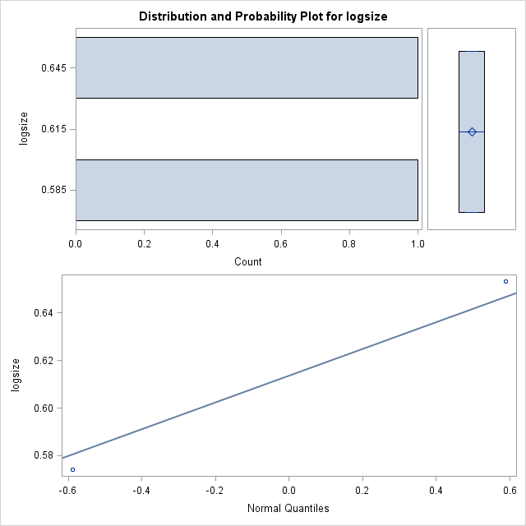

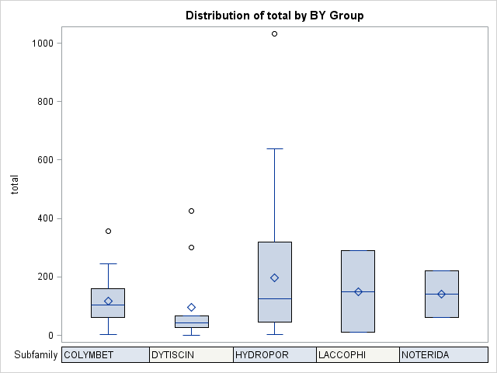

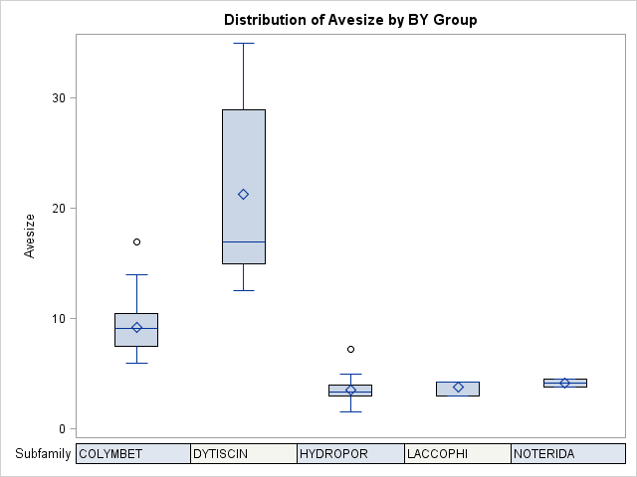

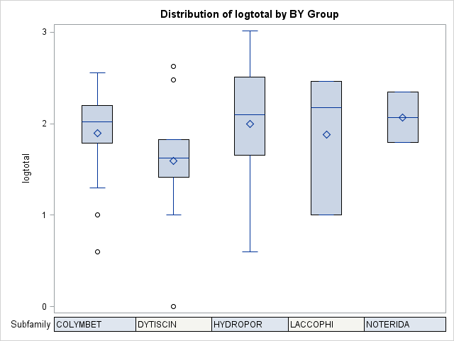

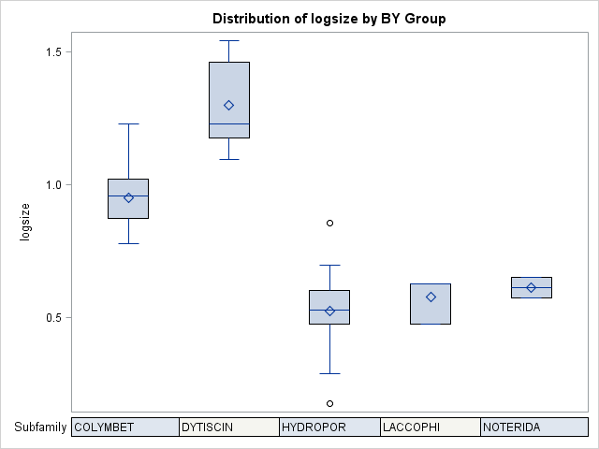

|  |
| --- |
| The SAS System |

The UNIVARIATE Procedure

Variable: total

| **Moments** | | | |
| --- | --- | --- | --- |
| **N** | 86 | **Sum Weights** | 86 |
| **Mean** | 161.546512 | **Sum Observations** | 13893 |
| **Std Deviation** | 176.892833 | **Variance** | 31291.0743 |
| **Skewness** | 2.0971212 | **Kurtosis** | 6.32492447 |
| **Uncorrected SS** | 4904107 | **Corrected SS** | 2659741.31 |
| **Coeff Variation** | 109.49963 | **Std Error Mean** | 19.0748447 |

| **Basic Statistical Measures** | | | |
| --- | --- | --- | --- |
| **Location** | | **Variability** | |
| **Mean** | 161.5465 | **Std Deviation** | 176.89283 |
| **Median** | 95.0000 | **Variance** | 31291 |
| **Mode** | 10.0000 | **Range** | 1031 |
|  |  | **Interquartile Range** | 205.00000 |

| **Tests for Location: Mu0=0** | | | | |
| --- | --- | --- | --- | --- |
| **Test** | **Statistic** | | **p Value** | |
| **Student's t** | **t** | 8.469087 | **Pr > |t|** | <.0001 |
| **Sign** | **M** | 43 | **Pr >= |M|** | <.0001 |
| **Signed Rank** | **S** | 1870.5 | **Pr >= |S|** | <.0001 |

| **Quantiles (Definition 5)** | |
| --- | --- |
| **Level** | **Quantile** |
| **100% Max** | 1032 |
| **99%** | 1032 |
| **95%** | 504 |
| **90%** | 391 |
| **75% Q3** | 246 |
| **50% Median** | 95 |
| **25% Q1** | 41 |
| **10%** | 12 |
| **5%** | 10 |
| **1%** | 1 |
| **0% Min** | 1 |

| **Extreme Observations** | | | |
| --- | --- | --- | --- |
| **Lowest** | | **Highest** | |
| **Value** | **Obs** | **Value** | **Obs** |
| 1 | 89 | 504 | 61 |
| 4 | 80 | 519 | 68 |
| 4 | 65 | 608 | 58 |
| 7 | 57 | 639 | 72 |
| 10 | 88 | 1032 | 71 |

| **Missing Values** | | | |
| --- | --- | --- | --- |
| **Missing Value** | **Count** | **Percent Of** | |
| **All Obs** | **Missing Obs** |
| . | 12 | 12.24 | 100.00 |

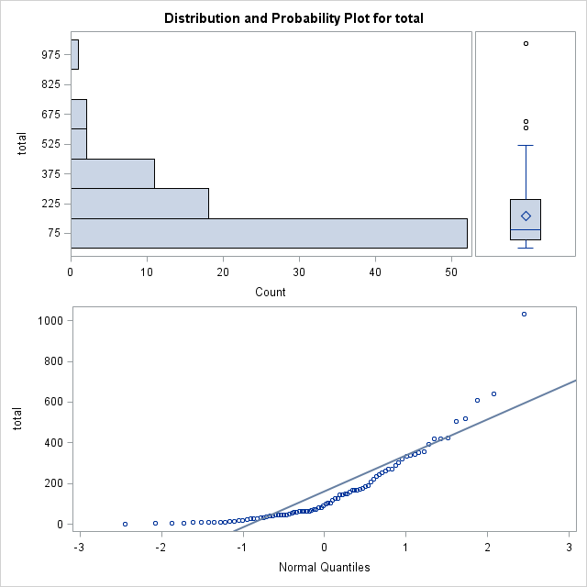

|  |
| --- |
| The SAS System |

The UNIVARIATE Procedure

Variable: Avesize

| **Moments** | | | |
| --- | --- | --- | --- |
| **N** | 98 | **Sum Weights** | 98 |
| **Mean** | 7.15408163 | **Sum Observations** | 701.1 |
| **Std Deviation** | 6.39131044 | **Variance** | 40.8488491 |
| **Skewness** | 2.38276708 | **Kurtosis** | 6.29510177 |
| **Uncorrected SS** | 8978.065 | **Corrected SS** | 3962.33837 |
| **Coeff Variation** | 89.3379579 | **Std Error Mean** | 0.64561985 |

| **Basic Statistical Measures** | | | |
| --- | --- | --- | --- |
| **Location** | | **Variability** | |
| **Mean** | 7.154082 | **Std Deviation** | 6.39131 |
| **Median** | 4.500000 | **Variance** | 40.84885 |
| **Mode** | 4.000000 | **Range** | 33.50000 |
|  |  | **Interquartile Range** | 6.00000 |

| **Tests for Location: Mu0=0** | | | | |
| --- | --- | --- | --- | --- |
| **Test** | **Statistic** | | **p Value** | |
| **Student's t** | **t** | 11.08095 | **Pr > |t|** | <.0001 |
| **Sign** | **M** | 49 | **Pr >= |M|** | <.0001 |
| **Signed Rank** | **S** | 2425.5 | **Pr >= |S|** | <.0001 |

| **Quantiles (Definition 5)** | |
| --- | --- |
| **Level** | **Quantile** |
| **100% Max** | 35.00 |
| **99%** | 35.00 |
| **95%** | 23.50 |
| **90%** | 15.00 |
| **75% Q3** | 9.25 |
| **50% Median** | 4.50 |
| **25% Q1** | 3.25 |
| **10%** | 2.50 |
| **5%** | 2.00 |
| **1%** | 1.50 |
| **0% Min** | 1.50 |

| **Extreme Observations** | | | |
| --- | --- | --- | --- |
| **Lowest** | | **Highest** | |
| **Value** | **Obs** | **Value** | **Obs** |
| 1.50 | 37 | 23.5 | 92 |
| 1.95 | 74 | 29.0 | 94 |
| 2.00 | 39 | 29.0 | 96 |
| 2.00 | 38 | 29.5 | 93 |
| 2.00 | 36 | 35.0 | 95 |

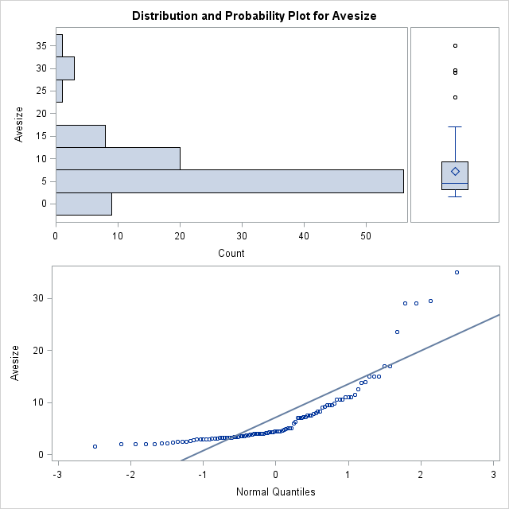

|  |
| --- |
| The SAS System |

The UNIVARIATE Procedure

Variable: logtotal

| **Moments** | | | |
| --- | --- | --- | --- |
| **N** | 86 | **Sum Weights** | 86 |
| **Mean** | 1.91891521 | **Sum Observations** | 165.026708 |
| **Std Deviation** | 0.58214135 | **Variance** | 0.33888855 |
| **Skewness** | -0.6940912 | **Kurtosis** | 0.39814964 |
| **Uncorrected SS** | 345.477787 | **Corrected SS** | 28.8055265 |
| **Coeff Variation** | 30.337002 | **Std Error Mean** | 0.06277392 |

| **Basic Statistical Measures** | | | |
| --- | --- | --- | --- |
| **Location** | | **Variability** | |
| **Mean** | 1.918915 | **Std Deviation** | 0.58214 |
| **Median** | 1.976856 | **Variance** | 0.33889 |
| **Mode** | 1.000000 | **Range** | 3.01368 |
|  |  | **Interquartile Range** | 0.77815 |

| **Tests for Location: Mu0=0** | | | | |
| --- | --- | --- | --- | --- |
| **Test** | **Statistic** | | **p Value** | |
| **Student's t** | **t** | 30.56867 | **Pr > |t|** | <.0001 |
| **Sign** | **M** | 42.5 | **Pr >= |M|** | <.0001 |
| **Signed Rank** | **S** | 1827.5 | **Pr >= |S|** | <.0001 |

| **Quantiles (Definition 5)** | |
| --- | --- |
| **Level** | **Quantile** |
| **100% Max** | 3.01368 |
| **99%** | 3.01368 |
| **95%** | 2.70243 |
| **90%** | 2.59218 |
| **75% Q3** | 2.39094 |
| **50% Median** | 1.97686 |
| **25% Q1** | 1.61278 |
| **10%** | 1.07918 |
| **5%** | 1.00000 |
| **1%** | 0.00000 |
| **0% Min** | 0.00000 |

| **Extreme Observations** | | | |
| --- | --- | --- | --- |
| **Lowest** | | **Highest** | |
| **Value** | **Obs** | **Value** | **Obs** |
| 0.000000 | 89 | 2.70243 | 61 |
| 0.602060 | 80 | 2.71517 | 68 |
| 0.602060 | 65 | 2.78390 | 58 |
| 0.845098 | 57 | 2.80550 | 72 |
| 1.000000 | 88 | 3.01368 | 71 |

| **Missing Values** | | | |
| --- | --- | --- | --- |
| **Missing Value** | **Count** | **Percent Of** | |
| **All Obs** | **Missing Obs** |
| . | 12 | 12.24 | 100.00 |

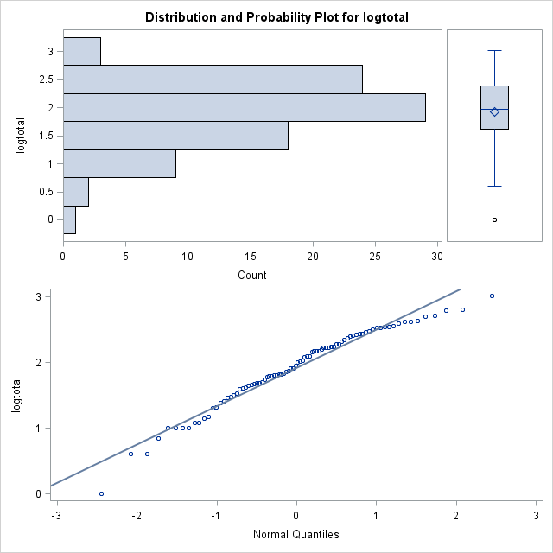

|  |
| --- |
| The SAS System |

The UNIVARIATE Procedure

Variable: logsize

| **Moments** | | | |
| --- | --- | --- | --- |
| **N** | 98 | **Sum Weights** | 98 |
| **Mean** | 0.73715436 | **Sum Observations** | 72.2411268 |
| **Std Deviation** | 0.3018691 | **Variance** | 0.09112495 |
| **Skewness** | 0.66712514 | **Kurtosis** | -0.120518 |
| **Uncorrected SS** | 62.0919818 | **Corrected SS** | 8.8391206 |
| **Coeff Variation** | 40.950596 | **Std Error Mean** | 0.03049338 |

| **Basic Statistical Measures** | | | |
| --- | --- | --- | --- |
| **Location** | | **Variability** | |
| **Mean** | 0.737154 | **Std Deviation** | 0.30187 |
| **Median** | 0.653213 | **Variance** | 0.09112 |
| **Mode** | 0.602060 | **Range** | 1.36798 |
|  |  | **Interquartile Range** | l |

| **Tests for Location: Mu0=0** | | | | |
| --- | --- | --- | --- | --- |
| **Test** | **Statistic** | | **p Value** | |
| **Student's t** | **t** | 24.17424 | **Pr > |t|** | <.0001 |
| **Sign** | **M** | 49 | **Pr >= |M|** | <.0001 |
| **Signed Rank** | **S** | 2425.5 | **Pr >= |S|** | <.0001 |

| **Quantiles (Definition 5)** | |
| --- | --- |
| **Level** | **Quantile** |
| **100% Max** | 1.544068 |
| **99%** | 1.544068 |
| **95%** | 1.371068 |
| **90%** | 1.176091 |
| **75% Q3** | 0.966142 |
| **50% Median** | 0.653213 |
| **25% Q1** | 0.511883 |
| **10%** | 0.397940 |
| **5%** | 0.301030 |
| **1%** | 0.176091 |
| **0% Min** | 0.176091 |

| **Extreme Observations** | | | |
| --- | --- | --- | --- |
| **Lowest** | | **Highest** | |
| **Value** | **Obs** | **Value** | **Obs** |
| 0.176091 | 37 | 1.37107 | 92 |
| 0.290035 | 74 | 1.46240 | 94 |
| 0.301030 | 39 | 1.46240 | 96 |
| 0.301030 | 38 | 1.46982 | 93 |
| 0.301030 | 36 | 1.54407 | 95 |

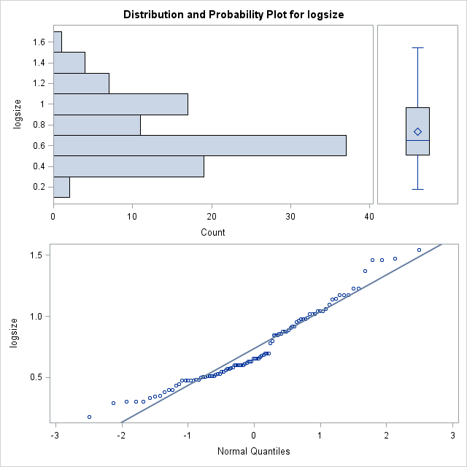

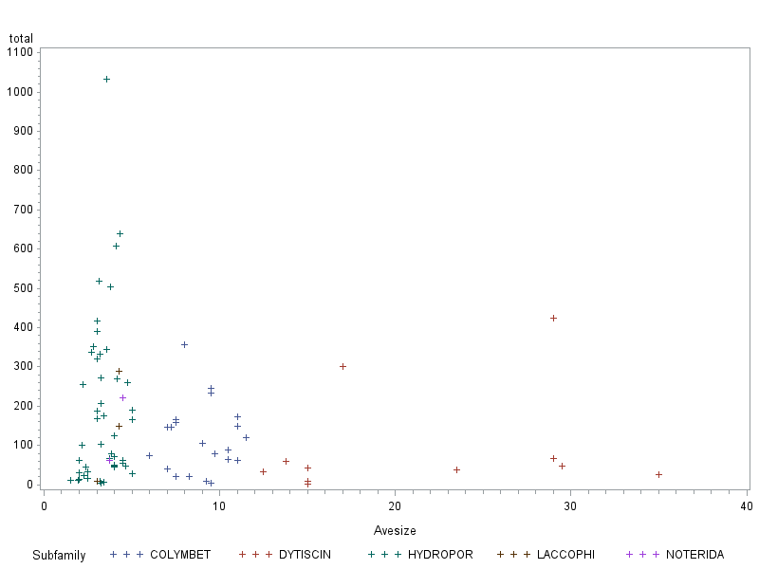

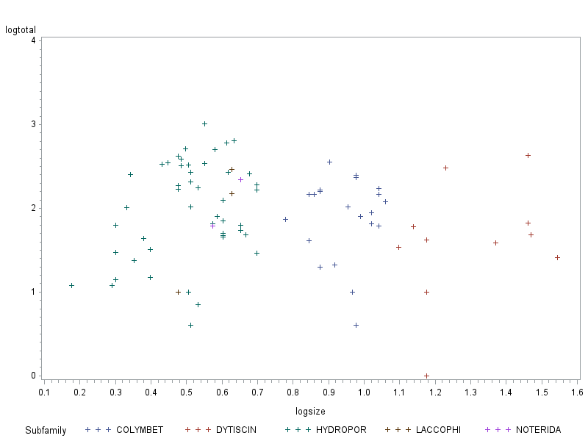

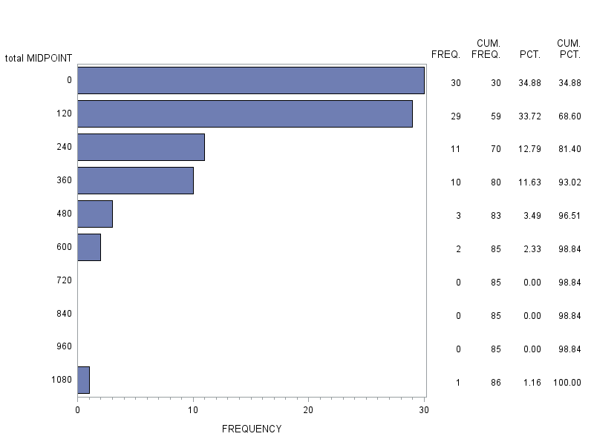

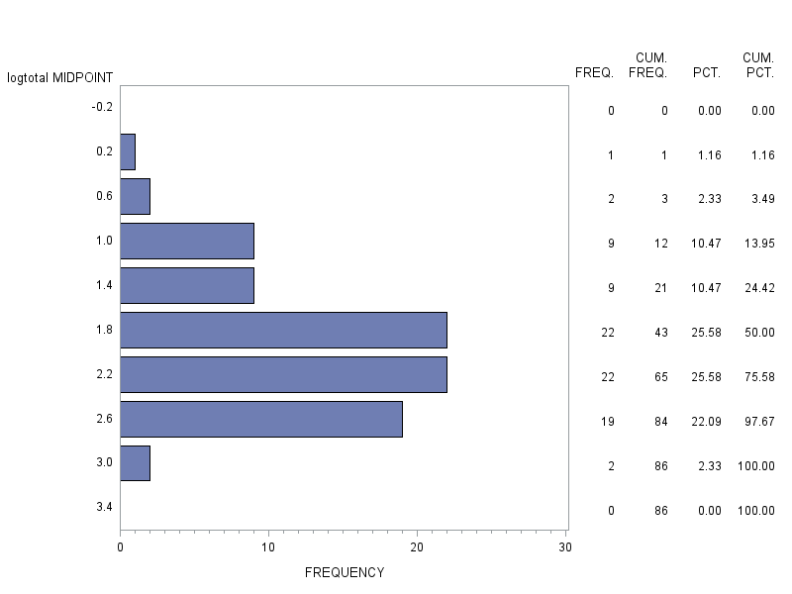

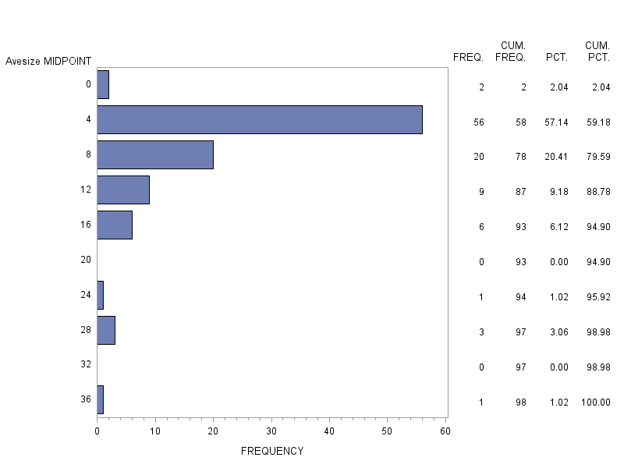

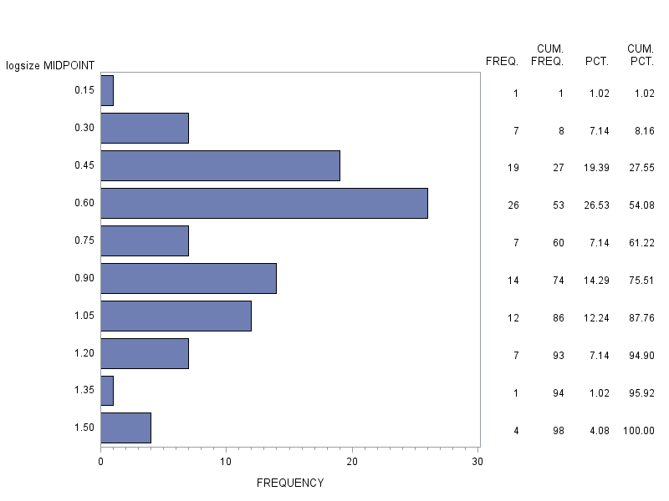

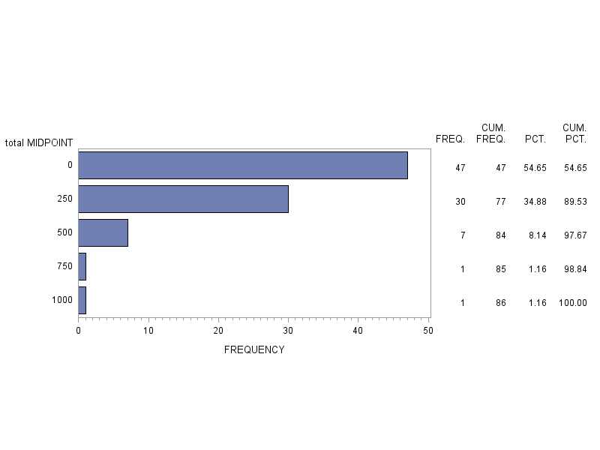

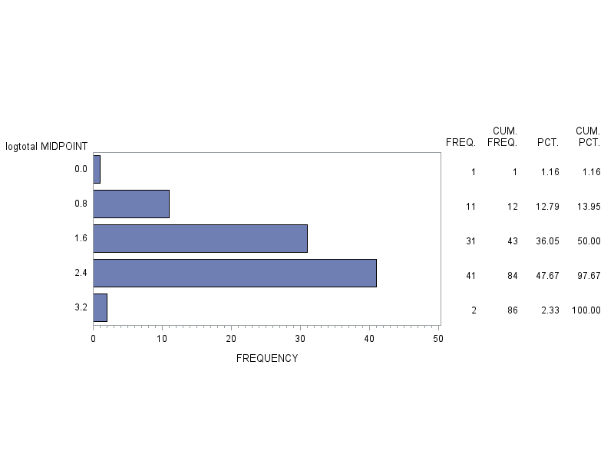

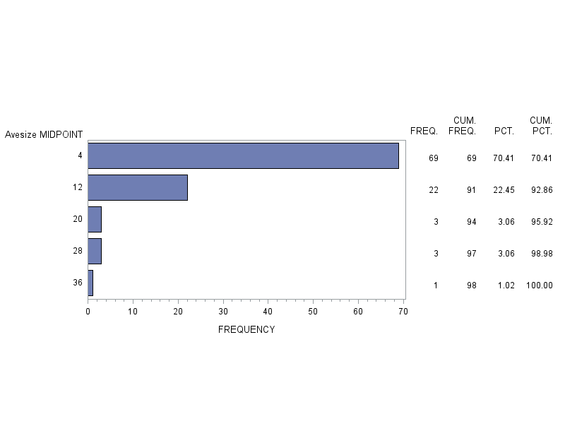

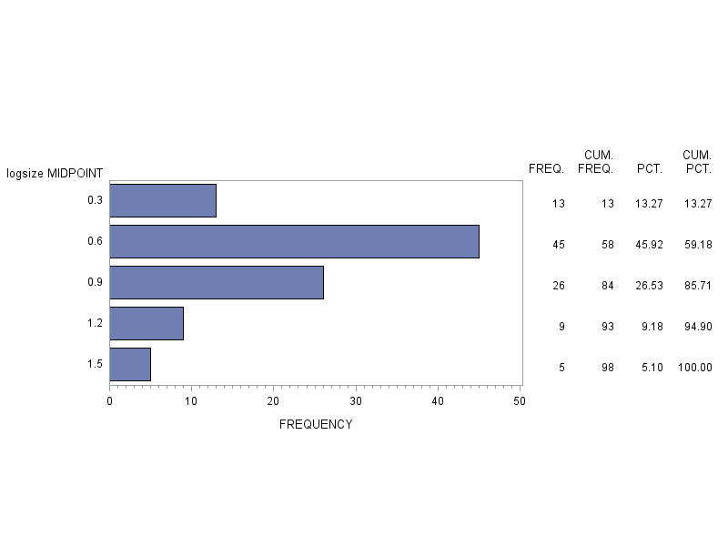

|  |
| --- |
| The SAS System |

The CORR Procedure

|  |  |
| --- | --- |
| **4 Variables:** | total Avesize logtotal logsize |

| **Simple Statistics** | | | | | | |
| --- | --- | --- | --- | --- | --- | --- |
| **Variable** | **N** | **Mean** | **Std Dev** | **Sum** | **Minimum** | **Maximum** |
| **total** | 86 | 161.54651 | 176.89283 | 13893 | 1.00000 | 1032 |
| **Avesize** | 98 | 7.15408 | 6.39131 | 701.10000 | 1.50000 | 35.00000 |
| **logtotal** | 86 | 1.91892 | 0.58214 | 165.02671 | 0 | 3.01368 |
| **logsize** | 98 | 0.73715 | 0.30187 | 72.24113 | 0.17609 | 1.54407 |

| **Pearson Correlation Coefficients  Prob > |r| under H0: Rho=0  Number of Observations** | | | | |
| --- | --- | --- | --- | --- |
|  | **total** | **Avesize** | **logtotal** | **logsize** |
| **total** | |  | | --- | | 1.00000 | |  | | 86 | | |  | | --- | | -0.14489 | | 0.1832 | | 86 | | |  | | --- | | 0.79837 | | <.0001 | | 86 | | |  | | --- | | -0.14249 | | 0.1906 | | 86 | |
| **Avesize** | |  | | --- | | -0.14489 | | 0.1832 | | 86 | | |  | | --- | | 1.00000 | |  | | 98 | | |  | | --- | | -0.12676 | | 0.2448 | | 86 | | |  | | --- | | 0.91687 | | <.0001 | | 98 | |
| **logtotal** | |  | | --- | | 0.79837 | | <.0001 | | 86 | | |  | | --- | | -0.12676 | | 0.2448 | | 86 | | |  | | --- | | 1.00000 | |  | | 86 | | |  | | --- | | -0.09447 | | 0.3869 | | 86 | |
| **logsize** | |  | | --- | | -0.14249 | | 0.1906 | | 86 | | |  | | --- | | 0.91687 | | <.0001 | | 98 | | |  | | --- | | -0.09447 | | 0.3869 | | 86 | | |  | | --- | | 1.00000 | |  | | 98 | |

|  |
| --- |
| The SAS System |

The UNIVARIATE Procedure

Variable: total

Subfamily=COLYMBET

| **Moments** | | | |
| --- | --- | --- | --- |
| **N** | 21 | **Sum Weights** | 21 |
| **Mean** | 117.428571 | **Sum Observations** | 2466 |
| **Std Deviation** | 88.4638748 | **Variance** | 7825.85714 |
| **Skewness** | 0.99153789 | **Kurtosis** | 1.23427923 |
| **Uncorrected SS** | 446096 | **Corrected SS** | 156517.143 |
| **Coeff Variation** | 75.3341999 | **Std Error Mean** | 19.3044001 |

| **Basic Statistical Measures** | | | |
| --- | --- | --- | --- |
| **Location** | | **Variability** | |
| **Mean** | 117.4286 | **Std Deviation** | 88.46387 |
| **Median** | 105.0000 | **Variance** | 7826 |
| **Mode** | . | **Range** | 353.00000 |
|  |  | **Interquartile Range** | 98.00000 |

| **Tests for Location: Mu0=0** | | | | |
| --- | --- | --- | --- | --- |
| **Test** | **Statistic** | | **p Value** | |
| **Student's t** | **t** | 6.082995 | **Pr > |t|** | <.0001 |
| **Sign** | **M** | 10.5 | **Pr >= |M|** | <.0001 |
| **Signed Rank** | **S** | 115.5 | **Pr >= |S|** | <.0001 |

| **Quantiles (Definition 5)** | |
| --- | --- |
| **Level** | **Quantile** |
| **100% Max** | 357 |
| **99%** | 357 |
| **95%** | 246 |
| **90%** | 233 |
| **75% Q3** | 159 |
| **50% Median** | 105 |
| **25% Q1** | 61 |
| **10%** | 20 |
| **5%** | 10 |
| **1%** | 4 |
| **0% Min** | 4 |

| **Extreme Observations** | | | |
| --- | --- | --- | --- |
| **Lowest** | | **Highest** | |
| **Value** | **Obs** | **Value** | **Obs** |
| 4 | 23 | 167 | 7 |
| 10 | 5 | 174 | 28 |
| 20 | 11 | 233 | 24 |
| 21 | 9 | 246 | 25 |
| 41 | 10 | 357 | 1 |

| **Missing Values** | | | |
| --- | --- | --- | --- |
| **Missing Value** | **Count** | **Percent Of** | |
| **All Obs** | **Missing Obs** |
| . | 7 | 25.00 | 100.00 |

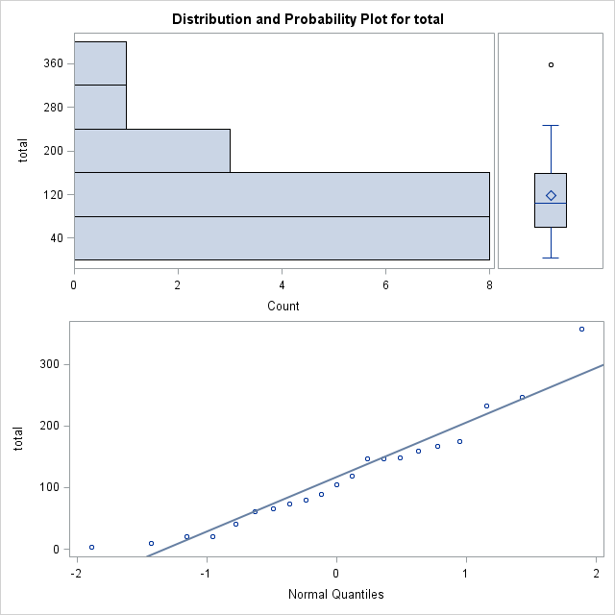

|  |
| --- |
| The SAS System |

The UNIVARIATE Procedure

Variable: Avesize

Subfamily=COLYMBET

| **Moments** | | | |
| --- | --- | --- | --- |
| **N** | 28 | **Sum Weights** | 28 |
| **Mean** | 9.24107143 | **Sum Observations** | 258.75 |
| **Std Deviation** | 2.40223868 | **Variance** | 5.77075066 |
| **Skewness** | 1.39086886 | **Kurtosis** | 2.91253649 |
| **Uncorrected SS** | 2546.9375 | **Corrected SS** | 155.810268 |
| **Coeff Variation** | 25.9952398 | **Std Error Mean** | 0.45398044 |

| **Basic Statistical Measures** | | | |
| --- | --- | --- | --- |
| **Location** | | **Variability** | |
| **Mean** | 9.241071 | **Std Deviation** | 2.40224 |
| **Median** | 9.125000 | **Variance** | 5.77075 |
| **Mode** | 7.000000 | **Range** | 11.00000 |
|  |  | **Interquartile Range** | 3.00000 |

|  |
| --- |
| **Note: The mode displayed is the smallest of 5 modes with a count of 3.** |

| **Tests for Location: Mu0=0** | | | | |
| --- | --- | --- | --- | --- |
| **Test** | **Statistic** | | **p Value** | |
| **Student's t** | **t** | 20.35566 | **Pr > |t|** | <.0001 |
| **Sign** | **M** | 14 | **Pr >= |M|** | <.0001 |
| **Signed Rank** | **S** | 203 | **Pr >= |S|** | <.0001 |

| **Quantiles (Definition 5)** | |
| --- | --- |
| **Level** | **Quantile** |
| **100% Max** | 17.000 |
| **99%** | 17.000 |
| **95%** | 14.000 |
| **90%** | 11.500 |
| **75% Q3** | 10.500 |
| **50% Median** | 9.125 |
| **25% Q1** | 7.500 |
| **10%** | 7.000 |
| **5%** | 6.250 |
| **1%** | 6.000 |
| **0% Min** | 6.000 |

| **Extreme Observations** | | | |
| --- | --- | --- | --- |
| **Lowest** | | **Highest** | |
| **Value** | **Obs** | **Value** | **Obs** |
| 6.00 | 8 | 11.0 | 15 |
| 6.25 | 20 | 11.0 | 28 |
| 7.00 | 21 | 11.5 | 12 |
| 7.00 | 10 | 14.0 | 16 |
| 7.00 | 6 | 17.0 | 22 |

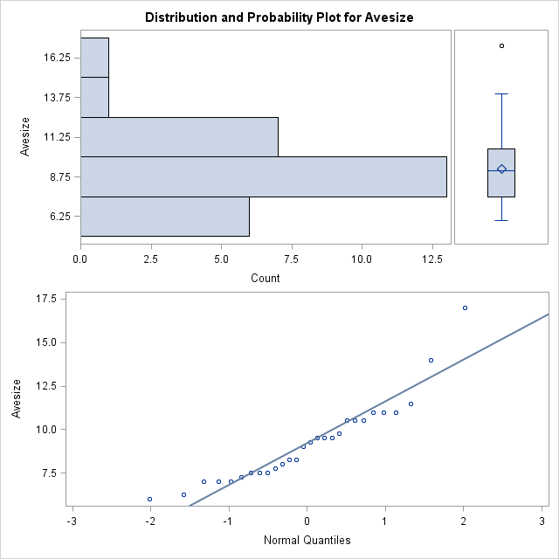

|  |
| --- |
| The SAS System |

The UNIVARIATE Procedure

Variable: logtotal

Subfamily=COLYMBET

| **Moments** | | | |
| --- | --- | --- | --- |
| **N** | 21 | **Sum Weights** | 21 |
| **Mean** | 1.89201611 | **Sum Observations** | 39.7323383 |
| **Std Deviation** | 0.48727753 | **Variance** | 0.23743939 |
| **Skewness** | -1.2284811 | **Kurtosis** | 1.27591059 |
| **Uncorrected SS** | 79.923012 | **Corrected SS** | 4.74878787 |
| **Coeff Variation** | 25.7544072 | **Std Error Mean** | 0.10633268 |

| **Basic Statistical Measures** | | | |
| --- | --- | --- | --- |
| **Location** | | **Variability** | |
| **Mean** | 1.892016 | **Std Deviation** | 0.48728 |
| **Median** | 2.021189 | **Variance** | 0.23744 |
| **Mode** | . | **Range** | 1.95061 |
|  |  | **Interquartile Range** | 0.41607 |

| **Tests for Location: Mu0=0** | | | | |
| --- | --- | --- | --- | --- |
| **Test** | **Statistic** | | **p Value** | |
| **Student's t** | **t** | 17.79337 | **Pr > |t|** | <.0001 |
| **Sign** | **M** | 10.5 | **Pr >= |M|** | <.0001 |
| **Signed Rank** | **S** | 115.5 | **Pr >= |S|** | <.0001 |

| **Quantiles (Definition 5)** | |
| --- | --- |
| **Level** | **Quantile** |
| **100% Max** | 2.55267 |
| **99%** | 2.55267 |
| **95%** | 2.39094 |
| **90%** | 2.36736 |
| **75% Q3** | 2.20140 |
| **50% Median** | 2.02119 |
| **25% Q1** | 1.78533 |
| **10%** | 1.30103 |
| **5%** | 1.00000 |
| **1%** | 0.60206 |
| **0% Min** | 0.60206 |

| **Extreme Observations** | | | |
| --- | --- | --- | --- |
| **Lowest** | | **Highest** | |
| **Value** | **Obs** | **Value** | **Obs** |
| 0.60206 | 23 | 2.22272 | 7 |
| 1.00000 | 5 | 2.24055 | 28 |
| 1.30103 | 11 | 2.36736 | 24 |
| 1.32222 | 9 | 2.39094 | 25 |
| 1.61278 | 10 | 2.55267 | 1 |

| **Missing Values** | | | |
| --- | --- | --- | --- |
| **Missing Value** | **Count** | **Percent Of** | |
| **All Obs** | **Missing Obs** |
| . | 7 | 25.00 | 100.00 |

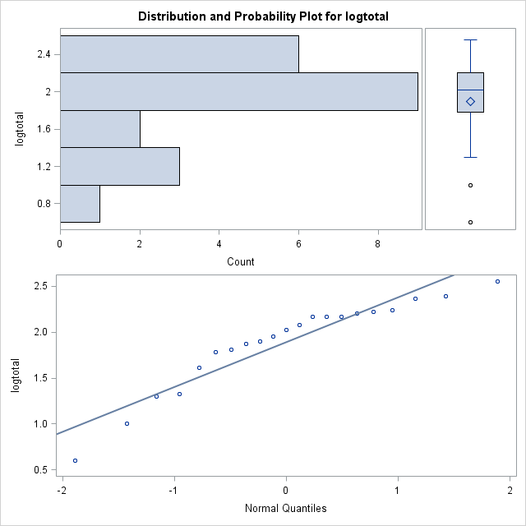

|  |
| --- |
| The SAS System |

The UNIVARIATE Procedure

Variable: logsize

Subfamily=COLYMBET

| **Moments** | | | |
| --- | --- | --- | --- |
| **N** | 28 | **Sum Weights** | 28 |
| **Mean** | 0.95313311 | **Sum Observations** | 26.6877272 |
| **Std Deviation** | 0.10413395 | **Variance** | 0.01084388 |
| **Skewness** | 0.60474609 | **Kurtosis** | 0.51277659 |
| **Uncorrected SS** | 25.7297413 | **Corrected SS** | 0.29278473 |
| **Coeff Variation** | 10.9254359 | **Std Error Mean** | 0.01967947 |

| **Basic Statistical Measures** | | | |
| --- | --- | --- | --- |
| **Location** | | **Variability** | |
| **Mean** | 0.953133 | **Std Deviation** | 0.10413 |
| **Median** | 0.960192 | **Variance** | 0.01084 |
| **Mode** | 0.845098 | **Range** | 0.45230 |
|  |  | **Interquartile Range** | 0.14613 |

|  |
| --- |
| **Note: The mode displayed is the smallest of 5 modes with a count of 3.** |

| **Tests for Location: Mu0=0** | | | | |
| --- | --- | --- | --- | --- |
| **Test** | **Statistic** | | **p Value** | |
| **Student's t** | **t** | 48.43287 | **Pr > |t|** | <.0001 |
| **Sign** | **M** | 14 | **Pr >= |M|** | <.0001 |
| **Signed Rank** | **S** | 203 | **Pr >= |S|** | <.0001 |

| **Quantiles (Definition 5)** | |
| --- | --- |
| **Level** | **Quantile** |
| **100% Max** | 1.230449 |
| **99%** | 1.230449 |
| **95%** | 1.146128 |
| **90%** | 1.060698 |
| **75% Q3** | 1.021189 |
| **50% Median** | 0.960192 |
| **25% Q1** | 0.875061 |
| **10%** | 0.845098 |
| **5%** | 0.795880 |
| **1%** | 0.778151 |
| **0% Min** | 0.778151 |

| **Extreme Observations** | | | |
| --- | --- | --- | --- |
| **Lowest** | | **Highest** | |
| **Value** | **Obs** | **Value** | **Obs** |
| 0.778151 | 8 | 1.04139 | 15 |
| 0.795880 | 20 | 1.04139 | 28 |
| 0.845098 | 21 | 1.06070 | 12 |
| 0.845098 | 10 | 1.14613 | 16 |
| 0.845098 | 6 | 1.23045 | 22 |

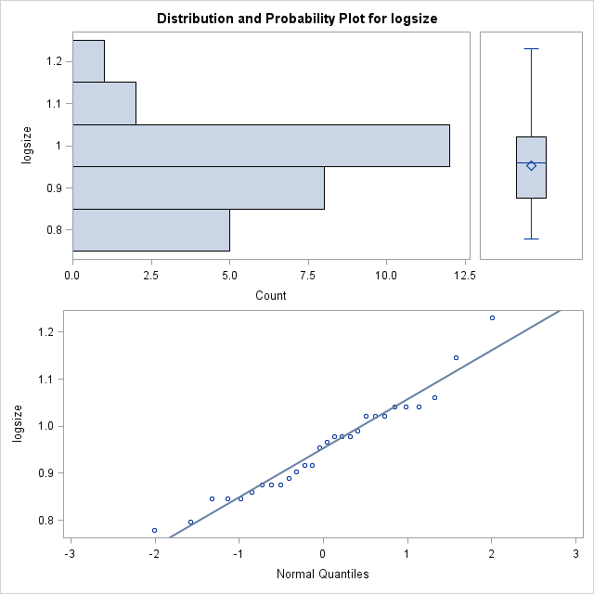

|  |
| --- |
| The SAS System |

The UNIVARIATE Procedure

Variable: total

Subfamily=DYTISCIN

| **Moments** | | | |
| --- | --- | --- | --- |
| **N** | 11 | **Sum Weights** | 11 |
| **Mean** | 95.7272727 | **Sum Observations** | 1053 |
| **Std Deviation** | 136.395081 | **Variance** | 18603.6182 |
| **Skewness** | 2.0124173 | **Kurtosis** | 3.10607576 |
| **Uncorrected SS** | 286837 | **Corrected SS** | 186036.182 |
| **Coeff Variation** | 142.482991 | **Std Error Mean** | 41.1246643 |

| **Basic Statistical Measures** | | | |
| --- | --- | --- | --- |
| **Location** | | **Variability** | |
| **Mean** | 95.72727 | **Std Deviation** | 136.39508 |
| **Median** | 42.00000 | **Variance** | 18604 |
| **Mode** | . | **Range** | 424.00000 |
|  |  | **Interquartile Range** | 41.00000 |

| **Tests for Location: Mu0=0** | | | | |
| --- | --- | --- | --- | --- |
| **Test** | **Statistic** | | **p Value** | |
| **Student's t** | **t** | 2.327734 | **Pr > |t|** | 0.0422 |
| **Sign** | **M** | 5.5 | **Pr >= |M|** | 0.0010 |
| **Signed Rank** | **S** | 33 | **Pr >= |S|** | 0.0010 |

| **Quantiles (Definition 5)** | |
| --- | --- |
| **Level** | **Quantile** |
| **100% Max** | 425 |
| **99%** | 425 |
| **95%** | 425 |
| **90%** | 301 |
| **75% Q3** | 67 |
| **50% Median** | 42 |
| **25% Q1** | 26 |
| **10%** | 10 |
| **5%** | 1 |
| **1%** | 1 |
| **0% Min** | 1 |

| **Extreme Observations** | | | |
| --- | --- | --- | --- |
| **Lowest** | | **Highest** | |
| **Value** | **Obs** | **Value** | **Obs** |
| 1 | 32 | 48 | 36 |
| 10 | 31 | 60 | 29 |
| 26 | 38 | 67 | 37 |
| 34 | 30 | 301 | 34 |
| 39 | 35 | 425 | 39 |

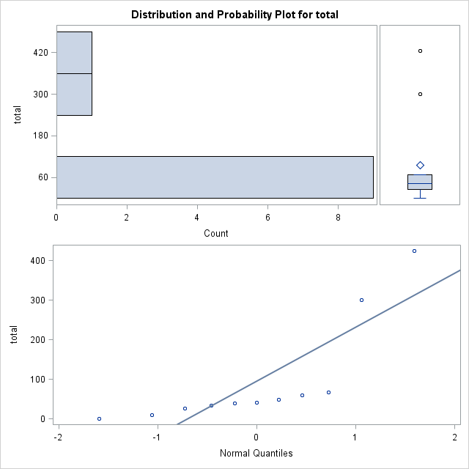

|  |
| --- |
| The SAS System |

The UNIVARIATE Procedure

Variable: Avesize

Subfamily=DYTISCIN

| **Moments** | | | |
| --- | --- | --- | --- |
| **N** | 11 | **Sum Weights** | 11 |
| **Mean** | 21.2954545 | **Sum Observations** | 234.25 |
| **Std Deviation** | 8.06444216 | **Variance** | 65.0352273 |
| **Skewness** | 0.49259962 | **Kurtosis** | -1.5158657 |
| **Uncorrected SS** | 5638.8125 | **Corrected SS** | 650.352273 |
| **Coeff Variation** | 37.8693121 | **Std Error Mean** | 2.4315208 |

| **Basic Statistical Measures** | | | |
| --- | --- | --- | --- |
| **Location** | | **Variability** | |
| **Mean** | 21.29545 | **Std Deviation** | 8.06444 |
| **Median** | 17.00000 | **Variance** | 65.03523 |
| **Mode** | 15.00000 | **Range** | 22.50000 |
|  |  | **Interquartile Range** | 14.00000 |

| **Tests for Location: Mu0=0** | | | | |
| --- | --- | --- | --- | --- |
| **Test** | **Statistic** | | **p Value** | |
| **Student's t** | **t** | 8.75808 | **Pr > |t|** | <.0001 |
| **Sign** | **M** | 5.5 | **Pr >= |M|** | 0.0010 |
| **Signed Rank** | **S** | 33 | **Pr >= |S|** | 0.0010 |

| **Quantiles (Definition 5)** | |
| --- | --- |
| **Level** | **Quantile** |
| **100% Max** | 35.00 |
| **99%** | 35.00 |
| **95%** | 35.00 |
| **90%** | 29.50 |
| **75% Q3** | 29.00 |
| **50% Median** | 17.00 |
| **25% Q1** | 15.00 |
| **10%** | 13.75 |
| **5%** | 12.50 |
| **1%** | 12.50 |
| **0% Min** | 12.50 |

| **Extreme Observations** | | | |
| --- | --- | --- | --- |
| **Lowest** | | **Highest** | |
| **Value** | **Obs** | **Value** | **Obs** |
| 12.50 | 30 | 23.5 | 35 |
| 13.75 | 29 | 29.0 | 37 |
| 15.00 | 33 | 29.0 | 39 |
| 15.00 | 32 | 29.5 | 36 |
| 15.00 | 31 | 35.0 | 38 |

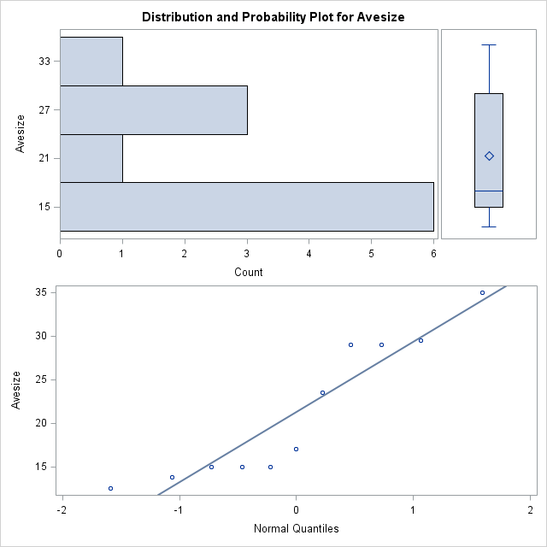

|  |
| --- |
| The SAS System |

The UNIVARIATE Procedure

Variable: logtotal

Subfamily=DYTISCIN

| **Moments** | | | |
| --- | --- | --- | --- |
| **N** | 11 | **Sum Weights** | 11 |
| **Mean** | 1.59574444 | **Sum Observations** | 17.5531889 |
| **Std Deviation** | 0.69844555 | **Variance** | 0.48782619 |
| **Skewness** | -0.8870597 | **Kurtosis** | 2.27358238 |
| **Uncorrected SS** | 32.8886655 | **Corrected SS** | 4.87826187 |
| **Coeff Variation** | 43.769261 | **Std Error Mean** | 0.21058926 |

| **Basic Statistical Measures** | | | |
| --- | --- | --- | --- |
| **Location** | | **Variability** | |
| **Mean** | 1.595744 | **Std Deviation** | 0.69845 |
| **Median** | 1.623249 | **Variance** | 0.48783 |
| **Mode** | . | **Range** | 2.62839 |
|  |  | **Interquartile Range** | 0.41110 |

| **Tests for Location: Mu0=0** | | | | |
| --- | --- | --- | --- | --- |
| **Test** | **Statistic** | | **p Value** | |
| **Student's t** | **t** | 7.577521 | **Pr > |t|** | <.0001 |
| **Sign** | **M** | 5 | **Pr >= |M|** | 0.0020 |
| **Signed Rank** | **S** | 27.5 | **Pr >= |S|** | 0.0020 |

| **Quantiles (Definition 5)** | |
| --- | --- |
| **Level** | **Quantile** |
| **100% Max** | 2.62839 |
| **99%** | 2.62839 |
| **95%** | 2.62839 |
| **90%** | 2.47857 |
| **75% Q3** | 1.82607 |
| **50% Median** | 1.62325 |
| **25% Q1** | 1.41497 |
| **10%** | 1.00000 |
| **5%** | 0.00000 |
| **1%** | 0.00000 |
| **0% Min** | 0.00000 |

| **Extreme Observations** | | | |
| --- | --- | --- | --- |
| **Lowest** | | **Highest** | |
| **Value** | **Obs** | **Value** | **Obs** |
| 0.00000 | 32 | 1.68124 | 36 |
| 1.00000 | 31 | 1.77815 | 29 |
| 1.41497 | 38 | 1.82607 | 37 |
| 1.53148 | 30 | 2.47857 | 34 |
| 1.59106 | 35 | 2.62839 | 39 |

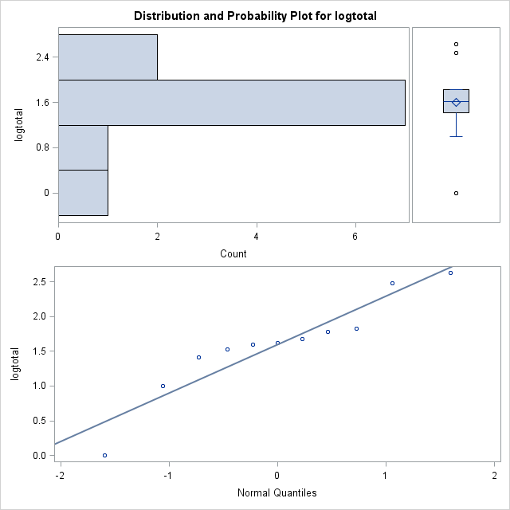

|  |
| --- |
| The SAS System |

The UNIVARIATE Procedure

Variable: logsize

Subfamily=DYTISCIN

| **Moments** | | | |
| --- | --- | --- | --- |
| **N** | 11 | **Sum Weights** | 11 |
| **Mean** | 1.30033539 | **Sum Observations** | 14.3036893 |
| **Std Deviation** | 0.16263253 | **Variance** | 0.02644934 |
| **Skewness** | 0.26843065 | **Kurtosis** | -1.8344478 |
| **Uncorrected SS** | 18.8640869 | **Corrected SS** | 0.26449339 |
| **Coeff Variation** | 12.5069677 | **Std Error Mean** | 0.04903555 |

| **Basic Statistical Measures** | | | |
| --- | --- | --- | --- |
| **Location** | | **Variability** | |
| **Mean** | 1.300335 | **Std Deviation** | 0.16263 |
| **Median** | 1.230449 | **Variance** | 0.02645 |
| **Mode** | 1.176091 | **Range** | 0.44716 |
|  |  | **Interquartile Range** | 0.28631 |

| **Tests for Location: Mu0=0** | | | | |
| --- | --- | --- | --- | --- |
| **Test** | **Statistic** | | **p Value** | |
| **Student's t** | **t** | 26.51822 | **Pr > |t|** | <.0001 |
| **Sign** | **M** | 5.5 | **Pr >= |M|** | 0.0010 |
| **Signed Rank** | **S** | 33 | **Pr >= |S|** | 0.0010 |

| **Quantiles (Definition 5)** | |
| --- | --- |
| **Level** | **Quantile** |
| **100% Max** | 1.54407 |
| **99%** | 1.54407 |
| **95%** | 1.54407 |
| **90%** | 1.46982 |
| **75% Q3** | 1.46240 |
| **50% Median** | 1.23045 |
| **25% Q1** | 1.17609 |
| **10%** | 1.13830 |
| **5%** | 1.09691 |
| **1%** | 1.09691 |
| **0% Min** | 1.09691 |

| **Extreme Observations** | | | |
| --- | --- | --- | --- |
| **Lowest** | | **Highest** | |
| **Value** | **Obs** | **Value** | **Obs** |
| 1.09691 | 30 | 1.37107 | 35 |
| 1.13830 | 29 | 1.46240 | 37 |
| 1.17609 | 33 | 1.46240 | 39 |
| 1.17609 | 32 | 1.46982 | 36 |
| 1.17609 | 31 | 1.54407 | 38 |

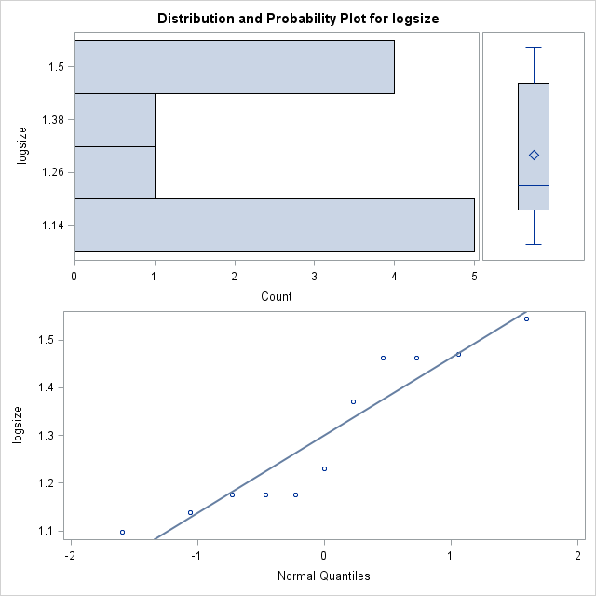

|  |
| --- |
| The SAS System |

The UNIVARIATE Procedure

Variable: total

Subfamily=HYDROPOR

| **Moments** | | | |
| --- | --- | --- | --- |
| **N** | 49 | **Sum Weights** | 49 |
| **Mean** | 196.734694 | **Sum Observations** | 9640 |
| **Std Deviation** | 209.901939 | **Variance** | 44058.824 |
| **Skewness** | 1.7582933 | **Kurtosis** | 4.07287248 |
| **Uncorrected SS** | 4011346 | **Corrected SS** | 2114823.55 |
| **Coeff Variation** | 106.692894 | **Std Error Mean** | 29.9859913 |

| **Basic Statistical Measures** | | | |
| --- | --- | --- | --- |
| **Location** | | **Variability** | |
| **Mean** | 196.7347 | **Std Deviation** | 209.90194 |
| **Median** | 125.0000 | **Variance** | 44059 |
| **Mode** | 12.0000 | **Range** | 1028 |
|  |  | **Interquartile Range** | 275.00000 |

|  |
| --- |
| **Note: The mode displayed is the smallest of 4 modes with a count of 2.** |

| **Tests for Location: Mu0=0** | | | | |
| --- | --- | --- | --- | --- |
| **Test** | **Statistic** | | **p Value** | |
| **Student's t** | **t** | 6.560887 | **Pr > |t|** | <.0001 |
| **Sign** | **M** | 24.5 | **Pr >= |M|** | <.0001 |
| **Signed Rank** | **S** | 612.5 | **Pr >= |S|** | <.0001 |

| **Quantiles (Definition 5)** | |
| --- | --- |
| **Level** | **Quantile** |
| **100% Max** | 1032 |
| **99%** | 1032 |
| **95%** | 608 |
| **90%** | 504 |
| **75% Q3** | 320 |
| **50% Median** | 125 |
| **25% Q1** | 45 |
| **10%** | 12 |
| **5%** | 10 |
| **1%** | 4 |
| **0% Min** | 4 |

| **Extreme Observations** | | | |
| --- | --- | --- | --- |
| **Lowest** | | **Highest** | |
| **Value** | **Obs** | **Value** | **Obs** |
| 4 | 79 | 504 | 75 |
| 7 | 71 | 519 | 82 |
| 10 | 74 | 608 | 72 |
| 12 | 88 | 639 | 86 |
| 12 | 56 | 1032 | 85 |

| **Missing Values** | | | |
| --- | --- | --- | --- |
| **Missing Value** | **Count** | **Percent Of** | |
| **All Obs** | **Missing Obs** |
| . | 5 | 9.26 | 100.00 |

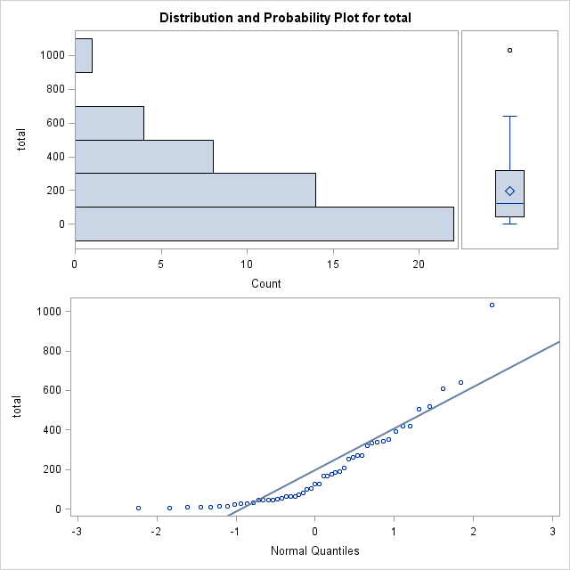

|  |
| --- |
| The SAS System |

The UNIVARIATE Procedure

Variable: Avesize

Subfamily=HYDROPOR

| **Moments** | | | |
| --- | --- | --- | --- |
| **N** | 54 | **Sum Weights** | 54 |
| **Mean** | 3.48796296 | **Sum Observations** | 188.35 |
| **Std Deviation** | 1.02717488 | **Variance** | 1.05508823 |
| **Skewness** | 0.7245961 | **Kurtosis** | 1.87503997 |
| **Uncorrected SS** | 712.8775 | **Corrected SS** | 55.9196759 |
| **Coeff Variation** | 29.4491337 | **Std Error Mean** | 0.1397808 |

| **Basic Statistical Measures** | | | |
| --- | --- | --- | --- |
| **Location** | | **Variability** | |
| **Mean** | 3.487963 | **Std Deviation** | 1.02717 |
| **Median** | 3.375000 | **Variance** | 1.05509 |
| **Mode** | 4.000000 | **Range** | 5.70000 |
|  |  | **Interquartile Range** | 1.00000 |

| **Tests for Location: Mu0=0** | | | | |
| --- | --- | --- | --- | --- |
| **Test** | **Statistic** | | **p Value** | |
| **Student's t** | **t** | 24.95309 | **Pr > |t|** | <.0001 |
| **Sign** | **M** | 27 | **Pr >= |M|** | <.0001 |
| **Signed Rank** | **S** | 742.5 | **Pr >= |S|** | <.0001 |

| **Quantiles (Definition 5)** | |
| --- | --- |
| **Level** | **Quantile** |
| **100% Max** | 7.200 |
| **99%** | 7.200 |
| **95%** | 5.000 |
| **90%** | 4.750 |
| **75% Q3** | 4.000 |
| **50% Median** | 3.375 |
| **25% Q1** | 3.000 |
| **10%** | 2.150 |
| **5%** | 2.000 |
| **1%** | 1.500 |
| **0% Min** | 1.500 |

| **Extreme Observations** | | | |
| --- | --- | --- | --- |
| **Lowest** | | **Highest** | |
| **Value** | **Obs** | **Value** | **Obs** |
| 1.50 | 56 | 4.85 | 66 |
| 1.95 | 88 | 5.00 | 52 |
| 2.00 | 58 | 5.00 | 63 |
| 2.00 | 57 | 5.00 | 93 |
| 2.00 | 55 | 7.20 | 67 |

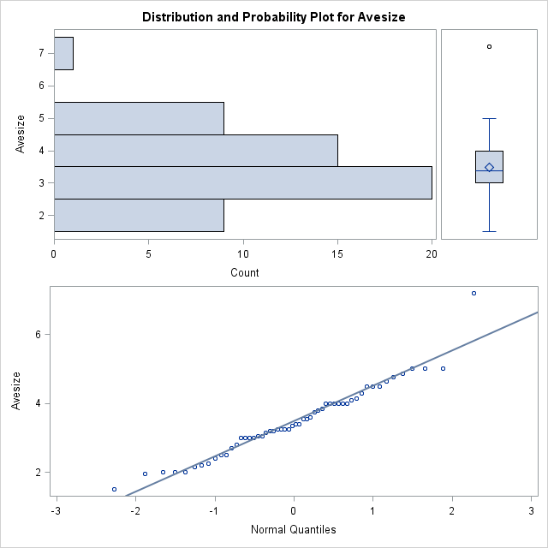

|  |
| --- |
| The SAS System |

The UNIVARIATE Procedure

Variable: logtotal

Subfamily=HYDROPOR

| **Moments** | | | |
| --- | --- | --- | --- |
| **N** | 49 | **Sum Weights** | 49 |
| **Mean** | 1.99926422 | **Sum Observations** | 97.963947 |
| **Std Deviation** | 0.58262119 | **Variance** | 0.33944745 |
| **Skewness** | -0.4689281 | **Kurtosis** | -0.5789379 |
| **Uncorrected SS** | 212.149292 | **Corrected SS** | 16.2934774 |
| **Coeff Variation** | 29.1417802 | **Std Error Mean** | 0.0832316 |

| **Basic Statistical Measures** | | | |
| --- | --- | --- | --- |
| **Location** | | **Variability** | |
| **Mean** | 1.999264 | **Std Deviation** | 0.58262 |
| **Median** | 2.096910 | **Variance** | 0.33945 |
| **Mode** | 1.079181 | **Range** | 2.41162 |
|  |  | **Interquartile Range** | 0.85194 |

|  |
| --- |
| **Note: The mode displayed is the smallest of 4 modes with a count of 2.** |

| **Tests for Location: Mu0=0** | | | | |
| --- | --- | --- | --- | --- |
| **Test** | **Statistic** | | **p Value** | |
| **Student's t** | **t** | 24.0205 | **Pr > |t|** | <.0001 |
| **Sign** | **M** | 24.5 | **Pr >= |M|** | <.0001 |
| **Signed Rank** | **S** | 612.5 | **Pr >= |S|** | <.0001 |

| **Quantiles (Definition 5)** | |
| --- | --- |
| **Level** | **Quantile** |
| **100% Max** | 3.01368 |
| **99%** | 3.01368 |
| **95%** | 2.78390 |
| **90%** | 2.70243 |
| **75% Q3** | 2.50515 |
| **50% Median** | 2.09691 |
| **25% Q1** | 1.65321 |
| **10%** | 1.07918 |
| **5%** | 1.00000 |
| **1%** | 0.60206 |
| **0% Min** | 0.60206 |

| **Extreme Observations** | | | |
| --- | --- | --- | --- |
| **Lowest** | | **Highest** | |
| **Value** | **Obs** | **Value** | **Obs** |
| 0.602060 | 79 | 2.70243 | 75 |
| 0.845098 | 71 | 2.71517 | 82 |
| 1.000000 | 74 | 2.78390 | 72 |
| 1.079181 | 88 | 2.80550 | 86 |
| 1.079181 | 56 | 3.01368 | 85 |

| **Missing Values** | | | |
| --- | --- | --- | --- |
| **Missing Value** | **Count** | **Percent Of** | |
| **All Obs** | **Missing Obs** |
| . | 5 | 9.26 | 100.00 |

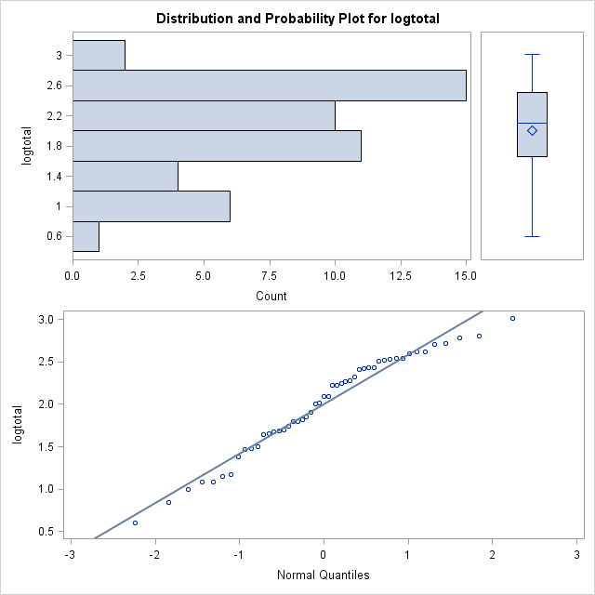

|  |
| --- |
| The SAS System |

The UNIVARIATE Procedure

Variable: logsize

Subfamily=HYDROPOR

| **Moments** | | | |
| --- | --- | --- | --- |
| **N** | 54 | **Sum Weights** | 54 |
| **Mean** | 0.52386236 | **Sum Observations** | 28.2885674 |
| **Std Deviation** | 0.13069117 | **Variance** | 0.01708018 |
| **Skewness** | -0.3341625 | **Kurtosis** | 0.26983045 |
| **Uncorrected SS** | 15.7245652 | **Corrected SS** | 0.90524958 |
| **Coeff Variation** | 24.9476152 | **Std Error Mean** | 0.01778481 |

| **Basic Statistical Measures** | | | |
| --- | --- | --- | --- |
| **Location** | | **Variability** | |
| **Mean** | 0.523862 | **Std Deviation** | 0.13069 |
| **Median** | 0.528262 | **Variance** | 0.01708 |
| **Mode** | 0.602060 | **Range** | 0.68124 |
|  |  | **Interquartile Range** | 0.12494 |

| **Tests for Location: Mu0=0** | | | | |
| --- | --- | --- | --- | --- |
| **Test** | **Statistic** | | **p Value** | |
| **Student's t** | **t** | 29.4556 | **Pr > |t|** | <.0001 |
| **Sign** | **M** | 27 | **Pr >= |M|** | <.0001 |
| **Signed Rank** | **S** | 742.5 | **Pr >= |S|** | <.0001 |

| **Quantiles (Definition 5)** | |
| --- | --- |
| **Level** | **Quantile** |
| **100% Max** | 0.857332 |
| **99%** | 0.857332 |
| **95%** | 0.698970 |
| **90%** | 0.676694 |
| **75% Q3** | 0.602060 |
| **50% Median** | 0.528262 |
| **25% Q1** | 0.477121 |
| **10%** | 0.332438 |
| **5%** | 0.301030 |
| **1%** | 0.176091 |
| **0% Min** | 0.176091 |

| **Extreme Observations** | | | |
| --- | --- | --- | --- |
| **Lowest** | | **Highest** | |
| **Value** | **Obs** | **Value** | **Obs** |
| 0.176091 | 56 | 0.685742 | 66 |
| 0.290035 | 88 | 0.698970 | 52 |
| 0.301030 | 58 | 0.698970 | 63 |
| 0.301030 | 57 | 0.698970 | 93 |
| 0.301030 | 55 | 0.857332 | 67 |

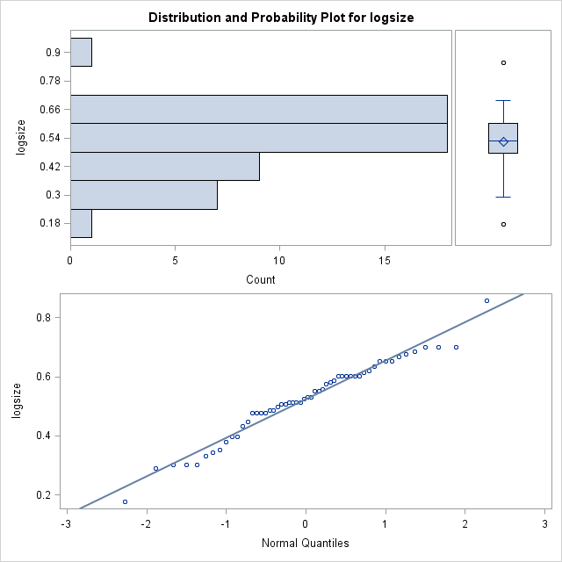

|  |
| --- |
| The SAS System |

The UNIVARIATE Procedure

Variable: total

Subfamily=LACCOPHI

| **Moments** | | | |
| --- | --- | --- | --- |
| **N** | 3 | **Sum Weights** | 3 |
| **Mean** | 150 | **Sum Observations** | 450 |
| **Std Deviation** | 140 | **Variance** | 19600 |
| **Skewness** | 0 | **Kurtosis** | . |
| **Uncorrected SS** | 106700 | **Corrected SS** | 39200 |
| **Coeff Variation** | 93.3333333 | **Std Error Mean** | 80.8290377 |

| **Basic Statistical Measures** | | | |
| --- | --- | --- | --- |
| **Location** | | **Variability** | |
| **Mean** | 150.0000 | **Std Deviation** | 140.00000 |
| **Median** | 150.0000 | **Variance** | 19600 |
| **Mode** | . | **Range** | 280.00000 |
|  |  | **Interquartile Range** | 280.00000 |

| **Tests for Location: Mu0=0** | | | | |
| --- | --- | --- | --- | --- |
| **Test** | **Statistic** | | **p Value** | |
| **Student's t** | **t** | 1.855769 | **Pr > |t|** | 0.2046 |
| **Sign** | **M** | 1.5 | **Pr >= |M|** | 0.2500 |
| **Signed Rank** | **S** | 3 | **Pr >= |S|** | 0.2500 |

| **Quantiles (Definition 5)** | |
| --- | --- |
| **Level** | **Quantile** |
| **100% Max** | 290 |
| **99%** | 290 |
| **95%** | 290 |
| **90%** | 290 |
| **75% Q3** | 290 |
| **50% Median** | 150 |
| **25% Q1** | 10 |
| **10%** | 10 |
| **5%** | 10 |
| **1%** | 10 |
| **0% Min** | 10 |

| **Extreme Observations** | | | |
| --- | --- | --- | --- |
| **Lowest** | | **Highest** | |
| **Value** | **Obs** | **Value** | **Obs** |
| 10 | 96 | 10 | 96 |
| 150 | 94 | 150 | 94 |
| 290 | 95 | 290 | 95 |

C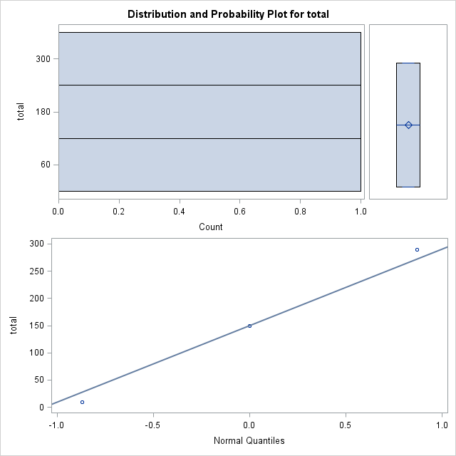

|  |
| --- |
| The SAS System |

The UNIVARIATE Procedure

Variable: Avesize

Subfamily=LACCOPHI

| **Moments** | | | |
| --- | --- | --- | --- |
| **N** | 3 | **Sum Weights** | 3 |
| **Mean** | 3.83333333 | **Sum Observations** | 11.5 |
| **Std Deviation** | 0.72168784 | **Variance** | 0.52083333 |
| **Skewness** | -1.7320508 | **Kurtosis** | . |
| **Uncorrected SS** | 45.125 | **Corrected SS** | 1.04166667 |
| **Coeff Variation** | 18.8266392 | **Std Error Mean** | 0.41666667 |

| **Basic Statistical Measures** | | | |
| --- | --- | --- | --- |
| **Location** | | **Variability** | |
| **Mean** | 3.833333 | **Std Deviation** | 0.72169 |
| **Median** | 4.250000 | **Variance** | 0.52083 |
| **Mode** | 4.250000 | **Range** | 1.25000 |
|  |  | **Interquartile Range** | 1.25000 |

| **Tests for Location: Mu0=0** | | | | |
| --- | --- | --- | --- | --- |
| **Test** | **Statistic** | | **p Value** | |
| **Student's t** | **t** | 9.2 | **Pr > |t|** | 0.0116 |
| **Sign** | **M** | 1.5 | **Pr >= |M|** | 0.2500 |
| **Signed Rank** | **S** | 3 | **Pr >= |S|** | 0.2500 |

| **Quantiles (Definition 5)** | |
| --- | --- |
| **Level** | **Quantile** |
| **100% Max** | 4.25 |
| **99%** | 4.25 |
| **95%** | 4.25 |
| **90%** | 4.25 |
| **75% Q3** | 4.25 |
| **50% Median** | 4.25 |
| **25% Q1** | 3.00 |
| **10%** | 3.00 |
| **5%** | 3.00 |
| **1%** | 3.00 |
| **0% Min** | 3.00 |

| **Extreme Observations** | | | |
| --- | --- | --- | --- |
| **Lowest** | | **Highest** | |
| **Value** | **Obs** | **Value** | **Obs** |
| 3.00 | 96 | 3.00 | 96 |
| 4.25 | 95 | 4.25 | 94 |
| 4.25 | 94 | 4.25 | 95 |

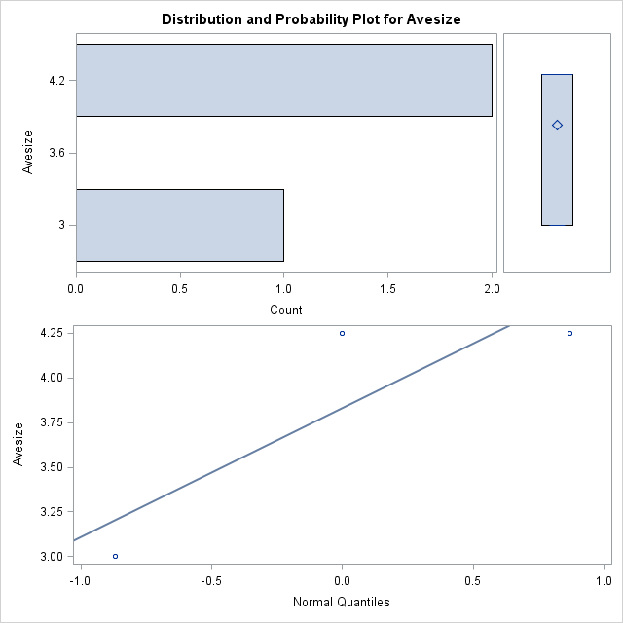

|  |
| --- |
| The SAS System |

The UNIVARIATE Procedure

Variable: logtotal

Subfamily=LACCOPHI

| **Moments** | | | |
| --- | --- | --- | --- |
| **N** | 3 | **Sum Weights** | 3 |
| **Mean** | 1.87949642 | **Sum Observations** | 5.63848926 |
| **Std Deviation** | 0.77500216 | **Variance** | 0.60062835 |
| **Skewness** | -1.4699301 | **Kurtosis** | . |
| **Uncorrected SS** | 11.7987771 | **Corrected SS** | 1.2012567 |
| **Coeff Variation** | 41.2345644 | **Std Error Mean** | 0.44744771 |

| **Basic Statistical Measures** | | | |
| --- | --- | --- | --- |
| **Location** | | **Variability** | |
| **Mean** | 1.879496 | **Std Deviation** | 0.77500 |
| **Median** | 2.176091 | **Variance** | 0.60063 |
| **Mode** | . | **Range** | 1.46240 |
|  |  | **Interquartile Range** | 1.46240 |

| **Tests for Location: Mu0=0** | | | | |
| --- | --- | --- | --- | --- |
| **Test** | **Statistic** | | **p Value** | |
| **Student's t** | **t** | 4.200483 | **Pr > |t|** | 0.0523 |
| **Sign** | **M** | 1.5 | **Pr >= |M|** | 0.2500 |
| **Signed Rank** | **S** | 3 | **Pr >= |S|** | 0.2500 |

| **Quantiles (Definition 5)** | |
| --- | --- |
| **Level** | **Quantile** |
| **100% Max** | 2.46240 |
| **99%** | 2.46240 |
| **95%** | 2.46240 |
| **90%** | 2.46240 |
| **75% Q3** | 2.46240 |
| **50% Median** | 2.17609 |
| **25% Q1** | 1.00000 |
| **10%** | 1.00000 |
| **5%** | 1.00000 |
| **1%** | 1.00000 |
| **0% Min** | 1.00000 |

| **Extreme Observations** | | | |
| --- | --- | --- | --- |
| **Lowest** | | **Highest** | |
| **Value** | **Obs** | **Value** | **Obs** |
| 1.00000 | 96 | 1.00000 | 96 |
| 2.17609 | 94 | 2.17609 | 94 |
| 2.46240 | 95 | 2.46240 | 95 |

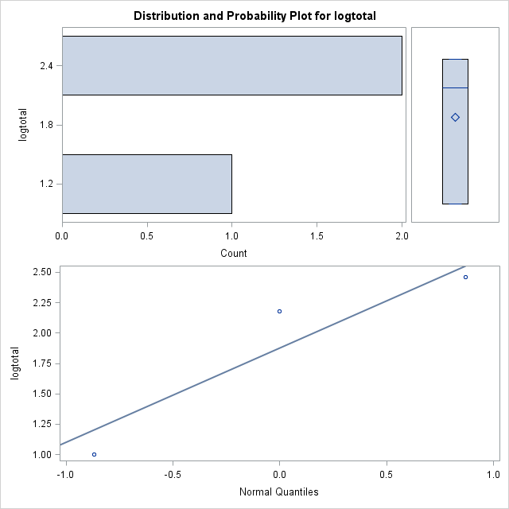

|  |
| --- |
| The SAS System |

The UNIVARIATE Procedure

Variable: logsize

Subfamily=LACCOPHI

| **Moments** | | | |
| --- | --- | --- | --- |
| **N** | 3 | **Sum Weights** | 3 |
| **Mean** | 0.57796637 | **Sum Observations** | 1.73389911 |
| **Std Deviation** | 0.08733443 | **Variance** | 0.0076273 |
| **Skewness** | -1.7320508 | **Kurtosis** | . |
| **Uncorrected SS** | 1.01738999 | **Corrected SS** | 0.01525461 |
| **Coeff Variation** | 15.1106427 | **Std Error Mean** | 0.05042256 |

| **Basic Statistical Measures** | | | |
| --- | --- | --- | --- |
| **Location** | | **Variability** | |
| **Mean** | 0.577966 | **Std Deviation** | 0.08733 |
| **Median** | 0.628389 | **Variance** | 0.00763 |
| **Mode** | 0.628389 | **Range** | 0.15127 |
|  |  | **Interquartile Range** | 0.15127 |

| **Tests for Location: Mu0=0** | | | | |
| --- | --- | --- | --- | --- |
| **Test** | **Statistic** | | **p Value** | |
| **Student's t** | **t** | 11.46246 | **Pr > |t|** | 0.0075 |
| **Sign** | **M** | 1.5 | **Pr >= |M|** | 0.2500 |
| **Signed Rank** | **S** | 3 | **Pr >= |S|** | 0.2500 |

| **Quantiles (Definition 5)** | |
| --- | --- |
| **Level** | **Quantile** |
| **100% Max** | 0.628389 |
| **99%** | 0.628389 |
| **95%** | 0.628389 |
| **90%** | 0.628389 |
| **75% Q3** | 0.628389 |
| **50% Median** | 0.628389 |
| **25% Q1** | 0.477121 |
| **10%** | 0.477121 |
| **5%** | 0.477121 |
| **1%** | 0.477121 |
| **0% Min** | 0.477121 |

| **Extreme Observations** | | | |
| --- | --- | --- | --- |
| **Lowest** | | **Highest** | |
| **Value** | **Obs** | **Value** | **Obs** |
| 0.477121 | 96 | 0.477121 | 96 |
| 0.628389 | 95 | 0.628389 | 94 |
| 0.628389 | 94 | 0.628389 | 95 |

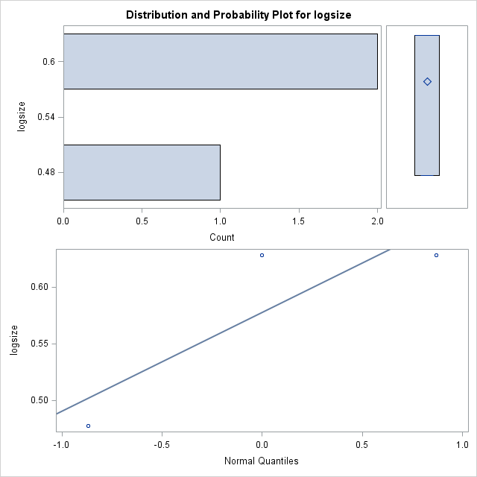

|  |
| --- |
| The SAS System |

The UNIVARIATE Procedure

Variable: total

Subfamily=NOTERIDA

| **Moments** | | | |
| --- | --- | --- | --- |
| **N** | 2 | **Sum Weights** | 2 |
| **Mean** | 142 | **Sum Observations** | 284 |
| **Std Deviation** | 113.137085 | **Variance** | 12800 |
| **Skewness** | . | **Kurtosis** | . |
| **Uncorrected SS** | 53128 | **Corrected SS** | 12800 |
| **Coeff Variation** | 79.6740035 | **Std Error Mean** | 80 |

| **Basic Statistical Measures** | | | |
| --- | --- | --- | --- |
| **Location** | | **Variability** | |
| **Mean** | 142.0000 | **Std Deviation** | 113.13708 |
| **Median** | 142.0000 | **Variance** | 12800 |
| **Mode** | . | **Range** | 160.00000 |
|  |  | **Interquartile Range** | 160.00000 |

| **Tests for Location: Mu0=0** | | | | |
| --- | --- | --- | --- | --- |
| **Test** | **Statistic** | | **p Value** | |
| **Student's t** | **t** | 1.775 | **Pr > |t|** | 0.3266 |
| **Sign** | **M** | 1 | **Pr >= |M|** | 0.5000 |
| **Signed Rank** | **S** | 1.5 | **Pr >= |S|** | 0.5000 |

| **Quantiles (Definition 5)** | |
| --- | --- |
| **Level** | **Quantile** |
| **100% Max** | 222 |
| **99%** | 222 |
| **95%** | 222 |
| **90%** | 222 |
| **75% Q3** | 222 |
| **50% Median** | 142 |
| **25% Q1** | 62 |
| **10%** | 62 |
| **5%** | 62 |
| **1%** | 62 |
| **0% Min** | 62 |

| **Extreme Observations** | | | |
| --- | --- | --- | --- |
| **Lowest** | | **Highest** | |
| **Value** | **Obs** | **Value** | **Obs** |
| 62 | 98 | 62 | 98 |
| 222 | 97 | 222 | 97 |

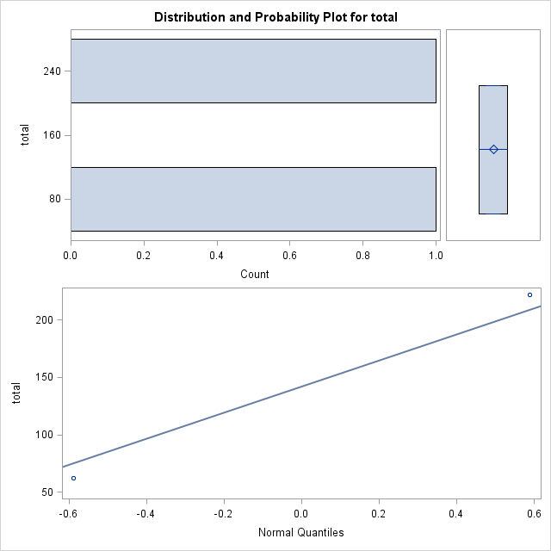

|  |
| --- |
| The SAS System |

The UNIVARIATE Procedure

Variable: Avesize

Subfamily=NOTERIDA

| **Moments** | | | |
| --- | --- | --- | --- |
| **N** | 2 | **Sum Weights** | 2 |
| **Mean** | 4.125 | **Sum Observations** | 8.25 |
| **Std Deviation** | 0.53033009 | **Variance** | 0.28125 |
| **Skewness** | . | **Kurtosis** | . |
| **Uncorrected SS** | 34.3125 | **Corrected SS** | 0.28125 |
| **Coeff Variation** | 12.8564869 | **Std Error Mean** | 0.375 |

| **Basic Statistical Measures** | | | |
| --- | --- | --- | --- |
| **Location** | | **Variability** | |
| **Mean** | 4.125000 | **Std Deviation** | 0.53033 |
| **Median** | 4.125000 | **Variance** | 0.28125 |
| **Mode** | . | **Range** | 0.75000 |
|  |  | **Interquartile Range** | 0.75000 |

| **Tests for Location: Mu0=0** | | | | |
| --- | --- | --- | --- | --- |
| **Test** | **Statistic** | | **p Value** | |
| **Student's t** | **t** | 11 | **Pr > |t|** | 0.0577 |
| **Sign** | **M** | 1 | **Pr >= |M|** | 0.5000 |
| **Signed Rank** | **S** | 1.5 | **Pr >= |S|** | 0.5000 |

| **Quantiles (Definition 5)** | |
| --- | --- |
| **Level** | **Quantile** |
| **100% Max** | 4.500 |
| **99%** | 4.500 |
| **95%** | 4.500 |
| **90%** | 4.500 |
| **75% Q3** | 4.500 |
| **50% Median** | 4.125 |
| **25% Q1** | 3.750 |
| **10%** | 3.750 |
| **5%** | 3.750 |
| **1%** | 3.750 |
| **0% Min** | 3.750 |

| **Extreme Observations** | | | |
| --- | --- | --- | --- |
| **Lowest** | | **Highest** | |
| **Value** | **Obs** | **Value** | **Obs** |
| 3.75 | 98 | 3.75 | 98 |
| 4.50 | 97 | 4.50 | 97 |

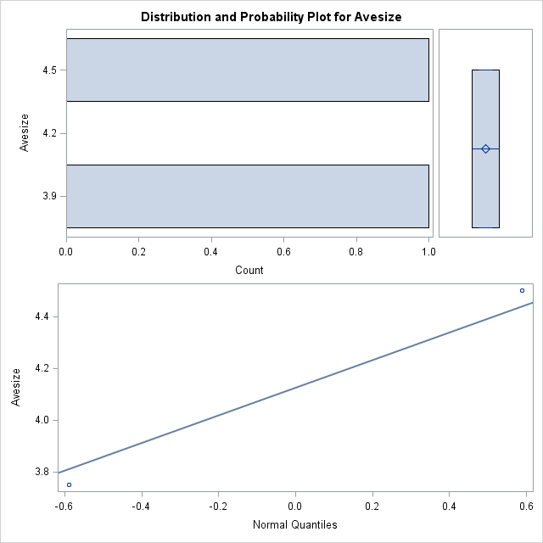

|  |
| --- |
| The SAS System |

The UNIVARIATE Procedure

Variable: logtotal

Subfamily=NOTERIDA

| **Moments** | | | |
| --- | --- | --- | --- |
| **N** | 2 | **Sum Weights** | 2 |
| **Mean** | 2.06937233 | **Sum Observations** | 4.13874466 |
| **Std Deviation** | 0.39170978 | **Variance** | 0.15343655 |
| **Skewness** | . | **Kurtosis** | . |
| **Uncorrected SS** | 8.71804025 | **Corrected SS** | 0.15343655 |
| **Coeff Variation** | 18.9289175 | **Std Error Mean** | 0.27698064 |

| **Basic Statistical Measures** | | | |
| --- | --- | --- | --- |
| **Location** | | **Variability** | |
| **Mean** | 2.069372 | **Std Deviation** | 0.39171 |
| **Median** | 2.069372 | **Variance** | 0.15344 |
| **Mode** | . | **Range** | 0.55396 |
|  |  | **Interquartile Range** | 0.55396 |

| **Tests for Location: Mu0=0** | | | | |
| --- | --- | --- | --- | --- |
| **Test** | **Statistic** | | **p Value** | |
| **Student's t** | **t** | 7.47118 | **Pr > |t|** | 0.0847 |
| **Sign** | **M** | 1 | **Pr >= |M|** | 0.5000 |
| **Signed Rank** | **S** | 1.5 | **Pr >= |S|** | 0.5000 |

| **Quantiles (Definition 5)** | |
| --- | --- |
| **Level** | **Quantile** |
| **100% Max** | 2.34635 |
| **99%** | 2.34635 |
| **95%** | 2.34635 |
| **90%** | 2.34635 |
| **75% Q3** | 2.34635 |
| **50% Median** | 2.06937 |
| **25% Q1** | 1.79239 |
| **10%** | 1.79239 |
| **5%** | 1.79239 |
| **1%** | 1.79239 |
| **0% Min** | 1.79239 |

| **Extreme Observations** | | | |
| --- | --- | --- | --- |
| **Lowest** | | **Highest** | |
| **Value** | **Obs** | **Value** | **Obs** |
| 1.79239 | 98 | 1.79239 | 98 |
| 2.34635 | 97 | 2.34635 | 97 |

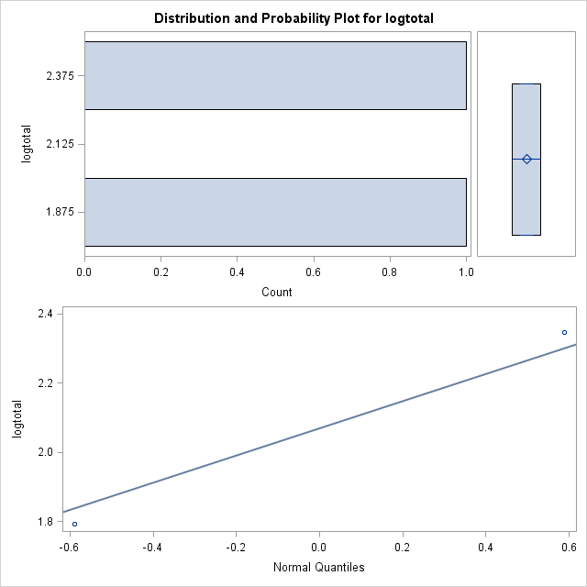

|  |
| --- |
| The SAS System |

The UNIVARIATE Procedure

Variable: logsize

Subfamily=NOTERIDA

| **Moments** | | | |
| --- | --- | --- | --- |
| **N** | 2 | **Sum Weights** | 2 |
| **Mean** | 0.61362189 | **Sum Observations** | 1.22724378 |
| **Std Deviation** | 0.0559896 | **Variance** | 0.00313483 |
| **Skewness** | . | **Kurtosis** | . |
| **Uncorrected SS** | 0.75619848 | **Corrected SS** | 0.00313483 |
| **Coeff Variation** | 9.12444567 | **Std Error Mean** | 0.03959062 |

| **Basic Statistical Measures** | | | |
| --- | --- | --- | --- |
| **Location** | | **Variability** | |
| **Mean** | 0.613622 | **Std Deviation** | 0.05599 |
| **Median** | 0.613622 | **Variance** | 0.00313 |
| **Mode** | . | **Range** | 0.07918 |
|  |  | **Interquartile Range** | 0.07918 |

| **Tests for Location: Mu0=0** | | | | |
| --- | --- | --- | --- | --- |
| **Test** | **Statistic** | | **p Value** | |
| **Student's t** | **t** | 15.49917 | **Pr > |t|** | 0.0410 |
| **Sign** | **M** | 1 | **Pr >= |M|** | 0.5000 |
| **Signed Rank** | **S** | 1.5 | **Pr >= |S|** | 0.5000 |

| **Quantiles (Definition 5)** | |
| --- | --- |
| **Level** | **Quantile** |
| **100% Max** | 0.653213 |
| **99%** | 0.653213 |
| **95%** | 0.653213 |
| **90%** | 0.653213 |
| **75% Q3** | 0.653213 |
| **50% Median** | 0.613622 |
| **25% Q1** | 0.574031 |
| **10%** | 0.574031 |
| **5%** | 0.574031 |
| **1%** | 0.574031 |
| **0% Min** | 0.574031 |

| **Extreme Observations** | | | |
| --- | --- | --- | --- |
| **Lowest** | | **Highest** | |
| **Value** | **Obs** | **Value** | **Obs** |
| 0.574031 | 98 | 0.574031 | 98 |
| 0.653213 | 97 | 0.653213 | 97 |









