**Method and Results**, the observation carried out in this work mostly surrounds the discrete computation by using several empirical binomial distribution. In our particular case, the binomial distribution has expected frequencies of 0,1,2 successes, probability of successes of $π$**.** Also note **x** is the number of repetitions. From result standpoint, there is several inferences which will be made by critically by observing and comparing from the results, theoretical expectation generated figures to SAS output for simulation of random draw from binomial population.

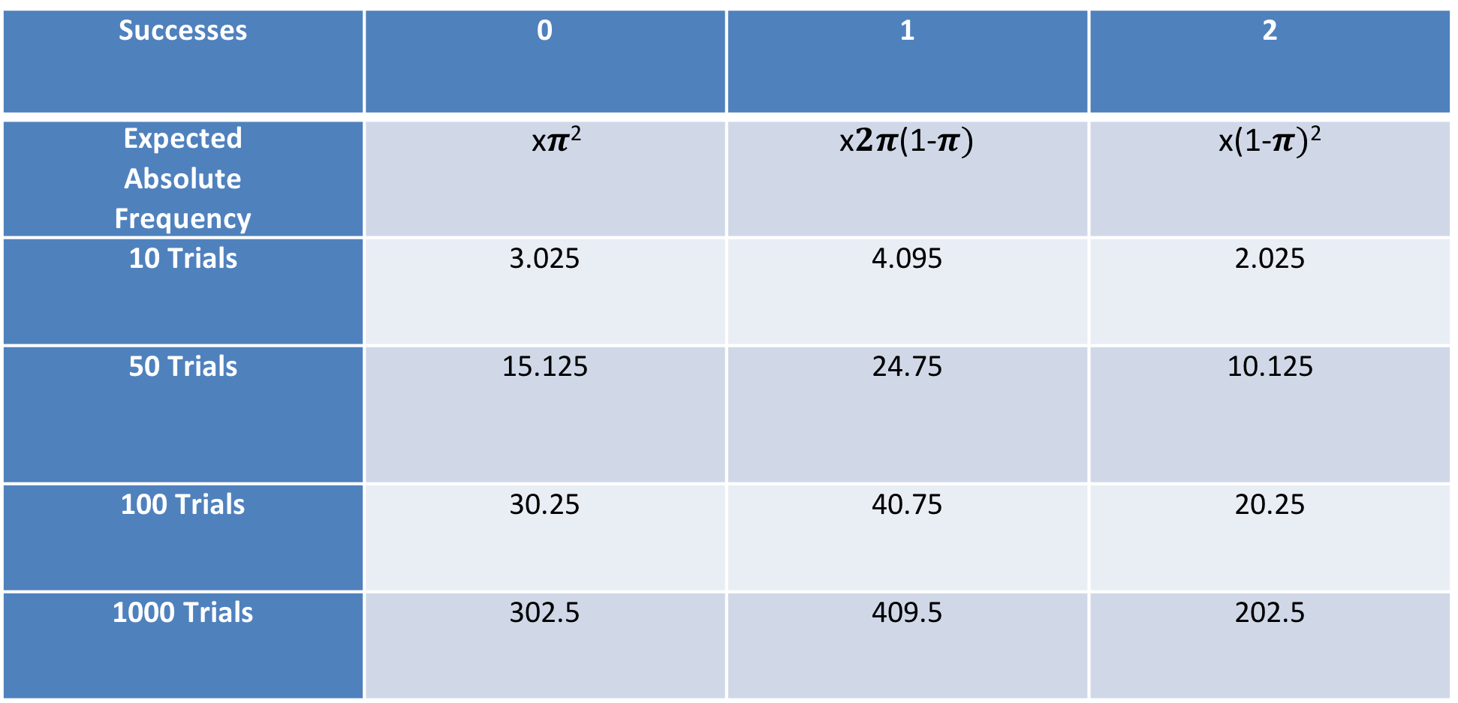

Table 1.0, THEORITICAL EXPECTATION CALCULATON

**TABULAR REPRESENTATION OF FREQUENCY (SAS OUTPUT)**

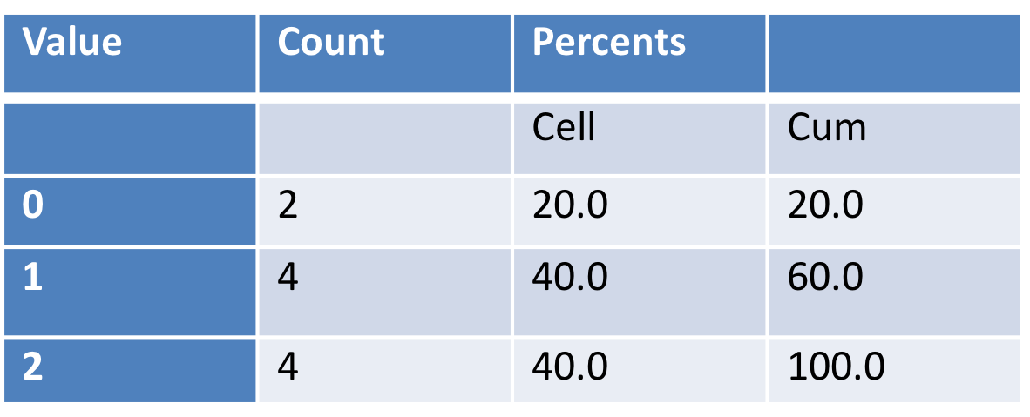

Table 2.0, Frequency counts for 10 trials

Table 2.1, Frequency counts for 50 trials

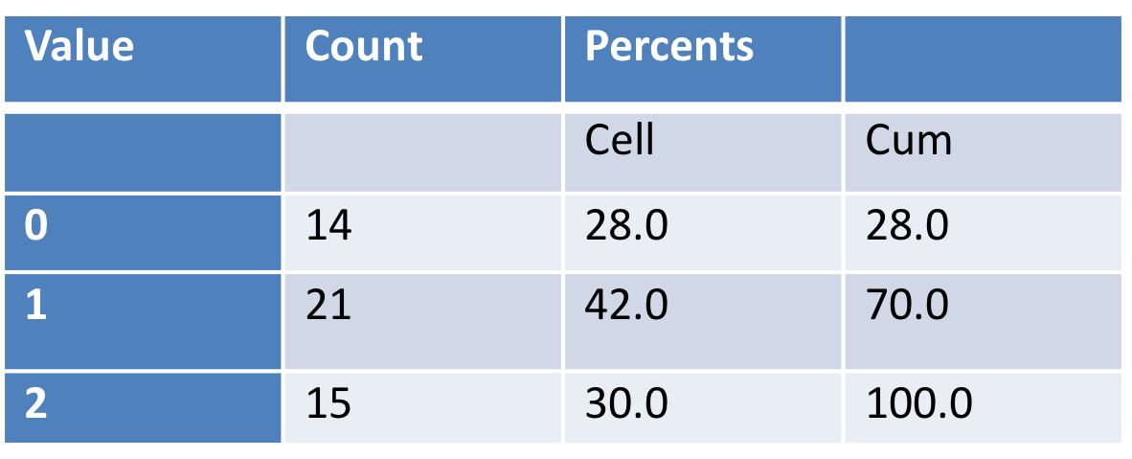

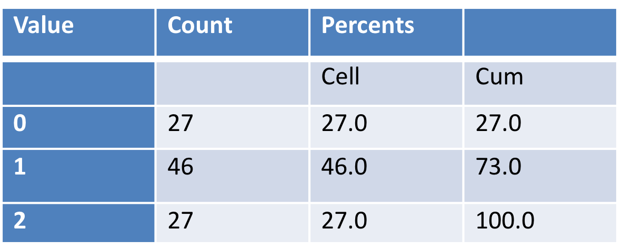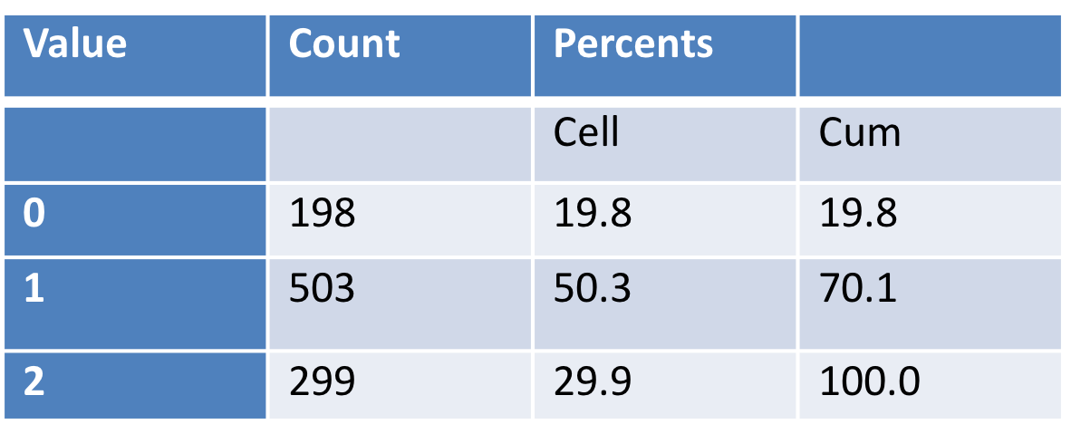

Table 2.3, Frequency counts for 1000 trials

Table 2.2, Frequency counts for 100 trials

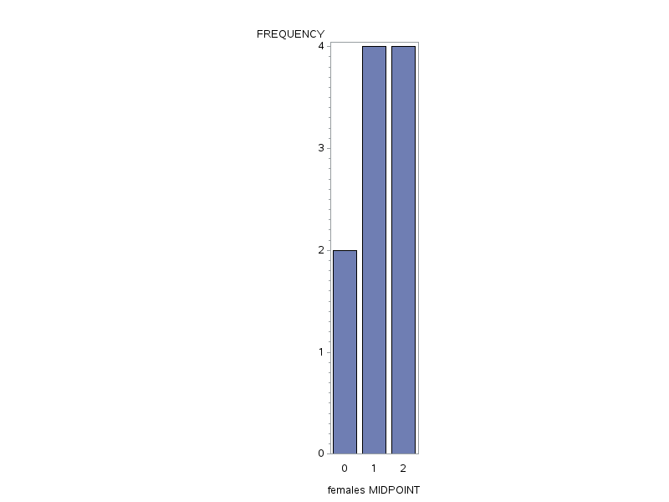

**GRAPHICAL REPRESENTATION OF FREQUENCY (SAS OUTPUT)**

Figure 1.0**,** female frequency for 10 trials

**Figure 1.0** This figure above displays the output from SAS from running experiments in 10 repetitions. Comparing our values in **Table 2.0** to the SAS generated output; we see there is a relatively small difference in value from what we expected.

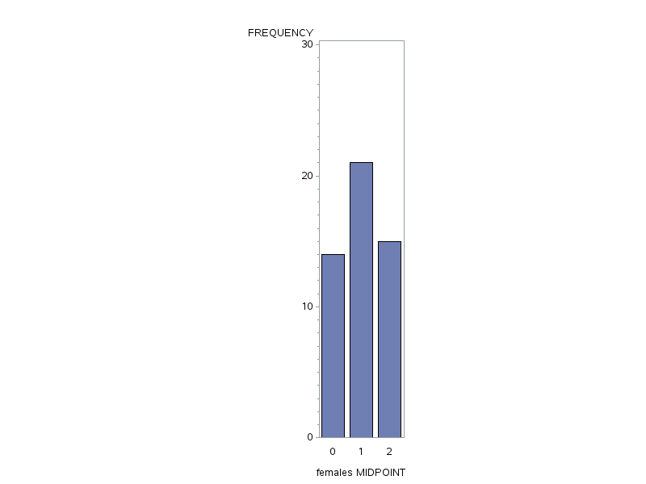

Figure1.1, female frequency for 50 trials

**Figure 1.1** This figure above displays the output from SAS from running experiments in 50 repetitions. Comparing our **Table 2.1** the SAS generated output, we see there is a relatively higher value than what we expected.

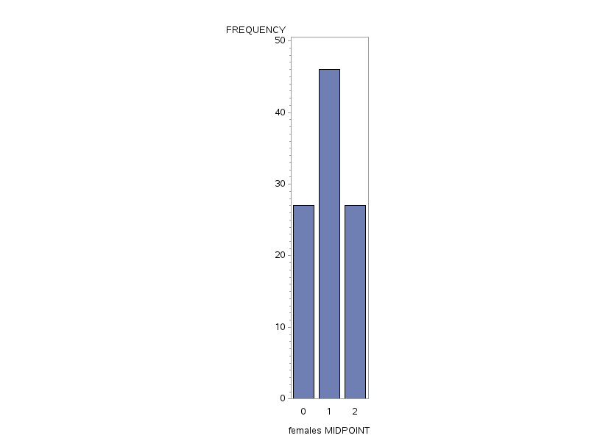

Figure 1.2, female frequency for 100 trials

**Figure 1.2** This figure above displays the output from SAS from running experiments in 100 repetitions. Comparing our values in Table **2.2 the** SAS generated output, we see there is a relatively higher value than what we expected.

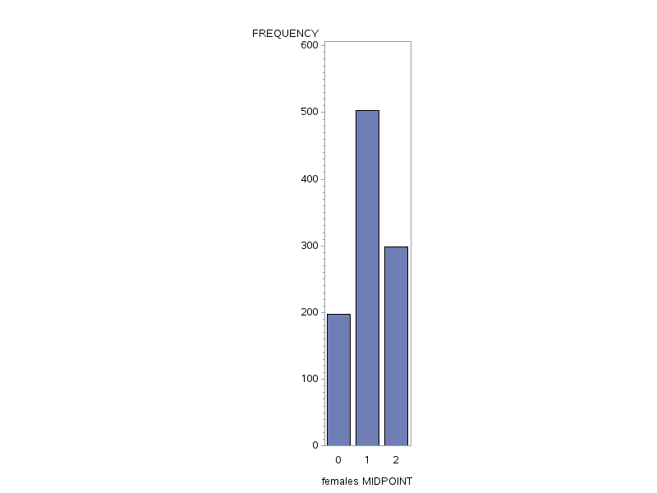

**Figure 1.3,** female frequency for 1000 trials

**Figure 1.3** This figure above displays the output from SAS from running experiments in 1000 repetitions. Comparing our values in Table **2.3 the** SAS generated output, we see there is a relatively higher value than what we expected.

The expected mean and standard deviation can be calculated using the probability of successes, which is drawing a female. To calculate these two summaries statistics, we use:

Expected Mean: μ $=Nπ$ Standard deviation: σ= $\sqrt{Nπ(1-π)}$

After doing this calculation, we see from **Table 3.0 – 3.3** that the expected mean for a sample set of individuals have different chances of success that yields a mean and a standard deviation that is relative to the number of trials **N**. The results can be seen in the tables below. We should be seeing that as our number of trials increases, our mean and standard deviation get closer and closer to the true value. In my particular experiments, the closest standard deviation was found when running 100 trials/repetitions in this particular case.

(NB:**N** is the number of trials)

Table 3.0, summary statistics for 10 trials Table 3.1, summary statistics for 50 trials

|  |  |
| --- | --- |
| N | 10 |
| Mean | 1.2 |
| Std Deviation | 0.78881064 |
| Sum Observations | 12 |
| Variance | 0.62222222 |

|  |  |
| --- | --- |
| N | 50 |
| Mean | 1.02 |
| Std Deviation | 0.76904393 |
| Sum  Observation | 51 |
| Variance | 0.59142857 |

Table 3.2, summary statistics for 100 trials Table 3.3, summary statistics for 1000 trials

|  |  |
| --- | --- |
| N | 1000 |
| Mean | 1.101 |
| Std Deviation | 0.69805894 |
| Sum  Observation | 1101 |
| Variance | 0.48728629 |

|  |  |
| --- | --- |
| N | 100 |
| Mean | 1 |
| Std Deviation | 0.73854895 |
| Sum  observation | 100 |
| Variance | 0.54545455 |

The tables (**Table 4.0 – 4.3**) below are the output from SAS when we run 400 experiment runs for each of the sample sizes. Also, after finding the mean and standard deviation of each individual experiment, we found the mean of all the results generated with a sample size of 4,16,64 and 100.

|  |  |
| --- | --- |
| N | 100 |
| Mean | 0.0270151 |
| Std Dev | 0.2656611 |
| Maximum | -0.6139300 |
| Minimum | 0.7521363 |

|  |  |
| --- | --- |
| N | 100 |
| Mean | 0.0202538 |
| Std Dev | 0.5277432 |
| Minimum | -1.0117944 |
| Maximum | 1.2635219 |

Table 4,0, summary statics for sample size 4 Table 4.2 summary statistics for sample size 64

|  |  |
| --- | --- |
| N | 100 |
| Mean | -0.0354255 |
| Std Dev | 0.1007915 |
| Minimum | -0.2818531 |
| Maximum | 0.2750593 |

|  |  |
| --- | --- |
| N | 100 |
| Mean | -0.0131796 |
| Std Dev | 0.0999645 |
| Minimum | -0.3139075 |
| Maximum | 0.2262990 |

Table 4.1, summary statics for sample size 16 Table 4.3, summary statics for sample size 100

Table 5.0, Summary statistics for 400 observations (SAS OUTPUT)

|  |  |  |  |  |  |
| --- | --- | --- | --- | --- | --- |
| observation | Ns | j | n | mean | Std deviation |
| 2 | 4 | 2 | 4 | 0.47397 | 0.82534 |
| 394 | 100 | 94 | 100 | -0.04726 | 1.09313 |

(**NB**:Above is a summary output of 400 observations, I randomly chose 2 values to fit the analysis below)

From **Table 5.0**, the standard deviation seems to range quite a bit. The least standard deviation is 0.82534. This data set has large standard deviation, it means that our values were relatively close and did not have a wide range. The kurtosis of our distribution would resemble the leptokurtic. Additionally, there were also standard deviations found that were very high, such as 1.09313. This value tells us that the spread of our data is wide and so the kurtosis of our distribution would be platykurtic This is to say, the higher our sample size for our experiments, the lower our standard deviation.

Now looking at the standard error of the mean, we also see that the larger our sample size is, the better our results as per **Table 4.0 – 4.3**. The desired value for standard error is the population standard deviation divided by the square root of the size of the sample which can be mathematically represented as $σ_{F}=\frac{σ}{\sqrt{N}}$**.** Using this formula, we obtain the values 0.2639,0 .0664, 0.0126, and 0.00999 for the trials using sample sizes of 4, 16, 64 and 100 respectively. Our standard error is smaller as the sample size increases, meaning we generate more accurate results with larger sample sizes.