|  |  |  |  |  |  |
| --- | --- | --- | --- | --- | --- |
| **Source** | **DF** | **Sum of Squares** | **Mean Square** | **F Value** | **Pr > F** |
| **Model** | 4 | 884.250000 | 221.062500 | 18.52 | <.0001 |
| **Error** | 35 | 417.750000 | 11.935714 |  |  |
| **Corrected Total** | 39 | 1302.000000 |  |  |  |

Table 1.0, ANOVA

Based on **Table1.0**, conducted a hypothesis test (with a 0.05 significance level) to see effects of soil nutrients on growth in a particular prairie soil. The output source shows source of variances, where models means effects of all the independent variables. This one way ANOVA is based on F-distribution and the F test statistics value is 18.52 with a P-value of 0. 0001.Since the P-value is less than 0.05, we reject the null hypothesis and conclude that there is enough evidence to support the null hypothesis. The experiment is as follows

H0: There is no difference between the individual treatment groups, thus our αj’s (effect of treatment *j* on response) are all the same and the sum will equal zero.

All αj’s = 0

HA: There is a difference between the individual treatment groups, thus some αj’s do not equal zero.

Some αj’s ≠ 0

In performing this experiment, some assumptions were made. These assumptions include that our observations are randomly selected and independent from one another, all of our random variation among individuals (αij) is randomly distributed, and our variance is the same for all groups

Table1.1 R squared value for ANOVA

|  |  |  |  |
| --- | --- | --- | --- |
| R-Square | Coeff Var | Root MSE | Y Mean |
| 0.679147 | 6.339101 | 3.454810 | 54.5 |

From **Table 1.1**, displays an R-Squared value. This value tells us more about the percentage of variance accounted for in our one-way ANOVA model.

Figure 1.0, Graphical representation of distribution(Treatment)

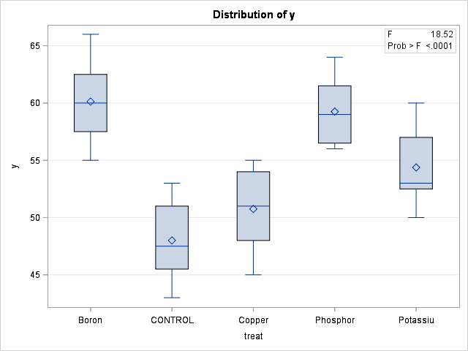

From **Figure1.0**, the box plots are used to show overall patterns of response of the treatment. Potassium is comparatively short as compared to copper. The medians (which generally will be close to the average) of Boron, Control, Copper, Phosphorous, Potassium are on different level as per the figure above. However, it is always important to consider the pattern of the whole distribution of response in a box plot.

Table2.0, Ryan-Einot-Gabriel-Welsch Multiple Range Test

|  |  |
| --- | --- |
| Alpha | .05 |
| Error Degrees of Freedom | 35 |
| Error Mean Square | 11.94 |

Table 2.1, Ryan-Einot-Gabriel-Welsch Multiple Range Grouping

|  |  |  |  |  |
| --- | --- | --- | --- | --- |
| REGWQ | Grouping | Mean | N | Treatment |
|  | A | 60.125 | 8 | Boron |
|  | A | 59.25 | 8 | Phosphorus |
|  | B | 54.375 | 8 | Potassium |
| C | B | 50.75 | 8 | Copper |
| C |  | 48 | 8 | Control |

Based on **Tables 2.0,2.1** we see the output when running a Ryan-Einot-Gabriel-Welsch Multiple Range Test for Y. The output shows us that there is no significant difference between the means of Boron and Phosphorus, Potassium and Copper, and Copper and Control. Additionally, looking at **Figure 1.0**, the disparity between the means in the different groups. Our Boron, and Phosphorus seem to have the highest mean and highest distribution, where Potassium sits right in the middle, and our Control group as well as our Copper group give us the lowest mean and range. This will also provide some information on our outcomes from the contrast tests.

Table 3.0, Orthogonal Contrast for Treatment

|  |  |  |  |  |  |  |
| --- | --- | --- | --- | --- | --- | --- |
| Contrast | DF | Contrast SS | Mean Square | F Value | t Value | Pr>F(|t|) |
| C vs Bo, Co, Po, Ph | 1 | 422.5 | 422.5 |  | -5.95 | <.0001 |
| Micro vs Macro | 1 | 15.125 | 15.125 | 1.27 |  | .2680 |
| Boron vs Copper | 1 | 351.563 | 351.563 | 28.45 |  | <.0001 |
| Potassium vs Phosphorus | 1 | 95.0625 | 95.0625 | 7.96 |  | .0078 |

(NB let C,Bo,Co,Po,Ph represent Control,Boron,Copper,Phosphorous,Potassium respectively)

**Control Group vs Treatment Groups**

For the first contrast, we will use a t-test since our hypothesis is one tailed. We have reason to believe that the treatments will provide an increase in growth compared to no treatments at all, thus we are just looking at one tail. Looking at **Table 3.0**, we see that our test statistic for our Control group versus our Treatment groups is <.0001. we can reject our null hypothesis.

**Micronutrients vs Macronutrients**

For the second contrast, and F-test can be used since it is two tailed. We have no reason to believe that Micronutrients and Macronutrients differ. Looking at **Table 3.0,** we get a test statistic of .2680, which is not small enough to be significant. Thus, we cannot reject the null hypothesis and state that more evidence is needed in order to determine a difference between Micronutrients and Macronutrients added to soil

**Boron vs Copper**

In the third contrast, we will also use the F-test, because once again we have no reason to believe that Boron and Copper will produce different results. In **Table 3.0,** we see that our test statistic comes out to be <.0001, which is less than our level of significance at α=.05. This means we can reject our null hypothesis and accept that there is a difference between our treatment group adding Boron and our treatment group adding Copper.

**Phosphorus vs Potassium**

For the fourth contrast, we will continue using the F-test. We see that in **Table 3.0**, our test statistic comes out to be .0078, which is less than our level of significance at α=.05. Thus, we can reject our null hypothesis and state that there is a difference between the treatment groups containing Phosphorus and Potassium.

Figure 2.0, Scatter plot for residual Figure 2.1, Normality plot for residual

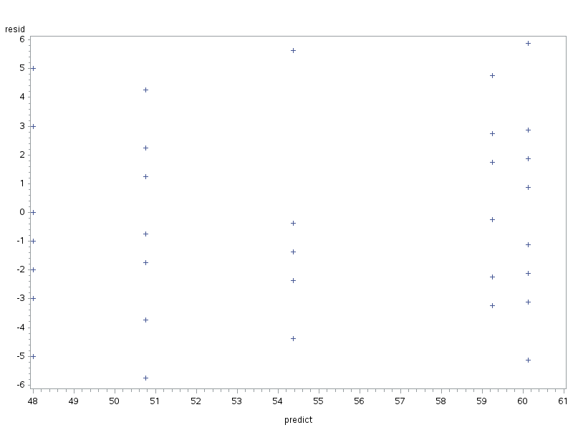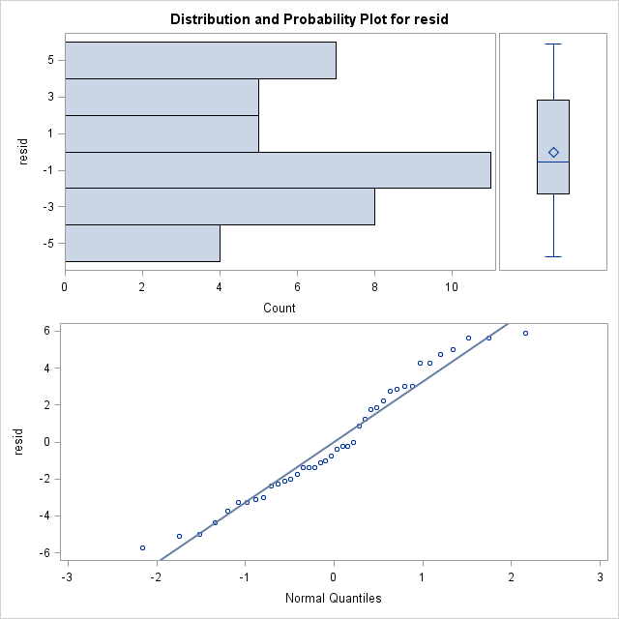

|  |  |  |  |  |  |
| --- | --- | --- | --- | --- | --- |
| Source | DF | Sum of Squares | Mean Square | F Value | Pr>F |
| Treatment | 4 | 3.35 | .8375 | .19 | .9403 |
| Error | 35 | 151.8 | 4.3357 |  |  |

Table 4.0,Brown and Forsythe's Test for Homogeneity of y Variance

|  |  |  |  |  |  |
| --- | --- | --- | --- | --- | --- |
| Source | DF | Sum of Squares | Mean Square | F Value | Pr>F |
| Treatment | 4 | 9.8000 | 2.4500 | 0.72 | 0.5773 |
| Error | 95 | 321.2 | 3.3811 |  |  |

In **Figures 2.0 and 2.1,** we see plots of our residuals. Looking just at **Figure 2.1,** the histogram shows us a relatively normal distribution, and the dots on the lower plot tend to stay pretty close to the solid line. The solid line indicates our data if it were 100% normally distributed, and though the dots range a little in their distance from this line, there is not enough disparity to conclude that our data is not normally distributed. Looking at **Figure 2.0**, this graph shows us our residuals plotted against predicted values. The dots on this graph seem relatively evenly dispersed in each of the columns. Their ranges also seem to show approximately the same spread. This tells us that to the best of our knowledge, the variances of our data are homogeneous. Now looking at our Brown and Forsythe’s test statistic in **Table 4.0,** we can see that our Pr>F value is .9403. Since this value is large we would fail to reject our null hypothesis of equal variances. Thus, we can conclude that our assumptions are met. Since our assumptions of ANOVA are reasonable met by the raw data, there is no need to do a transformation.

Table 5.0, Summary statistics for level of treatment

|  |  |  |  |  |
| --- | --- | --- | --- | --- |
| Level of treatment | N | Mean | Standard Deviation | Standard Error |
| Boron | 8 | 60.125 | 3.56320482 | 1.259783145 |
| Control | 8 | 48 | 3.42261387 | 1.210076738 |
| Copper | 8 | 50.75 | 3.65474252 | 1.29214661 |
| Phosphorous | 8 | 59.25 | 2.91547595 | 1.030776407 |
| Potassium | 8 | 54.375 | 3.66206421 | 1.294735218 |

Figure 3.0, Graphical representation of means for level of treatment

In **Table 5.0** and **Figure 3.0**, we can see our individual treatment along with their corresponding means and Standard Errors. The Standard Errors were obtained using the formula σ/√𝑛 where σ is the standard deviation for each individual treatment seen under the Standard Deviation, and 𝑛 is the size of the group. The graph in **Figure 3.0** gives a visual representation of the means of our treatment groups along with their individual Standard displayed in the Standard Error column in **Table 5.0**