|  |  |  |  |  |  |
| --- | --- | --- | --- | --- | --- |
| **Source** | **DF** | **Sum of Squares** | **Mean Square** | **F Value** | **Pr > F** |
| **Model** | 4 | 4555.400000 | 1138.850000 | 126.60 | <.0001 |
| **Error** | 95 | 854.600000 | 8.995789 |  |  |
| **Corrected Total** | 99 | 5410.000000 |  |  |  |

Table 1.0, ANOVA

Based on **Table1.0**, conducted a hypothesis test (with a 0.05 significance level) to determine whether size(length) of carabid beetles varies among local populations. The output source shows source of variances, where models means effects of all the independent variables. The beetles were selected at random from each population was collected and measured in length. The question for this particular study at hand is whether size of carabid beetles varies among local populations.

This one way ANOVA is based on F-distribution and the F test statistics value is 126.60 with a P-value of 0. 0001.Since the P-value is less than 0.05, we reject the null hypothesis and conclude that there is enough evidence to support the null hypothesis. The experiment is as follows; H0: There is no difference between the population groups, therefore σA2 will equal zero, HA: There is a difference between the individual population groups, therefore σA2 do not equal zero. In performing this experiment given, some assumptions were made. These assumptions include that our observations are randomly selected and are independent from one another, all of our random variation among individuals (σA2) is randomly distributed, and our variance is the same for all population groups at all levels.

|  |  |  |  |  |
| --- | --- | --- | --- | --- |
| Source | DF | Sum of Squares | Mean Square | Expected Mean Square |
| Population | 4 | 4555.4 | 1138.85 | Var(Error) + 20 Var(Population) |
| Error | 95 | 845.6 | 8.995789 | Var(Error) |
| Corrected Total | 99 | 5410 |  |  |

Table 1.2, Tests of Hypotheses for Random Model Analysis of Variance

Formula 1.0,

*SA2*=j  , where MSTR is Mean Square value for the population, MSE is Mean Square Error, and the parameter nj is our population size in each group.

Formula 1.1

$r_{1}=σ_{2}^{2}/(σ_{A}^{2}+σ^{2}$), where $r_{1}$ is coefficient of interclass correlation, $σ^{2} is variance$

Since we derived that F-test is significant, we will perform more detailed analysis on our data. However, we do not know the exact population variance in this scenario given, we will estimate it using our Mean Square Error(MSE) value that is seen from **Table 1.2.** So, to estimate our variance among groups, SA2, we will use the **Formula1.0**. All of these values can be found in **Table 1.2** above**.** Using this **formula1.0,** we obtain an estimation of SA2  to be 56.492 meaning, the estimation for Total Variation of our population, s2+ SA2, is equal to 65.488.

Additionally, using this value, we can find ${ r}_{1}$, our coefficient of intraclass correlation by using **Formula1.1** to find to obtain I=**0.86263559**. This is a large coefficient of correlation, because as $r_{1}$ ranges from 0 to 1 as per its assumption and obviously it falls at the upper end of the range close to 1

|  |  |  |  |
| --- | --- | --- | --- |
| Variance Component | Estimate | 95% Confidence Limits | |
| Var(Population) | 56.49271 | 19.98285 | 469.73233 |
| Var(Error) | 8.99579 | 6.89984 | 12.22169 |

Table 1.3, Variance components with confidence Intervals

**Table 1.3,** The confidence interval for our data can be found inwhich gives us the proportion of the total variance if the response is attributed to the population level. Our intervals obtained are (19.98285,469.73233), which is comparatively feasible because we don’t expect to see any values below 0 in our model.

Figure 2.0, Scatter plot representation (residual vs predicted)

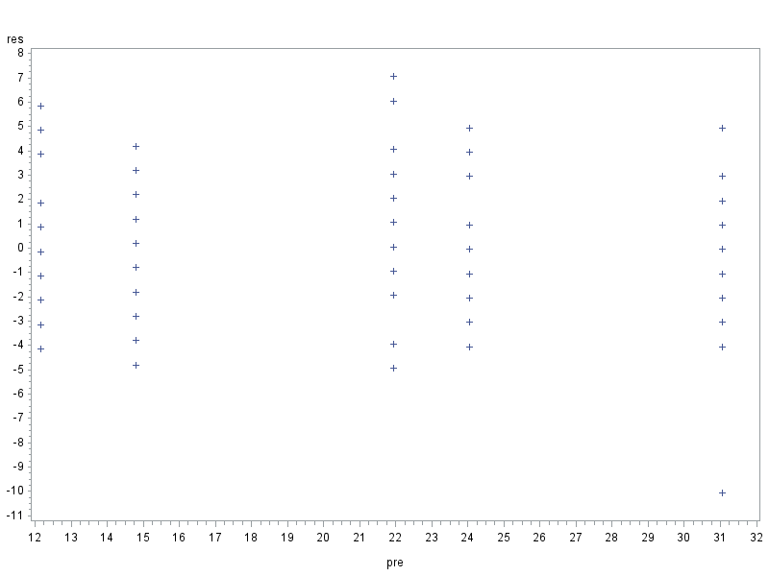

Figure 2.1, Scatter plot representation (residual vs order)

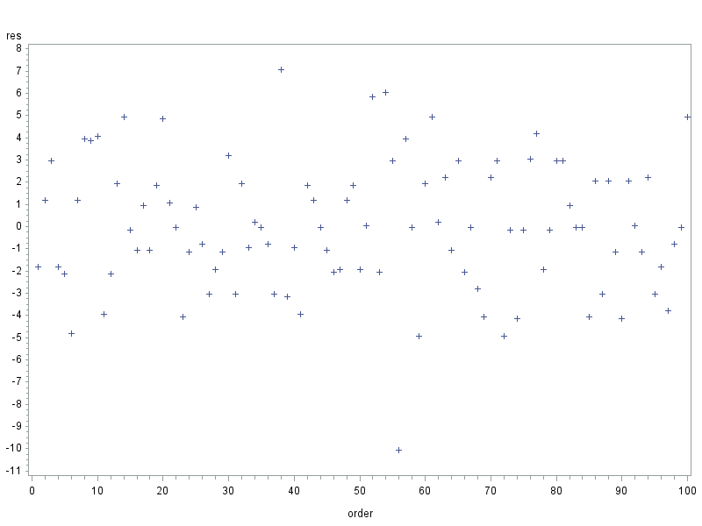

Figure 2.2, Normality plot for residual

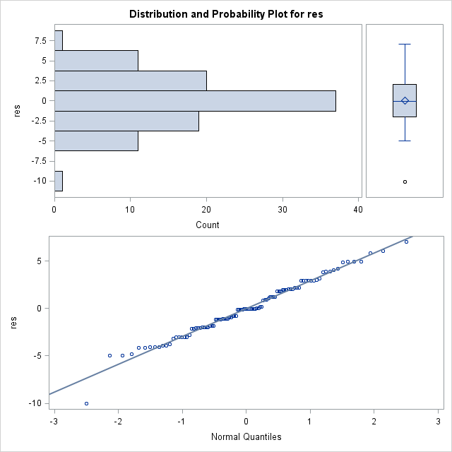

|  |  |  |  |  |  |
| --- | --- | --- | --- | --- | --- |
| Source | DF | Sum of Squares | Mean Square | F Value | Pr>F |
| Population | 4 | 9.8000 | 2.4500 | 0.72 | 0.5773 |
| Error | 95 | 321.2 | 3.3811 |  |  |

Table 2.0,Brown and Forsythe's Test for Homogeneity of length Variance

In **Figures 2.0 and 2.1,** we see plots of our residuals which show different trends. Looking just at **Figure2.2,** the histogram shows us a relatively normal distribution, and the dots on the lower plot tend to stay close to the solid line. The line indicates our data if it were normally distributed, and though the dots range a little in their distance from this line, there is not enough disparity to conclude that our data is not normally distributed. Looking at **Figure 2.0**, this graph shows us our residuals plotted against predicted values. The dots on this graph seem relatively evenly dispersed in each of the columns. Their ranges also closely show approximately the same spread-out look on the plot. This tells us that to the best of our knowledge, the variances of our data are homogeneous. Analyzing the Brown and Forsythe’s test statistic in **Table2.0,** we can notice that our Pr>F value is 0.5773. Since this value is larger than 0.05 we would fail to reject our null hypothesis of equal variances therefore we can conclude that our assumptions are met and there is enough evidence to support the claim. Since our assumptions of ANOVA are reasonable met by the raw data, there is no need to do any type of transformation on the data given.