|  |
| --- |
| The SAS System |

The GLM Procedure

| **Class Level Information** | | |
| --- | --- | --- |
| **Class** | **Levels** | **Values** |
| **population** | 5 | 1 2 3 4 5 |

|  |  |
| --- | --- |
| **Number of Observations Read** | 100 |
| **Number of Observations Used** | 100 |

|  |
| --- |
| The SAS System |

The GLM Procedure

Dependent Variable: length

| **Source** | **DF** | **Sum of Squares** | **Mean Square** | **F Value** | **Pr > F** |
| --- | --- | --- | --- | --- | --- |
| **Model** | 4 | 4555.400000 | 1138.850000 | 126.60 | <.0001 |
| **Error** | 95 | 854.600000 | 8.995789 |  |  |
| **Corrected Total** | 99 | 5410.000000 |  |  |  |

| **R-Square** | **Coeff Var** | **Root MSE** | **length Mean** |
| --- | --- | --- | --- |
| 0.842033 | 14.41970 | 2.999298 | 20.80000 |

| **Source** | **DF** | **Type III SS** | **Mean Square** | **F Value** | **Pr > F** |
| --- | --- | --- | --- | --- | --- |
| **population** | 4 | 4555.400000 | 1138.850000 | 126.60 | <.0001 |

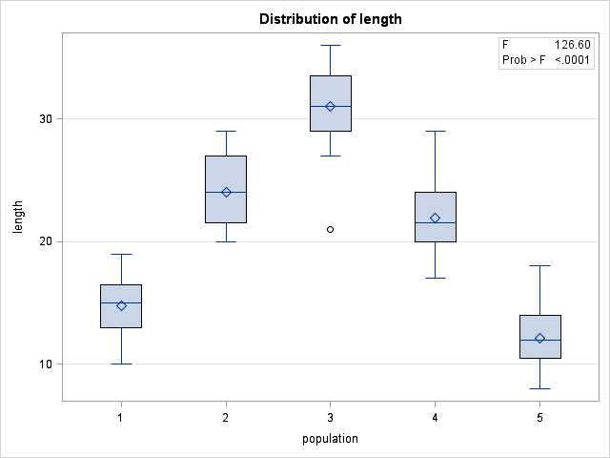

|  |
| --- |
| The SAS System |

The GLM Procedure

| **Source** | **Type III Expected Mean Square** |
| --- | --- |
| **population** | Var(Error) + 20 Var(population) |

|  |
| --- |
| The SAS System |

The GLM Procedure

Tests of Hypotheses for Random Model Analysis of Variance

Dependent Variable: length

| **Source** | **DF** | **Type III SS** | **Mean Square** | **F Value** | **Pr > F** |
| --- | --- | --- | --- | --- | --- |
| **population** | 4 | 4555.400000 | 1138.850000 | 126.60 | <.0001 |
| **Error: MS(Error)** | 95 | 854.600000 | 8.995789 |  |  |

|  |
| --- |
| The SAS System |

| **Brown and Forsythe's Test for Homogeneity of length Variance ANOVA of Absolute Deviations from Group Medians** | | | | | |
| --- | --- | --- | --- | --- | --- |
| **Source** | **DF** | **Sum of Squares** | **Mean Square** | **F Value** | **Pr > F** |
| **population** | 4 | 9.8000 | 2.4500 | 0.72 | 0.5773 |
| **Error** | 95 | 321.2 | 3.3811 |  |  |

|  |
| --- |
| The SAS System |

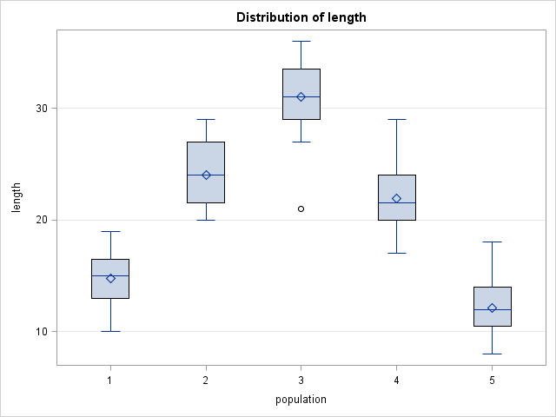

| **Level of population** | **N** | **length** | |
| --- | --- | --- | --- |
| **Mean** | **Std Dev** |
| **1** | **20** | 14.8000000 | 2.35304953 |
| **2** | **20** | 24.0500000 | 2.81864096 |
| **3** | **20** | 31.0500000 | 3.50150344 |
| **4** | **20** | 21.9500000 | 3.42552339 |
| **5** | **20** | 12.1500000 | 2.73909320 |

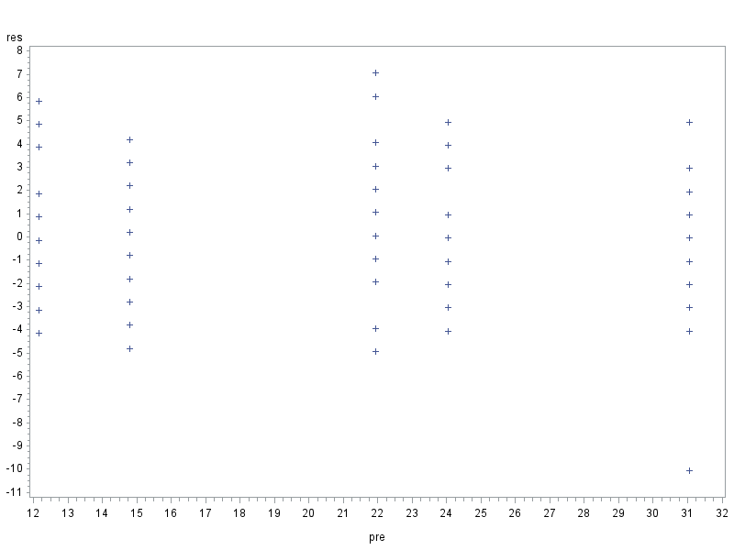

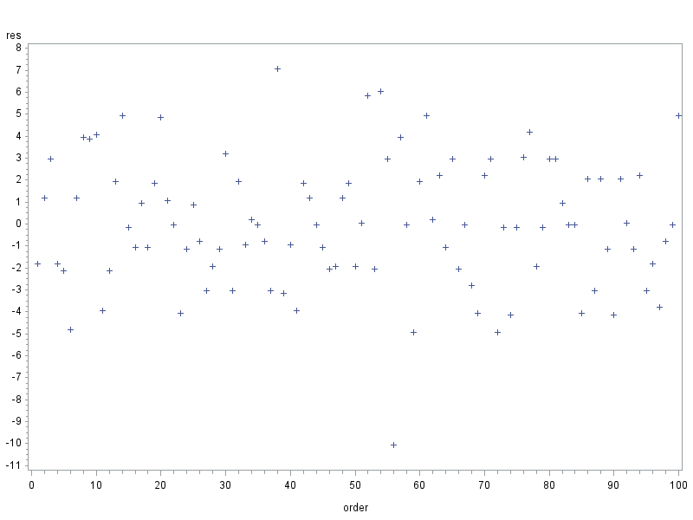

|  |
| --- |
| The SAS System |

The UNIVARIATE Procedure

Variable: res

| **Moments** | | | |
| --- | --- | --- | --- |
| **N** | 100 | **Sum Weights** | 100 |
| **Mean** | 0 | **Sum Observations** | 0 |
| **Std Deviation** | 2.93808156 | **Variance** | 8.63232323 |
| **Skewness** | -0.1199187 | **Kurtosis** | 0.40708981 |
| **Uncorrected SS** | 854.6 | **Corrected SS** | 854.6 |
| **Coeff Variation** | . | **Std Error Mean** | 0.29380816 |

| **Basic Statistical Measures** | | | |
| --- | --- | --- | --- |
| **Location** | | **Variability** | |
| **Mean** | 0.00000 | **Std Deviation** | 2.93808 |
| **Median** | -0.05000 | **Variance** | 8.63232 |
| **Mode** | -1.95000 | **Range** | 17.10000 |
|  |  | **Interquartile Range** | 4.00000 |

|  |
| --- |
| **Note: The mode displayed is the smallest of 6 modes with a count of 4.** |

| **Tests for Location: Mu0=0** | | | | |
| --- | --- | --- | --- | --- |
| **Test** | **Statistic** | | **p Value** | |
| **Student's t** | **t** | 0 | **Pr > |t|** | 1.0000 |
| **Sign** | **M** | -6 | **Pr >= |M|** | 0.2713 |
| **Signed Rank** | **S** | -28 | **Pr >= |S|** | 0.9239 |

| **Tests for Normality** | | | | |
| --- | --- | --- | --- | --- |
| **Test** | **Statistic** | | **p Value** | |
| **Shapiro-Wilk** | **W** | 0.984059 | **Pr < W** | 0.2711 |
| **Kolmogorov-Smirnov** | **D** | 0.073211 | **Pr > D** | >0.1500 |
| **Cramer-von Mises** | **W-Sq** | 0.060837 | **Pr > W-Sq** | >0.2500 |
| **Anderson-Darling** | **A-Sq** | 0.390563 | **Pr > A-Sq** | >0.2500 |

| **Quantiles (Definition 5)** | |
| --- | --- |
| **Level** | **Quantile** |
| **100% Max** | 7.05 |
| **99%** | 6.55 |
| **95%** | 4.95 |
| **90%** | 3.95 |
| **75% Q3** | 2.05 |
| **50% Median** | -0.05 |
| **25% Q1** | -1.95 |
| **10%** | -3.95 |
| **5%** | -4.15 |
| **1%** | -7.50 |
| **0% Min** | -10.05 |

| **Extreme Observations** | | | |
| --- | --- | --- | --- |
| **Lowest** | | **Highest** | |
| **Value** | **Obs** | **Value** | **Obs** |
| -10.05 | 50 | 4.95 | 51 |
| -4.95 | 78 | 4.95 | 59 |
| -4.95 | 70 | 5.85 | 87 |
| -4.80 | 4 | 6.05 | 68 |
| -4.15 | 96 | 7.05 | 65 |

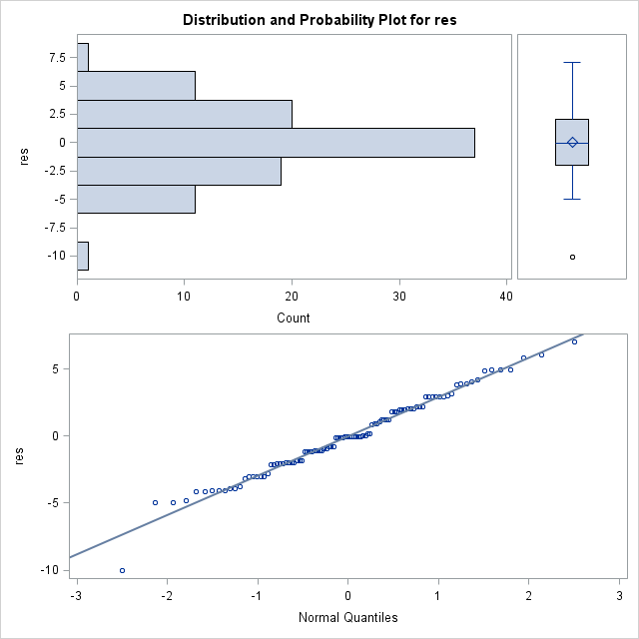

|  |
| --- |
| The SAS System |

Variance Components Estimation Procedure

| **Class Level Information** | | |
| --- | --- | --- |
| **Class** | **Levels** | **Values** |
| **population** | 5 | 1 2 3 4 5 |

|  |  |
| --- | --- |
| **Number of Observations Read** | 100 |
| **Number of Observations Used** | 100 |

|  |  |
| --- | --- |
| **Dependent Variable:** | length |

| **Type 1 Analysis of Variance** | | | | |
| --- | --- | --- | --- | --- |
| **Source** | **DF** | **Sum of Squares** | **Mean Square** | **Expected Mean Square** |
| **population** | 4 | 4555.400000 | 1138.850000 | Var(Error) + 20 Var(population) |
| **Error** | 95 | 854.600000 | 8.995789 | Var(Error) |
| **Corrected Total** | 99 | 5410.000000 |  |  |

| **Type 1 Estimates** | | | |
| --- | --- | --- | --- |
| **Variance Component** | **Estimate** | **95% Confidence Limits** | |
| **Var(population)** | 56.49271 | 19.98285 | 469.73233 |
| **Var(Error)** | 8.99579 | 6.89984 | 12.22169 |