|  |
| --- |
| The SAS System |

The GLM Procedure

| **Class Level Information** | | |
| --- | --- | --- |
| **Class** | **Levels** | **Values** |
| **Fruit** | 2 | NotRemoved Removed |
| **SoilTrt** | 3 | Control Legume Nitrogen |

|  |  |
| --- | --- |
| **Number of Observations Read** | 64 |
| **Number of Observations Used** | 64 |

|  |
| --- |
| The SAS System |

The GLM Procedure

Dependent Variable: Flowers Flowers

| **Source** | **DF** | **Sum of Squares** | **Mean Square** | **F Value** | **Pr > F** |
| --- | --- | --- | --- | --- | --- |
| **Model** | 5 | 1689.151042 | 337.830208 | 29.10 | <.0001 |
| **Error** | 58 | 673.333333 | 11.609195 |  |  |
| **Corrected Total** | 63 | 2362.484375 |  |  |  |

| **R-Square** | **Coeff Var** | **Root MSE** | **Flowers Mean** |
| --- | --- | --- | --- |
| 0.714989 | 6.586002 | 3.407227 | 51.73438 |

| **Source** | **DF** | **Type III SS** | **Mean Square** | **F Value** | **Pr > F** |
| --- | --- | --- | --- | --- | --- |
| **Fruit** | 1 | 106.714976 | 106.714976 | 9.19 | 0.0036 |
| **SoilTrt** | 2 | 1323.840534 | 661.920267 | 57.02 | <.0001 |
| **Fruit*SoilTrt** | 2 | 167.483058 | 83.741529 | 7.21 | 0.0016 |

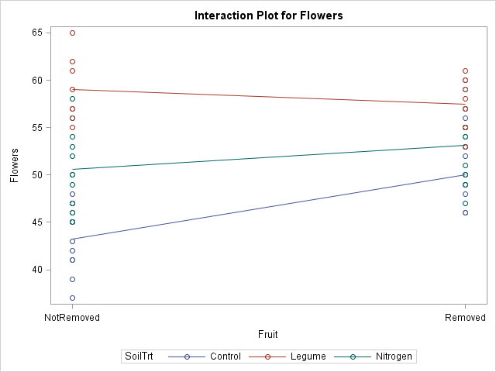

|  |
| --- |
| The SAS System |

The GLM Procedure

Least Squares Means

Adjustment for Multiple Comparisons: Tukey-Kramer

| **Fruit** | **Flowers LSMEAN** | **Standard Error** | **H0:LSMEAN=0** | **H0:LSMean1=LSMean2** |
| --- | --- | --- | --- | --- |
| **Pr > |t|** | **Pr > |t|** |
| **NotRemoved** | 50.9444444 | 0.6133710 | <.0001 | 0.0036 |
| **Removed** | 53.5555556 | 0.6045450 | <.0001 |  |

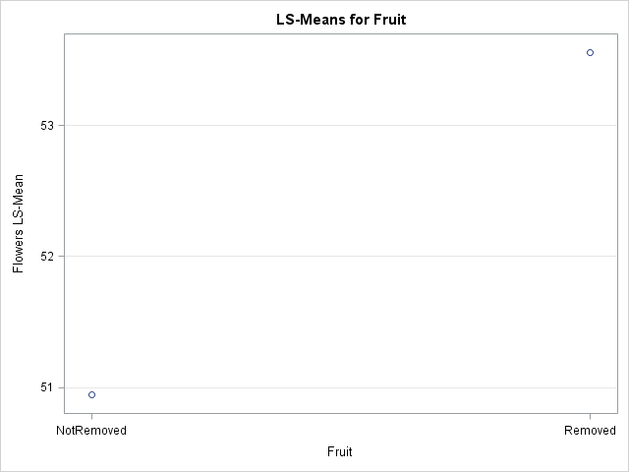

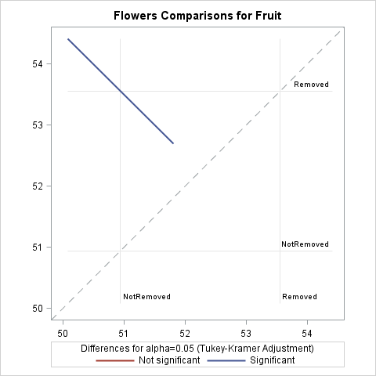

|  |
| --- |
| The SAS System |

The GLM Procedure

Least Squares Means

Adjustment for Multiple Comparisons: Tukey-Kramer

| **SoilTrt** | **Flowers LSMEAN** | **Standard Error** | **Pr > |t|** | **LSMEAN Number** |
| --- | --- | --- | --- | --- |
| **Control** | 46.6250000 | 0.7294437 | <.0001 | 1 |
| **Legume** | 58.2500000 | 0.8080948 | <.0001 | 2 |
| **Nitrogen** | 51.8750000 | 0.6954973 | <.0001 | 3 |

| **Least Squares Means for effect SoilTrt Pr > |t| for H0: LSMean(i)=LSMean(j) Dependent Variable: Flowers** | | | |
| --- | --- | --- | --- |
| **i/j** | **1** | **2** | **3** |
| **1** |  | <.0001 | <.0001 |
| **2** | <.0001 |  | <.0001 |
| **3** | <.0001 | <.0001 |  |

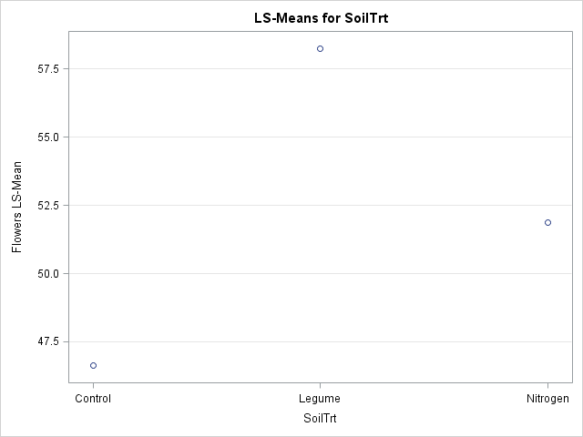

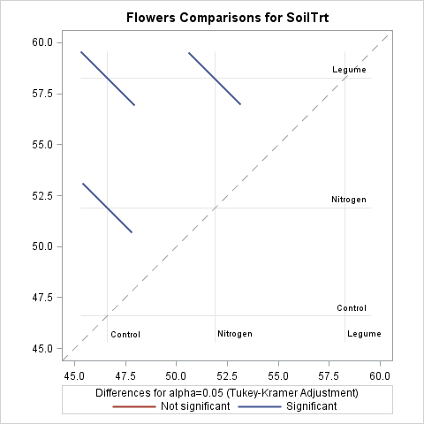

|  |
| --- |
| The SAS System |

The GLM Procedure

Least Squares Means

Adjustment for Multiple Comparisons: Tukey-Kramer

| **Fruit** | **SoilTrt** | **Flowers LSMEAN** | **Standard Error** | **Pr > |t|** | **LSMEAN Number** |
| --- | --- | --- | --- | --- | --- |
| **NotRemoved** | **Control** | 43.2500000 | 0.9835817 | <.0001 | 1 |
| **NotRemoved** | **Legume** | 59.0000000 | 1.2046366 | <.0001 | 2 |
| **NotRemoved** | **Nitrogen** | 50.5833333 | 0.9835817 | <.0001 | 3 |
| **Removed** | **Control** | 50.0000000 | 1.0774598 | <.0001 | 4 |
| **Removed** | **Legume** | 57.5000000 | 1.0774598 | <.0001 | 5 |
| **Removed** | **Nitrogen** | 53.1666667 | 0.9835817 | <.0001 | 6 |

| **Least Squares Means for effect Fruit*SoilTrt Pr > |t| for H0: LSMean(i)=LSMean(j) Dependent Variable: Flowers** | | | | | | |
| --- | --- | --- | --- | --- | --- | --- |
| **i/j** | **1** | **2** | **3** | **4** | **5** | **6** |
| **1** |  | <.0001 | <.0001 | 0.0003 | <.0001 | <.0001 |
| **2** | <.0001 |  | <.0001 | <.0001 | 0.9376 | 0.0052 |
| **3** | <.0001 | <.0001 |  | 0.9986 | 0.0002 | 0.4384 |
| **4** | 0.0003 | <.0001 | 0.9986 |  | 0.0001 | 0.2672 |
| **5** | <.0001 | 0.9376 | 0.0002 | 0.0001 |  | 0.0472 |
| **6** | <.0001 | 0.0052 | 0.4384 | 0.2672 | 0.0472 |  |

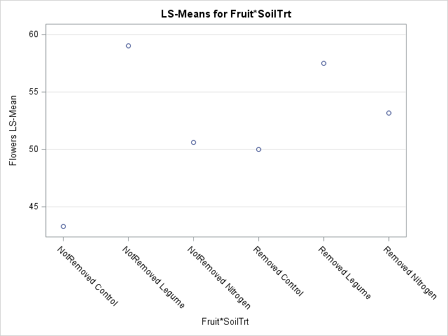

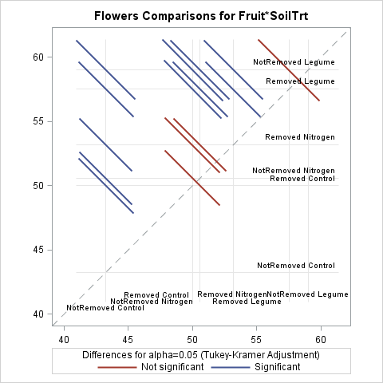

|  |
| --- |
| The SAS System |

The GLM Procedure

Least Squares Means

| **Fruit** | **SoilTrt** | **Flowers LSMEAN** | **Standard Error** | **Pr > |t|** | **LSMEAN Number** |
| --- | --- | --- | --- | --- | --- |
| **NotRemoved** | **Control** | 43.2500000 | 0.9835817 | <.0001 | 1 |
| **NotRemoved** | **Legume** | 59.0000000 | 1.2046366 | <.0001 | 2 |
| **NotRemoved** | **Nitrogen** | 50.5833333 | 0.9835817 | <.0001 | 3 |
| **Removed** | **Control** | 50.0000000 | 1.0774598 | <.0001 | 4 |
| **Removed** | **Legume** | 57.5000000 | 1.0774598 | <.0001 | 5 |
| **Removed** | **Nitrogen** | 53.1666667 | 0.9835817 | <.0001 | 6 |

| **Least Squares Means for effect Fruit*SoilTrt Pr > |t| for H0: LSMean(i)=LSMean(j) Dependent Variable: Flowers** | | | | | | |
| --- | --- | --- | --- | --- | --- | --- |
| **i/j** | **1** | **2** | **3** | **4** | **5** | **6** |
| **1** |  | <.0001 | <.0001 | <.0001 | <.0001 | <.0001 |
| **2** | <.0001 |  | <.0001 | <.0001 | 0.3572 | 0.0004 |
| **3** | <.0001 | <.0001 |  | 0.6907 | <.0001 | 0.0684 |
| **4** | <.0001 | <.0001 | 0.6907 |  | <.0001 | 0.0341 |
| **5** | <.0001 | 0.3572 | <.0001 | <.0001 |  | 0.0043 |
| **6** | <.0001 | 0.0004 | 0.0684 | 0.0341 | 0.0043 |  |



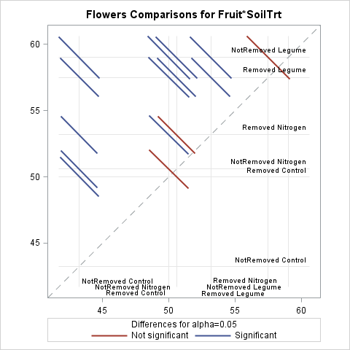

|  |  |
| --- | --- |
| Note: | To ensure overall protection level, only probabilities associated with pre-planned comparisons should be used. |

|  |
| --- |
| The SAS System |

The GLM Procedure

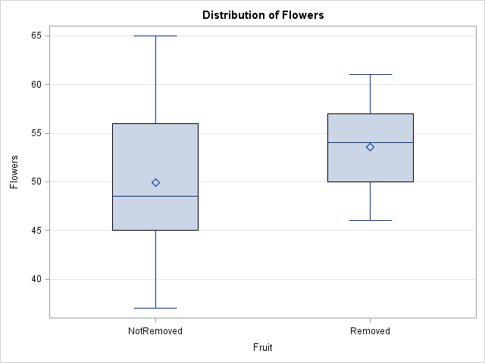

| **Level of Fruit** | **N** | **Flowers** | |
| --- | --- | --- | --- |
| **Mean** | **Std Dev** |
| **NotRemoved** | **32** | 49.9375000 | 7.15693888 |
| **Removed** | **32** | 53.5312500 | 4.28037061 |

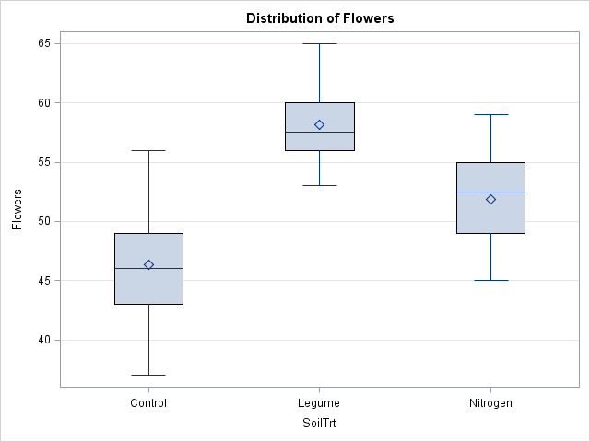

| **Level of SoilTrt** | **N** | **Flowers** | |
| --- | --- | --- | --- |
| **Mean** | **Std Dev** |
| **Control** | **22** | 46.3181818 | 4.70446964 |
| **Legume** | **18** | 58.1666667 | 2.99509403 |
| **Nitrogen** | **24** | 51.8750000 | 3.92663702 |

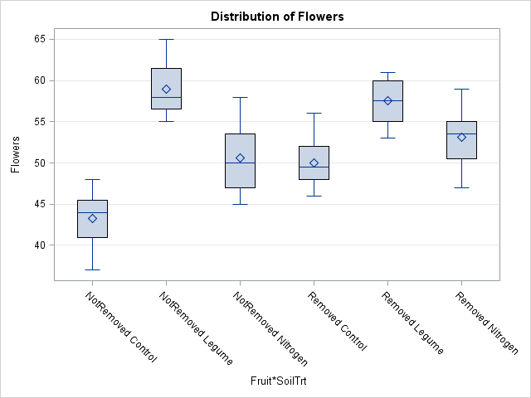

| **Level of Fruit** | **Level of SoilTrt** | **N** | **Flowers** | |
| --- | --- | --- | --- | --- |
| **Mean** | **Std Dev** |
| **NotRemoved** | **Control** | **12** | 43.2500000 | 3.33371210 |
| **NotRemoved** | **Legume** | **8** | 59.0000000 | 3.42261387 |
| **NotRemoved** | **Nitrogen** | **12** | 50.5833333 | 4.10007391 |
| **Removed** | **Control** | **10** | 50.0000000 | 3.23178657 |
| **Removed** | **Legume** | **10** | 57.5000000 | 2.59272486 |
| **Removed** | **Nitrogen** | **12** | 53.1666667 | 3.43334804 |

|  |
| --- |
| The SAS System |

The GLM Procedure

| **Class Level Information** | | |
| --- | --- | --- |
| **Class** | **Levels** | **Values** |
| **group** | 6 | 1 2 3 4 5 6 |

|  |  |
| --- | --- |
| **Number of Observations Read** | 64 |
| **Number of Observations Used** | 64 |

|  |
| --- |
| The SAS System |

The GLM Procedure

Dependent Variable: Flowers Flowers

| **Source** | **DF** | **Sum of Squares** | **Mean Square** | **F Value** | **Pr > F** |
| --- | --- | --- | --- | --- | --- |
| **Model** | 5 | 1689.151042 | 337.830208 | 29.10 | <.0001 |
| **Error** | 58 | 673.333333 | 11.609195 |  |  |
| **Corrected Total** | 63 | 2362.484375 |  |  |  |

| **R-Square** | **Coeff Var** | **Root MSE** | **Flowers Mean** |
| --- | --- | --- | --- |
| 0.714989 | 6.586002 | 3.407227 | 51.73438 |

| **Source** | **DF** | **Type III SS** | **Mean Square** | **F Value** | **Pr > F** |
| --- | --- | --- | --- | --- | --- |
| **group** | 5 | 1689.151042 | 337.830208 | 29.10 | <.0001 |

| **Contrast** | **DF** | **Contrast SS** | **Mean Square** | **F Value** | **Pr > F** |
| --- | --- | --- | --- | --- | --- |
| **fruit** | 1 | 106.714976 | 106.714976 | 9.19 | 0.0036 |
| **soil** | 2 | 1323.840534 | 661.920267 | 57.02 | <.0001 |
| **fruit x soil** | 2 | 167.483058 | 83.741529 | 7.21 | 0.0016 |

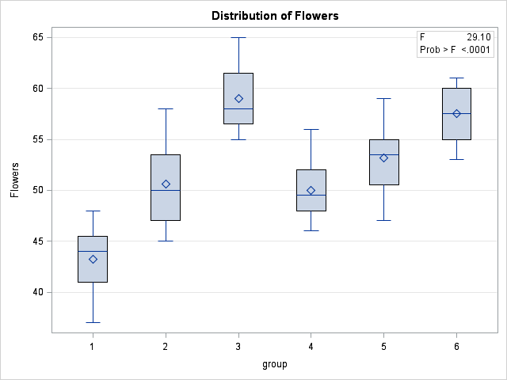

|  |
| --- |
| The SAS System |

The GLM Procedure

| **Class Level Information** | | |
| --- | --- | --- |
| **Class** | **Levels** | **Values** |
| **group** | 6 | 1 2 3 4 5 6 |

|  |  |
| --- | --- |
| **Number of Observations Read** | 64 |
| **Number of Observations Used** | 64 |

|  |
| --- |
| The SAS System |

The GLM Procedure

Dependent Variable: Flowers Flowers

| **Source** | **DF** | **Sum of Squares** | **Mean Square** | **F Value** | **Pr > F** |
| --- | --- | --- | --- | --- | --- |
| **Model** | 5 | 1689.151042 | 337.830208 | 29.10 | <.0001 |
| **Error** | 58 | 673.333333 | 11.609195 |  |  |
| **Corrected Total** | 63 | 2362.484375 |  |  |  |

| **R-Square** | **Coeff Var** | **Root MSE** | **Flowers Mean** |
| --- | --- | --- | --- |
| 0.714989 | 6.586002 | 3.407227 | 51.73438 |

| **Source** | **DF** | **Type III SS** | **Mean Square** | **F Value** | **Pr > F** |
| --- | --- | --- | --- | --- | --- |
| **group** | 5 | 1689.151042 | 337.830208 | 29.10 | <.0001 |

| **Contrast** | **DF** | **Contrast SS** | **Mean Square** | **F Value** | **Pr > F** |
| --- | --- | --- | --- | --- | --- |
| **fruit in control** | 1 | 248.5227273 | 248.5227273 | 21.41 | <.0001 |
| **fruit in nitrogen** | 1 | 40.0416667 | 40.0416667 | 3.45 | 0.0684 |
| **fruit in legume** | 1 | 10.0000000 | 10.0000000 | 0.86 | 0.3572 |
| **control vs any N in fruit** | 1 | 983.7051282 | 983.7051282 | 84.73 | <.0001 |
| **control vs any N in nofruit** | 1 | 195.0476190 | 195.0476190 | 16.80 | 0.0001 |
| **nitrogen vs legume in fruit** | 1 | 340.0333333 | 340.0333333 | 29.29 | <.0001 |
| **nitrogen vs legume in nofruit** | 1 | 102.4242424 | 102.4242424 | 8.82 | 0.0043 |

| **Parameter** | **Estimate** | **Standard Error** | **t Value** | **Pr > |t|** |
| --- | --- | --- | --- | --- |
| **difference R vs N, between C & N** | -4.16666667 | 2.01574264 | -2.07 | 0.0432 |

