Table 1.0, ANOVA (SAS OUTPUT)

|  |  |  |  |  |  |
| --- | --- | --- | --- | --- | --- |
| **Source** | **DF** | **Sum of Squares** | **Mean Squares** | **F Value** | **Pr > F** |
| **Model** | 5 | 1689.151042 | 337.830208 | 29.10 | <.0001 |
| **Error** | 58 | 673.333333 | 11.609195 |  |  |
| **Corrected Total** | 63 | 2362.484375 |  |  |  |

**Table 1.0** shows result from analysis of variance of experiment ran in SAS. The purpose of the study is to test for the effects of growing conditions and fruit removal production of flowers by morning glory vines. By default, certain assumptions for simplicity that is assuming without testing that data meet assumptions of ANOVA. This deter us from using residual/errors to performing any analysis for our study. ANOVA is based on F-distribution and the F test statistics value is 29.10 with a P-value of 0. 0001.Since the P-value is less than 0.05, we reject the null hypothesis and conclude that there is enough evidence to support the null hypothesis. The experiment is as follows; H0: There is no difference between the soil treatment groups, therefore null hypothesis is equal to zero, HA: There is a difference between the soil treatment groups, therefore alternative do not equal zero. **Table1.1** results the interaction (fruit*soiltreatment) has a significant effect (p-value<0.0001). When interactions are present, the main effects of the independent variables do not have their usual interpretations. It is now difficult to state the independent effect of fruit because the nature and magnitude of the effect depends on the particular level of soil treatment. Since there is evidence of interaction effect, we can proceed to testing the main effect of the independent variables.

Table 1.1, Type III Sum of Squares (SAS OUTPUT)

|  |  |  |  |  |  |
| --- | --- | --- | --- | --- | --- |
| **Source** | **DF** | **Type III SS** | **Mean Square** | **F Value** | **Pr > F** |
| **fruit** | 1 | 106.714976 | 106.714976 | 9.19 | 0.0036 |
| **soiltreatment** | 2 | 1323.840534 | 661.920267 | 57.02 | <.0001 |
| **fruit*soiltreatment** | 2 | 167.483058 | 83.741529 | 7.21 | 0.0016 |

**Table 1.2** seems the best measure for error respect to different types of errors available. One thing we asked and analyzed before making a choice is what does other types of sum of squares error reveal. Another is whether our sample sizes are unequal (unbalanced design), in our particular case Type III sum of squares is probably superior. Type I sum of squares are sequential, in that for each effect is adjusted for previous effect. We chose Type III because treats every effect as if it were last (that is, all effects are adjusted for all others).

Figure 1.0, Graphical representation of Interaction plot for flowers (SAS OUPUT)

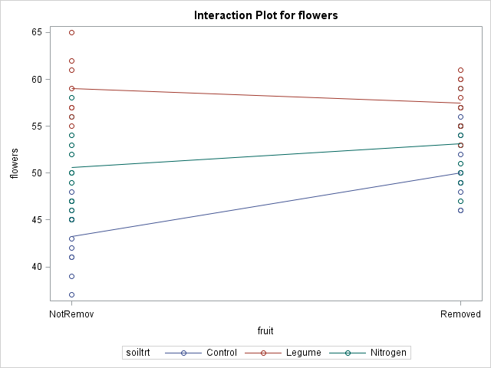

**Figure 1.0**, the lines on the interaction graph are not parallel. We notice an early departure from each other, which eventually looks like it, will converge at some point. The soil treatment plot is non-parallel meaning there is no interaction.

Table 2.0, Summary statistics for level of fruit and soil treatment

|  |  |  |  |  |
| --- | --- | --- | --- | --- |
| **Level of fruit** | **Level of soiltrt** | **N** | **Flowers** | **Flowers** |
|  |  |  | **Mean** | **Std Dev** |
| NotRemoved | Control | 12 | 43.2500000 | 3.33371210 |
| NotRemoved | Legume | 8 | 59.0000000 | 3.42261387 |
| NotRemoved | Nitrogen | 12 | 50.5833333 | 4.10007391 |
| Removed | Control | 10 | 50.0000000 | 3.23178657 |
| Removed | Legume | 10 | 57.5000000 | 2.59272486 |
| Removed | Nitrogen | 12 | 53.1666667 | 3.43334804 |

Figure 2.0, Graphical representation standard errors

According to the biological hypothesis described earlier, **Table 2.0** shows sample size(N), mean and standard deviation for level of fruit and soil treatment. Not Removed Legume had smallest sample size which records the highest number of mean 59.00 with a standard deviation comparatively lower too. Figure2.0 displays graphically the means and standard errors of these analysis as to which variables react to certain changes when the means fluctuates.

**Table 3.0,3.1** depicts the various pairwise comparison, contrast and the hypothesis of interest with respect to our study and findings. Data set in these table below was derived from our output in SAS. Note that, combined soil treatment was a merger of soil treatment which enable to deduce our comparison intuitively namely; **Not Removed(NR**), **Removed(R),** **Control(C**), **Legume(L**), **Nitrogen(N**). We adapted the Bonferroni correction (alpha/2) to aid in this process.

There are three biological area of interest we like to tailor our comparison namely:

1. Resources invested in maturing can’t be invested in producing more flower, hence removal of fruit prior to maturation
2. Flower production is Nitrogen limited and addition of nitrogen increase its production
3. The effects of fruit removal may depend on Nitrogen is available

Table 3.0, Biological hypothesis of interest (a)

|  |  |  |  |
| --- | --- | --- | --- |
| Combined soil treatment | P-value | Critical value | Conclusion |
| NRC Vs RC | <.0001 | 0.05 | Significant |
| NRL Vs RL | 0.3572 | 0.05/2 = 0.025 | Not significant |
| NRN Vs RN | 0.0684 | 0.05/3 = 0.0166667 | Not significant |

From **Table 3.0**, comparing the variables in the combined soil treatment column we can see there are more flower production if there is reasonable amount of nitrogen and legume, hence removal of fruits before it matured would have significant effect and interaction on flower production. Its seems there is more to it than main effect in fact there is a need for later investigation.

Table 3.1, Biological hypothesis of interest (b)

|  |  |  |  |
| --- | --- | --- | --- |
| Contrast | P-value | Critical value | Conclusion |
| Fruit in N | 0.0684 | 0.05 | Not Significant |
| Fruit in L | 0.3572 | 0.05 | Not Significant |
| N vs L in fruit | <.0001 | 0.05 | Significant |
| N vs L in nofruit | 0.0043 | 0.05 | Significant |

Using the contrast method in **Table 3.1**, holding fruit removed or fruit not removed constant we make critical inference that, addition of nitrogen naturally or artificially will increase flower production. Looking at combined soil treatment(contrast) column we made several pairwise contrasting using **Table 2.0** by checking differences in the mean. Upon analysis and the biological hypothesis at hand, N vs L in fruit has the most feasible contrast in our model because though Nitrogen(N) and Legume(L) is needed for fruit production, the means derived in **Table 2.0** has reasonable amount of difference hence giving significant difference.

Table 3.2, Biological hypothesis of interest (c)

|  |  |  |  |
| --- | --- | --- | --- |
| Parameter | t-value | Critical value | Conclusion |
| difference R vs NR, between C & N | -2.07 | 0.05 | significance |

Formula 1.0

(RC/2 + NRC/2) Vs (RN/2 + NRN/2) – (RL/2 + NRL/2)

we have statistically proven the significance of our hypothesis design earlier in our overall ANOVA result above in **Table1.0, 1.1**. It shows the availability of soilteatment (nitrogen) may have an adverse effect of removing fruits. Using estimate to derive our difference in soil treatment the appropriate contrast is to find the difference in Removed(R) vs NotRemoved(NR) between Control(c) and Nitrogen(N) because first of all, referring back to Table 3.2, the t value is -2.07 which clearly depict show a significant conclusion for hypothesis. Secondly, by averaging the means and finding the differences using **Formula 1.0** it tells us statistically whether fruit removal is dependent on Nitrogen(N) because it spits out significant figure which makes the biological investigation hypothesis model in **Table 3.2** more feasible.