|  |
| --- |
| ALL FACTORS RANDOM |

The GLM Procedure

| **Class Level Information** | | |
| --- | --- | --- |
| **Class** | **Levels** | **Values** |
| **sample** | 4 | 1 2 3 4 |
| **site** | 3 | Rural industrial suburban |

|  |  |
| --- | --- |
| **Number of Observations Read** | 60 |
| **Number of Observations Used** | 60 |

|  |
| --- |
| ALL FACTORS RANDOM |

The GLM Procedure

Dependent Variable: phosphorous phosphorous

| **Source** | **DF** | **Sum of Squares** | **Mean Square** | **F Value** | **Pr > F** |
| --- | --- | --- | --- | --- | --- |
| **Model** | 11 | 6.95200000 | 0.63200000 | 21.24 | <.0001 |
| **Error** | 48 | 1.42800000 | 0.02975000 |  |  |
| **Corrected Total** | 59 | 8.38000000 |  |  |  |

| **R-Square** | **Coeff Var** | **Root MSE** | **phosphorous Mean** |
| --- | --- | --- | --- |
| 0.829594 | 11.49879 | 0.172482 | 1.500000 |

| **Source** | **DF** | **Type III SS** | **Mean Square** | **F Value** | **Pr > F** |
| --- | --- | --- | --- | --- | --- |
| **site** | 2 | 6.18100000 | 3.09050000 | 103.88 | <.0001 |
| **sample(site)** | 9 | 0.77100000 | 0.08566667 | 2.88 | 0.0084 |

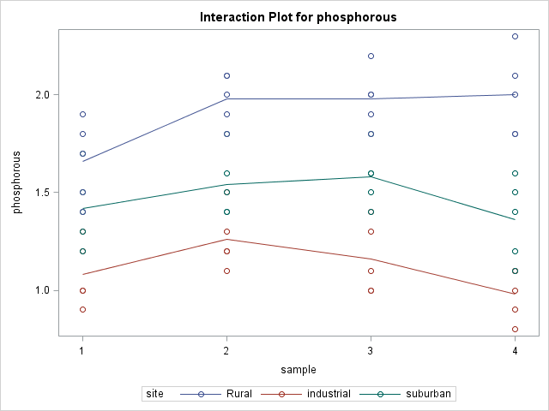

|  |
| --- |
| ALL FACTORS RANDOM |

The GLM Procedure

| **Source** | **Type III Expected Mean Square** |
| --- | --- |
| **site** | Var(Error) + 5 Var(sample(site)) + 20 Var(site) |
| **sample(site)** | Var(Error) + 5 Var(sample(site)) |

|  |
| --- |
| ALL FACTORS RANDOM |

The GLM Procedure

Tests of Hypotheses for Random Model Analysis of Variance

Dependent Variable: phosphorous phosphorous

| **Source** | **DF** | **Type III SS** | **Mean Square** | **F Value** | **Pr > F** |
| --- | --- | --- | --- | --- | --- |
| **site** | 2 | 6.181000 | 3.090500 | 36.08 | <.0001 |
| **Error** | 9 | 0.771000 | 0.085667 |  |  |
| **Error: MS(sample(site))** | | | | | |

| **Source** | **DF** | **Type III SS** | **Mean Square** | **F Value** | **Pr > F** |
| --- | --- | --- | --- | --- | --- |
| **sample(site)** | 9 | 0.771000 | 0.085667 | 2.88 | 0.0084 |
| **Error: MS(Error)** | 48 | 1.428000 | 0.029750 |  |  |

|  |
| --- |
| ALL FACTORS RANDOM |

Variance Components Estimation Procedure

| **Class Level Information** | | |
| --- | --- | --- |
| **Class** | **Levels** | **Values** |
| **site** | 3 | Rural industrial suburban |
| **sample** | 4 | 1 2 3 4 |

|  |  |
| --- | --- |
| **Number of Observations Read** | 60 |
| **Number of Observations Used** | 60 |

|  |  |
| --- | --- |
| **Dependent Variable:** | phosphorous |

| **REML Iterations** | | | | |
| --- | --- | --- | --- | --- |
| **Iteration** | **Objective** | **Var(site)** | **Var(sample(site))** | **Var(Error)** |
| **0** | -188.5754126201 | 0.1502416667 | 0.0111833333 | 0.0297500000 |
| **1** | -188.5754126201 | 0.1502416667 | 0.0111833333 | 0.0297500000 |

|  |
| --- |
| Convergence criteria met. |

| **REML Estimates** | |
| --- | --- |
| **Variance Component** | **Estimate** |
| **Var(site)** | 0.15024 |
| **Var(sample(site))** | 0.01118 |
| **Var(Error)** | 0.02975 |

| **Asymptotic Covariance Matrix of Estimates** | | | |
| --- | --- | --- | --- |
|  | **Var(site)** | **Var(sample(site))** | **Var(Error)** |
| **Var(site)** | 0.02388 | -0.0000163 | -2.107E-19 |
| **Var(sample(site))** | -0.0000163 | 0.00006671 | -7.3755E-6 |
| **Var(Error)** | -2.107E-19 | -7.3755E-6 | 0.00003688 |

|  |
| --- |
| ALL FACTORS RANDOM |

The Mixed Procedure

| **Model Information** | |
| --- | --- |
| **Data Set** | WORK.SITE |
| **Dependent Variable** | phosphorous |
| **Covariance Structure** | Variance Components |
| **Estimation Method** | REML |
| **Residual Variance Method** | Profile |
| **Fixed Effects SE Method** | Model-Based |
| **Degrees of Freedom Method** | Containment |

| **Class Level Information** | | |
| --- | --- | --- |
| **Class** | **Levels** | **Values** |
| **site** | 3 | Rural industrial suburban |
| **sample** | 4 | 1 2 3 4 |

| **Dimensions** | |
| --- | --- |
| **Covariance Parameters** | 3 |
| **Columns in X** | 1 |
| **Columns in Z** | 15 |
| **Subjects** | 1 |
| **Max Obs per Subject** | 60 |

| **Number of Observations** | |
| --- | --- |
| **Number of Observations Read** | 60 |
| **Number of Observations Used** | 60 |
| **Number of Observations Not Used** | 0 |

| **Iteration History** | | | |
| --- | --- | --- | --- |
| **Iteration** | **Evaluations** | **-2 Res Log Like** | **Criterion** |
| **0** | 1 | 56.37940925 |  |
| **1** | 1 | -17.04632114 | 0.00000000 |

|  |
| --- |
| Convergence criteria met. |

| **Covariance Parameter Estimates** | | | | |
| --- | --- | --- | --- | --- |
| **Cov Parm** | **Estimate** | **Standard Error** | **Z Value** | **Pr > Z** |
| **site** | 0.1502 | 0.1545 | 0.97 | 0.1655 |
| **sample(site)** | 0.01118 | 0.008168 | 1.37 | 0.0855 |
| **Residual** | 0.02975 | 0.006073 | 4.90 | <.0001 |

| **Fit Statistics** | |
| --- | --- |
| **-2 Res Log Likelihood** | -17.0 |
| **AIC (Smaller is Better)** | -11.0 |
| **AICC (Smaller is Better)** | -10.6 |
| **BIC (Smaller is Better)** | -13.8 |

|  |
| --- |
| ALL FACTORS RANDOM |

The NESTED Procedure

| **Coefficients of Expected Mean Squares** | | | |
| --- | --- | --- | --- |
| **Source** | **site** | **sample** | **Error** |
| **site** | 20 | 5 | 1 |
| **sample** | 0 | 5 | 1 |
| **Error** | 0 | 0 | 1 |

| **Nested Random Effects Analysis of Variance for Variable phosphorous** | | | | | | | | |
| --- | --- | --- | --- | --- | --- | --- | --- | --- |
| **Variance Source** | **DF** | **Sum of Squares** | **F Value** | **Pr > F** | **Error Term** | **Mean Square** | **Variance Component** | **Percent of Total** |
| **Total** | 59 | 8.380000 |  |  |  | 0.142034 | 0.191175 | 100.0000 |
| **site** | 2 | 6.181000 | 36.08 | <.0001 | sample | 3.090500 | 0.150242 | 78.5886 |
| **sample** | 9 | 0.771000 | 2.88 | 0.0084 | Error | 0.085667 | 0.011183 | 5.8498 |
| **Error** | 48 | 1.428000 |  |  |  | 0.029750 | 0.029750 | 15.5617 |

|  |  |
| --- | --- |
| **phosphorous Mean** | 1.50000000 |
| **Standard Error of phosphorous Mean** | 0.22695447 |

|  |
| --- |
| SITE FIXED |

The GLM Procedure

| **Class Level Information** | | |
| --- | --- | --- |
| **Class** | **Levels** | **Values** |
| **sample** | 4 | 1 2 3 4 |
| **site** | 3 | Rural industrial suburban |

|  |  |
| --- | --- |
| **Number of Observations Read** | 60 |
| **Number of Observations Used** | 60 |

|  |
| --- |
| SITE FIXED |

The GLM Procedure

Dependent Variable: phosphorous phosphorous

| **Source** | **DF** | **Sum of Squares** | **Mean Square** | **F Value** | **Pr > F** |
| --- | --- | --- | --- | --- | --- |
| **Model** | 11 | 6.95200000 | 0.63200000 | 21.24 | <.0001 |
| **Error** | 48 | 1.42800000 | 0.02975000 |  |  |
| **Corrected Total** | 59 | 8.38000000 |  |  |  |

| **R-Square** | **Coeff Var** | **Root MSE** | **phosphorous Mean** |
| --- | --- | --- | --- |
| 0.829594 | 11.49879 | 0.172482 | 1.500000 |

| **Source** | **DF** | **Type III SS** | **Mean Square** | **F Value** | **Pr > F** |
| --- | --- | --- | --- | --- | --- |
| **site** | 2 | 6.18100000 | 3.09050000 | 103.88 | <.0001 |
| **sample(site)** | 9 | 0.77100000 | 0.08566667 | 2.88 | 0.0084 |



|  |
| --- |
| SITE FIXED |

The GLM Procedure

| **Source** | **Type III Expected Mean Square** |
| --- | --- |
| **site** | Var(Error) + 5 Var(sample(site)) + Q(site) |
| **sample(site)** | Var(Error) + 5 Var(sample(site)) |

|  |
| --- |
| SITE FIXED |

The GLM Procedure

Tests of Hypotheses for Mixed Model Analysis of Variance

Dependent Variable: phosphorous phosphorous

| **Source** | **DF** | **Type III SS** | **Mean Square** | **F Value** | **Pr > F** |
| --- | --- | --- | --- | --- | --- |
| **site** | 2 | 6.181000 | 3.090500 | 36.08 | <.0001 |
| **Error** | 9 | 0.771000 | 0.085667 |  |  |
| **Error: MS(sample(site))** | | | | | |

| **Source** | **DF** | **Type III SS** | **Mean Square** | **F Value** | **Pr > F** |
| --- | --- | --- | --- | --- | --- |
| **sample(site)** | 9 | 0.771000 | 0.085667 | 2.88 | 0.0084 |
| **Error: MS(Error)** | 48 | 1.428000 | 0.029750 |  |  |

|  |
| --- |
| SITE FIXED |

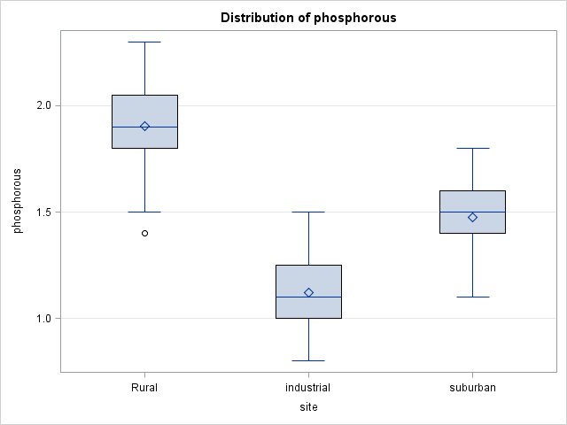

|  |
| --- |
| SITE FIXED |

Ryan-Einot-Gabriel-Welsch Multiple Range Test for phosphorous

|  |  |
| --- | --- |
| Note: | This test controls the Type I experimentwise error rate. |

|  |  |
| --- | --- |
| **Alpha** | 0.05 |
| **Error Degrees of Freedom** | 9 |
| **Error Mean Square** | 0.085667 |

| **Number of Means** | **2** | **3** |
| --- | --- | --- |
| **Critical Range** | 0.2093756 | 0.2584118 |

| **Means with the same letter are not significantly different.** | | | |
| --- | --- | --- | --- |
| **REGWQ Grouping** | **Mean** | **N** | **site** |
| A | 1.90500 | 20 | Rural |
|  |  |  |  |
| B | 1.47500 | 20 | suburban |
|  |  |  |  |
| C | 1.12000 | 20 | industrial |

|  |
| --- |
| SITE FIXED |

Variance Components Estimation Procedure

| **Class Level Information** | | |
| --- | --- | --- |
| **Class** | **Levels** | **Values** |
| **site** | 3 | Rural industrial suburban |
| **sample** | 4 | 1 2 3 4 |

|  |  |
| --- | --- |
| **Number of Observations Read** | 60 |
| **Number of Observations Used** | 60 |

|  |  |
| --- | --- |
| **Dependent Variable:** | phosphorous |

| **REML Iterations** | | | |
| --- | --- | --- | --- |
| **Iteration** | **Objective** | **Var(sample(site))** | **Var(Error)** |
| **0** | -190.8320784003 | 0.0111833333 | 0.0297500000 |
| **1** | -190.8320784003 | 0.0111833333 | 0.0297500000 |

|  |
| --- |
| Convergence criteria met. |

| **REML Estimates** | |
| --- | --- |
| **Variance Component** | **Estimate** |
| **Var(sample(site))** | 0.01118 |
| **Var(Error)** | 0.02975 |

| **Asymptotic Covariance Matrix of Estimates** | | |
| --- | --- | --- |
|  | **Var(sample(site))** | **Var(Error)** |
| **Var(sample(site))** | 0.00006671 | -7.3755E-6 |
| **Var(Error)** | -7.3755E-6 | 0.00003688 |

|  |
| --- |
| SITE FIXED |

The Mixed Procedure

| **Model Information** | |
| --- | --- |
| **Data Set** | WORK.SITE |
| **Dependent Variable** | phosphorous |
| **Covariance Structure** | Variance Components |
| **Estimation Method** | REML |
| **Residual Variance Method** | Profile |
| **Fixed Effects SE Method** | Model-Based |
| **Degrees of Freedom Method** | Containment |

| **Class Level Information** | | |
| --- | --- | --- |
| **Class** | **Levels** | **Values** |
| **site** | 3 | Rural industrial suburban |
| **sample** | 4 | 1 2 3 4 |

| **Dimensions** | |
| --- | --- |
| **Covariance Parameters** | 2 |
| **Columns in X** | 4 |
| **Columns in Z** | 12 |
| **Subjects** | 1 |
| **Max Obs per Subject** | 60 |

| **Number of Observations** | |
| --- | --- |
| **Number of Observations Read** | 60 |
| **Number of Observations Used** | 60 |
| **Number of Observations Not Used** | 0 |

| **Iteration History** | | | |
| --- | --- | --- | --- |
| **Iteration** | **Evaluations** | **-2 Res Log Like** | **Criterion** |
| **0** | 1 | -14.79157810 |  |
| **1** | 1 | -20.08588879 | 0.00000000 |

|  |
| --- |
| Convergence criteria met. |

| **Covariance Parameter Estimates** | | | | |
| --- | --- | --- | --- | --- |
| **Cov Parm** | **Estimate** | **Standard Error** | **Z Value** | **Pr > Z** |
| **sample(site)** | 0.01118 | 0.008168 | 1.37 | 0.0855 |
| **Residual** | 0.02975 | 0.006073 | 4.90 | <.0001 |

| **Fit Statistics** | |
| --- | --- |
| **-2 Res Log Likelihood** | -20.1 |
| **AIC (Smaller is Better)** | -16.1 |
| **AICC (Smaller is Better)** | -15.9 |
| **BIC (Smaller is Better)** | -15.1 |

| **Type 3 Tests of Fixed Effects** | | | | |
| --- | --- | --- | --- | --- |
| **Effect** | **Num DF** | **Den DF** | **F Value** | **Pr > F** |
| **site** | 2 | 9 | 36.08 | <.0001 |

| **Least Squares Means** | | | | | | |
| --- | --- | --- | --- | --- | --- | --- |
| **Effect** | **site** | **Estimate** | **Standard Error** | **DF** | **t Value** | **Pr > |t|** |
| **site** | **Rural** | 1.9050 | 0.06545 | 9 | 29.11 | <.0001 |
| **site** | **industrial** | 1.1200 | 0.06545 | 9 | 17.11 | <.0001 |
| **site** | **suburban** | 1.4750 | 0.06545 | 9 | 22.54 | <.0001 |

| **Differences of Least Squares Means** | | | | | | | | | |
| --- | --- | --- | --- | --- | --- | --- | --- | --- | --- |
| **Effect** | **site** | **site** | **Estimate** | **Standard Error** | **DF** | **t Value** | **Pr > |t|** | **Adjustment** | **Adj P** |
| **site** | **Rural** | **industrial** | 0.7850 | 0.09256 | 9 | 8.48 | <.0001 | Tukey | <.0001 |
| **site** | **Rural** | **suburban** | 0.4300 | 0.09256 | 9 | 4.65 | 0.0012 | Tukey | 0.0031 |
| **site** | **industrial** | **suburban** | -0.3550 | 0.09256 | 9 | -3.84 | 0.0040 | Tukey | 0.0100 |