|  |  |  |  |
| --- | --- | --- | --- |
| Table name | Primary key(s) | Non-keys | Foreign key(s) |
| Kennel | Kennel_code | Kennel_name, Kennel_locations |  |
| Puppy | Puppy_number | Puppy_name |  |
| Tricks (1-M with Kennel) | Trick_id | Trick_name | Kennel_code (FK1) |
| Skills (M-M between Puppy and Tricks) | Record # | Skill_level | Puppy_number (FK1)  Trick_id (FK2) |

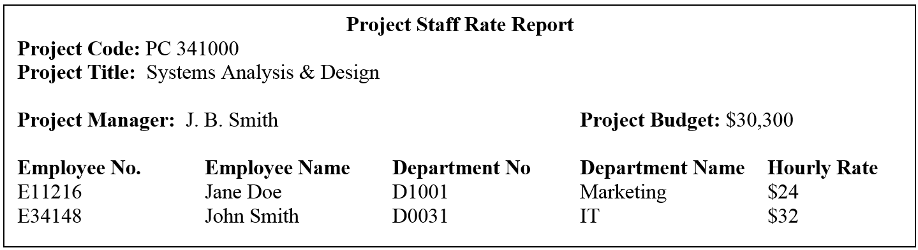

|  |  |  |  |
| --- | --- | --- | --- |
| Table name | Primary key(s) | Non-keys | Foreign key(s) |
| Employee | EmployeeNumber | EmployeeName, HourlyRate | DepartmentNumber (FK) |
| Project | ProjectCode | ProjectTitle, ProjectBudget | EmployeeNumber (FK) |
| Department | DepartmentNumber | DepartmentName |  |
| Employee-project | EmployeeNumber (FK1),  ProjectCode (FK2) | role | The two attributes are composite PK and each is a an FK |