**ATTACHMENT TO REPORT ON ANALYSIS PHASE LEARNING OUTCOMES**

**IT432- SYSTEMS ANALYSIS AND DESIGN**

**1. Domain Model Class Diagram on the AI Experiment “What We Eat”**

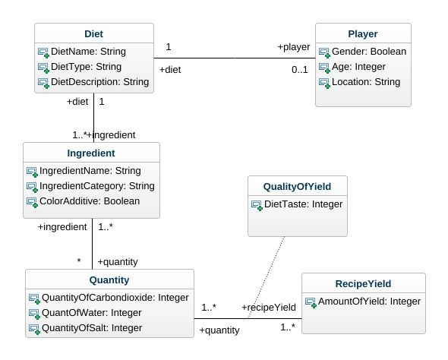

**2. Concept Mapp**

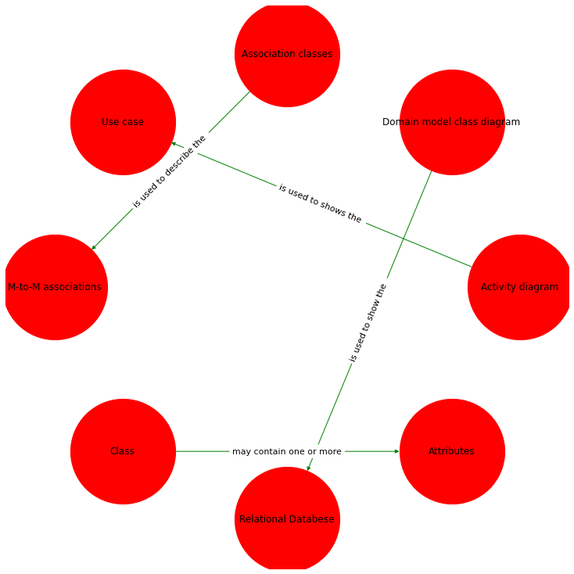

**3. Activity Diagram of Currency Conversion on the Wolfram Alpha System.**

