Lecture 1: Review of Statistical Distributions

# Normal distribution

Assume *Y*1*,..., Yn* are i.i.d. Normal random variables with mean *µ* and variance *σ*2.

That is,

*Yi* ∼ *N*(*µ,σ*2)*, i* = 1*,..., n.*

The probability density function is

*f*(*y*;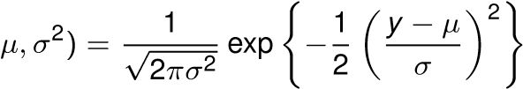

* Sample mean

*n*

*Y*¯ = X *Yi /n* *Y*·*.*

*n*

*i*=1

* Sample variance

*n*

*S*2 = X *Yi* *.*

*i*=1

* Standard normal distribution

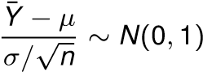*.*

* Unbiased estimates

E(*Y*¯) = *µ,* E(*S*2) = *σ*2*.*

* Multivariate normal distribution: Assume *Yi* ∼ *N* the covariance of *Yi* and *Yj* be

for *i* = 1*,..., n*, and let

cov(*Yi , Yj* ) = *ρij σi σj ,*

where *ρij* is the correlation coefficient for *Yi* and *Yj* . The joiont the joint distribution of the *Yi* ’ s is the multivariate Normal distribution

**y** ∼ MVN(*µ, V*)*,*

where *µ* is the mean vector, and *V* is the variance-covariance matrix.

* Suppose the random variables *Yi* *n* are independent. If

*W* = *a*1*Y*1 + *... anYn,*

where the *ai* ’s are constants, then *W* is also Normally distributed, so that

*W* ∼ *N 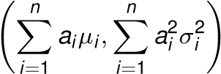.*

* When *V* is positive definite, the density function of **y** is

*f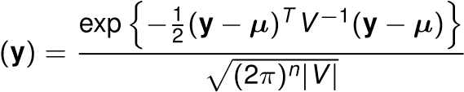.*

* For the bivariate case, we have

*f*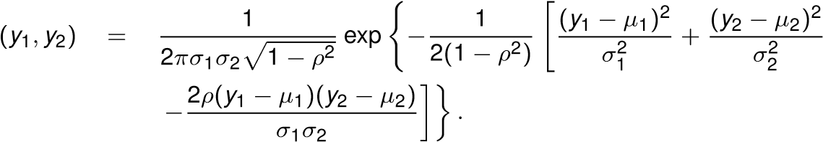

# Chi-squared distribution

* Central *χ*2 distribution

Let *Z*1*,..., Zn* be *n* i.i.d. standard normal random variables. Then, the chi-square random variable is defined as

*.*

It is known that

E*.*

In matrix notation, if

**z** = (*Z*1*,..., Zn*)*T*

then **z***T* **z**.

* Non-central *χ*2(*n,λ*)

Let *Yi* = *Zi* +*µi* , where at least one of the *µi* ’s is non-zero. Then the distribution of



has mean *n* + *λ* and variance 2*n* + 4*λ*, where *λ* = P*µ*2*i* . This is called the

non-central chi-squared distribution with *n* degrees of freedom and non-centrality parameter *λ*.

# Chi-squared distribution

* Assume that ***y*** ∼ MVN(*µ, V*) where the variance-covariance matrix *V* is non-singular and its inverse is *V*−1. Then,

(**y** − *µ*)*T V*−1(**y** − *µ*) ∼ *χ*2(*n*)*.*

* Generally, if ***y*** ∼ MVN(*µ, V*), then

**y***T V*−1**y** ∼ *χ*2(*n,λ*)*,*

where *λ* = *µT V*−1*µ*.

* If *Xi*2 ∼ *χ*2(*ni ,λi* )’s are independent, then

*m*  *m m* !

X *X*2 ∼ *χ*2 X *ni ,*X*λi .*

*i*

*i*=1 *i*=1 *i*=1

This is called the reproductive property of the chi-squared distribution.

Other related distributions

* t distribution

*Z* p*X*2*/n* ∼ *tn,*

where *Z* ∼ *N*(0*,* 1), *X*2 ∼ *χ*(*n*) and *Z* and *X*2 are independent.

* *F* distribution

*χ*2(*m*)*/m*

*F*(*m, n*) = *,*

*χ*2(*n*)*/n*

where *χ*2(*m*) and *χ*2(*n*) are independent. • Non-central *F* distribution

*χ*2(*m,λ*)*/m*

*F*(*m, n,λ*) = *,*

*χ*2(*n*)*/n*

# Estimation methods

* Maximum Likelihood estimator (MLE)

Suppose *Y*1*,..., Yn* are random variables with density function *f*(*y*;*θ*), where *θ* is an unknown parameter. Given independent observations *y*1*,..., yn*, the likelihood function can be expressed as

*n*

*L*(*θ*) = Y *f*(*yi* ;*θ*)*.*

*i*=1

The MLE can be obtained by maximizing *L*(*θ*) or log(*L*(*θ*)). That is,

*θ*ˆ= arg*θ* max *L*(*θ*)*.*

* Least square estimator (LSE)

The sample observations are assumed to be of the form

*Yi* *,*

where *fi* (*θ*) is a known function of the parameter *θ* and the *i* are random variables. The LSE can be obtained by minimizing the following function

*n*

*Q*(*θ*) = X[*Yi* − *fi* (*θ*)]2 *.*

*i*=1

That is, *θ*ˆ= arg*θ* min *Q*(*θ*)*.*