Stepwise MLR Diagnostics – All Vars No Interactions

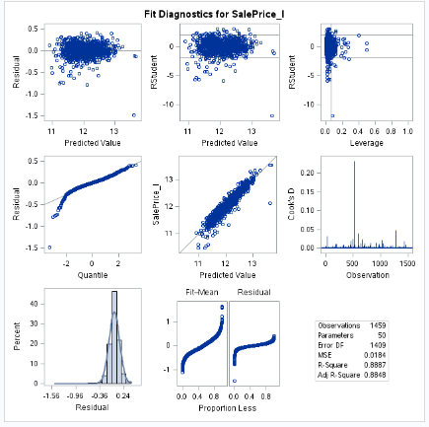

Forward MLR Diagnostics – All Vars No Interactions

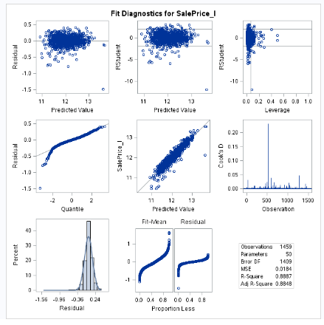

Backward MLR Diagnostics – All Vars No Interactions

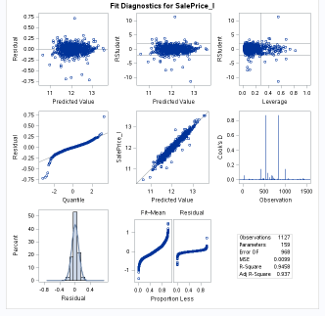

Stepwise – Final Model – Top Vars plus Interactions

