**Social cues modulate the strength of encoding alternative referents in cross-situational word learning**

Kyle MacDonald, Dan Yurovsky, Michael C. Frank

Word learning proceeds despite the potential for referential uncertainty: within a naming context, a new word could refer to many possible objects, properties of those objects, or even nothing at all. Both social cues and word-object co-occurrence statistics can reduce this uncertainty. But how do social cues, which function during the labeling moment, interact with cross-situational statistics, which function across multiple labeling events? In a large-scale experiment with adults, we show that the presence of social cues during labeling modulates learners’ tracking of cross-situational statistics: without social cues, learners are more likely to track multiple word-object associations.

Adults on Amazon Mechanical Turk saw a series of ambiguous word-learning trials that consisted of a set of novel objects (either 2, 4, 6, or 8) and heard a novel word. Participants were randomly assigned to either the *Social* condition in which a speaker looked at one of the objects during labeling or the *No-Social* condition in which a speaker looked straight ahead during labeling. In subsequent test trials, participants heard the novel word again after different numbers of intervening trials (0, 1, 3, and 7), this time paired with another set of novel objects. One of the objects in the set was either the participant’s initial guess (Same trials) or one of the objects that was not the initial guess (Switch trials). Word learning occurred at almost all levels of referential ambiguity and memory demands, but when a social cue was present during exposure trials adults performed worse on Switch trials, that is they were less likely to track alternative word—object links (see Figure 1).

Further, we present a computational model that takes a first-step in formalizing how social information influences cross-situational word learning. We use a variant on the computational model originally proposed by Frank, Goodman, and Tenenbaum (2009) and extended by Yurovsky and Frank (under review) to include cognitive constraints – encoding strength, memory decay, and attention. We modeled social information as a ”boost” to the amount of attention allocated to the initial hypothesis during exposure. This captured the tradeoff between reducing referential uncertainty with social cues and reduced tracking of multiple alternatives.

How does children’s learning differ from that of adults? Under this model, an agent with more restricted attention and less memory should appear to be a more categorical learner, encoding at most one hypothesis with any measurable strength. We performed the simplest version of the adult experiment (2 referents, no delay between training and test) with a group of XYZ children ages 3 – 6…

Together, the data and model suggest that there is a rational tradeoff between reducing uncertainty and the type of representations that learners store. The presence of social information reduces referential uncertainty during learning, which in turn makes learners less likely to track alternative word—object links.

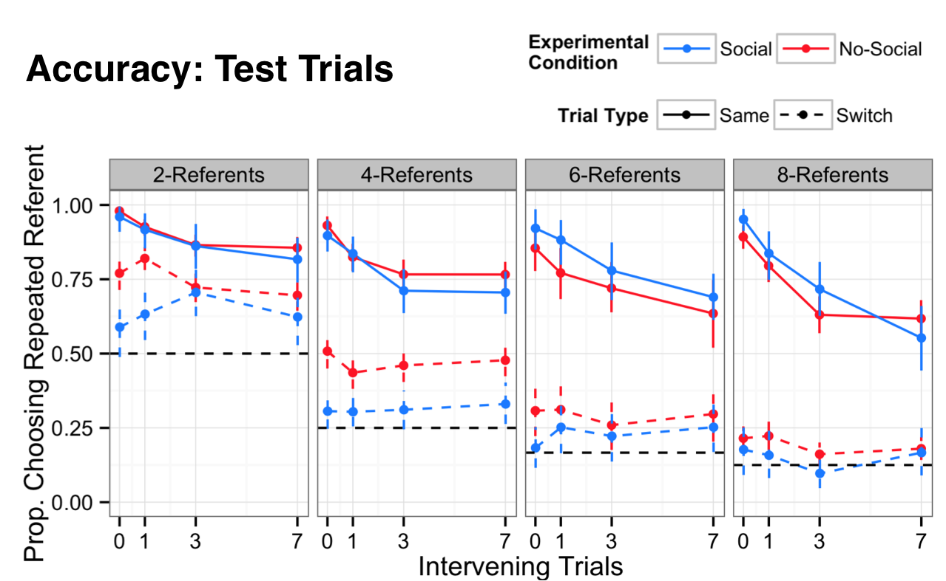

**Figure 1.** Adult data + model. Accuracy on test trials for both trial types (Same and Switch) and experimental conditions (Social and Non-Social). Each datapoint represents approximately 50-75 participants. Error bars indicate 95% confidence intervals computed by non-parametric bootstrap. Learners tracked multiple referents at all levels of memory and attention, but participants performed worse on Switch trials in the Social condition.

**Figure 2.** Kid data.