Device: cuda
Torch dtype: torch.float32

============================================================
Scanning C_1: q=1 bundles, side M=512
============================================================
Quotient leaves N = 513
Undirected edges E = 512
Source coordinate = (np.int64(256),)
Source index = 256
CG iter 1 | relative residual 7.050e-01
CG iter 100 | relative residual 4.324e-01
CG iter 200 | relative residual 1.548e-01
CG converged at iter 256 | relative residual 2.777e-08
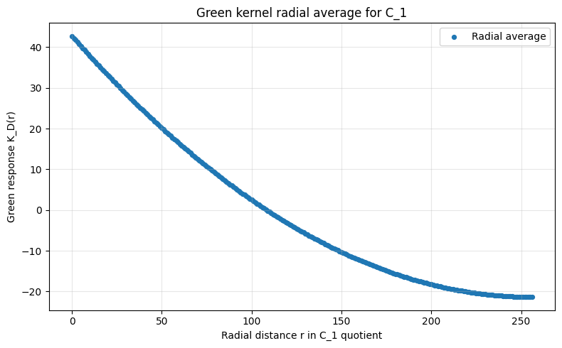
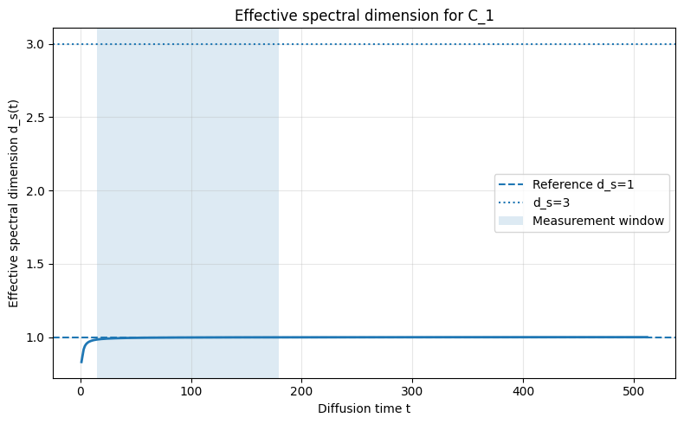

============================================================
Scanning C_2: q=2 bundles, side M=192
============================================================
Quotient leaves N = 37,249
Undirected edges E = 74,112
Source coordinate = (np.int64(96), np.int64(96))
Source index = 18624
CG iter 1 | relative residual 5.000e-01
CG iter 100 | relative residual 3.236e-02
CG iter 200 | relative residual 2.235e-03
CG iter 300 | relative residual 1.082e-05
CG converged at iter 338 | relative residual 9.293e-07
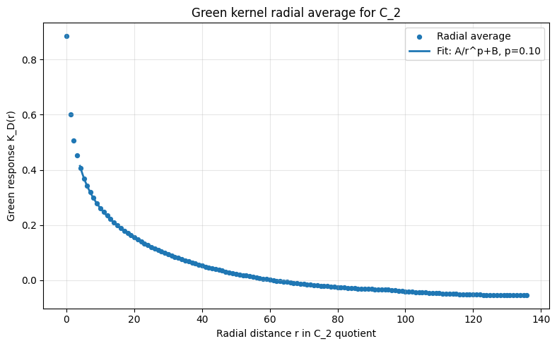
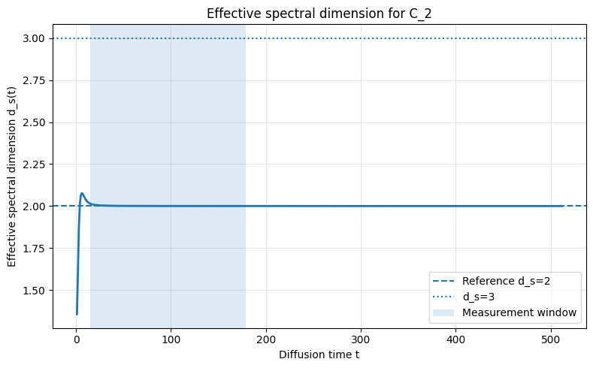

============================================================
Scanning C_3: q=3 bundles, side M=48
============================================================
Quotient leaves N = 117,649
Undirected edges E = 345,744
Source coordinate = (np.int64(24), np.int64(24), np.int64(24))
Source index = 58824
CG iter 1 | relative residual 4.082e-01
CG iter 100 | relative residual 1.888e-05
CG converged at iter 119 | relative residual 9.317e-07
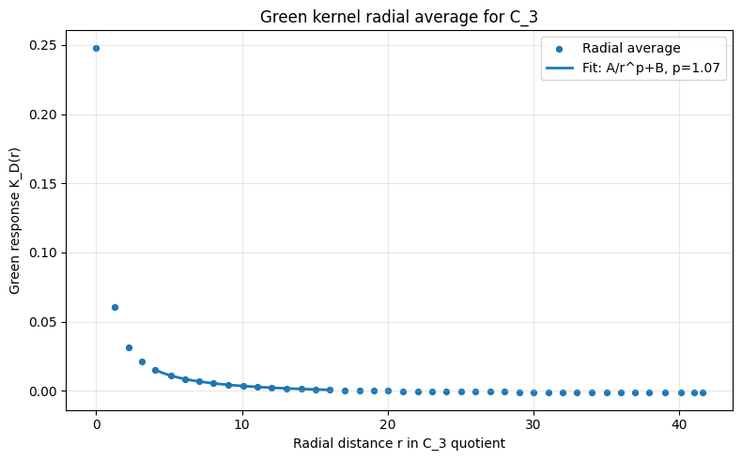
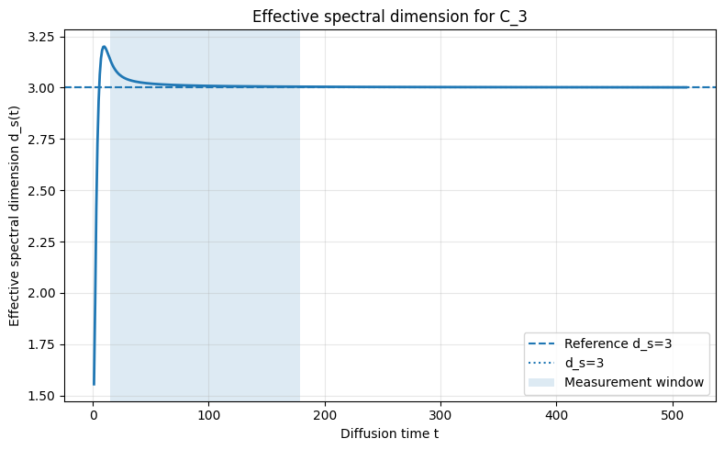

============================================================
Scanning C_4: q=4 bundles, side M=24
============================================================
Quotient leaves N = 390,625
Undirected edges E = 1,500,000
Source coordinate = (np.int64(12), np.int64(12), np.int64(12), np.int64(12))
Source index = 195312
CG iter 1 | relative residual 3.535e-01
CG converged at iter 70 | relative residual 8.416e-07
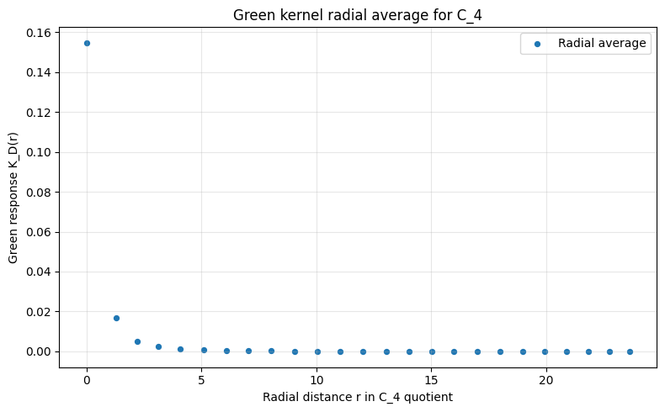
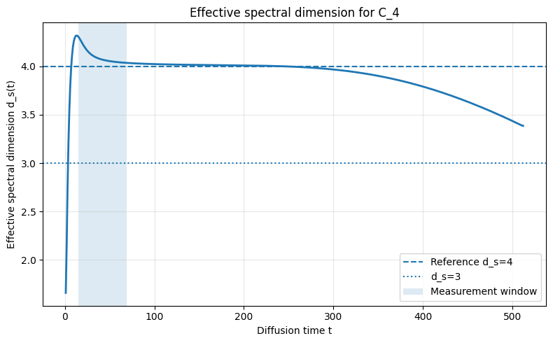

============================================================
C_q SELECTION SUMMARY
============================================================
q_bundles M_side N_leaves ds_median transient_by_ds_gt_2p05 \
0 1 512 513 0.997424 False
1 2 192 37249 2.000217 False
2 3 48 117649 3.008822 True
3 4 24 390625 4.068756 True

green_best_power_p green_expected_power_q_minus_2 green_power_fit_R2 \
0 NaN -1.0 NaN
1 0.10 NaN 0.999734
2 1.07 1.0 0.999989
3 NaN 2.0 NaN

expected_green_class
0 recurrent: no finite decaying infinite-volume ...
1 recurrent: no finite decaying infinite-volume ...
2 minimal transient: expected 1/r Green decay
3 transient higher-dimensional: expected 1/r^2 G...

Selection rule:
q_star = min { q : d_s(C_q) > 2.05 }
Selected q_star: 3

PASS: q=3 is selected as the minimal transient load sector.

Output directory:
/content/Cq_selection_scan_results

Manuscript-safe interpretation:

We scan a family of coarse load maps C_q, where q is the number of macroscopic
load bundles. The quotient associated with C_q has q-dimensional active-count
coordinates after quotienting microscopic binomial degeneracy through capacity
normalization.

The selection rule is not to impose Newtonian 1/r decay, but to require the
least macroscopic load dimension that supports a transient Green response:

q_* = min { q : d_s(C_q) > 2 }.

For q <= 2, diffusion is recurrent and the infinite-volume Green response does
not give a finite decaying potential. The first transient case is q=3. In that
case the Green kernel has the continuum form K_D(r) ~ 1/r. Higher q are also
transient but produce faster decays K_D(r) ~ 1/r^(q-2), so they are rejected by
dimensional economy.

This scan is numerical evidence for the selection rule. A formal theorem would
prove that least admissible structural action plus transience and dimensional
economy selects an effective d_s=3 load sector in the hypercube hierarchy.

