Nov 1999 / Paper 2 / Q6
(a)
(i)
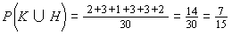
(ii)
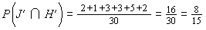
(iii)
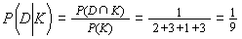

(b)
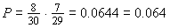

(c)
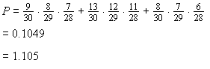

Nov 1999 / Paper 2 / Q7
- Let B = no. of Blue balls drawn = 3 – R
Let e = red balls drawn
Let b = blue balls draw
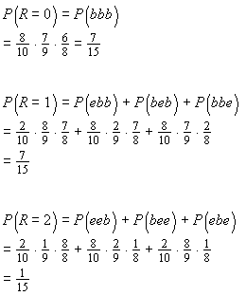

Probability distribution of R is:
r P(R=r)
0 7/15
1 7/15
2 1/15

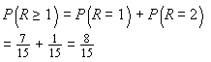

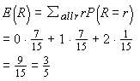

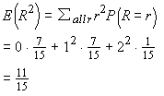

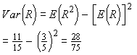

- Deduce that M = 4R and J = B = 3-R

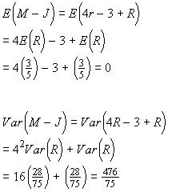

Nov 1999 / Paper 2 / Q8

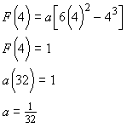

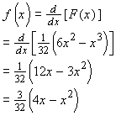
- f(x) is symmetrical about x = 2
E(X) = 2
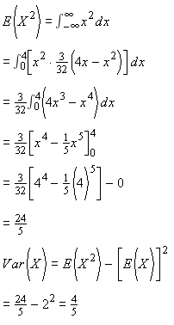

- Let n = no. of observations = 100
Let μ = E(X) = 2
Let σ² = Var(X) = 4/5

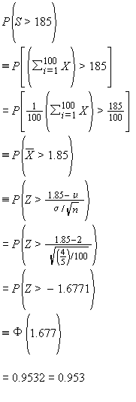

Nov 1999 / Paper 2 / Q9
- Let n = sample size = 12
Let p = successful connection rate = 0.8 and q = 1- p = 0.2
Let X = no. of successful calls out of n

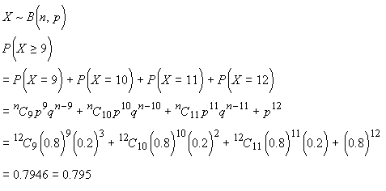
- Let n₂ = sample size =120
Let p_{s} = sample success rate = 105/120 = 0.875
Let p₀ = assumed success rate = 0.8 and q₀ = 1- p₀ =0.2
Test H₀: p = p₀ against H₁: p>p₀ a 1- tailed test for improvement
The 4%critical value, z_{0.04}=1.751
Reject H₀ if z > z_{0.04}
Under H₀, the test statistic is
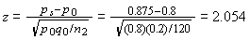

Since z > z_{0.04}, reject H₀ and conclude that, at the 4% level of significance, there is significant evidence that the successful connection rate has improved.
- Let n₃ = sample size = 150
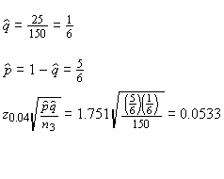
The 92% confidence interval for q is

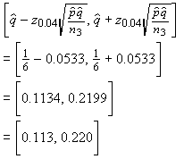

Nov 1999 / Paper 2 / Q10
- Let n = sample size = 225
Let p = average proportion of rockets that fail to burn properly = 1/75
Let X = no. of rockets out of n that fail to burn properly.
Since n(=225) is large and np=3<5,X~P₀(λ) approximately, where λ=np =3
P(at most 221 burn properly)

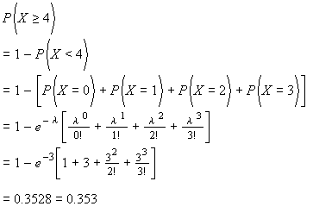
The distribution that should be used is the Binominal distribution, i.e. X ~ B(n,p).

- Let n = sample size = 50
Let μ= mean burning time
Let σ² = variance of burning time
Let μ₀ = assumed μ=40.

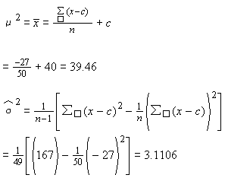
Test H₀: μ=μ₀ against H₁ : μ≠μ₀ a 2-tailed test for difference
The 5% critical value, z_{0.025} = 1.960
Under H₀, the test statistic is
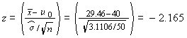
Reject H₀ and conclude that, at the 5% level of significance, there is significant evidence that the mean burning time fifers from 40 seconds.

Nov 1999 / Paper 2 / Q11
Nov 1999 / Paper 2 / Q12
Nov 1999 / Paper 2 / Q13
Nov 1999 / Paper 2 / Q14
Nov 1999 / Paper 2 / Q15

