Ministerul Educației, Culturii și Cercetării al Republicii Moldova
Universitatea Tehnică a Moldovei
Facultatea Calculatoare Informatică și Microelectronică
Departamentul Ingineria Software și Automatică

Disciplina: Tehnologii Web

Lucrarea de laborator nr.1
Tema: Familiarizaea cu structura unui document HTML/CSS

A efectuat studentul: Eric Capațîna gr. TI-184
A verificat: asist.univ. Cristian Rusu

Chișinău 2020
Scopul lucrării:
Familiarizarea cu posibilitățile HTML/CSS.

Documentele HTML/CSS în lucru:

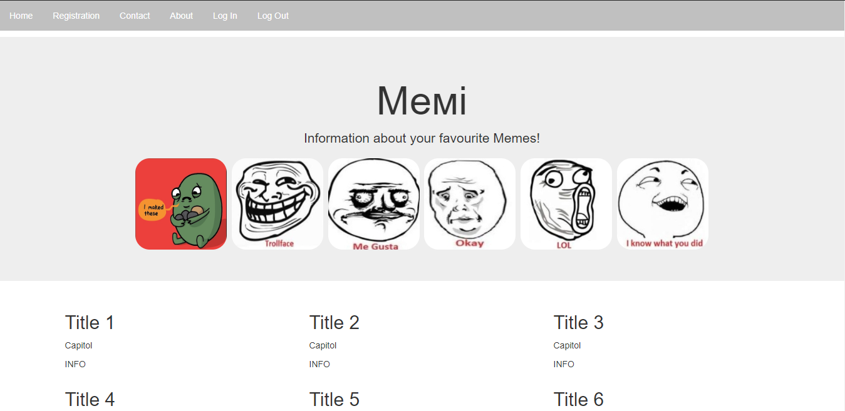
Figura 1 Pagina principala

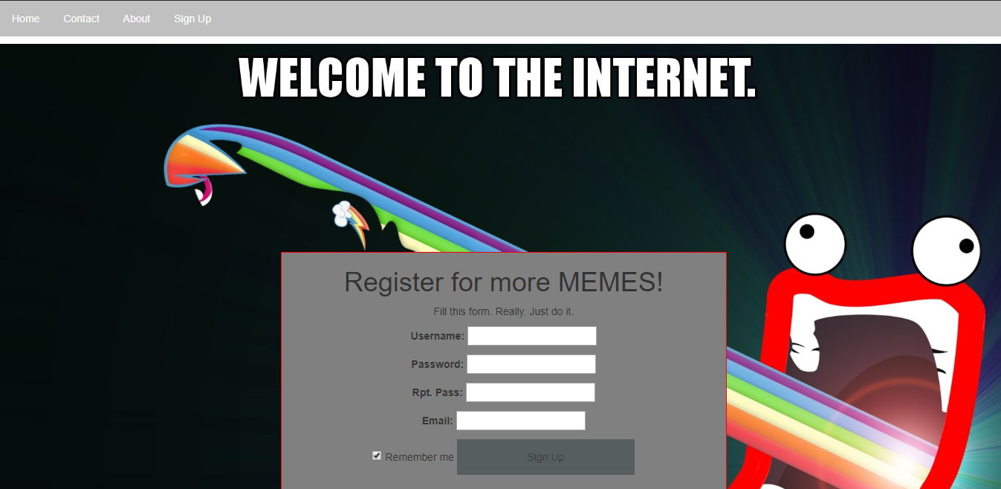
Figura 2 Pagina de înregistrare

Codul HTML / CSS:

Codul HTML la pagina principală:

{% load static %}
<head>
<title>MEMES INFO</title>
<meta charset="utf-8">
<meta name="viewport" content="width=device-width, initial-scale=1">
<link rel="stylesheet" type="text/css" href="{% static 'css/csscode.css' %}">
<link rel="stylesheet" href="https://maxcdn.bootstrapcdn.com/bootstrap/3.4.1/css/bootstrap.min.css">
<script src="https://ajax.googleapis.com/ajax/libs/jquery/3.4.1/jquery.min.js"></script>
<script src="https://maxcdn.bootstrapcdn.com/bootstrap/3.4.1/js/bootstrap.min.js"></script>
</head>
<body>
{% if user.is_authenticated %}
<ul>
<li><a class="active" href="/home">Home</a></li>
<li><a href="/contact">Contact</a></li>
<li><a href="/home">About</a></li>
<li><a href="/create_note">Create Post</a></li>
<li><a href="/create">View Created Posts</a></li>
<li><a href="/logout">Log Out</a></li>
{% if request.user.is_superuser %}
<li><a href="/admin">Admin Panel</a></li>
{% else %}
{% endif %}
</ul>
{% else %}
<ul>
<li><a class="active" href="/home">Home</a></li>
<li><a href="/registration">Registration</a></li>
<li><a href="/contact">Contact</a></li>
<li><a href="/home">About</a></li>
<li><a href="/signup">Log In</a></li>
<li><a href="/logout">Log Out</a></li>
</ul>
{% endif %}
<div class="jumbotron text-center">
<div class="container for-about">
<h1>Мемi</h1>
<p>Information about your favourite Memes!</p>
<img src="https://sun9-8.userapi.com/c853620/v853620790/1efb1c/hNyyJmAV8oc.jpg" alt="IDidThese" style="width:150px">
<img src="https://sun9-31.userapi.com/c204524/v204524248/562d2/Sk8o-bEhOvs.jpg" alt="TrollFace" style="width:150px">
<img src="https://sun9-46.userapi.com/c204524/v204524248/562f4/owsTyOkqZG8.jpg" alt="MeGusta" style="width:150px">
<img src="https://sun9-66.userapi.com/c204524/v204524248/56304/DdPvolmC5mA.jpg" alt="Okay" style="width:150px">
<img src="https://sun9-26.userapi.com/c204524/v204524248/56315/X_bfrmsn1P0.jpg" alt="LOL" style="width:150px">
<img src="https://sun9-42.userapi.com/c204524/v204524248/5632f/5f2EALcBeiE.jpg" alt="IKnowWhatUDid" style="width:150px">
</div>
</div>
<div class="container">
<div class="row">
<div class="col-md-4">
<h2>Title 1</h2>
<p>Capitol</p>
<p>INFO</p>
</div>
<div class="col-md-4">
<h2>Title 2</h2>
<p>Capitol</p>
<p>INFO</p>
</div>
<div class="col-md-4">
<h2>Title 3</h2>
<p>Capitol</p>
<p>INFO</p>
</div>
<div class="col-md-4">
<h2>Title 4</h2>
<p>Capitol</p>
<p>INFO</p>
</div>
<div class="col-md-4">
<h2>Title 5</h2>
<p>Capitol</p>
<p>INFO</p>
</div>
<div class="col-md-4">
<h2>Title 6</h2>
<p>Capitol</p>
<p>INFO</p>
</div>
</div>
</div>
</body>
</html>
Codul CSS pentru pagina principală:
img {
border: 1px solid #ddd;
border-radius: 25px;
padding: 2px;
width: 550px;
margin-left: auto;
margin-right: auto;
height: 150px;
}
ul {
list-style-type: none;
margin: 0;
padding: 0;
overflow: hidden;
background-color: silver;
}
li {
float: left;
}
li a {
display: block;
color: white;
text-align: center;
padding: 14px 16px;
text-decoration: none;
}
li a:hover {
background-color: gray;
}
Codul HTML pentru pagina de înregistrare:
{% load static %}
<head>
<meta charset="UTF-8">
<meta name="viewport" content="width=device-width, initial-scale=1">
<link rel="stylesheet" type="text/css" href="{% static 'css/csscode2.css' %}">
<link rel="stylesheet" href="https://maxcdn.bootstrapcdn.com/bootstrap/3.4.1/css/bootstrap.min.css">
<script src="https://ajax.googleapis.com/ajax/libs/jquery/3.4.1/jquery.min.js"></script>
<script src="https://maxcdn.bootstrapcdn.com/bootstrap/3.4.1/js/bootstrap.min.js"></script>
<title>Pepe Registration</title>
<style>
</style>
</head>
<body>
<ul>
<li><a class="active" href="/home">Home</a></li>
<li><a href="/contact">Contact</a></li>
<li><a href="/home">About</a></li>
<li><a href="/signup">Sign Up</a></li>
</ul>
<div class="background">
<form method="POST" class="div2">
<h1>Register for more MEMES!</h1>
<p>Fill this form. Really. Just do it.</p>
{% csrf_token %}
{{ form.as_p }}
<div class="form-group">
<input type="checkbox" checked="checked" name="remember" style="margin-bottom:15px"> Remember me</label>
<button class="signupbtn" type="submit">Sign Up</button>
</div>
</form>
</div>
</div>
</body>
<script>
function myFunction()
{
document.getElementById("id01").style.background = "purple";
location.href = "lab3.html";
}
</script>
</html>

Codul CSS pentru pagina de înregistrare:
ul {
list-style-type: none;
margin: 0;
padding: 0;
overflow: hidden;
background-color: silver;
}
button {
background-color: #515A5A;
color: black;
padding: 14px 20px;
margin: 8px 0;
border: none;
cursor: pointer;
width: 40%;
opacity: 0.9;
}
li {
float: left;
}
li a {
display: block;
color: white;
text-align: center;
padding: 14px 16px;
text-decoration: none;
}
li a:hover {
background-color: gray;
}
.div2 {
background-color: gray;
width: 600px;
height: 340px;
position:absolute;
border: 1px solid red;
text-align: center;
margin-left: auto;
margin-right: auto;
left:28%;
top:40%;
}
p.date {
text-align: center;
}
.background {
background-image: url('https://wallpaperaccess.com/full/172117.jpg');
background-size: cover;
height:700px;
position:relative;
}

Concluzia:
În urma efectuării lucrării de laborator nr.1 am făcut cunoștința cu documentele de format CSS și HTML. Am creat primele două pagini formate din aceste documente, legate prin ele. Am făcut cunoștință cu bootstrap și posibilitățile ce ne oferă acesta.

GitHub:
https://github.com/EricCapatina/TehWebLaborator

