Eric Diaz

Jaime Bonilla

Group Project Proposal

Project site title: PS4 vs Xbox

Client: Anyone deciding on which console to purchase

Goal:

1. The idea is to create a website that includes information about PS4’s and Xbox’s and state facts about each one. The site will include pros and cons of each console as well.
2. This site will help anyone decide which console they believe is better for them and which one they prefer.

Audience:

1. The users/audience will be anyone who enjoys playing video games and is looking for the better console to purchase
2. A visitor using our site will first go to the home page which will be “PS4 vs Xbox” and it will include pictures and what the rest of the site will contain. The next pages will consist of pros and cons of each console that lists specifications of both. These pages may also contain prices of each console. The last page will have links to outside websites where a PS4 or Xbox can be purchased.

Project Road Map: First we want to have our ideas fully thought out then complete the mockup. Next, we are going to design and make the home page. After that is complete, we will design the rest of our pages and edit them as we go.

How far along is the idea: We have a pretty good idea of what all the content is going to be. We are still brainstorming the layout and design though.

Site Map:

1. Home
2. Compare/Contrast (PS4 vs Xbox)
3. Prices
4. Editorial

Inspiration:

1. 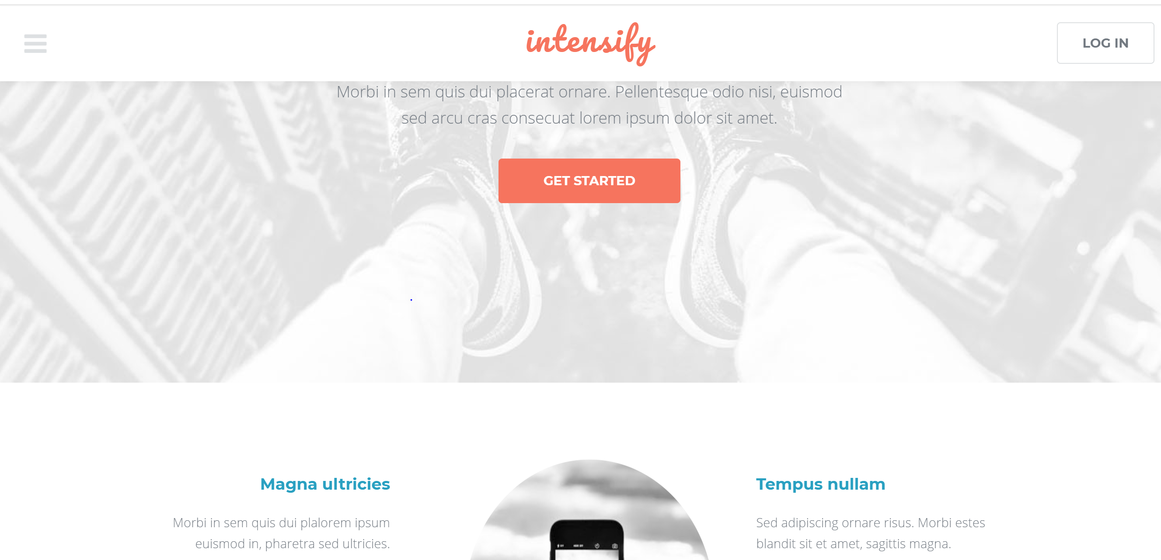
2. 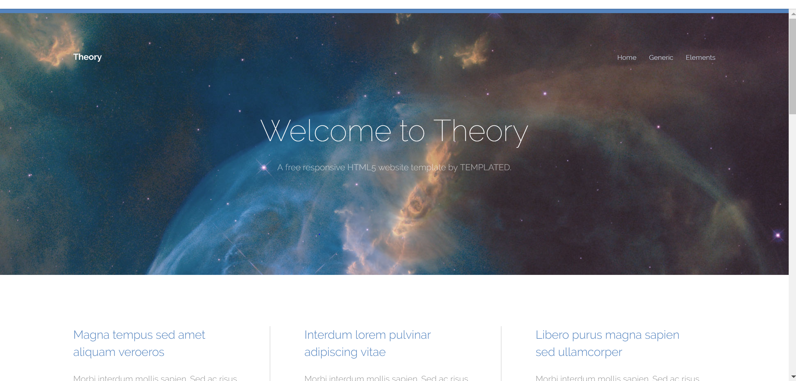

Color Combination:

1. 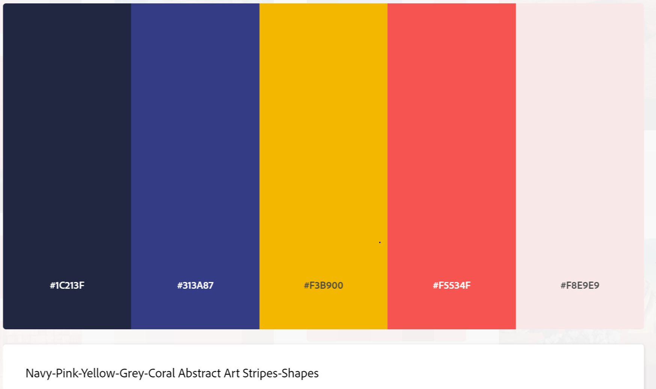
2. 