[Theme - Topic title]

1-2 sentences that describe the topics and top tasks that can be accessed on this page.

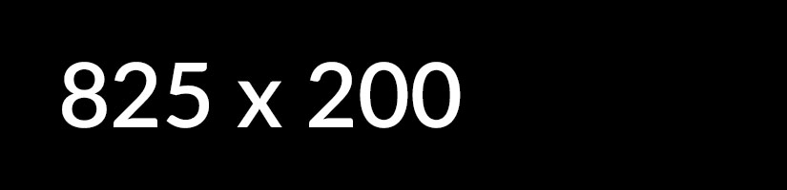

Most requested

* [[Top task hyperlink]](https://design.canada.ca/coded-layout/theme_topic_guidance.html)
* [[Top task hyperlink]](https://design.canada.ca/coded-layout/theme_topic_guidance.html)
* [[Top task hyperlink]](https://design.canada.ca/coded-layout/theme_topic_guidance.html)
* [[Top task hyperlink]](https://design.canada.ca/coded-layout/theme_topic_guidance.html)
* [[Top task hyperlink]](https://design.canada.ca/coded-layout/theme_topic_guidance.html)
* [[Top task hyperlink]](https://design.canada.ca/coded-layout/theme_topic_guidance.html)

**Services and information**

[[Topic hyperlink text]](https://design.canada.ca/coded-layout/theme_topic_guidance.html)

Use action verbs, or simply list keywords to summarize the information or tasks that can be accomplished on the page it links to.

[[Topic hyperlink text]](https://design.canada.ca/coded-layout/theme_topic_guidance.html)

Use action verbs, or simply list keywords to summarize the information or tasks that can be accomplished on the page it links to.

[[Topic hyperlink text]](https://design.canada.ca/coded-layout/theme_topic_guidance.html)

Use action verbs, or simply list keywords to summarize the information or tasks that can be accomplished on the page it links to.

[[Topic hyperlink text]](https://design.canada.ca/coded-layout/theme_topic_guidance.html)

Use action verbs, or simply list keywords to summarize the information or tasks that can be accomplished on the page it links to.

[[Topic hyperlink text]](https://design.canada.ca/coded-layout/theme_topic_guidance.html)

Use action verbs, or simply list keywords to summarize the information or tasks that can be accomplished on the page it links to.

[[Topic hyperlink text]](https://design.canada.ca/coded-layout/theme_topic_guidance.html)

Use action verbs, or simply list keywords to summarize the information or tasks that can be accomplished on the page it links to.

[[Topic hyperlink text]](https://design.canada.ca/coded-layout/theme_topic_guidance.html)

Use action verbs, or simply list keywords to summarize the information or tasks that can be accomplished on the page it links to.

[[Topic hyperlink text]](https://design.canada.ca/coded-layout/theme_topic_guidance.html)

Use action verbs, or simply list keywords to summarize the information or tasks that can be accomplished on the page it links to.

[[Topic hyperlink text]](https://design.canada.ca/coded-layout/theme_topic_guidance.html)

Use action verbs, or simply list keywords to summarize the information or tasks that can be accomplished on the page it links to.

(end of doormats)

Features

[](https://design.canada.ca/coded-layout/theme_topic_guidance.html)

[[Feature hyperlink text]](test.html)

Brief description of the feature being promoted.

On social media

* [FacebookPageName](https://design.canada.ca/coded-layout/theme_topic_guidance.html)

[@TwitterAccount](https://design.canada.ca/coded-layout/theme_topic_guidance.html)

[YouTubeName](https://design.canada.ca/coded-layout/theme_topic_guidance.html)

[InstagramName](https://design.canada.ca/coded-layout/theme_topic_guidance.html)

[LinkedInName](/)

From:

* [Treasury Board of Canada Secretariat](https://www.canada.ca/en/treasury-board-secretariat.html)
* [[Department or agency]](https://design.canada.ca/coded-layout/theme_topic_guidance.html)