Exercise 4.3



Exercise 4.5

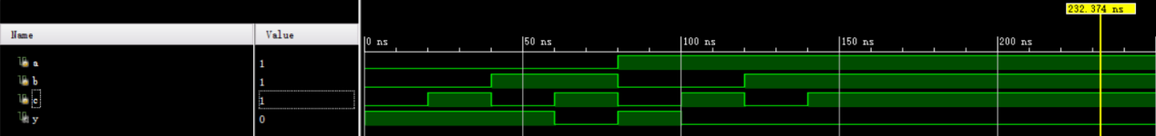

Exercise 4.19



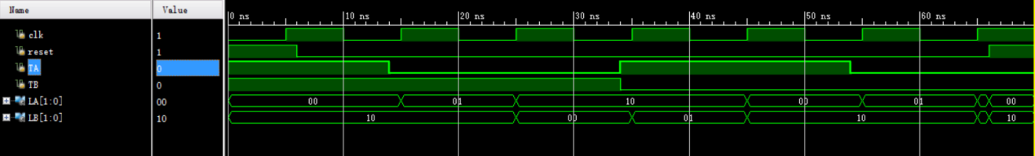Exercise 4.29

Exercise 4.35

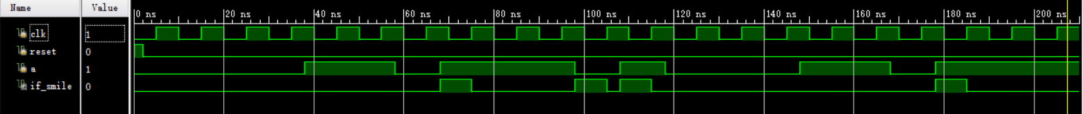

Exercise 4.37

