DwsIde – A Demonstration IDE for the DWS Script.

Introduction and Objectives.
DWS is a powerful, fast Pascal scripting tool for Delphi. It can be used to embed significant user-defined capability within an Application or to avoid hard-coding certain parts of an Application. The history of DWS is a matter of record but at time of writing it has been very significantly updated by Eric Grange – his blog is at http://delphitools.info/dwscript/ with the public SVN repository at http://dwscript.googlecode.com/svn . DWS when downloaded is a set of Delphi components, the most important of which is TDelphiWebScript. Don’t be misled by the ‘Web’ part of the name which is really an historical use.
Eric, with the help of few other contributors, has put a vast amount of energy into the compiler code, introducing structures that Delphi users have come to expect such as standard classes, interfaces etc and which are not available in other Pascal scripts, creating test cases to prove solid execution. Any script is only as good as its compiler and the result is a very fast pre-compiled script which is almost as fast as native Delphi code.
As this work has progressed though, potential users of the script have been held back by the lack of any more than very basic demos and when I came to employ a script I was attracted by the sheer speed and flexibility of DWS other solutions such as PascalScript and yet frustrated that there was no credible IDE. There were old examples from early releases of DWS but these did not compile readily with the newer features implemented by Eric, thus I decided to create an IDE solution that would provide a good starting point for someone wishing to include DWS within their application. I admit to having selfish reasons for this, I needed an IDE for my own work and indeed there is almost no limit to the amount of work that can be put into such a project, after all you are almost recreating Delphi itself.
Rather than embark upon a huge amount of work I decided to set some limited objectives as follows:
- The IDE should be a modal, single form that can be invoked upon an existing script (if you have an instance of TDelphiWebScript, you can point the IDE at it).
- No components need to be installed to demo the IDE other than the DWS components and the common text editor components SynEdit (from http://sourceforge.net/projects/synedit/files/)
- Debugging should support breakpoints, watches, a call stack and local variables.
- To a TDelphiWebScript it is only necessary to provide a text script (which need not even come from a file). The IDE should support this with source files in a similar way to Delphi where a project file defines a ‘main module’ file (the script) and manages any references unit or include files. (More about this later).
- Simple Run modes should be available including a built-in timing function.
- Debug windows should be frames to allow the IDE appearance and functionality to be customised.
- Only Delphi XE (and on) should be supported (sorry Delphi 7 users but you really should move on!).

The following developments are possible but not presently planned:
- A ‘docking’ IDE, e.g. using the Delphi TTabDock controls.
- Code proposal / Code completion.
- WYSIWYG form design (of dfm files).

Downloading and running the IDE demo.

To work with the IDE, take the following steps:
Download and install the latest DWS files from http://code.google.com/p/dwscript/. When these are installed you should see a DWS component tab.
Download the Delphi SynEdit text editor components from https://synedit.svn.sourceforge.net/svnroot/synedit When these are installed you should see a SynEdit component tab.
From the downloaded DWS files copy the folder ‘..\DwsIde\DWS Script Files’ to your desktop. These are the example script files to get you started, and will be your working folder while you edit and debug.
Locate the folder ...\DwsIde\Delphi projects’ and open the file ‘DwsIdeDemo.dproj’ and open this with Delphi XE. This should compile and you should see:
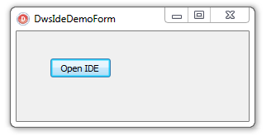
Click on the button and the IDE should open as follows:
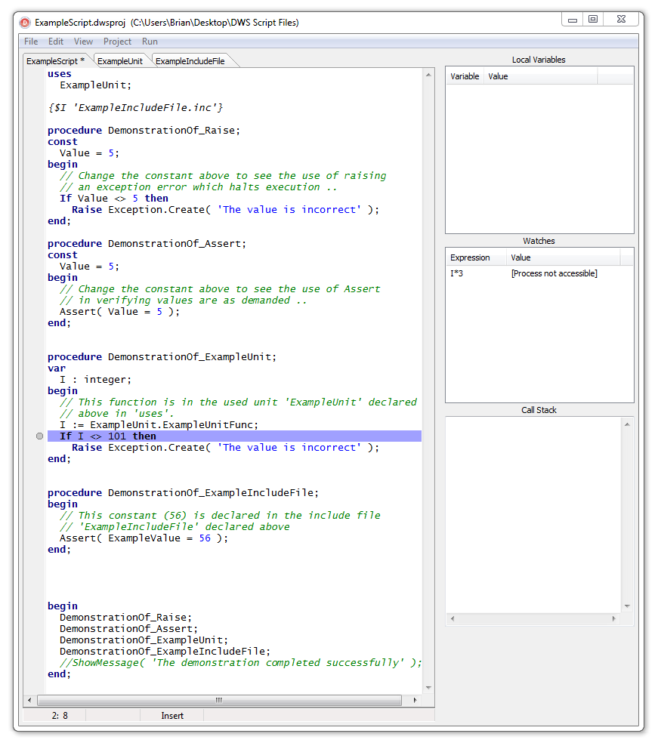
You will notice that there are three tabs labelled ‘Example Script *’, ‘ExampleUnit’ and ‘ExampleIncludeFile’. These three files have been loaded from the Desktop folder ‘Dws Script Files’ and make up a project similar to Delphi’s project structure as follows:
A ‘main module’ (like Delphi’s DPR file) saved with the ‘dws’ extension (ExampleScript.dws). There is always one of these files in a project.
One or more optional ‘unit’ files with a ‘.pas’ extension, for example the single ‘ExampleUnit.pas’ file shown above. (You might use a unit to hold code that gets called from more than one script in your application).
One or more optional ‘include’ files with any extension, for example the single ‘ExampleIncludeFile.inc’ file shown above. (If you don’t know why you might use an include file, just ignore this!).
Finally, a project configuration file to hold references to all of these file and to store breakpoints and watches etc. The IDE creates an XML file with a ‘.dwsproj’ extension which is the equivalent of Delphi ‘s ‘.dproj’ file. In our demo this is the file ExampleScript.dwsproj in the desktop folder.

Working with the IDE menus.
You should already be fairly familiar with the menu layout, but here are a few nudges:
File Menu. The File menu allows you to create, load and save ‘DWS projects’ as well as the individual *.pas, *.dws and other file types that you may need.
Edit Menu. There is not much here because most of the edit functions are available in a context menu that you can access by right-clicking one of the editor page tabs. Toggling the read-only status is possible here.
View Menu. View Project Source always takes you to the ‘main module’ (indicated with ‘*’ in its tab). Show Symbols is just for show for now.
Project Menu. Build compiles the project without executing it. You should see blue ‘executable line’ dots appear when you do this.
Run Menu. This has the familiar run options ‘Run’ (starts a run within the debugger) ‘Run without debugging’ (no debugger is used) and the various debugger commands whilst stepping.
If you go ahead and choose ‘Run’ you should see the script stop at line 33 of the main module where there is a breakpoint.
Breakpoints can be set by clicking the blue execution dots much as in Delphi.
'Run Procedure at Cursor' can be used to execute just a single procedure in the main module (this will be further developed to use DWS as a host for multiple events, each implemented by an event procedure). To use this, double-click the name of a procedure and then select the option. Presently only procedures with no parameters are supported.

Debug Windows.
The debug windows are pretty obvious and are read-only expect for the watches where you can right-click and create, edit or delete a watch expression. Watches, like breakpoints are stored in the *.dwsproj XML file for persistence.
The output window needs a little explanation. This window ‘catches’ both Write and Writeln calls (i.e writes to StdOut) AND any use of OutputDebugString(). Note that if you use ‘Run without debugging’ the output window will only show Write and Writeln – OutputDebugString() is still active but is sending output to Windows.

Using the IDE in your own Application.
At present, the IDE is just a ‘demo’ and still has some bugs but it should provide you with a start. Typically, you will provide the instance of ‘TDelphiWebScript’ in your application and then you will call the routine ‘DwsIDE_ShowModal()’ passing this instance to the IDE to open as a modal form. The unit ‘UDwsIdeDemoForm.pas’ shows this done. The only other work you have to do in your application is to provide a means of your TDelphiWebScript opening the relevant unit and include files as also shown in UDwsIdeDemoForm.pas.

