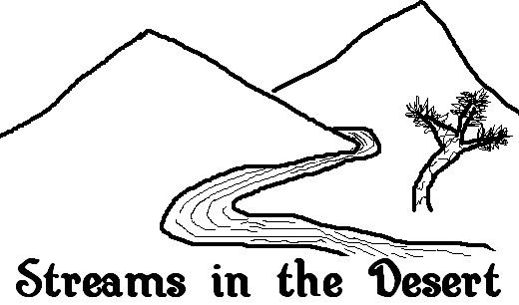Antelope Valley
Christian Writer’s Conference

May 5-6 2006

Sponsored by:

Quartz Hill School of Theology

and

The High Desert Christian Writer’s Guild

Location:

Christ Our Savior United Methodist Church

5027 W. Avenue M

Quartz Hill, CA 93536

Our Program Features Three Popular Authors & Speakers

Lauraine Snelling

Author of

Way of Women, A Hand to Hold, Ruby

Seminar: Writing from Your Soul

Ellie Kay

Author of

The Debt Diet, A Woman’s Guide to Family Finance, The New Bride Guide

Seminar: Writing Non-Fiction

Alton Gansky

Author of

Submerged, The Incumbent, The Secrets God Kept

Seminar: Edgy Fiction

Friday

6:00 pm Registration,

7:00 pm Welcome, Narrow Road Coffee House:
chat, entertainment and readings

Saturday

8:00 am Continental breakfast

8:30 am Large Group: Opening Speaker

9:15 am Speaker Seminar I, Individual classes

10:30 am Coffee Break

11:00 am Speaker Seminar II, Individual classes

12:15 pm Lunch (pre-registered)

1:15 pm Speaker Seminar III, Individual classes

2:45 pm Large Group: Closing Speaker

4:00 pm Seminar Close

