**Supplementary information for “No phylogenetic evidence for angiosperm mass extinction at the Cretaceous–Paleogene (K-Pg) boundary”**

**Nucleotide and taxonomic sampling**

The tree reconstructed by Zanne et al. (2014) and edited by Qian and Jin (2016) sampled seven gene regions, including slowly and more quickly evolving regions (18S rDNA, 26S rDNA, ITS, matK, rbcL, atpB, and trnL-F). It included 30,199 angiosperm species, in 7,877 of the 13,779 genera recognised by World Flora Online (WFO), and 412 of 414 families. ~38% of sampled families are represented by over 10% of their accepted species, and ~10% sampled at least 50%.

The tree reconstructed by Smith and Brown (2018) and edited by Jin and Qian (2019), and Igea and Tanentzap (2020), clustered published nucleotide data (Genbank release 218, February 2017, Clark et al., 2015), and there was an average of 2,340bp, roughly corresponding to one or two gene regions. 72,575 angiosperm species were sampled, in 10,240 genera. 401 families were sampled, with ~39% represented by over 10% of their accepted species, and ~9% represented by at least 50%. Sampling level varies across the trees, with most families represented by fewer than 25% of their described species. Sampling fraction is negatively related to family richness (-0.45 and -0.42 for SB and QJ, respectively, both p < 2.2e-16).

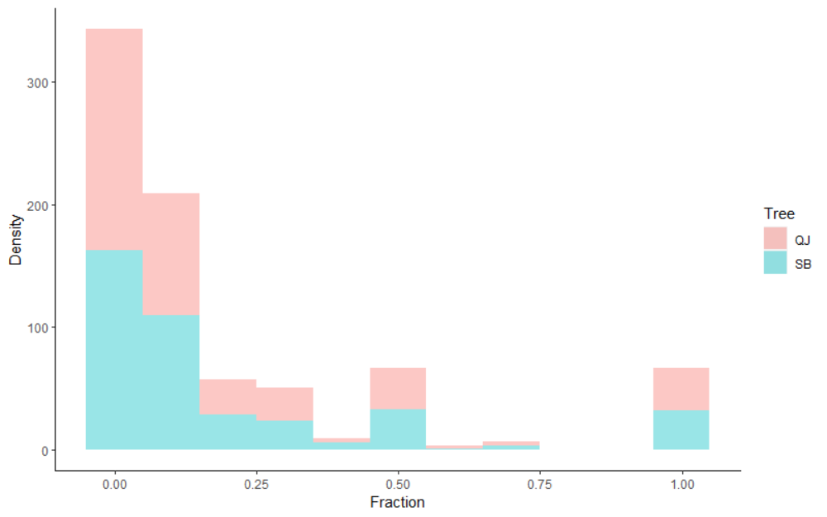

**Supplementary figure 1: The distribution of the sampling fraction among families.** A density plot showing incomplete sampling at family level in the two phylogenies, estimated with known richness described by World Flora Online (WFO).

**Model-selection in TESS**

We performed model-selection to assess the degree of support for constant-rate extinction models and models with a mass extinction at ~66 Mya, using the R package TESS (Höhna et al., 2016). We set up the constant model with exponential priors of speciation and extinction defined as 0.1, so that the mean of the exponential was 1/rate = 10. Following this, we set up the mass extinction model, with the same speciation and extinction priors, and a mass extinction event at ~66 Mya with 75% species loss. This is more relaxed than the threshold of 90% instantaneous species loss commonly used, but in line with estimates of species loss at K-Pg (Tabor et al., 2020, Wilf et al., 2023). In both models, we specified the sampling fraction assuming ~290,000 angiosperms (Ramírez-Barahona et al., 2020). After defining the likelihood models following the author’s documentation (Höhna et al., 2015), we performed marginal likelihood estimation with stepping stone sampling. In these analyses, we used 1,000 iterations with a burnin of 100, and 50 stepping stones. Finally, we calculated Bayes Factor support for each model, to identify the best-supported model.

**Parameter choices in CoMET models**

Despite overwhelming support for constant diversification in the model selection stages, we still allowed mass extinctions in the final estimations of extinction rates with CoMET. This was in order to visualise low-supported mass extinctions, which might have still been informative.

In the analyses presented in the MS, the number of expected rate changes was set at 25 although we explored the sensitivity here. 25 was chosen as slightly fewer than the thirty core shifts detected by Magallón et al. (2018). The number of expected mass extinctions was set at one, because we were interested specifically in K-Pg, although the timing was not enforced. However, we relaxed this assumption to accommodate uncertainty in species loss among lineages at K-Pg, by defining the beta distribution of survival probability as ~0.18-~0.33, by setting a prior of 100 for pMassExtinctionPriorShape2. All other parameters, including mean and sd of speciation and extinction rates, were set by empirical hyperprior analyses. During this stage, an initial Bayesian MCMC analysis under a constant-rate birth-death model was performed. During the final analyses, no maximum run time or number of generations was enforced. Instead, analyses were halted once an effective sample size of 300 was reached on all parameters, indicating convergence. This was checked afterwards, and two replicate runs were combined. We explored the sensitivity of the number of expected rate shifts parameter, because this was the least certain. While Magallón et al. (2018) provide a robust estimate, these are lineage-specific rate shifts rather than tree-wide shifts, which have not been explored thoroughly in large angiosperm phylogenies. We replicated analysis on the QJ tree (the smallest one), testing expected numbers of rate shifts ranging from 1-1,000 (1, 100, 250, 500, 1,000). None of these sensitivity analyses recovered a model with a significant mass extinction at any time (BF > 6).

**References**

Alroy, J. (2008) ‘Dynamics of origination and extinction in the Marine Fossil Record’, *Proceedings of the National Academy of Sciences*, 105(supplement_1), pp. 11536–11542. doi:10.1073/pnas.0802597105.

Barnosky, A.D. *et al.* (2011) ‘Has the Earth’s sixth mass extinction already arrived?’, *Nature*, 471(7336), pp. 51–57. doi:10.1038/nature09678.

Clark, K. *et al.* (2015) ‘GenBank’, *Nucleic Acids Research*, 44(D1). doi:10.1093/nar/gkv1276.

Höhna, S., May, M. R. & Moore, B. R. (2015) Phylogeny Simulation and Diversification Rate Analysis with TESS; https://cran.r-project.org/web/packages/TESS/vignettes/Bayesian_Diversification_Rate_Analysis.pdf 1–98. 93/bioinformatics/btv651.

Höhna, S., May, M.R. and Moore, B.R. (2016) ‘Tess: An R package for efficiently simulating phylogenetic trees and performing bayesian inference of lineage diversification rates’, *Bioinformatics*, 32(5), pp. 789–791. Doi:10.10

Igea, J. and Tanentzap, A.J. (2020) ‘Angiosperm speciation cools down in the Tropics’, *Ecology Letters*, 23(4), pp. 692–700. doi:10.1111/ele.13476.

Jablonski, D. (1994) ‘Extinctions in the fossil record’, *Philosophical Transactions of the Royal Society of London. Series B: Biological Sciences*, 344(1307), pp. 11–17. doi:10.1098/rstb.1994.0045.

Jin, Y. and Qian, H. (2019) ‘V.PhyloMaker: An R package that can generate very large phylogenies for vascular plants’, *Ecography*, 42(8), pp. 1353–1359. doi:10.1111/ecog.04434.

Qian, H. and Jin, Y. (2016) ‘An updated megaphylogeny of plants, a tool for generating plant phylogenies and an analysis of phylogenetic community structure’, *Journal of Plant Ecology*, 9(2), pp. 233–239. doi:10.1093/jpe/rtv047.

Ramírez-Barahona, S., Sauquet, H. and Magallón, S. (2020) ‘The delayed and geographically heterogeneous diversification of flowering plant families’, *Nature Ecology & Evolution*, 4(9), pp. 1232–1238. doi:10.1038/s41559-020-1241-3.

Smith, S.A. and Brown, J.W. (2018) ‘Constructing a broadly inclusive seed plant phylogeny’, *American Journal of Botany*, 105(3), pp. 302–314. doi:10.1002/ajb2.1019.

Tabor, C.R. *et al.* (2020) ‘Causes and climatic consequences of the Impact Winter at the cretaceous‐paleogene boundary’, *Geophysical Research Letters*, 47(3). doi:10.1029/2019gl085572.

Wilf, P., Carvalho, M.R. and Stiles, E. (2023) ‘The end-cretaceous plant extinction: Heterogeneity, ecosystem transformation, and insights for the future’, *Cambridge Prisms: Extinction*, 1. doi:10.1017/ext.2023.13.

WFO (2023): World Flora Online. Published on the Internet; http://www.worldfloraonline.org. Accessed on: 24 April 2023

Zanne, A.E. *et al.* (2013) ‘Three keys to the radiation of angiosperms into freezing environments’, *Nature*, 506(7486), pp. 89–92. doi:10.1038/nature12872.