|  |  |
| --- | --- |
| TEH_logo_big | TOUR EAST GROUP |
| Sabre Fare Checker (SFC) |
| Software Requirements Specification (SRS) |
| TEG-SFC v2.0.7 |
|  |
| Version 2.0.7 |
| June 28th, 2017 |
| Tour East Holidays  15 Kern Road, Toronto, Ontario M3B 1S9  CANADA |
|  |
|  | |
| **All information contained in this document shall be kept in strict confidence.**  None of this information shall be divulged to persons other than Tour East Group employees authorized by the nature of their duties to receive such information, or individuals or organizations authorized by Tour East Group in accordance with existing policy regarding release of company information. | |

About this document

This document is the Software Requirements Specification of the SFC project.

Reviews

This document has been distributed to:

|  |  |  |
| --- | --- | --- |
| **Name** | **Organization** | **Distribution** |
| Jason Ho | Tour East Holidays | Email |
| Herman Tam | Tour East Holidays | Email |
| Doris Ma | Tour East Holidays | Email |

Document Approval

The Software Requirements Specification has been accepted and approved by the following:

|  |  |  |  |
| --- | --- | --- | --- |
| **Signature** | **Printed Name** | **Title** | **Date** |
|  |  |  |  |

Revision History

This section records the history of changes to this document.

| **Version** | **Date** | **Author** | **Description of Change** |
| --- | --- | --- | --- |
| 0.1 | 2017-05-18 | Eric Li | Project was assigned |
| 0.2 | 2017-05-26 | Eric Li | 1. Display modified 2. Batch Run 3. Run a batch of commands 4. Operate in the editable textbox 5. Export to Excel by EPPLUS 6. Add two IPCCS:    1. 2BY2    2. 2CQ2 |
| 0.3 | 2017-06-02 | Eric Li | 1. Add the transpacific confirm box option 2. Display the result line by line 3. Deploy and test the program officially |
| 1.0 | 2017-06-06 | Eric Li | 1. Correct all the run-time error, first version complete 2. Updated Use Case |
| 1.0.1 | 2017-06-07 | Eric Li | 1. Add wait cursor during run-time  2. The second deployment starts and version  1.0.1 releases. |
| 2.0 | 2017-6-18 | Eric Li | 1.Add new function of calculating commission fee to the program by using APC interface  2.Format Excel sheet by adding border and adjusting height and width |
| 2.0.1 | 2017-6-23 | Eric Li | 1.Fix empty line- string exceed length problem  2.Add external flight option eg.B6 |
| 2.0.2 | June 22th | Eric Li | Change method of getting Fare Basis |
| 2.0.3 | June 26th | Eric Li | Logic error in trans full price Num->(Num+j) |
| 2.0.4 | June 26th | Eric Li | WPPJCB->WPNC ¥JCB |
| 2.0.5 | June 27th | Eric Li | Display fare basis in the excel form |
| 2.0.6 | June 27th | Eric Li | Adjust Sabre screen font size to 12 |
| 2.07 | June 28th | Eric Li | Correct “DCA” origin error  Change method of get index of dest an ori |

Table of Contents

[1 Introduction 4](#_Toc480811045)

[1.1 Purpose 4](#_Toc480811046)

[1.2 Scope 4](#_Toc480811047)

[1.3 Definitions, Acronyms, and Abbreviations 4](#_Toc480811048)

[1.4 References 5](#_Toc480811049)

[1.5 Overview 5](#_Toc480811050)

[2 General Description 5](#_Toc480811051)

[2.1 Product Perspective 6](#_Toc480811052)

[2.2 Product Functions 6](#_Toc480811053)

[2.3 User Characteristics 7](#_Toc480811054)

[3 Specific Requirements 7](#_Toc480811057)

[3.2 Functional Requirements (Use Cases) 7](#_Toc480811063)

[3.2.1 Use Case UC-01: Add Flight 8](#_Toc480811064)

[3.2.2 Use Case UC-02: Clear Flights 9](#_Toc480811065)

[3.2.3 Use Case UC-03: Change Currency 10](#_Toc480811066)

[3.2.4 Use Case UC-04: Execute and Display 10](#_Toc480811067)

[3.2.5 Use Case UC-05: Export to Excel 11](#_Toc480811068)

[3.2.2 Use Case UC-06: Search Flight 12](#_Toc480811065)

[4 Change Management Process 12](#_Toc480811086)

# Introduction

This document contains the Software Requirements Specification (SRS) for the Sabre Fare Checker (SFC) project. It provides an overview of the SRS purpose, scope, definitions, acronyms, abbreviations, references and overview of the SRS.

## Purpose

The purpose of this document is to specify the software requirements that apply to the SFC. This includes a complete description of the behaviours of the system to be developed and a set of use cases that describe all interactions the users will perform with the software. Use cases are also known as functional requirements.

## Scope

The SFC provides a friendly user interface to acquire price of flights from Sabre terminal. It supports Sabre command and non Sabre Command from multiple Sabre iPCC concurrently and displaying of the price of consolidated flight itineraries according to departure city, destination, airline, departure date and returning date. In addition to the Sabre terminal, it provides a user interface to input directly and output useful information that users want.

## Definitions, Acronyms, and Abbreviations

The table below provides the definition of all terms, acronyms and abbreviations required to properly interpret this document.

|  |  |
| --- | --- |
| GDS | Global Distribution System |
| IEEE | Institute of Electrical and Electronics Engineers |
| IIS | Internet Information Services |
| iPCC | Pseudo City Code for web services connection |
| PC | Personal Computer |
| SVN | A software versioning and revision control system |
| TEG | Tour East Group |
| UML | Unified Modeling Language |

## References

The list of documents referenced is shown below.

1. IEEE Software Engineering Standards Committee, “IEEE Std 830-1998, IEEE Recommended Practice for Software Requirements Specifications”.

## Overview

The remainder of this document includes three chapters and appendixes. The second one provides an overview of the system functionality and system interaction with other systems.

The third chapter provides the requirements specification in detailed terms and a description of the different system interfaces. Different specification techniques are used in order to specify the requirements more precisely for different audiences.

# General Description

This section will give an overview of the whole system. The system will be explained in its context to show how the system interacts with other systems and introduce the basic functionality of it. It will also describe what type of stakeholders that will use the system and what functionality is available for each type. At last, the constraints and assumptions for the system will be presented.

## Product Perspective

The top level workflow diagram illustrates the interaction among SFC users, SFC system and Sabre GDS.

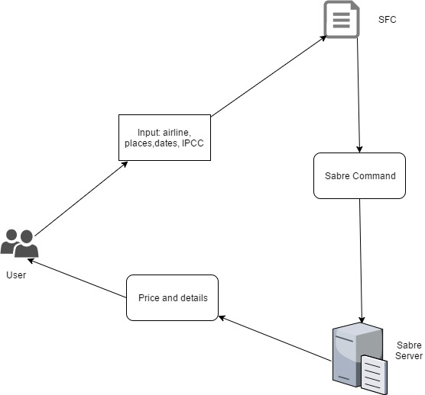

## Product Functions

This section lists the relevant functional modules that will be described in detail in the chapter “Functional Requirements” (product use cases).

1. **Add Flight**

* Add Command one by one to the input box according to the textboxes

1. **Input Box**

* Display Command
* Enable copy and paste functionalities

1. **Currency Option**

* 2BY2: display price in CAD
* 2CQ2: display price in USD

1. **Clear flights**

* Clear all the input

1. Search flights

* Search the flight’s detailed information we want

1. **Export to Excel**

* Export all the output data into excel sheet

## User Characteristics

The SFC supports three types of users:

1. Consultant User
   1. Search the price
   2. Create booking
   3. Manage self-searching price
   4. Manage booking created by consultants within the same Center
2. Agency Administrator
   1. Includes all Consultant User capability
   2. Manage user of all Centers
   3. Manage bookings created by users of all Centers
   4. Manage information of all Centers

.

## Functional Requirements (Use Cases)

This section describes the top level Use Cases of the SFC. The diagram shows relationship between Actors and Use Cases. The details of each use case will be described in the following sub-sections.

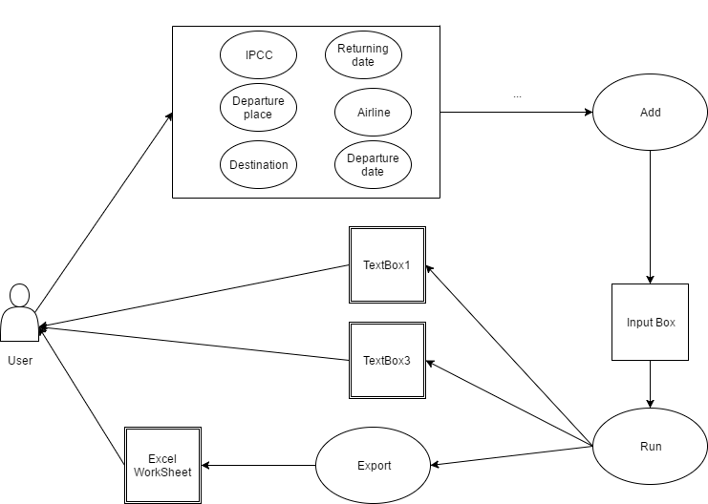

### Use Case UC-01: Add Flight

|  |  |
| --- | --- |
| **Use Case:** | Add Flight |
| **ID:** | UC-01 |
| **Description:** | User wants to add the flight information into the input box so that it will format automatically to the correct form which can be executed after |
| **Actor:** | * Agency Administrator |
| **Input:** | * Airline * Origin * Destination * Departure date * Returning date |
| **Precondition:** | * The format of each box is entered validly |
| **Flow of events:** | 1. User opens the Window form 2. User enters the airline 3. User enters the Origin, Destination 4. User enters the Departure date, Returning date 5. User clicks the Add button 6. System validates all the inputs 7. System formats and combines all of the small input boxes and display on the input box |
| **Secondary scenarios:** | None |
| **Postcondition – Success:** | * User has access to the system * All of the input boxes are filled and filled correctly |
| **Postcondition – Failed:** | Wrong user input:   * The fail message box appears and show users where is wrong * Program terminates |

### Use Case UC-02: Clear Flights

|  |  |
| --- | --- |
| **Use Case:** | Clear Flights |
| **ID:** | UC-02 |
| **Description:** | User clears all the inputs in the input box. In order to type a new batch of flight information. |
| **Actor:** | * Consultant/CSO User * Center Administrator * Agency Administrator |
| **Input:** | None |
| **Precondition:** | None |
| **Flow of events:** | 1. User clicks the "Clear" button/link 2. System Clear all the inputs in the input box. |
| **Secondary scenarios:** | none |
| **Postcondition – Success:** | No input in the input box. |
| **Postcondition – Failed:** | None |

### Use Case UC-03: Change Currency

|  |  |
| --- | --- |
| **Use Case:** | Change Currency |
| **ID:** | UC-03 |
| **Description:** | User selects the based currency of the price. |
| **Actor:** | * Consultant/CSO User * Center Administrator * Agency Administrator |
| **Input:** | * Currency selection: 2CQ2(USD) / 2BY2(CAD) |
| **Precondition:** | None |
| **Flow of events:** | 1. User opens the selection box 2. User clicks the currency drop-down list in the middle of the display and selects a currency from the list. 3. System changes the user interface display to the selected currency |
| **Secondary scenarios:** | None |
| **Postcondition – Success:** | * System display user interface with the selected currency * Output box display the selected currency |
| **Postcondition – Failed:** | Error box appears |

### Use Case UC-04: Execute and Display prices

|  |  |
| --- | --- |
| **Use Case:** | Execute and Display prices |
| **ID:** | UC-04 |
| **Description:** | A new user wants to execute the batch of flight information. Upon completion, the cursor will stay in the waiting status and the result will appear line by line. |
| **Actor:** | * new Consultant User |
| **Input:** | None |
| **Precondition:** | * User has correct IPCC and correct input |
| **Flow of events:** | 1. User type command in the input box. 2. User clicks “run” on the mid right of the display. 3. System displays title. 4. Cursor changes to wait cursor type 5. System displays output line by line. 6. User enters yes or no to confirm when confirm box appears. 7. Cursor changes to default cursor |
| **Secondary scenarios:** | None |
| **Postcondition – Success:** | All the results are displayed |
| **Postcondition – Failed:** | Error box appears |

### Use Case UC-05: Export to Excel

|  |  |
| --- | --- |
| **Use Case:** | Export to Excel |
| **ID:** | UC-05 |
| **Description:** | User wants to export all the data in the output box to excel work sheet. |
| **Actor:** | * Consultant/CSO User * Center Administrator * Agency Administrator |
| **Input:** | * Output box |
| **Precondition:** | * User has successfully run the commands * The excel sheet is closed |
| **Flow of events:** | 1. User opens the Window form. 2. User inputs a batch of inputs and selects the right IPCC. 3. User clicks “Run” successfully. 4. User clicks “Export”. 5. A excel work sheet opens automatically. |
| **Secondary scenarios:** | None. |
| **Postcondition – Success:** | A excel work sheet opens automatically |
| **Postcondition – Failed:** | * The excel we modify is already opened. |

### Use Case UC-04: Search Flight

|  |  |
| --- | --- |
| **Use Case:** | Search Flight |
| **ID:** | UC-06 |
| **Description:** | A new user wants to extract the detailed information of specific flight. The key words will be highlighted and the text box will scroll down to where they are. |
| **Actor:** | * new Consultant User |
| **Input:** | Key words you want to search |
| **Precondition:** | * User’s input exists in the Sabre screen |
| **Flow of events:** | 1. User type words in the Search box. 2. User clicks “search” to the right of the Search box. 3. System highlight the words and the Sabre Box will scroll down to where they are 4. User clicks “reset” button to cancel the highlights |
| **Secondary scenarios:** | None |
| **Post condition – Success:** | The key words will be highlighted and the text box will scroll down to where they are. |
| **Post condition – Failed:** | Error box appears |

# Change Management Process

The document is expected to change over time as needed, when project scope, requirements change or more information about the project becomes available. All changes will be logged in the Revision History and all old versions will be achieved.

SVN revision control system will be used to support the change management process. This document will be controlled under the SVN.