SPECCHIO

TutorialTutorial

Version: 3.03.0

Date: 13.06.201213.06.2012

Status: DraftDraft

Authors: P. Roberts (Intersect), A. Hueni & D. Kuekenbrink (Remote Sensing Laboratories, University of Zurich)P. Roberts (Intersect), A. Hueni & D. Kuekenbrink (Remote Sensing Laboratories, University of Zurich)

File: SPECCHIO\_Tutorial.docx

Pages: 28

Classification:

Distribution: SPECCHIO UsersSPECCHIO Users

::::RSL_logo_new.pdf

Table of Contents

Table of Contents 2

1 Introduction 3

1.1 Document scope 3

1.2 Intended Audience 3

1.3 For Further Information 3

1.4 Copyright and licensing 4

2 Overview 5

3 SPECCHIO Online Test Database 6

3.1 Creating Campaigns on the Test Database 6

3.2 Downloading Test Data Sets 6

4 Part 1: Loading, Editing and Retrieving Data 8

4.1 Examine the Folder and File Structure 8

4.2 Creating a new Campaign and Loading the Spectra 8

4.3 Get to Know Your Data 9

4.4 Exporting Data to CSV 10

4.5 Exporting Data to ENVI Spectral Libraries 11

4.6 Editing Metadata 12

5 Part 2: GER Files 17

6 Part 3: Directional Data 19

7 Part 4: Data Querying, Processing and Exploration 22

7.1 Converting Radiances to Reflectances 22

7.2 Data Queries 24

8 Document History 27

# Introduction

SPECCHIO is a spectral database combined with user-friendly interface software designed to store spectral data acquired by spectroradiometers and associated metadata.

SPECCHIO was first developed at the Remote Sensing Labs at the Geography Department, University of Zurich to support long term usability and data sharing between researchers. It was then further enhanced through a project run by the University of Wollongong in 2012/2013. This project was supported by the Australian National Data Service (ANDS). ANDS is supported by the Australian Government through the National Collaborative Research Infrastructure Strategy Program and the Education Investment Fund (EIF) Super Science Initiative.

SPECCHIO is an Italian word meaning “mirror” or “looking glass”. It can also be used to refer to a table of data or a scoreboard.

## Document scope

SPECCHIO uses a Client-Server architecture. This Tutorial provides instruction into the operation of key areas of the SPECCHIO Client operation.

## Intended Audience

This document assumes that readers are familiar with...

* remote sensing and the disciplines and processes related to it.
* the general operation of their own computer.

## Copyright and licensing

SPECCHIO is licensed under the Creative Commons Attribution-ShareAlike 3.0 Unported Licence. Therefore its source is readily available for inspection and development. It can be found in LICENCE.html and at http://creativecommons.org/licenses/by-sa/3.0/.

## For Further Information

Please refer to the following documents for more information about SPECCHIO.

**SPECCHIO\_UserGuide.pdf** provides detailed information about all aspects of the SPECCHIO Client.

**SPECCHIO\_ServerInstallation.pdf** provides system administrators with information to assist in managing and maintaining a SPECCHIO Server System.

**SPECCHIO\_ReleaseNotes.txt** can be found in each Installation Kit and provides installation instructions for the SPECCHIO Client.

**SPECCHIO Web Site** [www.specchio.ch](http://www.specchio.ch) General information about SPECCHIO. Some of this information may be related to other non-UOW versions of SPECCHIO.

**SPECCHIO GitHub** <https://github.com/IntersectAustralia/dc10> Installation kits for University of Wollongong version of SPECCHIO Client and documentation for that version.

# Overview

The tutorial is comprised of four parts illustrating the functionality of SPECCHIO:

Part 1: Loading, Editing and Retrieving Data:  
The folder and directory structure of a sampling campaign, the creation of a new campaign, loading of data, editing of metadata and data retrieval is shown on a vegetation example. The data set contains ASD spectra of New Zealand native plants.

Part 2: Handling of GER Files:  
The automatic splitting of GER files into target and reference radiances upon loading is demonstrated using a RSL GER3700 dataset.

Part 3: Directional Data:  
The handling of directional data including sun angle and sensor geometry calculation and automated linking of target to reference spectra is demonstrated using RSL FIGOS goniometer data.

Part 4: Data Querying, Processing and Exploration

Each part contains several exercises that are listed in a logical order. In order to support the learning process every exercise lists the relevant sections in the User Guide.

All tutorial data are available for downloading on [www.specchio.ch](http://www.specchio.ch).

The test data sets used for the specific tutorial parts are explicitly specified at the start of the respective section.

# SPECCHIO Online Test Database

%%% Will UOW set up a test database for Users to learn the system? Elaine

An online test database is provided on db.specchio.ch. Please use this database for the tutorial exercise and all other tests you would like to carry out.

%%% What are the restrictions of such a database – e.g. does it support Publishing to ANDS? Is it cleaned out and reset on a regular basis so it remains usable? Who to contact if there’s a problem or you want it hosed out?

To change you database connection to the test database, select ‘Database‘->‘Connect to database’ from the main menu.

Connect to the test database by entering ‘specchio\_test’ in the database connection dialog (cf. Figure 1).

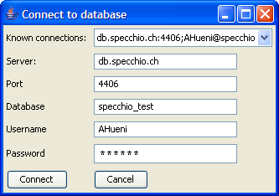

Figure 1: Connecting to the specchio\_test database

## Creating Campaigns on the Test Database

%%% What conventions are going to be used in the UOW database? Should they be documented here? Will they be the same as Andy’s database conventions? Elaine

In order to keep things organised, always include your name in the campaign name by using the following template: <your name>\_<campaign name>, e.g. Andy\_veg\_example. This will make it easier to find your campaigns in the Query Builder where you can see all campaigns of the other users as well (Note that the Query Browser includes a switch that will show only your own data).

## Downloading Test Data Sets

%%% Do we want Users to download from here? Elaine

The data sets used in this tutorial are available on the internet: <http://specchio.ch/tutorial_data.php>.

The following data sets are provided as ZIP archives:

* vegetation\_example.zip
* ger\_example.zip
* gonio\_example.zip

To download the ZIP files click on the links and select ‘Save to Disk’ in the web browser dialog (see Figure 2).

Unzip the ZIP files to some working directory on your machine, e.g. create a new folder called ‘SPECCHIO\_data’ and unzip all datasets into this directory.

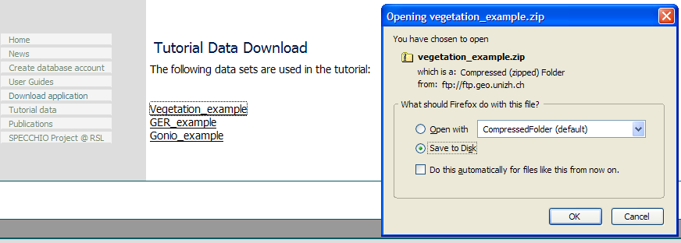

Figure 2: Tutorial data download page

# Part 1: Loading, Editing and Retrieving Data

Data set: Vegetation\_example

## Examine the Folder and File Structure

Open a filing system window and browse the directory structure of the ‘Vegetation\_example’ folder.

It contains three species folders: Blackfern, Cabbage tree and Lemonwood. Open each of these species folders and examine the contents of the site directories contained in them. Blackfern has only one sample site while Lemonwood and Cabbage tree have three resp. two. Also browse inside the site directories to find the ASD binary files (cf. Figure 3).

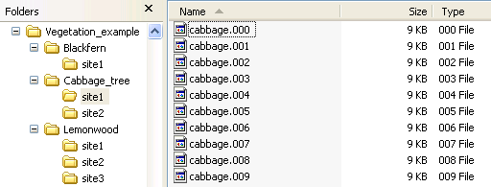

Figure 3: Folder and file structure of the Vegetation\_example campaign

### Example Structure 1

%%% The example web site needs to be defined so this can describe exactly what is available. Elaine

|  |  |
| --- | --- |
| Species: | Multiple |
| Sites: | Multiple sites for each species |
| Measurements: | Multiple measurements per site using ASD file format |
| Example files: | Vegetation\_example %%% SPECCHIO’s web site or UOW web site or... Elaine. |

The spatial extent where a specimen is sampled is termed a sample site, thus a species contains a number of sample sites. The sites are numbered in the order of sampling. At each site, several readings are taken to capture the variation exhibited by the specimen in question. A site therefore contains a number of spectra. This leads to a hierarchical directory structure (Figure 15).

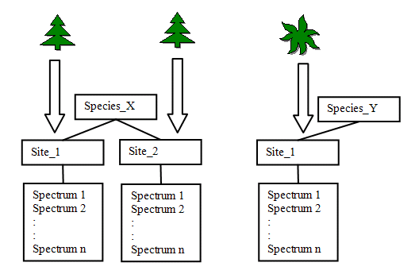

Figure 15: Hierarchical directory structure

Although the term “species” is used it essentially represents the different classes found in a study. These classes can either be assigned due to already existing classification systems for e.g. plants or minerals. In other cases a hypothesis might exist that a number of objects can be separated into classes. If so the setup of the experiment should mirror this hypothesis. If no such assumption exists all objects can be put into the same class (i.e. species) and the identification of classes could then be carried out by a technique such as cluster analysis.

Figure 16 shows an example of a directory structure containing ASD spectral files. The main directory ‘Vegetation\_example’ holds all species directories of the study. This main directory is the folder that needs to be specified in the Path in the Campaign Creation dialog.

The three species directories contain their related site directories.

The site directories contain all spectral files collected at these sites for that species.

The spectral files are auto-numbered by the ASD capturing software within each site directory.



Figure 16: Example of a directory structures holding spectral files

### Example for Reference and Target Spectra

|  |  |
| --- | --- |
| Species: | Multiple |
| Sites: | Multiple sites for each species |
| Measurements: | Radiance spectra measured with use of a reference panel |
| Example files: | Vegetation\_example %%% SPECCHIO’s web site or UOW web site or... Elaine |

If a spectroradiometer is configured to acquire radiances, the irradiance will commonly be characterised indirectly by measuring the radiance reflected by a reference panel. This may be preferable to the direct acquisition of reflectance data as information about the irradiance can be retrieved from the dataset.

The structure must therefore hold target and the related reference radiance spectra in adjacent directories.

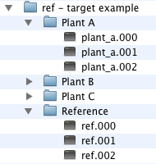

Figure 17: A possible structure for the storage of target and reference radiance spectra

In this example, the Reference sub-directory holds the reference spectra which relate to Plant A, Plant B and Plant C.

## Creating a new Campaign and Loading the Spectra

Create a new campaign by selecting ‘Data Input ‘->‘Create new campaign’. In the new dialog, enter <your name>\_veg\_example as campaign name, e.g. ahueni\_veg\_example. Set the Main directory to the Vegetation example folder (cf. Figure 4).

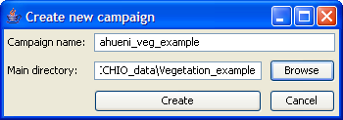

Figure 4: Creation of a new campaign for the vegetation example

Press the create button and a message box should pop up informing about the successful creation of the campaign (cf. Figure 5).

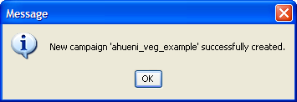

Figure 5: Message box informing on successful campaign creation

Once the campaign has been created load the spectral data of your campaign by selecting ‘Data Input’->’Load campaign data’ and selecting the campaign you just created (cf. Figure 6).

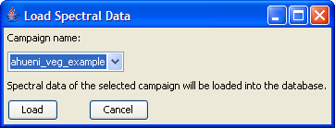

Figure 6: Loading spectral data into a campaign

A message box pops up when the campaign has been loaded (cf. Figure 7). A total of 64 spectral files should now have been loaded into the database.

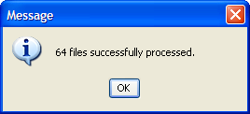

Figure 7: Message box showing the number of processed files during campaign loading

## Get to Know Your Data

Your data are now ready to be visualised and exported. Open the Query Builder by selecting ‘Data Processing & Output’->’Build query’. In the Spectral Data Browser (the tree like display on the left side of the dialog) select your campaign (tick the box ‘Show only my data’ to restrict the displayed campaigns to your own) and explore the structure. Note that the database has stored the hierarchical structure of the campaign folder and displays it accordingly (cf. Figure 8). Also note that as you click around the tree (selecting folders or files) the SQL query and the number of resulting rows on the right side are updated simultaneously. You can also use Ctrl and Shift keys to do multiple selections.

Now select the first 6 spectra of the Blackfern, site1, (the number of resulting rows should be 6) and click on ‘Show report’. A new window will appear looking similar to Figure 9. Note that a scrollable list containing the metadata is associated with every spectrum. Have a look at the metadata and note the data filled in automatically: filename, capture date, spatial position, measurement unit, sensor name, number of spectral channels, instrument name, owner and serial number.

The strong noise in the water bands is due to the generally high humidity found in New Zealand (maritime climate coupled with high yearly rainfall (up to 10 metres in Fjordland)).

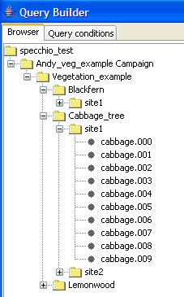

Figure 8: Vegetation example campaign shown in the Spectral Data Browser of the Query Builder

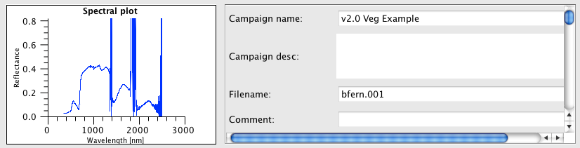

Figure 9: Part of the report on Blackfern spectra

## Exporting Data to CSV

Select File Export in the Query Builder (first select some data as described in 4.3). Specify CSV as file format, an output directory (use the Browse button to select a directory) and a base filename and then press ‘OK’ (cf. Figure 10).

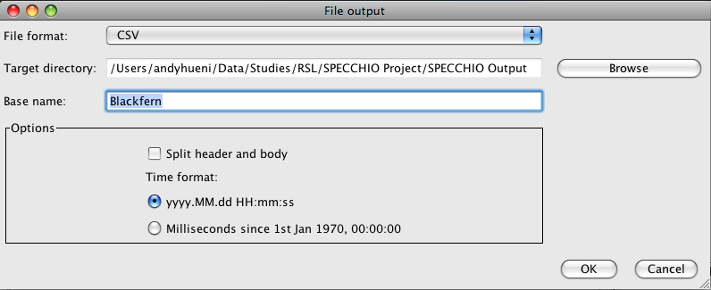

Figure 10: File export dialog

A message box will appear once the export is finished.

Use your file system browser to have a look at the output file that has been written into the output directory you specified (cf. Figure 11). The file name is partly auto-generated and includes the following parts:

* blackfern: the base name you specified
* INR\_ASD: name of the instrument used to sample the data
* ASD FS FR-3: the sensor type



Figure 11: Exported CSV file

CSV files can be conveniently loaded into spreadsheet and statistics applications. Alternatively you can view them in a text editor.

CSV files can be split into header and body, where the header contains all metadata and the body consists of the channel and spectral information.

Figure 12 shows a spectral plot of the first six Blackfern spectra in Microsoft Excel. The first column contains the central wavelength of the bands in nanometres.

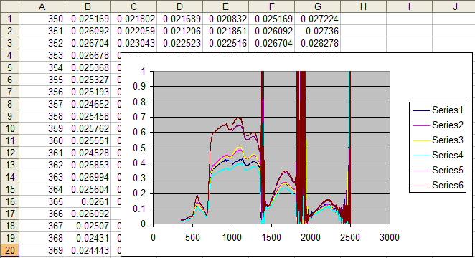

Figure 12: Example of a spectral (XY) plot in Microsoft Excel

## Exporting Data to ENVI Spectral Libraries

Note This exercise assumes that you have access to ENVI. If this is not the case you may skip it.

As a first step repeat the process of file exporting as described for CSV Files in 4.4 but change the file format to ENVI SLB.

To open SLB files in ENVI, start ENVI and select ‘Spectral’->’Spectral Libraries’->Spectral Library Viewer’. Specify an input file by selecting the .slb file (cf. Figure 13).

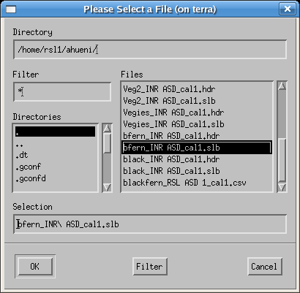

Figure 13: Selecting an slb file to load as spectral library

The spectra names can then be displayed in the Spectral Library viewer (cf. Figure 14) and plotted as Spectral Library Plots. Note that the maximum range of the Y axis must be set to 1 manually as otherwise only noise will be visible (cf. Figure 15).

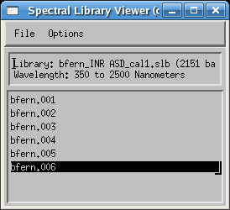

Figure 14: Spectra listed in the Spectral Library Viewer

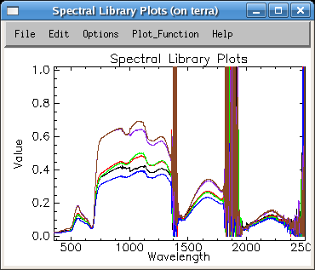

Figure 15: Blackfern spectra as Spectral Library Plots

## Editing Metadata

Open the metadata editor by selecting ‘Data Input’->’Edit metadata’ from the main menu and select your campaign. Note that in the ‘Campaign Data’ tab your name is automatically listed as Investigator.

Enter some description into the description text field, e.g. ‘Just a test’. Note that as soon as you change some data in the metadata editor the relevant ‘Update’ button (in this case the button in the campaign data section) gets activated (cf. Figure 16).

Perform the update by clicking on the update button. This stores your changes in the database. The update is done when the ‘Update’ button reverts to being grey and inactive.

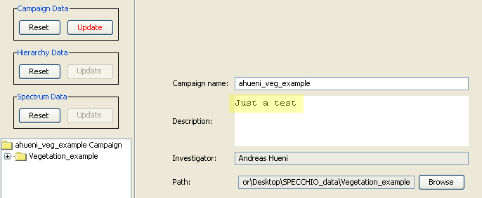

Figure 16: Editing the description of a campaign

Switch to the ‘Spectrum Data’ tab and select the ‘Blackfern’ folder in the Spectral Data Browser (cf. Figure 17).

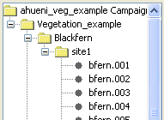

Figure 17: Selecting 'Blackfern' in the Spectral Data Browser of the Metadata Editor

By selecting multiple spectra (e.g. by selecting a folder or several single spectra) you automatically enter the so called ‘group update modus’. All data that you enter will apply to all the selected spectra. Note that some fields are not editable but greyed and inactive. These fields contain already individual spectrum metadata and are therefore disabled.

As all the spectra under the Blackfern hierarchy are of the same plant species and entering the plant names can be done for all spectra with a single operation. To enter a new name, click ‘Add’ in the ‘Names’ section. First type the common name ‘Blackfern’, then specify the type as ‘Common’ from the list (cf. Figure 18). In a similar manner enter the Latin name: ‘Cyathea medullaris’.

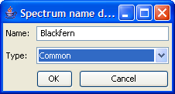

Figure 18: Entering a common name

The names now appear as shown in Figure 19. Note that the ‘Update’ button of the ‘Spectrum Data’ section has been activated. Perform now the update on the database by clicking the ‘Update’ button.

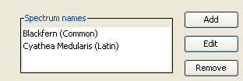

Figure 19: Spectrum names

All three species (Blackfern, Cabbage Tree and Lemonwood) are typical for New Zealand forests. They all share a common landcover type. To set the landcover for all spectra, first select the top folder called ‘Vegetation\_example’.

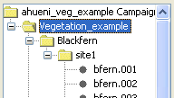

Figure 20: Selecting the top folder 'Vegetation\_example'

Now select the landcover type ‘Deciduous Forest’ in the CORINE landcover tree (cf. Figure 21). Press ‘Update’ to apply the selected landcover type to all spectra of this campaign.

You can now check the fact that indeed all spectra have this landcover type set by selecting single spectra in the Spectral Data Browser.

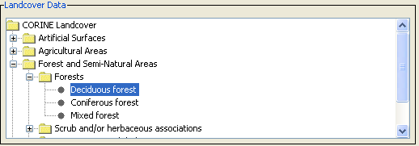

Figure 21: Specification of the landcover

Pictures taken at the sampling sites can be entered into the spectral database. Pictures for Blackfern and Lemonwood are provided in the vegetation\_example.zip file. You will find the pictures alongside with the Vegetation\_example folder in the directory where you un-zipping the data.

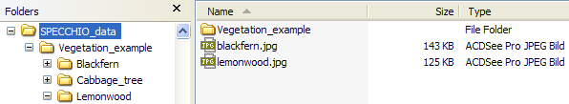

Figure 22: Location of the species pictures

To apply the Blackfern picture to all Blackfern spectra select the Blackfern hierarchy in the Spectral Data Browser. Click ‘Add’ in the Pictures section, browse to the Tutorial folder and select blackfern.jpg. To enter a caption, simply type it into the editable field below the picture (cf. Figure 23). Then update the database.

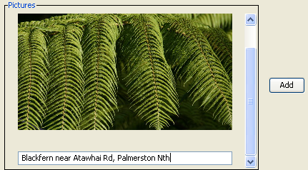

Figure 23: Example of a picture with a caption

In a similar manner insert the supplied lemonwood.jpg picture for all Lemonwood spectra.

Note that performing group updates not only speeds up the input process but also minimizes the amount of data stored in the database. All spectra in the selected group are referencing a single entry in the database, thus avoiding data redundancy.

A general problem of spectral data collections is the quality and trustability of the data. This is especially true if the data were collected by third parties and the sampling conditions are unknown. One way to improve the usability and shareability of spectral data is to include more metadata. SPECCHIO addresses this by the means of metadata quality levels.

In the Metadata Editor activate the checkboxes ‘Highlight mandatory fields’ and ‘Show quality compliance in tree’. Select the bfern.001 spectrum in the Spectral Data Browser and set the required quality level of this spectrum to B (cf. Figure 24).



Figure 24: Required quality level set to B

All required field should now be highlighted. Update the spectrum on the database. If the quality compliance is not shown in the tree, have it displayed properly by selecting your campaign explicitly again in the ‘Campaign Selection’ of the Metadata Editor. All non-complying spectra plus the containing hierarchies are marked with an asterisk (cf. Figure 25).

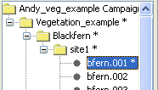

Figure 25: Non quality compliance indicated by asterisks

Fill in the missing metadata for the bfern.001 spectrum:

* Cloud cover: 1 okta or less, but not zero
* Beam geometry: Hemispherical-conical (CASE 8)
* Sampling Environment: Field
* Target Homogeneity: homogenous
* Sensor zenith: 0
* Sensor azimuth: 180 (this is equivalent to the principal plane opposite the sun)
* Sensor distance: 1
* Illumination zenith: 40
* Illumination azimuth: 0 (In the Southern hemisphere the sun stands in the North at midday)
* Target type: Add a new target type by clicking the ‘Add’ button, then specify the target type as ‘Tree’ and set it’s abundance = 100   
    
  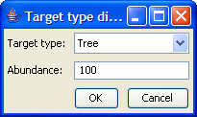

After updating the spectrum in the database, the non-compliance indicators in the spectral data browser should be removed.

# Part 2: GER Files

Data set: GER\_example

The GER files are contained in the GER\_example folder. Explore the folder. You will notice that there are 10 files as created by the GER instrument. Create a new campaign to hold GER files (cf. Figure 26).

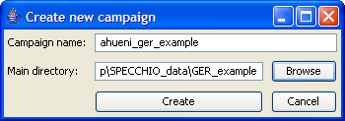

Figure 26: Creation of a GER example campaign

After creating the campaign load the spectral data into the database by selecting ‘Data Input’->’Load campaign data’ and selecting the campaign you just created (cf. Figure 27).

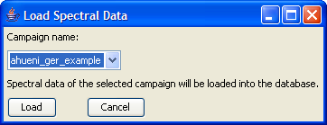

Figure 27: Loading spectral data into the GER campaign

Open the Query Builder. Open the tree of the GER campaign and study the contents. The files have been automatically split into target and reference spectra (cf. Figure 28). Remember that GER instruments write the sampled radiances of target and white reference into the same file. The names of the corresponding targets and references are identical, e.g. target GR083005.080 is associated with reference GR083005.080.

|  |  |
| --- | --- |
|  |  |

Figure 28: GER files split into target and reference spectra (left) and report showing target and reference spectra (right)

Targets and references are linked internally by a datalink on spectrum level. Open the Metadata Editor and display the spectrum data for one of the GER target spectra. Note that a link referring to the reference spectrum of the type Spectralon has been created (cf. Figure 29).

These datalinks are used during radiance to reflectance conversion.

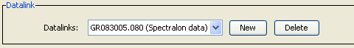

Figure 29: Automatically created link between target and reference spectra

# Part 3: Directional Data

Data set: Gonio\_example

This exercise uses FIGOS goniometer data. FIGOS is used at RSL to acquire spectrodirectional measurements in 66 points arranged on a hemisphere. For more information please refer to Schopfer et al. (2007).

Goniometer data is provided in the Gonio\_example folder. It contains two subfolders: one holding the targets and one the references. The spectra of targets and references have been manually moved to these folders. This separation should be carried out before the data is loaded into SPECCHIO (alternatively all data can be loaded and the unwanted spectra removed using the Data Remover tool). It must also be noted that any surplus measurements must also be removed, i.e. the system expects 66 directional measurements maximum. SPECCHIO can however deal with gaps in the data as will be demonstrated hereafter.

Create a new campaign for goniometer data and load the campaign data.

If you explore the data in the Metadata Editor, you will find that the Measurement unit has been set to Radiance and the FOV to 3 degrees. Use a group update to set the Beam geometry of all spectra of this campaign to ‘Hemispherical-conical (CASE 8)’.

In the Metadata Editor select the special function ‘Link targets to references’ (cf. **Error! Reference source not found.**). In the ‘Link Target to Reference’ dialog select the target and reference directories of the goniometer campaign as inputs (cf. Figure 30) and press ‘Link’. The datalinks have now been created.

In the Metadata Editor explore the datalink settings (cf. Figure 29). You should find that the targets triticaa.001 and triticaa.002 are referencing the triticaa.000 white reference spectrum. Targets triticaa.003 – triticaa.009 reference triticaa.006 and so on and so forth. The linking mechanism is based on the spectrum capture time and does not depend on the spectrum file name.

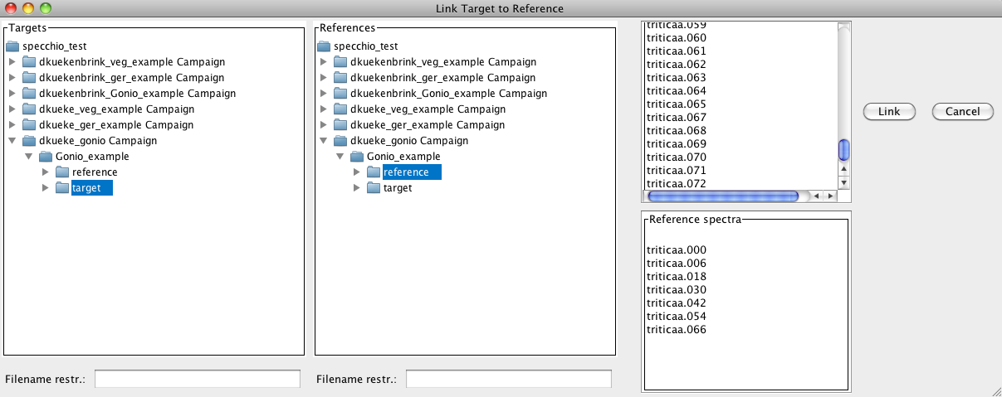

Figure 30: Specifying target and reference directories

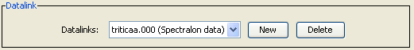

Figure 31: Example of an automatic created datalink

The illumination geometry (i.e. the sun zenith angle and azimuth) can be calculated automatically if the spatial position (latitude and longitude) and the capture time in UTC are known.

For the given dataset we assume that the time is local time and not UTC. This can be corrected by the special function ‘Correct local time to UTC’. In the time correction dialog select the Gonio\_example folder because the time shift should be applied to both target and reference spectra. The time difference to GMT is 2 hrs (East) as the sampling took place during summer in Switzerland, i.e. daylight saving applies (cf. Figure 32).

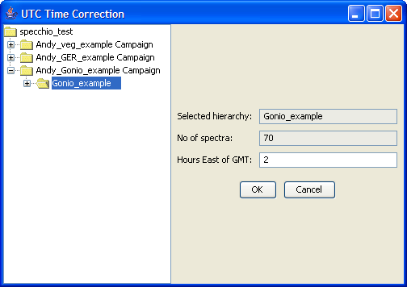

Figure 32: Applying a time shift to goniometer data

As a next step the coordinates of the sampling area must be defined. A position of N47° 22.400’ E08° 32.438’ is assumed. Positions must be entered as floating point degrees (GARMIN hddd.ddddd° format). This yields: N47.37333° E08.54063°.

In the Metadata Editor select the Gonio\_example hierarchy in the Spectral Data Browser. As the position applies to all spectra of the campaign a group update should be carried out. Now enter the latitude (47.37333) and longitude (-8.54063). Longitudes East of Greenwich are negative.

Having entered position and time (do not forget to press the ‘Update’ button), the calculation of the illumination geometry can be carried out by clicking the ‘Calc Sun Angles’ button (cf. Figure 33).

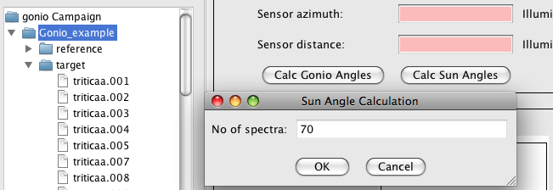

Figure 33: Sun angle calculation for goniometer data

Use the Spectral Browser of the Metadata Editor to check the sun angles that have been calculated. Every spectrum has been assigned slightly differing sun angles according to the individual capturing time.

The angles of the goniometer can be calculated for each spectrum using the ‘Calc Gonio Angles’ function. Select the target hierarchy and click the ‘Calc Gonio Angles’ button. On the left side of the dialog the number of spectra in the selected hierarchy is displayed (63 spectra). There are three spectra missing from the normal total of 66. If you study the names of the target spectra it seems that the missing spectra numbers are: 55, 56 and 57. Specify the gaps as 55,56,57 and press ‘Insert gaps’. The total number of positions is shown in the field ‘Spectra + dummies’, i.e. 66 in this case. Press ‘Calculate’. The list above the ‘Calculate’ button now contains the positions (starting at zero), the calculated angles and the spectrum filenames. Scroll down till you find the inserted dummies called ‘gap dummy’ (cf. Figure 34).

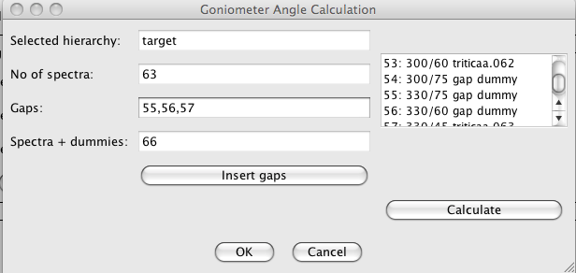

Figure 34: Inserted gaps and resulting angles

At this point you would have to refer to your field protocol in order to confirm that the gaps you specified did occur at the calculated angles. Let us assume that number 57 actually exists but number 60 is missing. Change the gap specification to: 55,56,60. Press ‘Insert gaps’ and ‘Calculate’ and check the list again. Once you are satisfied with the calculated angles press ‘Ok’ to store the angles in the database. Use the Metadata Editor to check that the angles have indeed been saved and are now correctly displayed.

E.g. for the spectrum triticaa.040 you should find a sensor zenith of 30° and azimuth = 270° (cf. Figure 35).

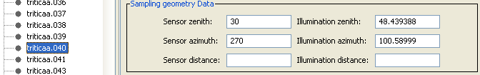

Figure 35: Calculated sensor zenith and azimuth angles

# Part 4: Data Querying, Processing and Exploration

## Converting Radiances to Reflectances

Data set: GER\_example

The GER example data set contains reference and target measurements that have been linked automatically during data load. Our goal is the conversion of target radiances to reflectances using the respective function of the Space Network Processor.

Open the Query Builder, browse to your GER example, select the targets hierarchy (Figure 36) and press the ‘Process’ button.



Figure 36: Selection of the target hierarchy of the GER example data set

A Space Network Processor window will open, containing a space holding the ten target spectra (Figure 37). The dimensionality of the space is 647, which is equal to the number of bands of the GER instrument.

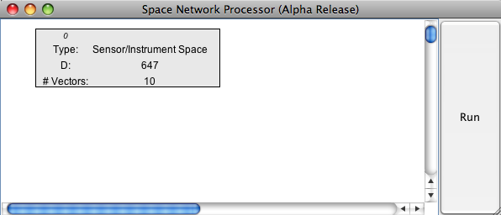

Figure 37: Space Network Processor window with space containing the target spectra

Add ‘Radiance to Reflectance Transformation’ as a new processing module to the processing plane by clicking the menu button over the processing plane and selecting the module.

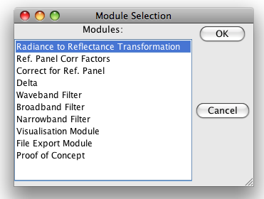

Figure 38: Selection of the ‘Radiance to Reflectance Transformation’ module

Connect the new module with the input space (space 0) by clicking the menu button over the module and selecting ‘Set Input Spaces’ in the module menu (Figure 39) and choosing space number 0 as input space (Figure 40).

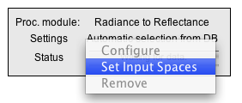

Figure 39: Module menu

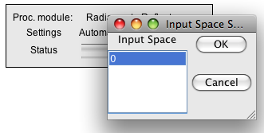

Figure 40: Input space selection for the ‘Radiance to Reflectance Transformation’ module

A new space is added to the processing plane automatically, containing to output of the ‘Radiance to Reflectance Transformation’ module (Figure 41).

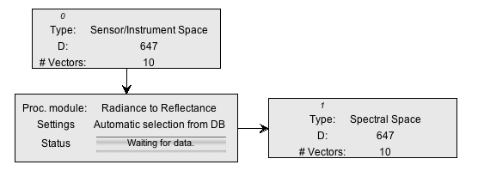

Figure 41: Input and output spaces of the ‘Radiance to Reflectance Transformation’ module

Now, we would like to see what this transformation is actually doing by plotting the input and output spectra.

Add two new modules of the type ‘Visualisation Module’ to the processing plane, configure them as ‘Spectral Line Plot’ and connect them with the input space (space 0) and the output space (space 1) respectively. Your Space Processing Network should now be similar to the one shown in Figure 42.

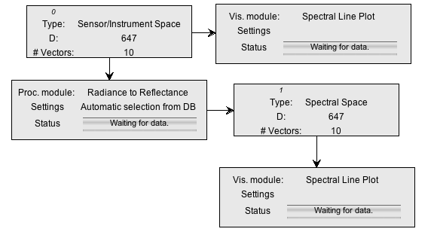

Figure 42: Space Processing Network for radiance to reflectance transformation and visualisation

Press the ‘Run’ button of the Space Network Processor and two spectral plots should appear (Figure 43).

|  |  |
| --- | --- |
|  |  |

Figure 43: Spectral plots of radiance and calculated reflectance

The calculated reflectances show the typical features of a vegetation spectrum (green peak, red edge, water absorption features). The high reflectance in the UV-Blue of the first few bands is an artefact of the instrument and indicates an unreliable calibration of the according channels.

## Data Queries

Data set: all campaigns loaded to the database.

If you worked through the whole tutorial a total of three new campaigns should now be loaded to the database. Note that you have access to campaigns other persons entered in the database. Queries on the database can thus return more rows than you might expect!

Open the Query Builder and switch to the ‘Query conditions’ tab.

In the wildcard field of the Campaign name type in your first or last name followed by the percentage sign, e.g. ‘hueni%’. Alternatively, select your name from the investigators list.

The number of resulting rows should be 154 (if all 3 tutorial data sets were loaded).

Select ‘Hemispherical-conical (CASE 8)’ as beam geometry The number of rows should drop to 70 and the autobuilt SQL statement looks similar to:

SELECT distinct count(\*) FROM spectrum, campaign WHERE campaign.user\_id = '6' AND spectrum.date >= 20050531105830 AND spectrum.date <= 20120224110223 AND spectrum.measurement\_type\_id = '2' AND spectrum.campaign\_id = campaign.campaign\_id

As a matter of fact, the spectra selected by this query all belong to the goniometer campaign that you created in this tutorial. The same result set is returned when the goniometer campaign is selected implicitly.

The result set can be further restricted by e.g. sampling geometry conditions. Narrow the search for spectra with zenith angles between 0º and 30º by entering a sensor zenith angle of 15 and a buffer size of 15 and sensor azimuth of 90 with buffer size 90 (cf. Figure 44).

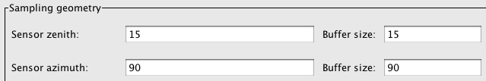

Figure 44: Specifying a sensor zenith/azimuth angles and buffer values

The resulting SQL statement should look like:

SELECT distinct count(\*) FROM spectrum, campaign, sampling\_geometry WHERE campaign.user\_id = '6' AND spectrum.date >= 20050531105830 AND spectrum.date <= 20120224110223 AND (sampling\_geometry.sensor\_zenith >= 0.0 AND sampling\_geometry.sensor\_zenith <= 30.0) AND (sampling\_geometry.sensor\_azimuth >= 0.0 AND sampling\_geometry.sensor\_azimuth <= 180.0) AND spectrum.measurement\_type\_id = '2' AND spectrum.campaign\_id = campaign.campaign\_id AND spectrum.sampling\_geometry\_id = sampling\_geometry.sampling\_geometry\_id

The number of resulting rows should be 17.

Press the ‘Process’ button in the Query Builder to load the selected data into the Space Network Processor. Add a new Visualisation Module, configure it as ‘Gonio Hemisphere Explorer’ and connect it with the input space (Figure 45).

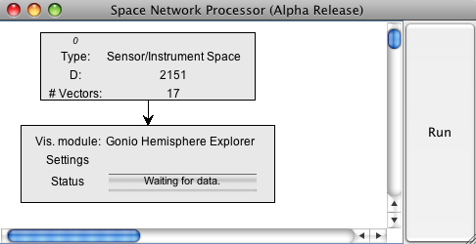

Figure 45: Gonio Hemisphere Explorer connected to the input space

Press the ‘Run’ button of the Space Network Processor. A Gonio Hemisphere Explorer window will open (Figure 46).

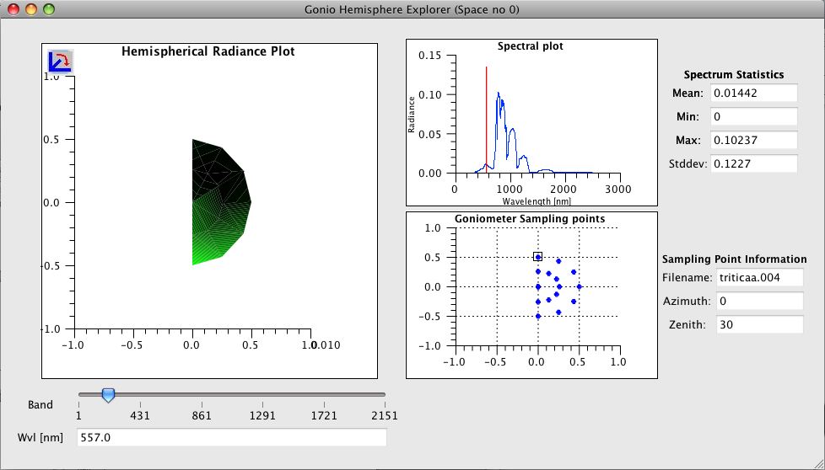

Figure 46: Gonio Hemisphere Explorer showing the data points selected in the Query Browser

Note that according to the selection in the Query Browser, only a limited number of points are displayed. The Gonio Hemisphere Explorer can handle any number of spectrodirectional data points and could thus be used on data stemming from different goniometer systems as well.

The data comprises spectrodirectional measurements of a wheat field (triticale). The hemispherical plot nicely illustrates the backward scattering of vegetation canopies (highest radiances are observed in the principal plane). The illumination source is at azimuth position 180° in the shown plot.

# Document History

|  |  |  |  |
| --- | --- | --- | --- |
| **Version** | **Date** | **Author** | **Remark** |
| 3.0 | %%% TBD | Peter Roberts (Intersect) | The Tutorial Chapter has been separated from the User Guide into its own document. |