SPECCHIO

SPECCHIO Virtualbox

Version: 3.2.1.63.2.1.6

Date: 04.04.201704.04.2017

Status: ApprovedApproved

Authors: A. Hueni (UZH)A. Hueni (UZH)

File: SPECCHIO\_VM.docx

Pages: 22

Classification:

Distribution: SPECCHIO UsersSPECCHIO Users

::::RSL_logo_new.pdf

# Contents

1 Contents 2

2 Introduction 3

2.1 Document scope 3

2.2 Intended audience 3

2.3 SPECCHIO ownership and access 3

2.4 Copyright and licensing 3

2.5 For Further Information 3

3 Installation, Configuration and Usage 4

3.1 Prerequisites 4

3.2 Installing the SPECCHIO Virtual Machine 4

3.3 Logging into the Virtual Machine 4

3.4 Virtual Machine Configuration 4

3.5 Accessing SPECCHIO via the Web Interface 5

3.6 Launching the SPECCHIO Application 6

3.7 Creating a User Account 7

3.8 Networking Access to the SPECCHIO Server 8

3.9 Accessing SPECCHIO from the Host Machine 10

3.10 Accessing SPECCHIO from Outside the Virtual Machine 11

3.11 Accessing SPECCHIO from Outside the Virtual Machine using the VM Name 12

3.12 Accessing SPECCHIO VM in the Field without any existing Network 13

3.13 Mounting a host folder into the VM 14

3.14 Handling larger database requirements 15

4 Upgrading the SPECCHIO System 16

4.1 Automatic Upgrade 16

4.2 Manual Upgrade 17

4.2.1 Manual Web Service Update 17

4.2.2 Manual SPECCHIO Client Update 18

Appendix A: Change History 19

Appendix B: Installing the Automatic Updating Script 20

Appendix C: Bridged Networking under MacOS – Ethernet and WiFi 21

# Introduction

This document introduces the SPECCHIO Virtualbox. It is a complete SPECCHIO server and client installed under a virtual CentOS 6.4 installation using Virtualbox.

## Document scope

This Guide details operation of the Virtualbox installation of SPECCHIO only.

## Intended audience

SPECCHIO users who want to run the full system locally, either on their personal machines or on a server at their own institution and who do not want to go through the hassle of a full system installation themselves.

## SPECCHIO ownership and access

SPECCHIO was originally built by the Remote Sensing Laboratories at the University of Zurich, and extended by Intersect for the School of Earth and Environmental Sciences at the University of Wollongong.

## Copyright and licensing

SPECCHIO is licensed under the Creative Commons Attribution-ShareAlike 3.0 Unported Licence. Therefore its source is readily available for inspection and development. It can be found in LICENCE.html and at http://creativecommons.org/licenses/by-sa/3.0/.

## For Further Information

Please refer to the following documents for more information about SPECCHIO. Unless otherwise stated, they can be found in the SPECCHIO Installation kit.

**SPECCHIO\_ReleaseNotes.pdf** can be found in each Installation Kit and provides installation instructions for the SPECCHIO Client.

**SPECCHIO\_Tutorial.pdf** provides instruction in the operation of key areas of the SPECCHIO Client.

**SPECCHIO\_ServerInstallation.pdf** provides system administrators with information to assist in managing and maintaining a SPECCHIO Server System.

**SPECCHIO Web Site (**[www.specchio.ch](http://www.specchio.ch)) General information about SPECCHIO. Some of this information may be related to other non-UOW versions of SPECCHIO.

**SPECCHIO UoW (**https://specchio.uow.edu.au)Installation kits for University of Wollongong version of the SPECCHIO Client and documentation for that version.

**SPECCHIO DC10 GitHub (**<https://github.com/IntersectAustralia/dc10>) Source code for the University of Wollongong version of SPECCHIO.

**SPECCHIO GitHub (**https://github.com/ahueni/SPECCHIO) Source code for the community version of SPECCHIO, currently developed under the lead of RSL (University of Zurich).

# Installation, Configuration and Usage

## Prerequisites

Download the SPECCHIO virtual machine image (2.7 GB) from <ftp://v473.vanager.de/SPECCHIO-3.2.0-VM.ova> (or use any other SPECCHIO image that you have received).

Install the Virtualbox on your computer (<https://www.virtualbox.org>).

Install the Virtualbox Extension Pack (<https://www.virtualbox.org>): this will, among other things, give you access to USB ports, better mouse support.

## Installing the SPECCHIO Virtual Machine

Caveat: this virtual machine has been setup using a MacOS 10.9 system as host and the Virtualbox extension pack was installed. Non-MacOS host installations may have to be slightly reconfigured.

Double-click the SPECCHIO-3.2.1-VM.ova file and it should show up as virtual machine in the Virtualbox Manager.

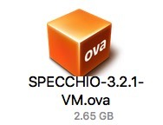

## Logging into the Virtual Machine

Login as user ‘centos’ using the password ‘reverse’.

## Virtual Machine Configuration

Depending on your host machine, you may have to configure the keyboard to be used by the VM. To do this, select ‘System’-‘Preferences’-‘Keyboard’ from the menu



## Accessing SPECCHIO via the Web Interface

SPECCHIO features a new interface via a web browser, starting with version 3.2.1.6.

The SPECCHIO VM comes pre-installed with the web interface. To start it open a browser in the VM and enter localhost:8080 as address:

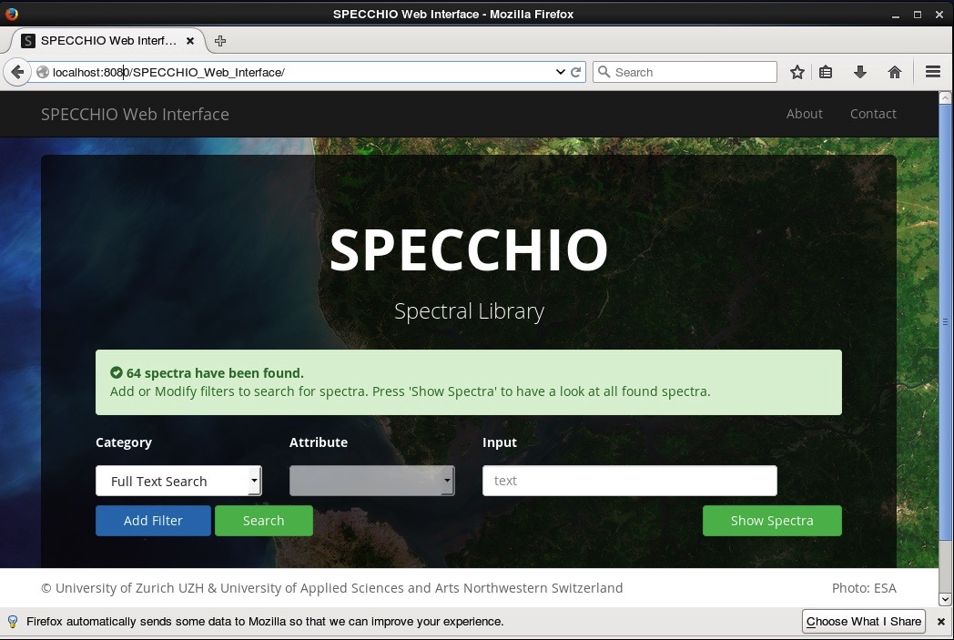

To access the web interface from host system, no further configurations are required, as port 8080 is by default forwarded to the SPECCHIO VM. Hence, in your host system type localhost:8080 into the address field:

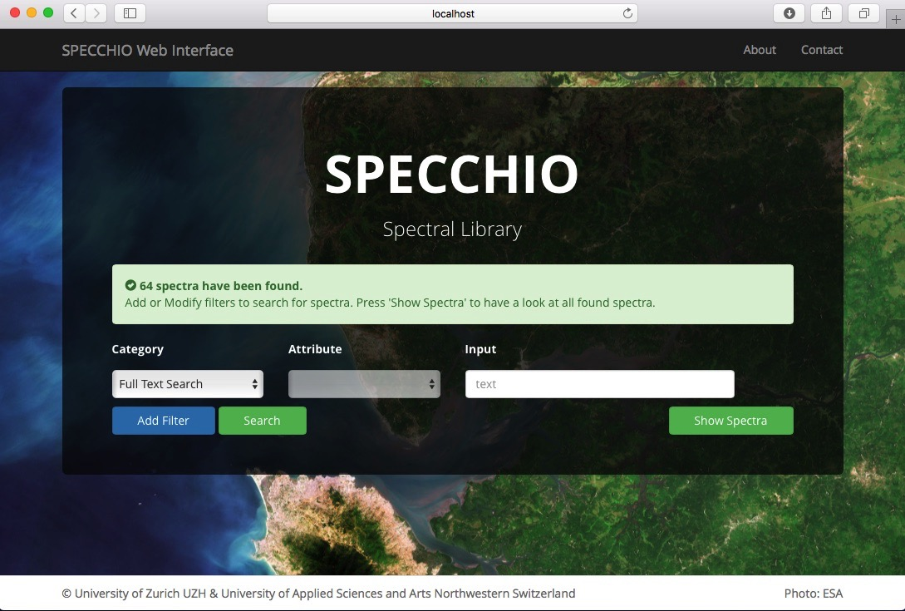

## Launching the SPECCHIO Application

Double-click the SPECCHIO Client App icon on the desktop or on the top icon bar and a few seconds later the SPECCHIO application is launched.[[1]](#footnote-1)

 

Figure : SPECCHIO client launching icon on the desktop (left) and on the top icon bar (right)

Use the existing connection using port 8080 to connect to the database as SPECCHIO database administrator (sdb\_admin).

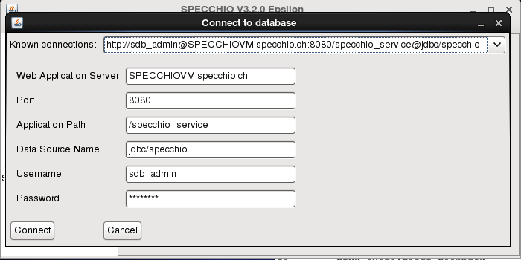

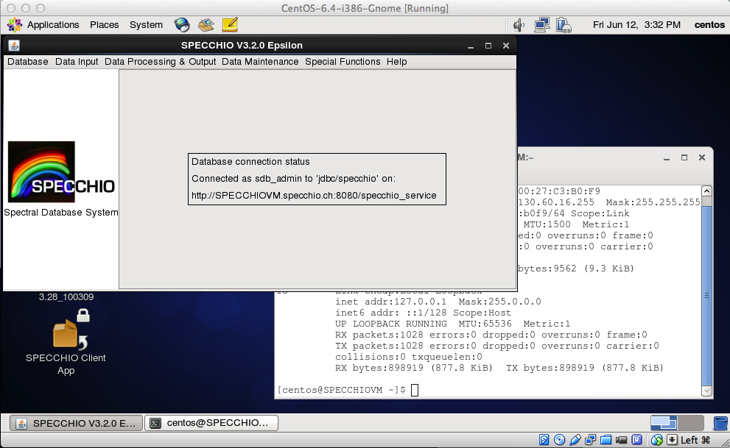

## Creating a User Account

**Note:** this SPECCHIO server is preconfigured for use with the sdb\_admin user. Adding a new user is not strictly required.

User Accounts can be created by connecting to the https port 8181.

This works without any further configuration from within the SPECCHIO VM.

Connecting from outside of the VM with a SPECCHIO Client to port 8181 requires a DNS that can resolve SPECCHIOVM.specchio.ch to the SPECCHIO VM IP (see also 3.10). Note that the connection **must** be done via SPECCHIOVM.specchio.ch and not via an IP; this is a restriction imposed by the certificate definition used by the SPECCHIO server.

The easiest solution is therefore to create the account for a SPECCHIO client installed on a different machine is using the SPECCHIO client within the VM and then copy the generated connection string from the db\_config file and paste it into the db\_config file of the SPECCHIO application installed on the target machine.

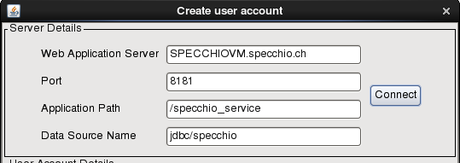

## Networking Access to the SPECCHIO Server

The SPECCHIO server running inside the VM can be accessed from the network. The following options exist:

* Connect to SPECCHIO server from the host machine, i.e. the machine running the VM (see 3.9)
* Connect to SPECCHIO server from a machine different from the host machine (see 3.10)

The SPECCHIO VM comes preconfigured in the NAT networking mode. Connections to the VM are established via port forwarding rules.

By default the localhost, i.e. the host machine is preconfigured for the port forwarding. To open the port forwarding option dialogue, open the ‘Settings’ dialogue of your VM, then select the ‘Network’ tab and display the ‘Advanced’ settings, then click on the ‘Port Forwarding’ button.

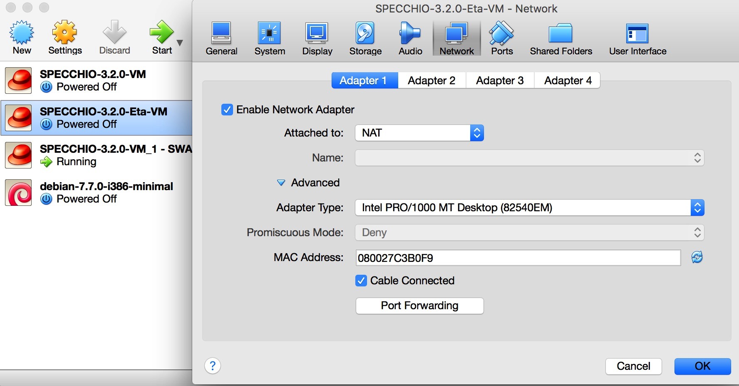

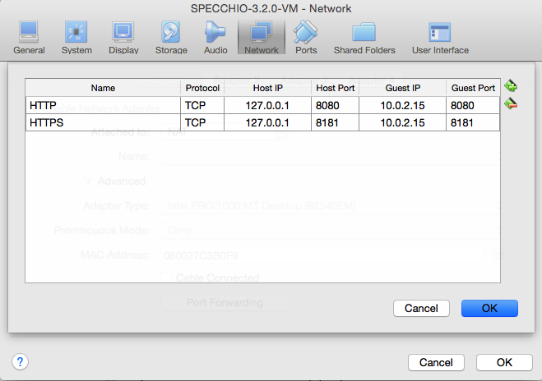

If access to the SPECCHIO VM is required from other machines in the network, then the forwarding rule must be defined with the IP of the host machine. The port forwarding defines which packets reaching a port on the host shall be forwarded to a certain port in the VM. The example below defines two forwarding rules (a) all connections on the host via port 8080 or 8181 are forwarded to the VM, and (b) all connections from external to the host (which in this example got the dynamic IP 130.60.16.221) on port 8080 or 8181 are forwarded to the VM.

Note that the guest IP remains the same once the networking is configured as NAT. The only problem that presents itself is the changing IP of the host machine. Ideally the host has a static IP, otherwise, once the IP is assigned via DHCP, the port forwarding table must be updated.

If the IP is defined by DHCP then the rules must be adapted each time the IP changes, usually a re-lease is triggered by disconnecting the machine from the network and not reconnecting for a certain time. Thus, the easiest solution is to keep the host machine running the SPECCHIO VM connected to the network as long as it must be accessible via the network. Optionally, a fix IP would solve this issue once and for all, but this may only be feasible for servers.

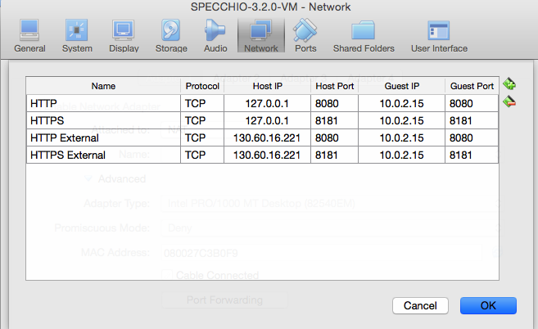

## Accessing SPECCHIO from the Host Machine

You can connect to the virtual SPECCHIO server from the hosting machine using the SPECCHIO Client.

Open the SPECCHIO db\_config.txt file in the Virtual Machine by selecting ‘Edit db\_config file’ from the SPECCHIO menu and copy the http connection string to the db\_config file on the host machine.

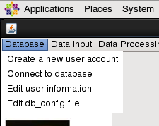

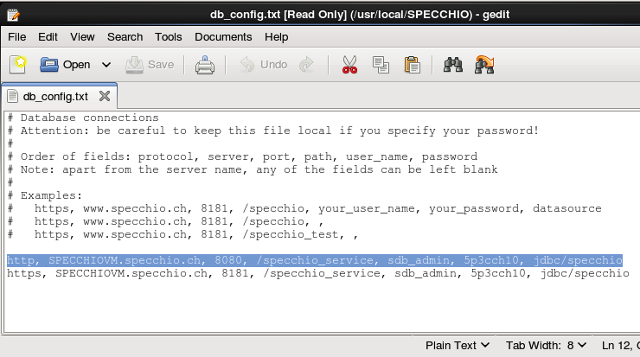

In the db\_config file on the host machine replace the server name ‘SPECCHIOVM.specchio.ch’ with ‘localhost’:

http, localhost, 8080, /specchio\_service, sdb\_admin, 5p3cch10, jdbc/specchio

Connect to the SPECCHIO server running in the Virtual Machine:

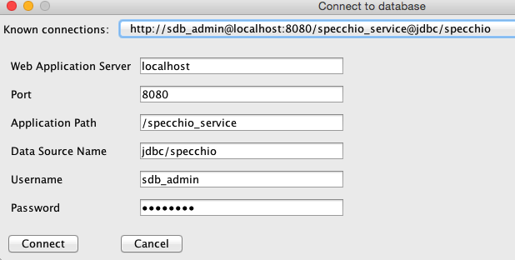

## Accessing SPECCHIO from Outside the Virtual Machine

Connecting from outside[[2]](#footnote-2) of the VM with a SPECCHIO Client requires a connection via the IP of the host machine, the connection is then automatically forwarded to the VM[[3]](#footnote-3).

Copy the connection details as described in section 3.9. In the db\_config file on the external machine replace the server name ‘SPECCHIOVM.specchio.ch’ with the IP of the host, e.g. for 130.60.16.221:

http, 130.60.16.221, 8080, /specchio\_service, sdb\_admin, 5p3cch10, jdbc/specchio

Connect to the SPECCHIO server running in the Virtual Machine:

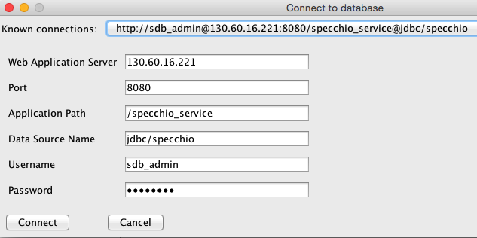

## Accessing SPECCHIO from Outside the Virtual Machine using the VM Name

Connecting from outside of the VM with a SPECCHIO Client using the SPECCHIOVM.specchio.ch machine name requires a DNS that can resolve SPECCHIOVM.specchio.ch to the SPECCHIO VM IP. Using the VM name ‘SPECCHIOVM.specchio.ch’ instead of the IP is mandatory if a HTTPS connection is required, e.g. to create a new user account [[4]](#footnote-4).

Once the port forwarding for external connections to the host is defined, the hosts file of a client machine wishing to connect to the SPECCHIO VM must be updated to map the host IP to the SPECCHIO VM hostname. On a Mac, this would be defined in the /etc/hosts file, on Windows, the C:\Windows\System32\drivers\etc\hosts file is used. Of course, this gets inconvenient if the host IP changes frequently.

Table : Edited hosts file to map the IP of the host running the VM to SPECCHIOVM.specchio.ch

|  |
| --- |
| ##  # Host Database  #  # localhost is used to configure the loopback interface  # when the system is booting. Do not change this entry.  ##  127.0.0.1 localhost  255.255.255.255 broadcasthost  ::1 localhost  fe80::1%lo0 localhost  **130.60.16.221 SPECCHIOVM.specchio.ch** |

To be able to connect via HTTPS the SPECCHIO App on non-host machines must have the correct keystore file that contains the certificate of the SPECCHIO VM. Copy the specchio.keystore file from the VM (/usr/local/SPECCHIO/specchio.keystore) into the appropriate SPECCHIO directory on the non-host machine, essentially replacing the existing keystore file with the VM keystore file.[[5]](#footnote-5) If you somehow lost the keystore file because of an update of the SPECCHIO client App then a copy of the SPECCHIO VM keystore file can be found on the VM in /root/Documents/SPECCHIO\_Installation.

The SPECCHIO App can now be configured to connect to the SPECCHIO VM via https:

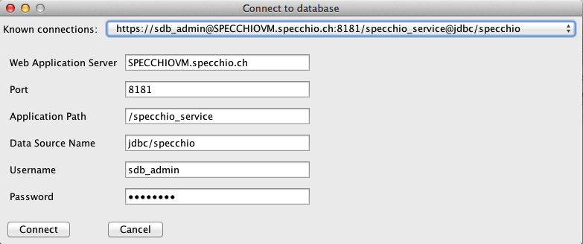

## Accessing SPECCHIO VM in the Field without any existing Network

**In Work … This section is not yet finished. More information will be added when practical tests have been conducted.**

This assumes that the SPECCHIO VM is used in a setting where no Ethernet of WiFi connection is existing per se.

Using the SPECCHIO VM on a single machine is no problem as no network is required.

Using the SPECCHIO VM running on one machine and connection from other machines to it requires the setup of an ad-hoc wireless.

This will be machine dependent and only the case of MacOS is used to illustrate this.

On the host machine running the SPECCHIO VM create a WiFi network:

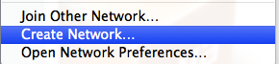

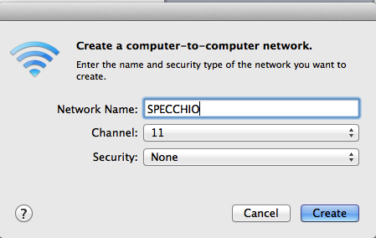

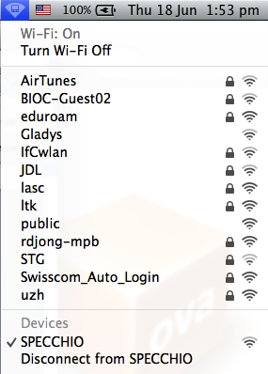

If the SPECCHIO VM is configured to have a static IP, the VM should be accessible to all machines connecting to the new wireless network.

## Mounting a host folder into the VM

This is not specific to the SPECCHIO VM, but useful to know anyway:

Add the folder of the host machine to be shared with the VM in the Shared Folders list and give it a name, in the case below ‘Documents’:

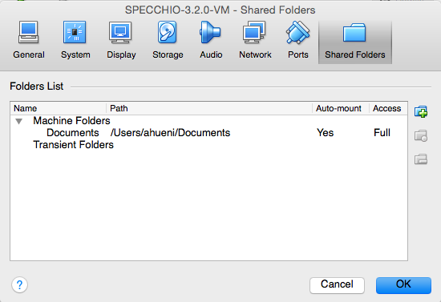

Assume you want to share your Documents folder and mount it in /mnt in the VM.

In the VM, mount the shared folder by opening a terminal window and type:

mount –t vboxsf Documents /mnt

## Handling larger database requirements

The size of the VM is limited by means of configuration. For larger databases it is suggested that the database physical files are not held within the database but put onto a different server that will then be visible to the SPECCHIO VM. This could for example be achieved by putting the database file on the host machine and linking the directory into the VM.

While theoretically possible, this option has not yet been implemented, thus, no details can be presented here.

# Upgrading the SPECCHIO System

SPECCHIO remains under active development and both the client application and the web service binary require occasional updates.

## Automatic Upgrade

The SPECCHIO server and client can be automatically upgraded.

To do so **log into the VM as ‘root’** (The root password is also ‘reverse’).

On the desktop there is an application launch icon called ‘SPECCHIO Software Update’. Double click the icon and a terminal window will open, carrying out the update script.

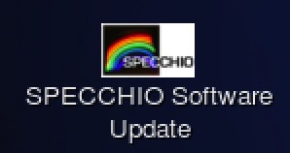

Figure : SPECCHIO Software Update icon

The upgrade first downloads and deploys the newest SPECCHIO server binary; check the terminal output to see if no errors occur. If all works as planned, the output will be similar to:

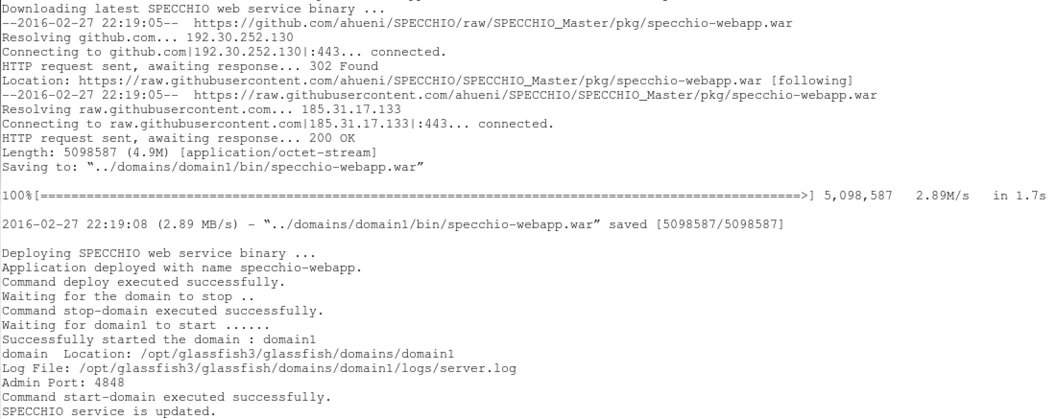

In a second step, the client installer is downloaded and started.

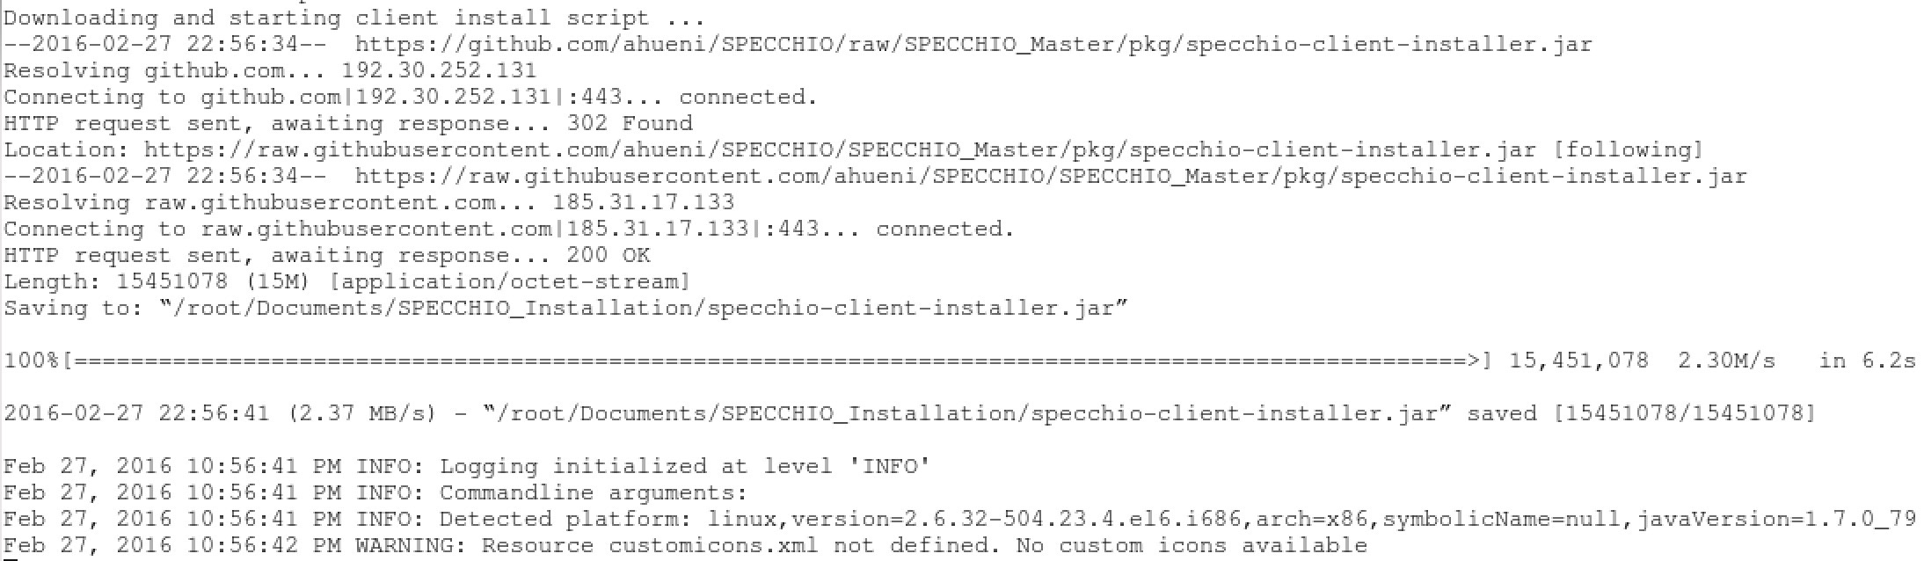

The installation dialogue will be displayed, guiding you through the installation process:

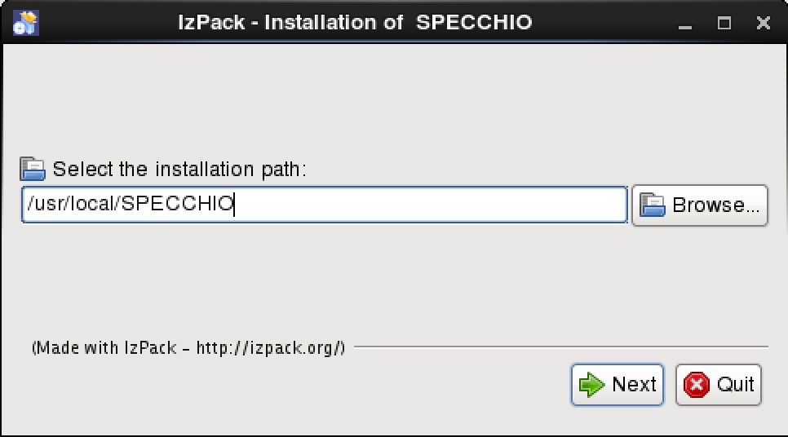

## Manual Upgrade

Follow these instructions if:

* You have no network access in the VM but have the binaries on some disk.
* The automatic upgrade fails for some reason.
* The binaries you want to install are not the ones on GitHub (e.g. if you get a test version)

### Manual Web Service Update

Download the new binary specchio-webapp.war from the SPECCHIO github page [[6]](#footnote-6):

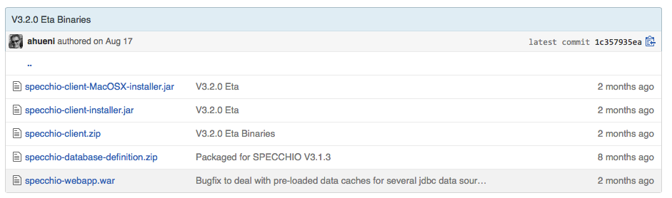

Figure : Github SPECCHIO package page

* Login as root in the SPECCHIO VM (The root password is also ‘reverse’)
* Copy the new binary into /opt/glassfish3/glassfish/domains/domain1/bin

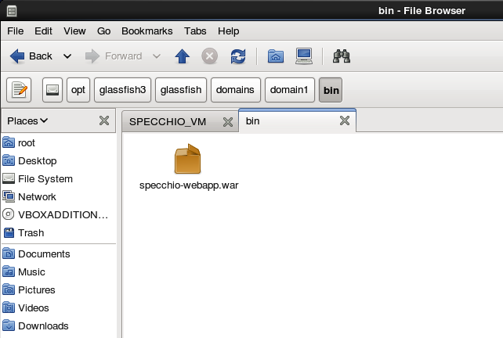

Figure : Location of the web service binary

* Deploy the new binary by the following commands in the shell:

cd /opt/glassfish3/glassfish/bin

./asadmin deploy --force ../domains/domain1/bin/specchio-webapp.war

./asadmin stop-domain

./asadmin start-domain domain1

### Manual SPECCHIO Client Update

Login as centos user or root.

Download the latest cross-platform client installation package from <http://specchio.ch/app_download.php> and run the installation package. The SPECCHIO client is installed in /usr/local/SPECCHIO.

1. Change History

|  |  |  |
| --- | --- | --- |
| Date | Version | Changes |
| 18.06.2015 | 3.2.0.1 | Added networking details and fixes for MacOS.  Updated VM Machine Name  Fixed the authentication issue: user accounts can be created in the VM. |
| 01.07.2015 | 3.2.0.2 | More info on static IPs in connection with the NAT networking and port forwarding.  Added info on how to mount a host folder in the VM. |
| 07.10.2015 | 3.2.0.3 | Added info on how to upgrade the system to new SPECCHIO binaries.  Updates on the networking configuration. |
| 26.2.2016 | 3.2.1.0 | Added automatic installation info.  Updates to reflect new client launch icons. |
| 20.9.2016 | 3.2.1.3 | Update to add info on the keyboard configuration and version number update. |
| 25.1.2017 |  | Update on how to set up the host file on Windows to use the VM name. |
| 04.04.2017 | 3.2.1.6 | DB and java binaries update. Installation of new SPECCHIO WWW interface. Update of update shell script to properly restart the glassfish service. |

1. Installing the Automatic Updating Script

Starting from V3.2.1 the SPECCHIO VM has an automatic updating script built in.

Older VM versions can be set up to achieve the same.

1. Login as root
2. Make sure that the VM can access the internet
3. Open terminal and run:
   1. rpm -ivh http://rpms.famillecollet.com/enterprise/remi-release-6.rpm
   2. yum install wget
4. Create a new shell script (downloadable from <http://specchio.ch/vm_download.php>):

#!/bin/bash

#--------------------------------------------#

# 2016-02-16 ahueni

# Get webapp war file from github and deploy

#--------------------------------------------#

cd /opt/glassfish3/glassfish/bin

mv -f ../domains/domain1/bin/specchio-webapp.war ../domains/domain1/bin/specchio-webapp.bk.war

echo "Downloading latest SPECCHIO web service binary ..."

wget --directory-prefix=../domains/domain1/bin/ https://github.com/ahueni/SPECCHIO/raw/SPECCHIO\_Master/pkg/specchio-webapp.war

echo "Deploying SPECCHIO web service binary ..."

./asadmin deploy --force ../domains/domain1/bin/specchio-webapp.war

./asadmin stop-domain

nohup ./asadmin start-domain domain1 &

echo "SPECCHIO service is updated."

echo "Downloading and starting client install script ..."

cd /root/Documents/SPECCHIO\_Installation

mv specchio-client-installer.jar specchio-client-installer.bk.jar

wget --directory-prefix=/root/Documents/SPECCHIO\_Installation https://github.com/ahueni/SPECCHIO/raw/SPECCHIO\_Master/pkg/specchio-client-installer.jar

java -jar specchio-client-installer.jar

echo "SPECCHIO client is updated. Have a nice day!"

1. Bridged Networking under MacOS – Ethernet and WiFi

The SPECCHIO VM is shipped with the networking set to NAT. The information hereafter is intended for user who want to user Bridged Networking under MacOS.

The SPECCHIO VM is then configured with the networking set to ‘Bridged Adapter’ and ‘en0: Ethernet’ selected [[7]](#footnote-7).

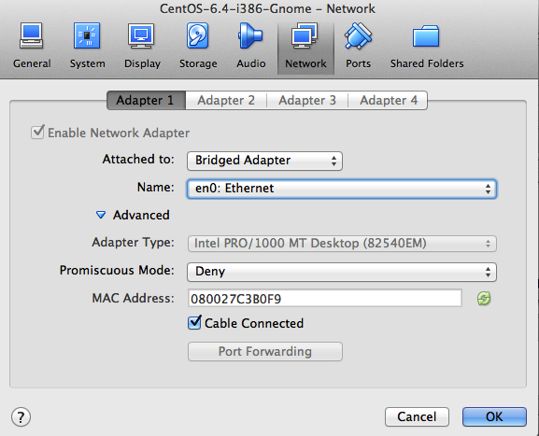

This allows the VM to access the Internet and to receive an IP from the DHCP. If using an Internet connection via WiFi, then this should be switched to Wi-Fi. [[8]](#footnote-8)

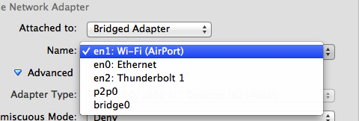

When using the MacOS host machine connected to the Ethernet, the DHCP will assign an IP to the virtual machine. If connected to WiFi then the bridging does not work at all, i.e. no connection to the Internet is possible from the VM. This is a persistent bug[[9]](#footnote-9).

There is however a workaround:

* On the Mac, open the ‘Sharing’ menu in the System Settings and select to share the Internet of the WiFi connection via Thunderbolt Bridge  
    
  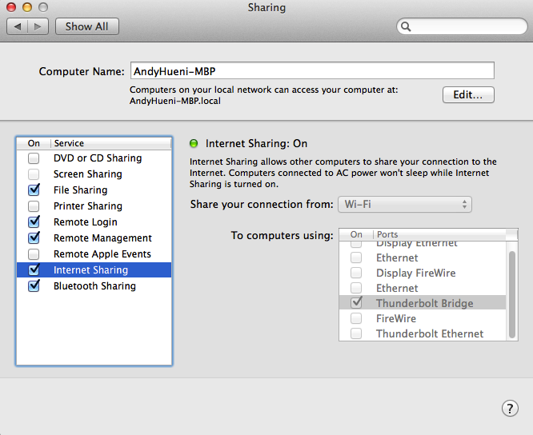
* In the VM, select ‘en2: Thunderbolt 1’  
    
  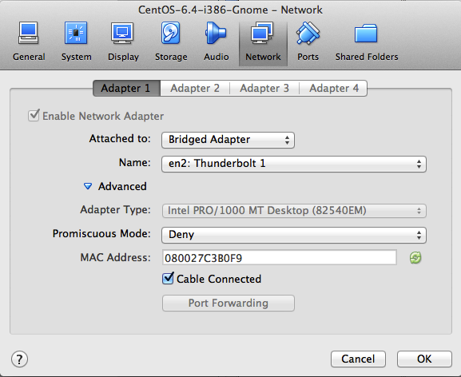
* The VM should now receive an IP from the DHCP and be able to access the Internet

1. The SPECCHIO application is installed in /usr/local/SPECCHIO [↑](#footnote-ref-1)
2. The host machine itself qualifies as well as ‘outside’ of the VM; i.e. the connection option described here works as well for the host machine, but using localhost as described in section 3.9 is the better option. [↑](#footnote-ref-2)
3. Ensure that the forwarding rules are defined in the VM. [↑](#footnote-ref-3)
4. Essentially only required to create a new SPECCHIO user account; all other connections can be made via HTTP on port 8080 [↑](#footnote-ref-4)
5. Future SPECCHIO App releases will come preconfigured to already include the SPECCHIO VM certificate. [↑](#footnote-ref-5)
6. https://github.com/ahueni/SPECCHIO/tree/SPECCHIO\_Master/pkg [↑](#footnote-ref-6)
7. This is presumably so, I actually do not know if these settings are part of the stored VM image. Should anyone know, give me notice of the fact. [↑](#footnote-ref-7)
8. I have not tested this yet, as on the Mac it does not work anyway. [↑](#footnote-ref-8)
9. https://www.virtualbox.org/ticket/10019 [↑](#footnote-ref-9)