## Creating the study Description File using the GUI Program

The study description file contains all the information about the study. This file can be created by hand, but it is easy to introduce errors, so a simple GUI program has been written that asks for the information in a series of dialogs. Below we show the dialog boxes for a simple study that has a single participant, session, imaged region and ROI file.

The program is started from the command line and has no command-line arguments

-> python studyDescriptionGUI.py

### Step 1. Define the name of the study

The first step is define the name of the study and where it will be saved using a directory dialog. If the directory does not already exist, it can be created using the dialog.

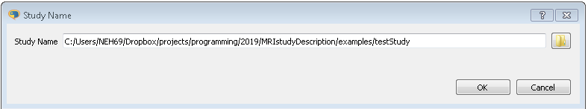

Figure 1 Define the name of the study

### Step 2. Number of different Groups in the study

In the study the number of different participant groups is defined. This is based on simple criteria such as healthy controls and participants with the condition. Within these groups, sub-groups can be defined based on the number of visits/sessions, the different protocols that they have.

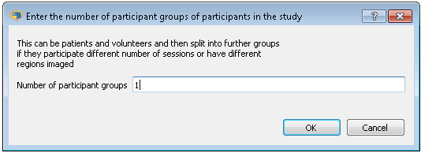

Figure 2 Number of Different Groups

### Step 3. Number of MRI protocols used in the study

The different MRI protocols that will be performed in the study should be listed next. Examples could be based on diffusion, T2, T1, and Dixon. The MRI protocols are added to the field separated by a space. In the example one MRI protocol is given.

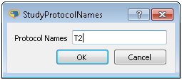

Figure 3 Names of the protocols used in the study

### Step 4. Enter the initials of the people who will have created ROIs

In the data analysis of a study many people work on the project, especially with the data analysis. Many projects require regions of interest to be drawn on the images for use in the analysis. This task is often performed by different people so it is useful for quality control reasons to keep track of who created the ROIs and this is done by giving a list of initials of the different people who will draw the ROIs. This is added to the ROI name so that this aspect of the data analysis may be audited. In the dialog one set of initials has been input. Further sets of initials could be entered separated by a space

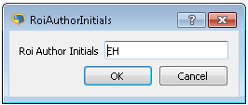

Figure 4 List of author initials who have created ROIs

### Step 5. Enter the names of the groups, number of sessions and a list of imaged regions

The names of the different groups of participants are entered in this dialog. The names must be unique. For each group the number of sessions/visits that the participants in the group attend during the study is entered. Finally, the imaged regions of the body are entered. In this field, if a phantom is used throughout the study a place name for it may be entered.

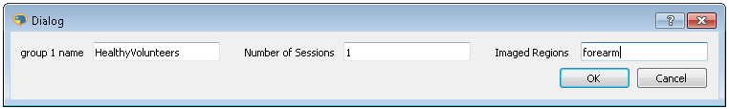

Figure 5 For each group defined previously, enter a name for the group the number of visits/sessions the participants will take part in and the imaged regions that will be looked at

### Step 6. Add the list of participant names/id codes for each defined group

For each defined group the participants id-code is entered in this dialog. The id-code is entered one per line. If more than one group is defined in the study then then it will appear along side the other groups in the dialog window.

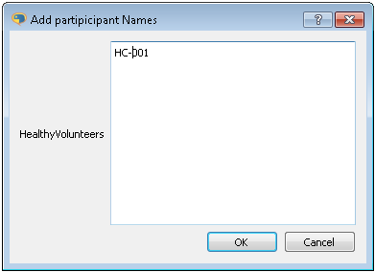

Figure 6 List of participant names/ID codes for each defined group

### Step 7. Definition of ROI/imaged region types

In this step the ROI/Imaged Region types are entered for each imaged region, forearm, upperarm,... This dialog is repeated separately for each group in the study. The group name appears in the dialog title in the border. Each ROI/Imaged Region type is entered on a separate line.

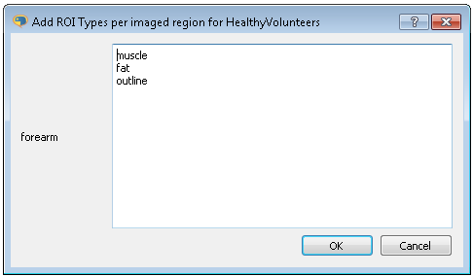

Figure 7 ROI/imaged region types being entered for Healthy volunteers group and the foream imaged region

### Step 8. Definition of the labels for individual ROIs

The names of the regions of interest for the different ROI/imaged region types are entered in this dialog. The names can be words or numbers, but must be unique with the same category

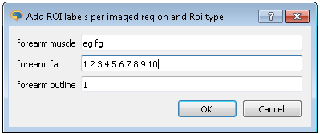

Figure 8 ROI labels entered for the different imaged regions and imaged region types

### Step 9. Slice index for the different imaged regions

The slices used in the study are dependent on the MRI protocol, the imaged region and imaged region/ROI type. Imaged slices are numbered based on a starting index of 1.

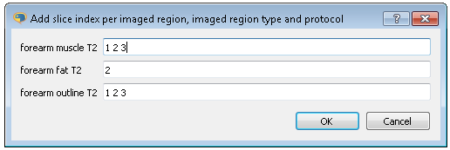

Figure 9 Slices used in the analysis of the data are defined in this dialog.

### Step 10. Saving the study template file

When the final dialog is closed the study template file is saved in the study directory. A number of fields within the study template file remain blank, these should be filled in by the user, using a text editor. The fields requiring updating by the user are:

* principal investigators
* research associates
* students

Below is the study description file produced by the previous dialogs

studyName: testStudy  
studyRootDir: MRIstudyDescription/examples  
  
HealthyVolunteers:  
 imagedRegions: [forearm]  
 name: HealthyVolunteers  
 numSessions: 1  
 participants: [HC-001]  
 rois:  
 forearm:  
 fat: ['1', '2', '3', '4', '5']  
 muscle: [fg, eg]  
 outline: ['1']  
 sessions: [sess-1]  
 slices:  
 forearm:  
 fat:  
 T2: ['2']  
 muscle:  
 T2: ['1', '2', '3']  
 outline:  
 T2: ['1', '2', '3']  
  
groupNames: [HealthyVolunteers]  
protocols: [T2]  
roiAuthors: [EH]  
  
principalInvestigators:  
- {address: '', email: '', initials: '', name: ''}  
  
researchAssociates:  
- {address: '', email: '', initials: '', name: ''}  
  
students:  
- {address: '', email: '', initials: '', name: ''}