## Analyzing Data in the Study Structure

### Copying image data into the study directory structure

To start with, copy the image data into the testStudy data directory. The image data is in ANALYZE format and can be found in the ***simplemodelData*** directory. It needs to be copied into the T2 directory, see the tree structure above. The two image files are

WIP_Forearm_T2_CLEAR.hdr  
WIP_Forearm_T2_CLEAR.img

### Modifying the ROI files for the data

ROI template files were created automatically in the previous section. They now need to be edited using imageJ to correspond correctly to the data in the image file. An example is shown in Figure 1 below. The ROI file is loaded into imageJ by dragging the zip file on to the toolbar of the imageJ main window.

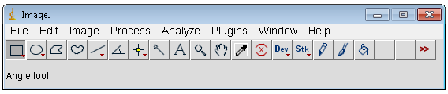

Figure 1 Drag files onto this window to load them into imageJ

The image is loaded in a similar manner, drag the hdr or img file onto the toolbar of the main imageJ window. The image needs to be flipped in the vertical direction as in Figure 2, before editing the ROIs.

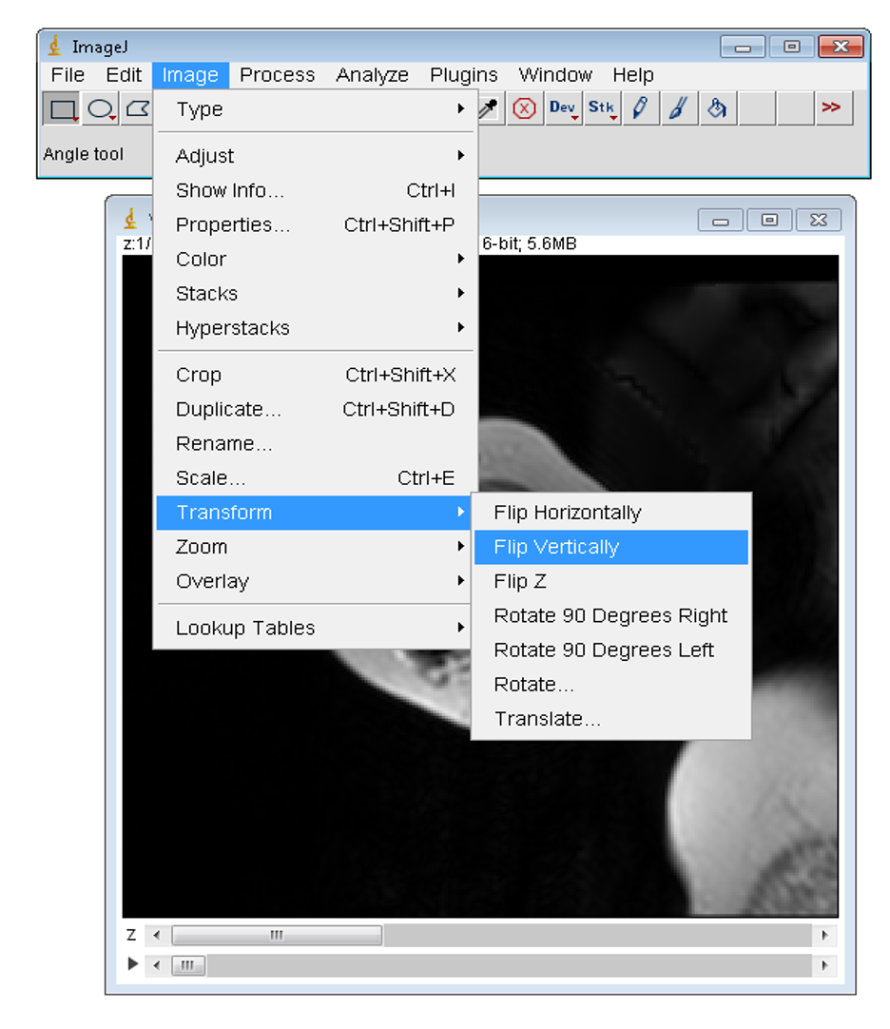

Figure 2 Flip vertically the data set before working with the ROIs

In Figure 3, the images have been flipped and the ROI file for the outlines have been loaded. One can see on the image the outline of the template ROI that will be edited. The ROI is edited by clicking the polygon button in the main imageJ window. Then clicking outside the template ROI and then clicking again at the position where you want to start drawing the ROI

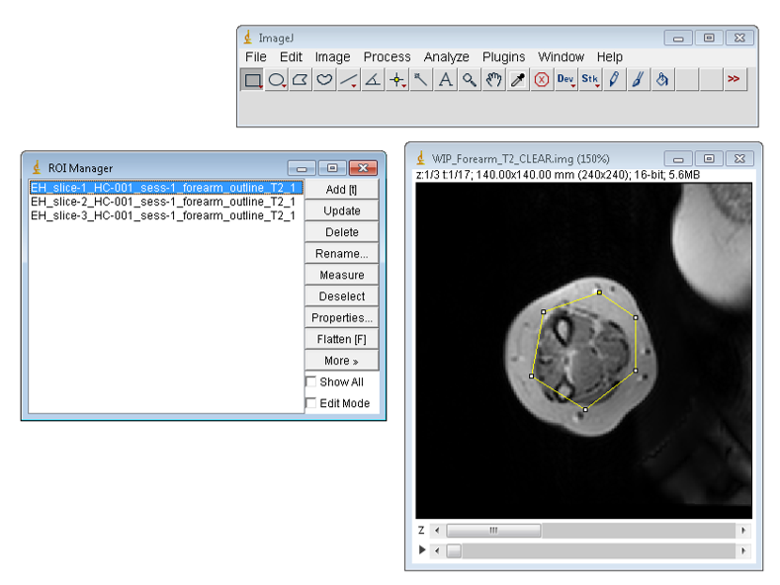

Figure 3 Outline template ROI prior to setting the polygon button and editing

Upon completion of the drawing of the ROI the update button is pressed in the ROI manager window to save the modifications. An example of a edited ROI is shown in Figure 4. When all ROIs have been drawn, making sure to increment the slice to correspond with the ROI name, all the ROIs are highlighted in the ROI manager window and the ***more*** button is clicked and then the ***save*** button. The user should then overwrite the corresponding zip ROI file.

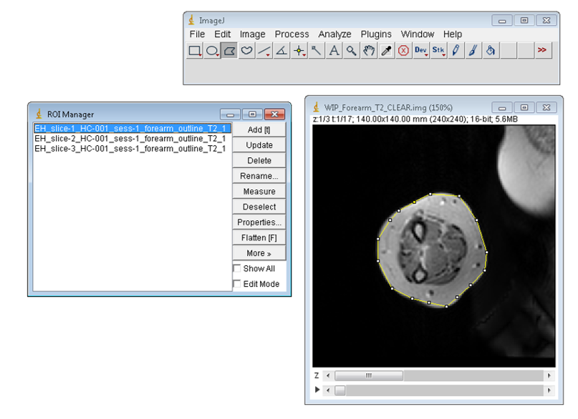

Figure 4 Newly drawn ROI ouline the muscle and fat of the forearm

The rois for the fat are best drawn using the rectangle tool in imageJ. Figure 5 shows the fat ROIs about to be saved after they have been edited

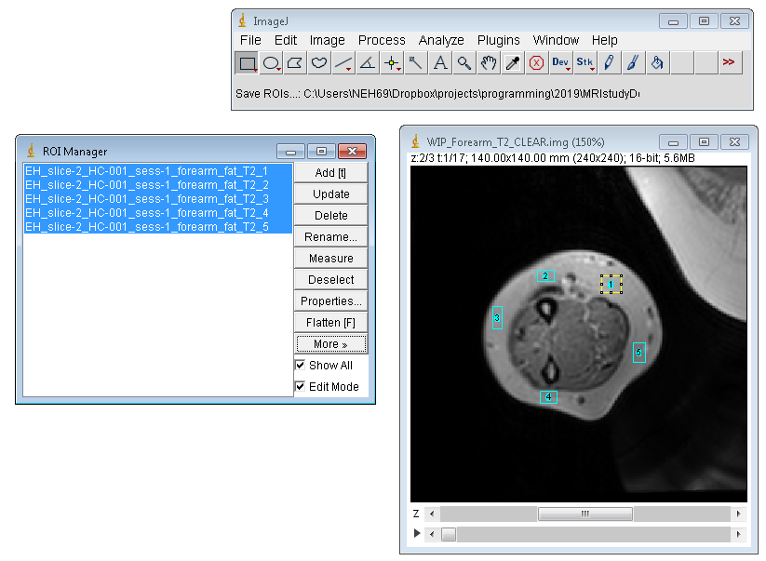

Figure 5 Fat ROIs using rectangle tool ready to be saved