# Automatic NMR sample submission to the Bruker NMR spectrometers

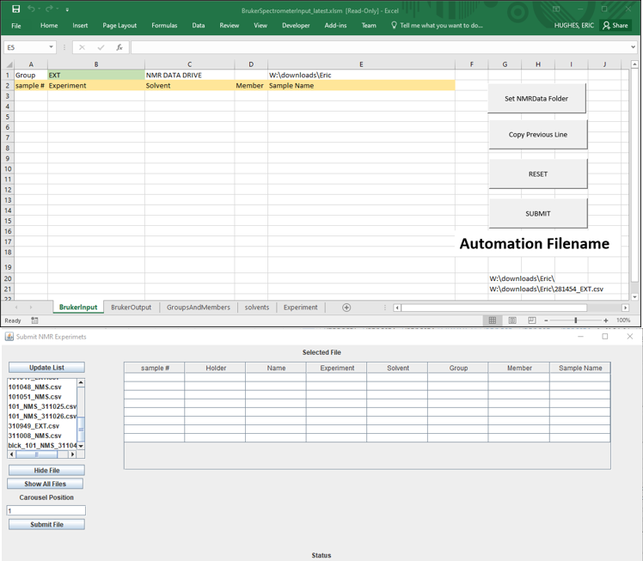

## Introduction

Automatic sample submission to the three Bruker NMR spectrometers can be accomplished in a two-step process utilizing an Excel worksheet and a simple jython GUI program.

The excel sheet resides on the computers of the users in their lab/office. The user creates a list of entries in the spreadsheet with information regarding the NMR experiments required and the sample.

The user, when finished, submits the information to a central access directory on nmrdata.

The user then puts the NMR tubes on an NMR carousel and then uses a second program at the spectrometer to load the information into the automation software of the spectrometer so that the experiments can be run.

### Advantages

* Less time is spent at the spectrometer
* Fewer mistakes in terms of group and member miss-spelling as entry is controlled by dropdown menus in the Excel sheet.
* A log is kept of submissions via CSV file that can be used to track samples.

### Disadvantages

* Users have to be careful when submitting samples that the starting position in the carousel is correctly noted.
* The program requires users operating the spectrometers in a more controlled manner.
* Users need to be disciplined in choosing carousel starting positions in order to maximise the carousel occupancy.

## List of programs

* BrukerSpectrometerInput_latest.xlsm
* jBrukerSubmit.py
* readCSV243A.py

## Filling in the Excel sheet

As mentioned in the introduction, there are two parts to submitting NMR samples for automatic acquisition. The first part involves filling out an excel sheet describing the samples and experiments required. In the next few paragraphs this process will be described in detail.

After opening the Excel spreadsheet the user should do the following:

|  |  |
| --- | --- |
| 1. | Enable Content so that the macros in the Excel sheet will work |
|  |  |
|  |  |
| 2. | Click on No and continue to the main screen |
|  |  |
|  |  |
|  |  |
| 3. | Click on reset to clear the tables |
|  |  |
|  |  |
|  |  |
|  |  |
| 4 | Set the group name to where the user belongs to |
|  |  |
|  |  |
|  |  |
| 5. | Set the nmrdata directory by clicking the “Set NMRDATA Folder” button |
|  |  |
|  |  |
|  |  |
| 6 | Start to fill in the form with sample information. Start at sample positon 1. The experiment, solvent and member cells are accessed via drop-down menus so that input can be controlled. Only the sample name can be typed in directly. |
|  |  |
|  |  |
| 7 | Click on the “copy Previous Line” button to save typing in information. If another experiment is to be performed on the same sample keep the sample number the same and just change the experiment field. |
|  |  |
|  |  |
| 8 | For each new sample, the sample number must be changed. Also the title. In this example the solvent and experiment have been changed from the previous line. |
|  |  |
|  |  |
| 9 | When all the experiments and samples have been added to the sheet, click the “SUBMIT” button to send the information as a CSV file to the nmrdata folder  . |
|  |  |
|  |  |
| 10 | Upon submission a new Excel window will open up and ask you to save the file. Click on yes and the window will disappear. |
| 11 | The filename of the CSV file sent to the nmrdata folder will appear in read on the main Excel sheet. Note this filename down before you take your samples to the NMR room. |
|  |  |
|  |  |
|  |  |

This GUI program is designed to work within TOPSPIN as it is written in jython and can be started automatically when TOPSPIN is started.

The program consists of two files:

* jBrukerSubmit.py
  + a java SWING GUI written in jython
* readcsv243A.py
  + a jython compatible python module that creates the text file that is submitted to the TOPSPIN automation directory.

Using the GUI program.

|  |  |
| --- | --- |
| 1 | Click the Update List Button to refresh the list of csv files |
|  |  |
|  |  |
| 2 | Find your csv file and click on it to display its contents in the table |
|  |  |
|  |  |
| 3 | CSV files can be hidden from the list by highlighting the file and then clicking the “Hide File” button. All csv files can be revealed by clicking the “Show All Files” button. |
|  |  |
|  |  |
| 4 | Set starting position of the carousel where your samples can be found. In this example it has been set to 21. The holder column is updated automatically, taking into account samples with multipe experiments. The holder number is set to zero for samples destined for high field |
|  |  |
|  |  |
| 5 | Click the Submit file button to create the automation text file from the table and submit it to the automation folder. A popup dialog opens to ask if you are happy with everything and ready to proceed. |
|  |  |
|  |  |
| 6 | If everything is okay, click yes and the experiments will be submitted to the automatic folder as a text file and run. The status line will turn green and give a message of what has been submitted |
|  |  |
|  |  |
| 7 | If a mistake has occurred, such as submitting NMR experiments that cannot be run on the spectrometer, or the starting position of the carousel does not make sense for the number of NMR experiments expected then a warning dialog will pop up and the status line background will turn red and an error message will be displayed. |
|  |  |
| 8 | In the above example the starting position was set to 58, the carousel contains a maximum of 60 holders, the csv file has three samples so it would finish at positon 64 which is not allowed, so an error message is displayed and the file is not submitted |
|  |  |

## Editing the Holder Column Manually

After discussions with users and from past experience of students submitting samples during the summer via blocks the program has been upgraded in a number of respects.

1. The program can cope with CSV files where the block/sample number is not in order. The student or user may have filled the block in non-sequentially and therefore the excel sheet. The GUI program will attempt to reorder the data so that the block/sample number increases in order.
2. Samples submitted for high field can be submitted in the same block as samples for low field. A sample for high field is identified by setting the experiment column to “High Field” for the sample. In such cases the assigned “Holder” number is set to zero. When the data is submitted to automation they are skipped over.
3. Finally, when the carousels on the NMR spectrometers have started to fill up during the day from other people’s samples it may be impossible to submit a large number of samples in sequence. If this is the case then the Holder column in the table can be altered manually so that NMR samples may be put in empty holder positions that are nor in sequence.
   1. When the user does enter the holder positions manually, samples with more than one experiment assigned to them will have their holder number adjusted automatically once the user has changed the first position.
   2. A check is made to see that each sample has a unique holder sample each time a holder position is changed manually. If two different samples have the same holder number then a warning dialog is shown and the holder number that was being edited is reset to its original value.

## Installing the Programs

The Excel file should be stored in the NMRDATA drive in downloads\Eric

Both the Jython files must be saved in the jython user program directory which is

Bruker\TopSpin4.0.8\exp\stan\nmr\py\user

The specific TOPSPIN folder will depend on the spectrometer

## Running the program on the B4 and A4

After starting Topspin and before starting Icon-NMR with the icona command, type

jBrukerSubmit

in the Topspin command line.

## Running the program automatically on TOPSPIN start up for the N4

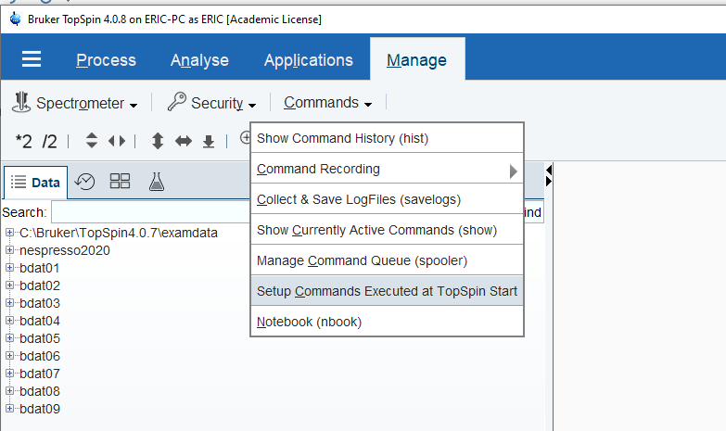The program jBrukerSubmit.py can be started automatically by adding it to the autostart.mac file that is accessed via the Manage->Commands menu

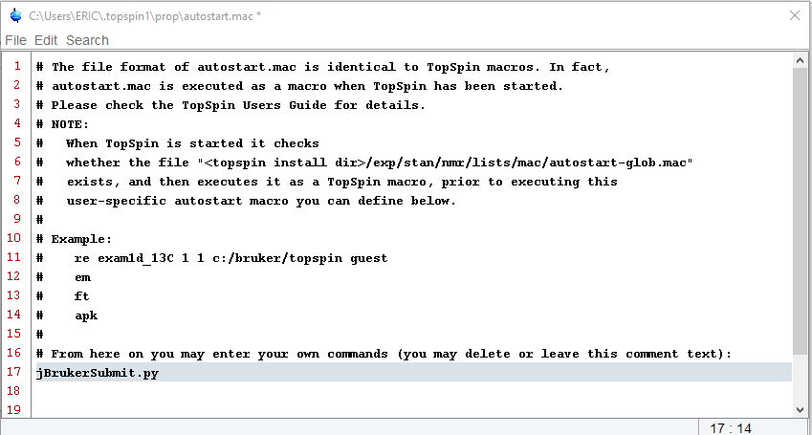

The program is added to the end of the file and saved.