# Data Preparation

## Introduction

This document outlines the best way to process a set of NMR spectra using Mnova and extract the information necessary for use with the simplePredict tool. It also discusses how tave and name your data so that the simpleNMR suite of tools can find your data.

Since simplePredict can cope with various amounts of input (presence or absence of certain spectra), the information below is in the form of general guidance but, in this document, we assume that we are working on a data set containing the most commonly encountered set of experiments, namely: 1D-1H, 1H-Pureshift (PSYCHE), 1D-13C{1H}, 1H-1H COSY, 1H-13C HSQC, and 1H-13C HMBC. The HSQC experiment includes multiplicity editing to facilitate the easy identification of CH2 groups. The actual set of experiments used may vary over time and with the particular application, but the general guidance will still be applicable.

## Directory Structure and File Naming

For each new molecule that is being assigned using simpleNMR create a unique directory based on the sample name of the molecule. If a student had made aspirin as part of a project then the student should save the data in a directory called aspirin_1 for example.

The MNOVA file corresponding to this file should should be saved in this directory under the same name.

Directory structure and naming convention


Figure 1 Directory structure and naming convention dorm nova files used with simpleNMR tools.

## Processing Steps

The following bullet points are general rules and advice when processing the NMR data for use with the simpleNMR tool set.

* Process the data so as to facilitate the accurate extraction of the required data. For all spectra, ensure the use of zero filling before FT (at least a factor of two). In the case of 2D spectra, the acquired data will typically be severely truncated in both dimensions. So, assuming that we have a reasonable S/N ratio, it is a good idea to double the number of data points acquired using forward linear prediction and then double the size of that using zero filling (in both dimensions). This helps considerably with the accurate positioning of correlations. Note, however, that large 2D datasets will considerably slow down the response of the processing software (how large depends to some extent on how much memory is present in the processing computer). It is also worth considering whether the data has been acquired using compressive sensing (non-uniform sampling) in the indirect dimension. If compressive sensing has been used and reconstruction has then yielded a large dataset in that dimension already (say 1k or greater), then linear prediction should probably not be applied. For a more detailed discussion of this topic see Section 4 of “Minimizing the risk of deducing wrong natural product structures from NMR data”, D. C. Burns, W. F. Reynolds, *Magn. Reson. Chem*. (2021), **59**, 500–533, and references therein.
* Ensure all spectra are correctly phased if appropriate, and baseline correct as necessary (particularly the 1D-1H spectrum if integrals are to be used).
* Check that the referencing is consistent between the 1D and 2D spectra. It should be consistent by default but, if it is not, make the necessary adjustments. Note that in this case consistency of referencing (so that peaks align properly) is more important than absolute accuracy, so don’t worry too much at this stage about which spectrum has the correct referencing. Just get them to line up.
* Have a look at the HSQC spectrum. This is the key spectrum in the data set. In particular, make a note of any proton signals that do not show an HSQC correlation (such as amide NH’s) and any correlations to proton signals that are overlapped. This is quite common, which is why the extra dispersion available in the HSQC is so valuable.
* You are now ready to “peak pick” the correlations in the 2D data sets. Note that we are not necessarily going to pick the actual peaks. Rather, we are going to identify chemical shift correlations as accurately as we can. The easiest way to do this, assuming that you have the appropriate data sets, is to use the simplePeakPick tool (see the appropriate documentation).
* If you do not have a 1H-Pureshift experiment in your dataset and so cannot use the simplePeakPick tool, it is still possible to mark the 2D correlations “by hand”, although this is considerably more time consuming. Expand a portion of the spectrum so that you can easily see the correlations at a reasonable size. Under Peak Picking, click on the “Peak by Peak” icon (do not use “Auto Peak Picking”). Scroll the mouse so that the crosshairs appear on the spectrum, then press the shift key. This turns off the “jump to nearest peak” function, so you are now free to position the crosshairs exactly where you want them. Scroll the mouse to position the cross-hairs over a correlation then align the cross hairs with the corresponding carbon peak in the 1D-13C spectrum and with the centre of the corresponding proton multiplet in the 1D-1H spectrum. Note that this may not actually be on a local maximum in the 2D spectrum. See the example in the figure below. Click on the left mouse button to “peak pick” (ie define) that position. Repeat the procedure for other correlations until you have picked all the required correlations.
* When you “peak pick” the HMBC spectrum (either using the simplePeakPick tool or “by hand”), there are a couple of caveats. First you do not need to “pick” correlations to proton signals that did not show a correlation in the HSQC experiment. It is not a disaster if you do, but the simplePredict tool makes no use of them so you are just wasting your time and it is potentially unhelpful. Second, you need to set the threshold sensibly and may need to adjust it during the “picking” process. Given the sensitivity of modern instruments, HMBC is often capable of detecting weak correlations over more than 3 bonds, which generally do not help greatly. So how do you know if you have the threshold set correctly? There is no hard and fast rule but if you are seeing an average of 2 or 3 correlations per carbon, that is probably plenty. Don’t worry that you might be missing a correlation or two. There is generally a lot of redundant information in the HMBC so you are unlikely to need them. The converse of that is that if you have adjusted the threshold to suit a couple of methyl singlets in the proton spectrum of your molecule you are likely to be missing most of the correlations from highly-coupled CH multiplets elsewhere in the spectrum. And if you set the threshold to suit the lowest intensity CH multiplet, you may well see correlations over 4, 5, or even six bonds from a methyl singlet. So you may need to pick a sensible number of correlations from the methyl signals first, then turn up the intensity so that you can see correlations from other signals.

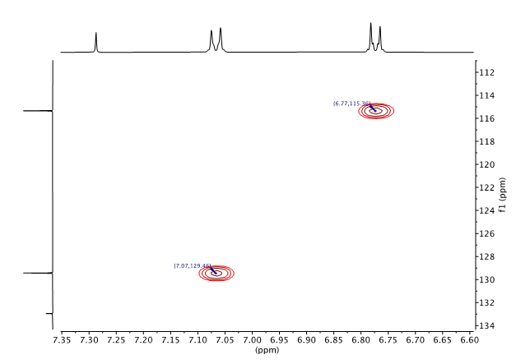

Figure 2 2-D peak picking showing peak position between centre of proton doublets.

If you get to the point where you are seeing significant amounts of 1-bond breakthrough you have almost certainly turned the intensity up too far. Err on the side of fewer rather than more and if you don’t have enough information when you come to use the simplePredict tool you can always go back and pick a few more correlations. Finally, if you look at a correlation in the HMBC and you can’t tell for sure which two signals in the respective 1D spectra are correlated, don’t pick it. The redundant information in the HMBC means you are unlikely to need it. Conversely, a false correlation in your data will be highly confusing when you run it through the simplePredict tool. This is usually only a problem where you have near degeneracy of signals in either the 1D-1H or 1D-13C spectra.

* When looking at a classic COSY spectrum, only pick the correlations you can reliably identify. As before, if you are not using the simplePeakPick tool, pick positions that align with the centres of the corresponding proton multiplets in the 1D-1H spectrum and leave out any correlations where you cannot be sure what is correlating to what (again, only a problem where you have significant peak overlap). You do not need to pick peaks that lie on the diagonal (they contain no information) and if you pick a correlation on one side of the diagonal you do not need to pick the symmetric peak on the other side of the diagonal. So the number of peaks you pick will be only a fraction of the peaks visible in the spectrum – see the example in the figure below. Note that, as shown in the inset expansion, the “picked” position does not necessarily correspond to a local maximum in the 2D spectrum.

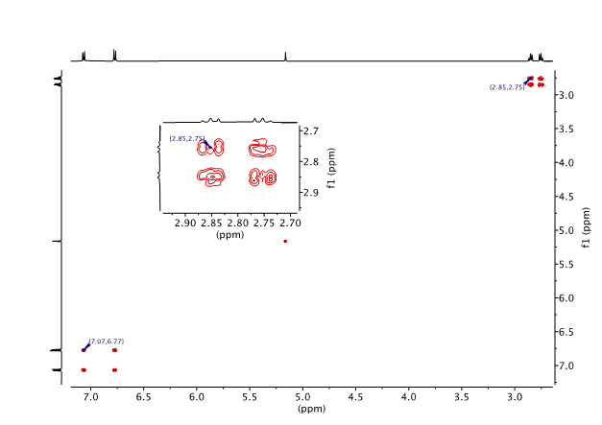

Figure 3 COSY 2D peak picking showing that position of pick peak does not necessarily correspond to a peak maximum.