# SimpleNMR HTML GUI Interface

## Introduction

The simplePREDICT tools writes the results of the prediction and assignment into a standalone html file. This file can be displayed in a browser window and is small enough to be sent via email to other users or included as supplementary information in a publication. To display properly, the browser must have access to the internet as it uses the d3.js library to display the interactive graph networks of the COSY and HMBC correlations over a static svg image of a molecular structure supplied by the user.

In this note, the features of the html display will be outlined.

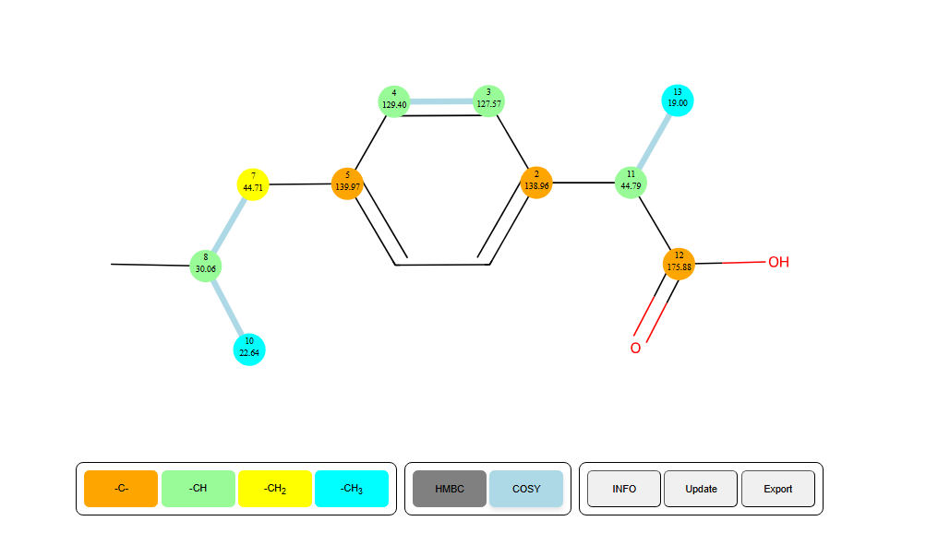

Figure 1 HTML output of a predicted and assigned ibuprofen example.

## HTML GUI Description

The main features of the interface will be described below.

### SVG molecule

The GUI includes a background image of a 2-D representation of the molecular structure.

### Carbon nodes

Nodes are placed overlaying the background image to represent the NMR distinct carbon atoms.

* Each carbon atom node is colour coded to depict the number of protons attached to the carbon (CH3, CH2, CH, and C)
* The experimental carbon chemical shift is written on top of each node together with the atom number derived from the MNOVA molecule display
  + The displayed atom number does not necessarily correspond to the atom index in a mol file representation of the molecule.
* The nodes can be moved by the user if the user thinks that the predictions are not correct and a better arrangement of the carbon atoms is valid.

### COSY and HMBC Correlations

The COSY and HMBC correlations are represented as edges in a graph network between the carbon nodes.

* The COSY correlations are shown by default, they are the sky-blue lines. They can be toggled off by clicking the COSY button

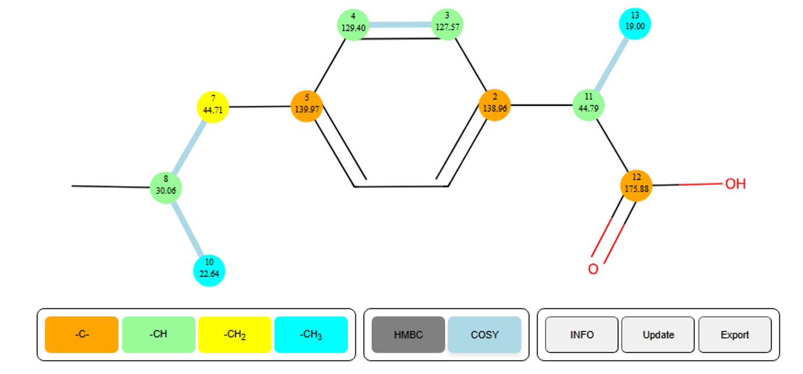

Figure 2 COSY correlations are shown in blue.

* The HMBC correlations are hidden in the first instance, but if the user hovers over a carbon node with the cursor the HMBC correlations for that carbon node will be displayed.

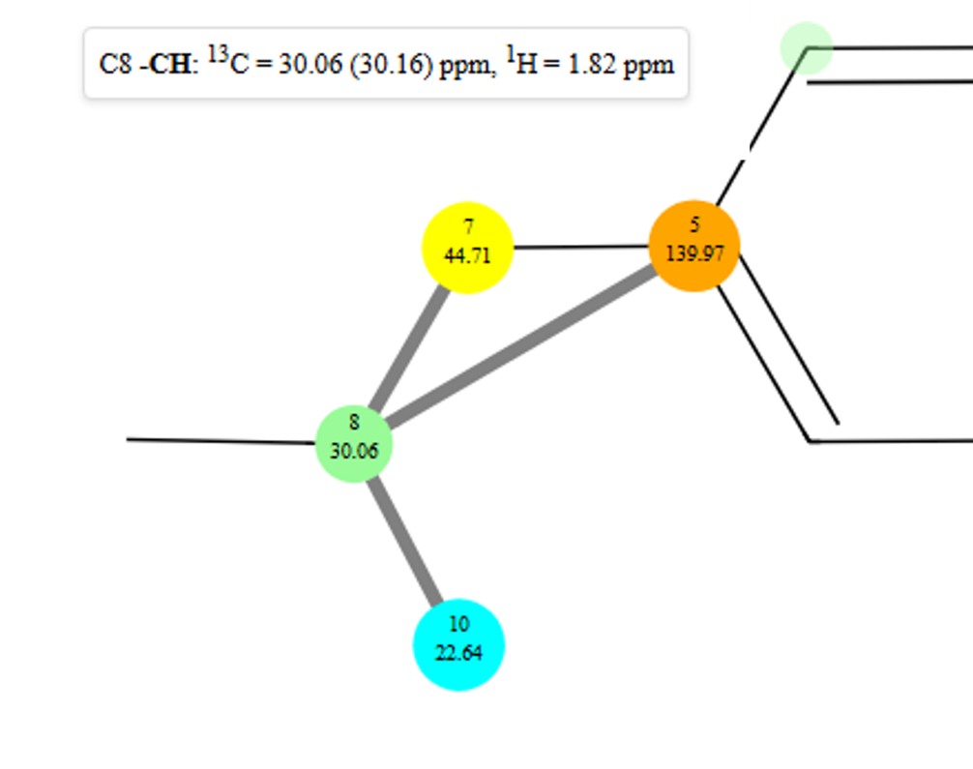

Figure 3 HMBC correlation network displayed on moving the cursor over carbon atom 8. Nodes in the HMBC correlation network are linked by grey lines. The node diameters of carbon atoms in the HMBC network are increased. Nodes that are not in the network are made less opaque and the annotations on the node are made invisible.

* Further information is displayed upon hovering over a carbon node. (see Figure 3)
  + The displayed atom number and the number of protons attached
  + The experimental and (predicted) carbon chemical shift.
  + The proton chemical shift of any attached protons to the carbon.

### Interactive Features of the HTML GUI

Since the image is an SVG image and the nodes and edges are displayed using the d3.js library, the display has a number of interactive features.

* The graphical display can be shrunk and expanded using the wheel on the mouse
* The image can be moved around the screen by clicking on a blank part of the screen, holding down the left mouse button, and moving the mouse to drag the image around the screen.
* The image can be rotated clockwise and anti-clockwise in 10 degree steps by pressing the “R” and “L” keys. Holding the shift key down at the same time will rotate the image by 90 degrees.