# simplePeakPick

## Introduction

Precise 2D peak picking is required for the simpleNMR tools to work correctly. Using MNOVA 2D manual peak picking is somewhat challenging, but if it is necessary you should refer to the notes in the Data Preparation document. The simplePeakPick tool has been developed to make the process simpler. The tool requires a 1H Pureshift (PSYCHE) and a 1D-carbon spectrum to be available. If the Pureshift spectrum is not available, the tool has been updated so that the user can use the proton information from the HSQC spectrum to peak pick automatically the other 2D datasets.

## 1-D peak picking the Pureshift and Carbon Spectra

The pureshift and carbon spectra are first peak picked and the positions of the peaks are used as cluster points that the picked 2D peaks snap to.

Peak pick the carbon and pureshift spectra. This is best done using the MNOVA manual threshold peak picking tool. Do not include the solvent signal, TMS, or any impurities. Check that the number of carbon peaks you have picked is the same as the number of carbon signals you expect for your structure.

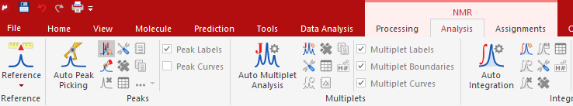

Figure 1 Manual Threshold being chosen for peak picking

Figure 2 shows the manual threshold tool in action.

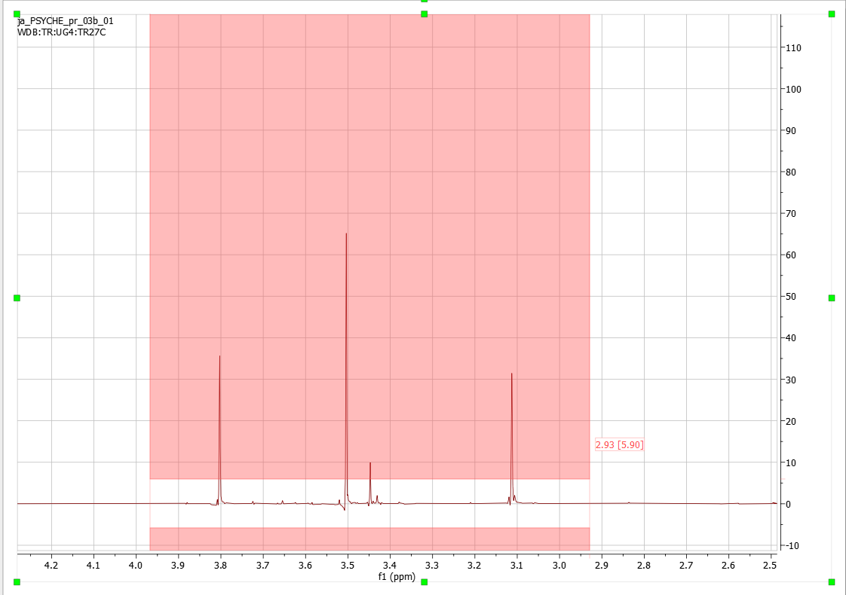

Figure 2 Manual Threshold being used on a pureshift spectrum

## HSQC spectrum alternative

As stated in the introduction, if the Pureshift proton spectrum is unavailable, the tool has been updated to use the proton information from a manually peak picked HSQC spectrum.

The HSQC spectrum should be peak picked manually. With peaks picked at the centre of the HSQC peak in the proton dimension which could be at the centre of proton doublet or even multiplet and not at the peak maximum.

Use CTRL+k to peak pick and press the shift key once to move the mouse smoothly over the peak and not jump to a maximum peak.

## Snap to Carbon HSQC tool

When all the peaks in the HSQC spectrum have been picked, use the simpleNMR 2-D integrate button to integrate all the peaks at once. The scatter in the carbon dimension of the picked HSQC peaks can be removed by clicking on the snap to carbon button. This tool replaces the carbon positions of the HSQC peaks with the values found in the 1-D carbon spectrum.

## Peak Picking a 2-D Spectrum using the simpleNMR Peak-Pick Tool.

Choose a 2-D spectrum. Zoom in around a few peaks. Set the threshold so that the weak peaks are removed and the peaks remaining are well above the noise. Click the simplePeakPick tool and if the 2-D peaks occur at a carbon/pureshift intersection then the peak will be picked at the coordinates of the intersection.

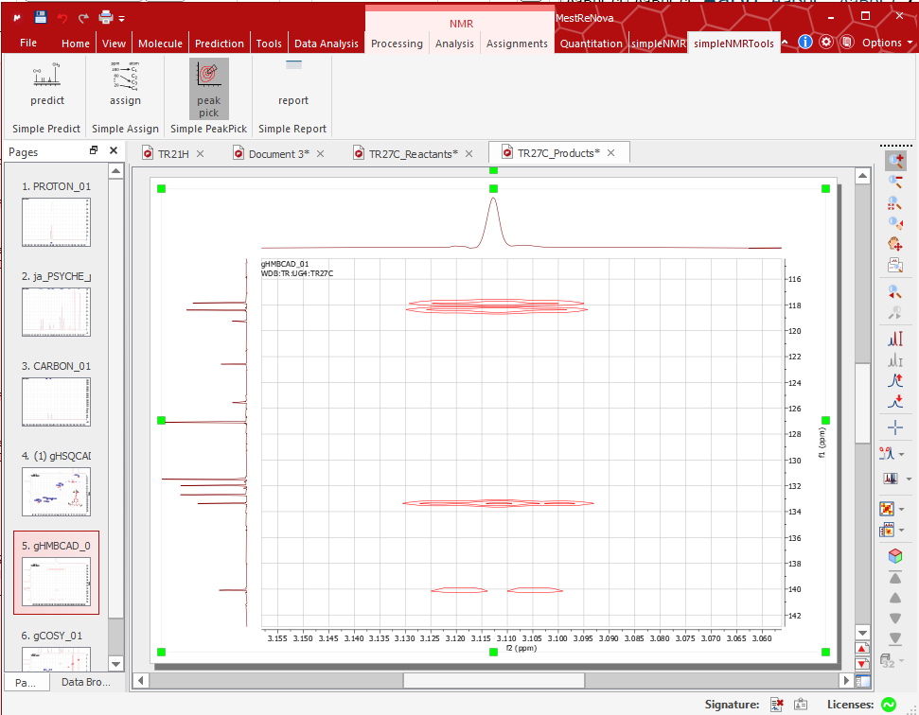

Figure 3 Peak picking of 2-D dataset using simplePeakPick Took.

If the 2-D peak is an even multiplet (such as a doublet) then the position of the picked peak will be in the centre of the multiplet, which will not correspond to a peak maximum in the 2D spectrum.

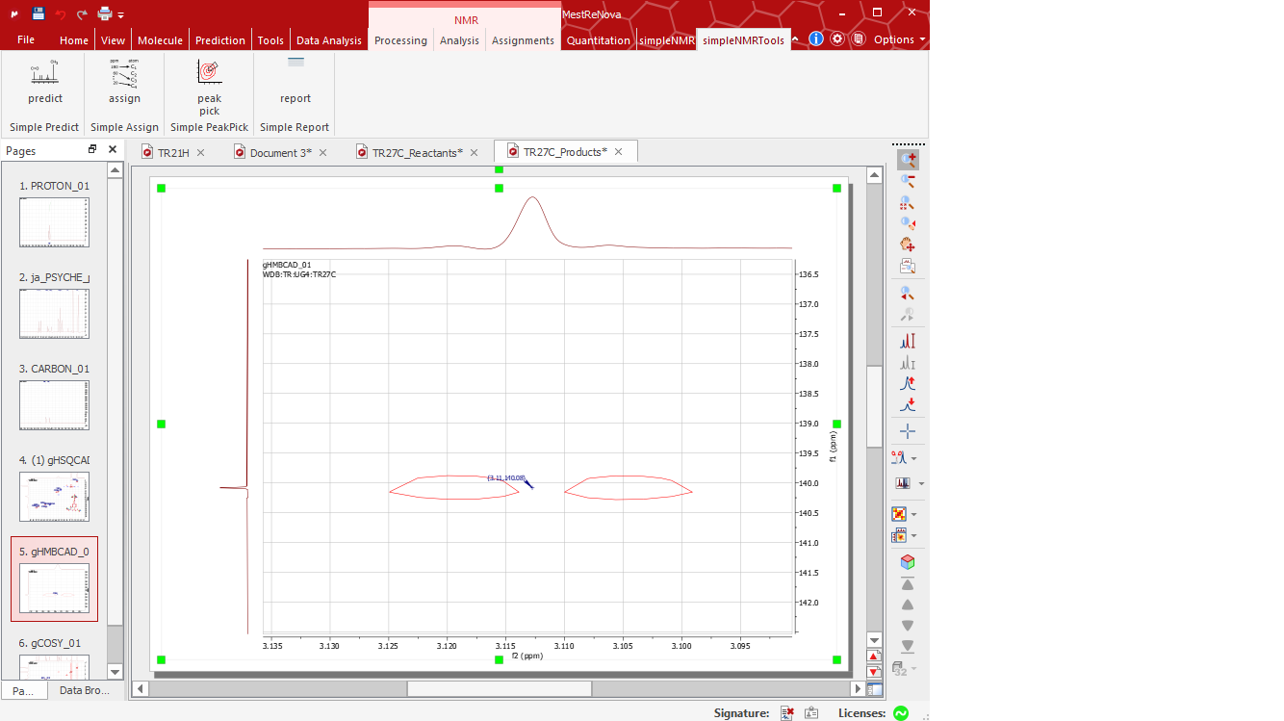

Figure 4 Peak picked at centre of doublet using simplePeakPick tool, not at a 2D peak maximum.

If the peak position is offset or misaligned, then this corresponds to an incorrect peak and should be deleted before moving on to a new area of the spectrum.