# simpleNMR MNOVA Installation

## Introduction

The simpleNMR suite of tools are now embedded in MNOVA. This decision was made because Durham University, where the software was developed, has a site license for MNOVA and it is the software of choice for the students to process their NMR data.

In this instruction note we show how to install the simpleNMR tools in MNOVA. With the help of Mestrenova company we have simplified the process as much as possible.

## Setting up simpleNMR in MNOVA

All the simpleNMR qs scripts that run in MNOVA are in the folder MNOVAscripts. This folder can be stored anywhere on your computer, or, as we have done at Durham University, they can be stored on a shared drive where all the students can access them and they can be updated easily.

For example, if the MNOVAscripts are installed at

Y:\downloads\Eric\MNOVAscripts

Do the following:

* Open the MNOVA software and click on the cog icon in the right-hand corner of the toolbar

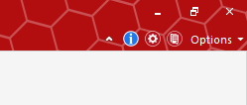

Figure 1 Click on the cog icon in MNOVA

* A dialog window opens. Click on the scripting icon

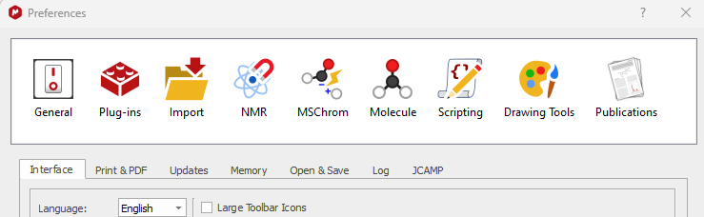

Figure 2 Click on the scripting icon

* Click on the + icon in the dialog on the right

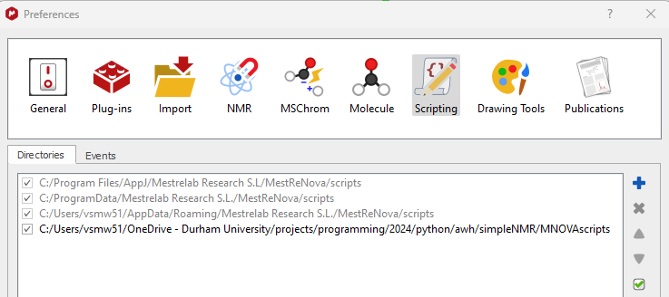

Figure 3 Click on the + icon to add the directory path

* Add the directory path to MNOVAscripts

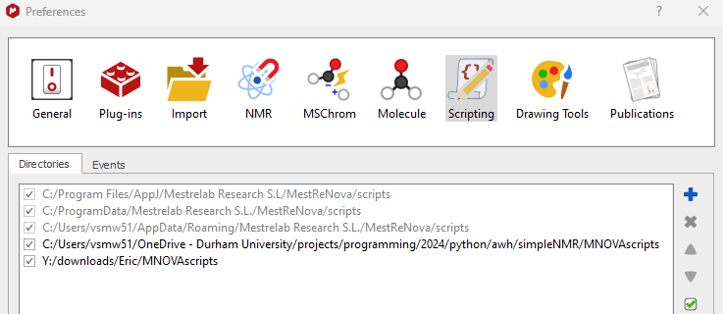

Figure 4 Add the directory path to MNOVAscripts

* Restart MNOVA to see the simpleNMR tools installed in MNOVA

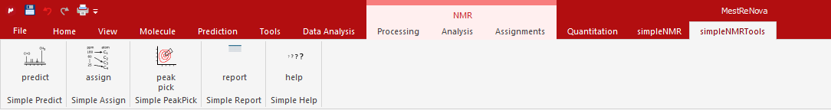

Figure 5 simpleNMR tools installed in MNOVA