# simplePeakPick

## Introduction

Precise 2D peak picking is required for the simpleNMR tools to work correctly. Using MNOVA 2D manual peak picking is somewhat challenging, but if it is necessary you should refer to the notes in the Data Preparation document. The simplePeakPick tool has been developed to make the process simpler. The tool requires a 1H Pureshift (PSYCHE) and a 1D-carbon spectrum to be available.

The pureshift and carbon spectrum are first peak picked and the positions of the peaks are used as cluster points that the picked 2D peaks snap to.

Peak pick the carbon and pureshift spectra. This is best done using the manual threshold peak picking tool. Do not include the solvent signal, TMS, or any impurities. Check that the number of carbon peaks you have picked is the same as the number of carbon signals you expect for your structure.

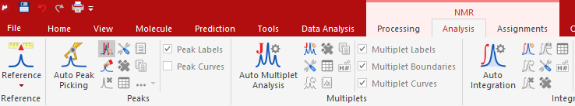

Figure 1 Manual Threshold being chosen for peak picking

Figure 2 shows the manual threshold tool in action.

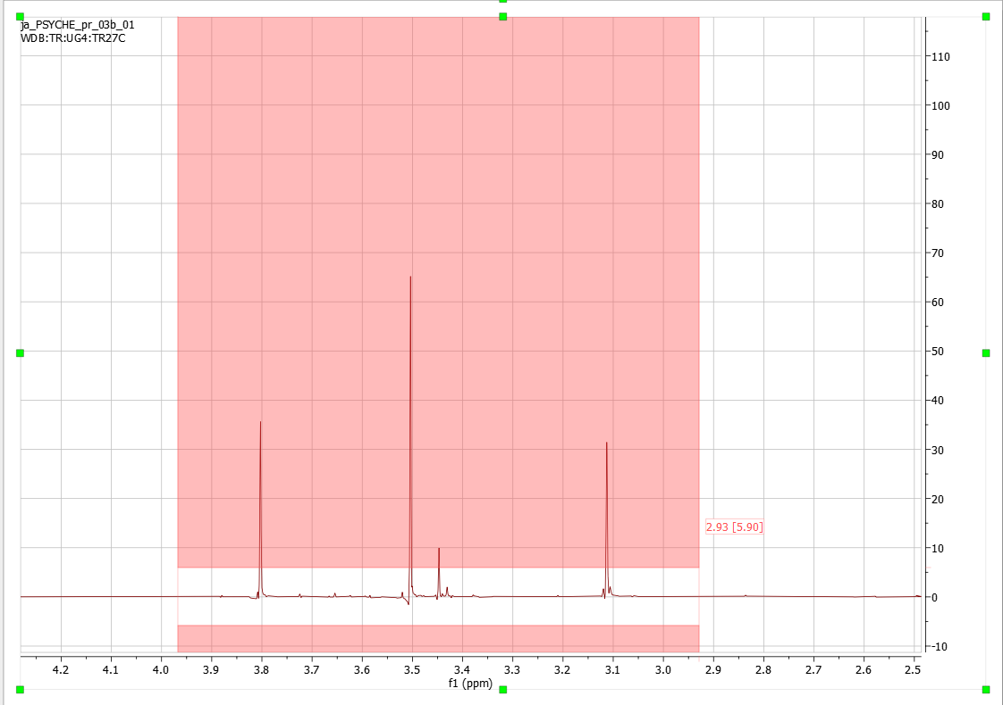

Figure 2 Manual Threshold being used on a pureshift spectrum

Choose a 2-D spectrum. Zoom in around a few peaks. Set the threshold so that the weak peaks are removed and the peaks remaining are well above the noise. Click the simplePeakPick tool and if the 2-D peaks occur at a carbon/pureshift intersection then the peak will be picked at the coordinates of the intersection.

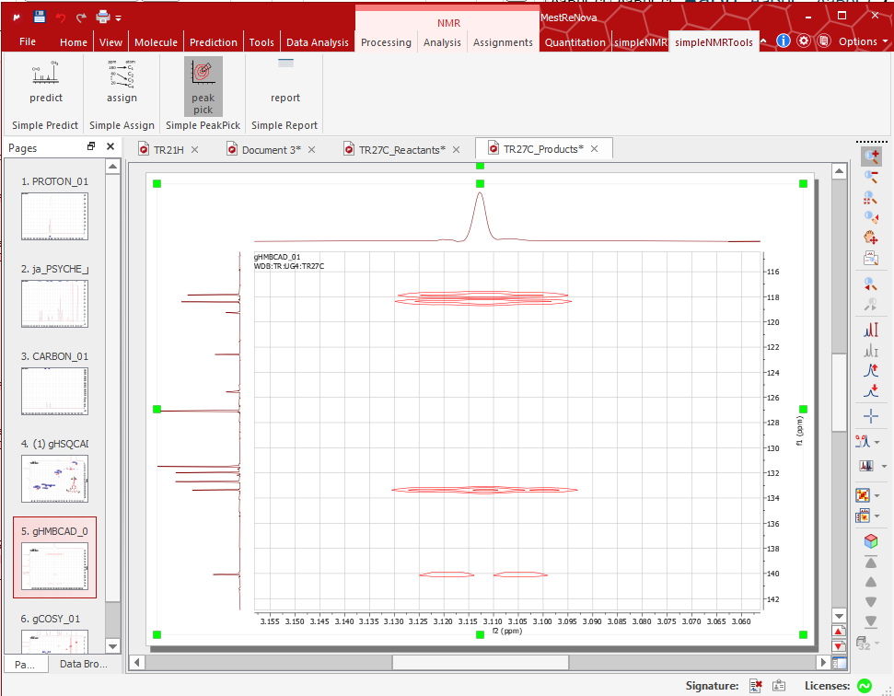

Figure 3 Peak picking of 2-D dataset using simplePeakPick Took.

If the 2-D peak is an even multiplet (such as a doublet) then the position of the picked peak will be in the centre of the multiplet, which will not correspond to a peak maximum in the 2D spectrum.

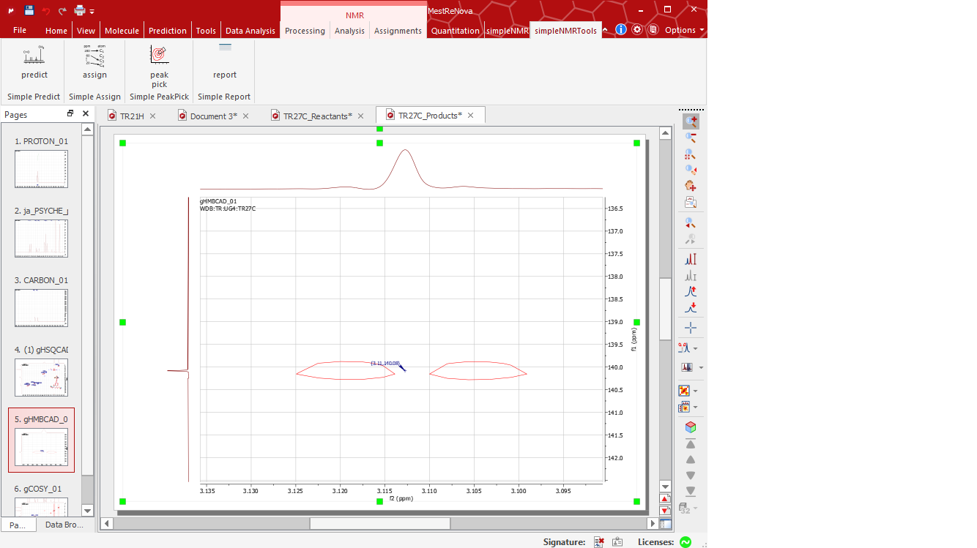

Figure 4 Peak picked at centre of doublet using simplePeakPick tool, not at a 2D peak maximum.

If the peak position is offset or misaligned, then this corresponds to an incorrect peak and should be deleted before moving on to a new area of the spectrum.