# Structures

## Introduction

The simpleNMR suite of tools requires a molecular structure to work with. The following provides some guidelines for preparing structures to use with the suite.

## Guidelines

* While we use the term “molecular structure” somewhat loosely in these documents, the simpleNMR suite of tools actually facilitates structural isomer verification (for a fuller discussion of this distinction see “SimpleNMR: An interactive graph network approach to aid constitutional isomer verification using standard 1D and 2D NMR experiments”, E. Hughes, A. M. Kenwright, *Magn. Reson. Chem*. (2024), **62**, 556–565). So, while it is possible to use molecular structures that contain stereochemical features such as stereo bonds, these have no effect on the functioning of the program. The simpleNMR suite aims to answer the question “Are these NMR spectra consistent with the postulated structural isomer (in terms of number of signals, approximate carbon chemical shift, and 2D correlations), and can an assignment be made on that basis?” While the answer to that question may be yes, that does not necessarily imply that the stereochemistry you have drawn is correct. So, it may be preferable to draw the structure without stereo bonds as a reminder that the results from the simpleNMR suite contain and/or imply no information about stereochemistry.
* While carbon shift prediction packages (as used in the simpleNMR suite) generally take no account of R/S stereochemistry, the MNOVA prediction package (if available) does take account of the E/Z configuration of double bonds and will return a better answer if the correct configuration is drawn, but this will not affect assessment of correlations. So, care needs to be taken in reaching conclusions about double bond configurations.
* Structures must be 2D. The simplePREDICT tool will not work correctly with 3D structures
* The structures must be drawn without explicit hydrogens except for those attached to terminal carbons and hetero atoms.
* If a specific orientation of the molecule and/or numbering scheme is desired in the final report it is worth spending some time getting this right before starting with simpleNMR. Possibly the best way of doing this is to produce the desired molecular structure and numbering scheme using ChemDraw and then import that structure into MNOVA using the ChemDraw Exchange File format (see the section on Molecular Structure in the MNOVA manual).
* If the molecular structure has unequal dimensions (longer on one axis), the longer axis should be horizontal in order to make best use of the available computer screen real-estate.  
    
  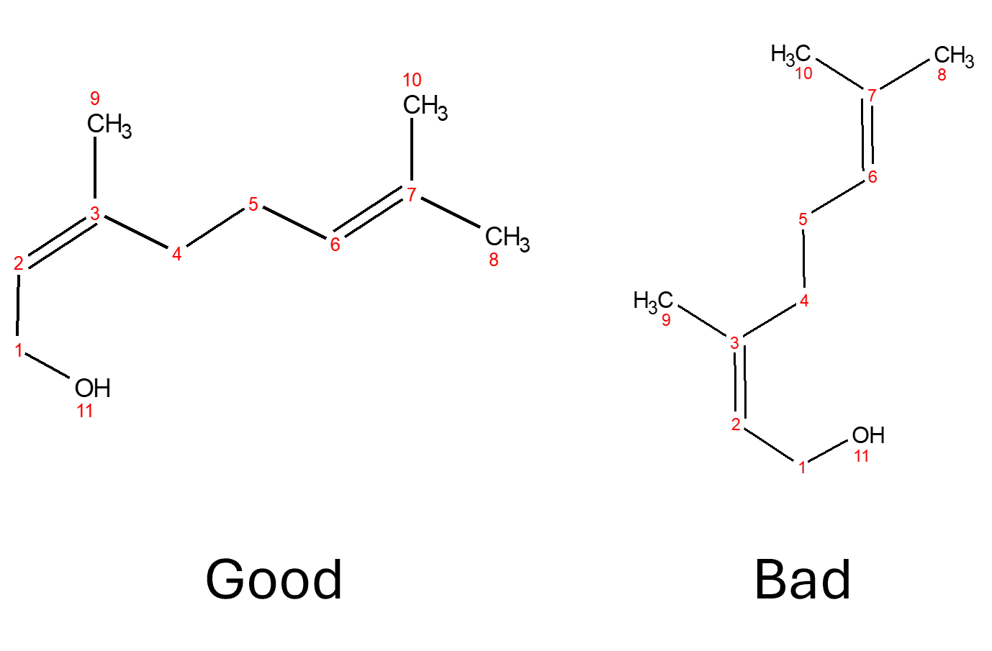

Figure 1 Good and Bad orientation of molecule when using simpleNMR tools