v0.1 - September 2025 • Brussels, Belgium
CENTR Registry Lock
- Task Force Documentation -

About CENTR

CENTR, the association of European country code top-level domain (ccTLD) registries, such as .at for Austria or .es for Spain
About the CENTR Registry Lock Task Force
The CENTR Registry Lock Task Force was initiated at a meeting of the Business Operations & Processes Working Group and officially kicked off in January 2025 with the goal to design a lock service that many registries can implement.
The Task Force was made up of representatives of .de, .dk, .es, .fr, .ie, .lt, .pl, .pt, .se, .sk
Introduction
A Registry Lock secures a domain from any unauthorized changes to it on the registry level as opposed to the registrar level.
Many registries provide registrants for a way to add protection to their domains by locking them at the registry or registrar level. By locking a domain a registrant ensures that changes are verified by the registry before going into effect. As of yet there have been no standardized processes for registry lock and registries that provide the service have come up with different processes, most including some level of manual intervention.
In this document, we define a Standard for Registry Lock that enables registries and registrars to further automate the registry lock process and make sure that there is one standard that all registries adhere to which makes it easier for registrars to automate the processes and flows and easier for registrants to understand how Registry Lock works.

Goals
- Make a registry lock design that many registries can implement
- Make sure the design works on an administrative, legal and technical level
- Create a secure way for a registrant to update a locked domain without manual registry staff work
Expectations
- By doing this we can make the feature free or cost efficient which again is more likely to make it successful
- Focus on the needs of the registrars in terms of a lock product and plan with the registrars on how such a design could be promoted (from a Marketing perspective)
- By doing this, registrars can market the same product for many TLDs which is more likely to make it successful
Business Requirements
- There should be no paper forms involved
- To activate registry lock and to make updates for a registrar managed domain it must be possible via EPP or similar interface
- Dedicated lock contact(s) must approve updates
  - If there are multiple lock contacts than a policy may exist
(eG “at least 2 out of 3 lock contacts must approve a request”)
- Communication to the registry via EPP or similar interface
- Registrant and lock contact(s) must confirm activation - at the same time 2FA must be added
  - Choice of 2FA can be different from registry to registry (eG TOTP, SMS code, eID etc.)
- Domain will stay locked at all times, but changes must be approved by lock contacts
  - A registry lock will never prevent a domain renewal
- A lock must be removed before deletion of a domain

Registry Lock Contact
A registry lock contact is a contact connected to a domain object that is able to authorize changes to the object. A domain may have multiple registry lock contacts, in which case changes may need to be authorized by multiple registry lock contacts. A registry may restrict the maximum number of lock contacts connected to a domain.
If multiple lock contact(s) are connected with a domain a quorum-policy may exist that defines the approval of changes (eG “at least 2 out of 3 lock contacts must approve a request”).
Status Values of a locked domain
A locked domain must have a “serverDeleteProhibited”-Status set to prevent the domain to be deleted by the registrar while locked.
Handling requests for a locked domain
An active lock will prevent the following operations without authorisation of the lock contact(s).
- Updating the registrant data
- Updating the domain data - including
  - changing the registrant
  - changing the DNS-records (Nameserver, IP addresses)
  - adding or removing DNSSEC
- deleting a domain
Once a request is received the lock contact(s) are informed and the request is pending. The registrar will be informed of the approval, disapproval or timeout via poll messages.
Only one pending request is allowed at any time.
Since - during a change of provider - the new registrar may not provide a registry lock service a lock must be removed before a change of provider.

Processes
Set a Registry Lock
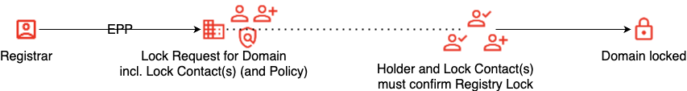
Update a Domain with Registry Lock
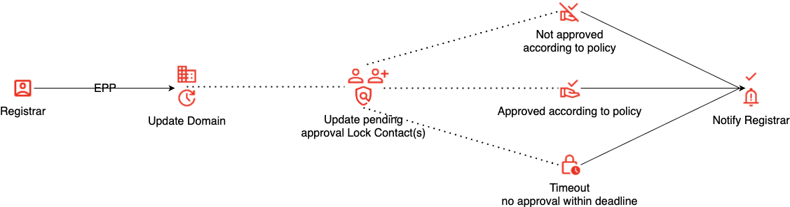
Remove a Registry Lock
<<tbd>>
(Dis)Approve a Request
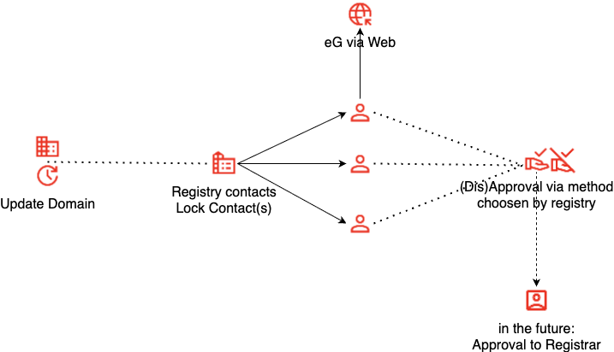
Work in progress
- Define whether a lock contact must be protected the same way as the registrant
- Define if additional status must be set in addition to serverDeleteProhibited
- Define it only one request for a locked domain should be allowed at any time
- Define Unlocking of a locked domain - Original idea: Registrar must manually via webinterface start unlocking. Registrant and lock contacts must approve as well.
- Define Intervention if registrant and/or lock contacts are no longer valid
Further references
EPP Extension Draft: https://github.com/EricIO/draft-regext-epp-registry-lock

