**Sorted List Program**

Eric Vara

The University of Arizona Global Campus

CPT 307: Data Structures & Algorithms

Professor Joel Short

February 19, 2024

**Creating and Filling the List**

In this Java program, we use a special list called LinkedList to show how to work with lists. We start by making a new LinkedList that holds numbers (integers). First, we fill this list with numbers. We use a loop (a way to do something over and over) to add numbers from 5 to 60, increasing by 10 each time. Right after each of these numbers, we also add a number that's 5 more. So, we're adding pairs of numbers like 5 and 10, 15 and 20, and so on. This shows how we can easily put new numbers into our list.

**Showing the List**

Then, we show what's on our list by printing it out. This lets us see all the numbers we've just put in.

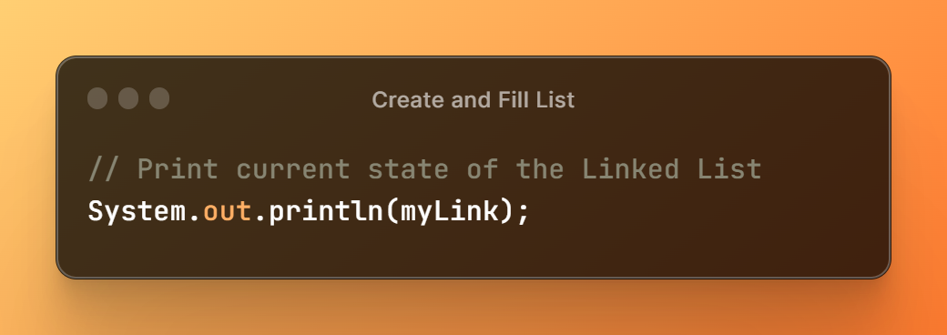

**Removing Numbers from the List**

Next, we take out some numbers from our list. We remove the first number, then the third, and so on. We do this by telling the list which place (like first, third) to take a number out from. This shows that we can also take numbers out of our list easily. After taking some numbers out, we print the list again to show how it's changed. Now, it has fewer numbers because we removed some.

**Conclusion**

By adding and then removing numbers, this program helps us see how lists in Java can be changed easily. We can put in new numbers and take out others whenever we need to. This is a great way to keep track of and change a bunch of numbers in our programs.

