**Telecommuting in Our Organization:**

**An Evidence-Based Recommendation Report**

Eric Vara

The University of Arizona Global Campus

ENG 328: Scientific & Technology Writing

Professor Imani Muhammad

July 17, 2023

**AUDIENCE PROFILE SHEET**

**Reader’s Name:** Henry Holstein

**Reader’s Job Title:** Lead, Network Software Engineer

**Kind of Reader:** Primary___X___ Secondary________

**Education:** MS, Computer Science, University of Chicago, 2010.

**Professional Experience:** 10 years of experience in network software engineering.

Job Responsibilities: Leading a team of software engineers, designing and developing network software solutions, ensuring network reliability and performance.

Personal Characteristics: Detail-oriented, analytical, innovative, collaborative, goal-driven.

**Personal Preferences:** Henry prefers concise and well-organized documents with clear recommendations. He values data-driven analysis and evidence-based solutions. He appreciates practical examples and real-world applications of concepts.

**Cultural Characteristics:** Henry works in a culturally diverse environment that values collaboration and open communication. The organization encourages technological advancements and embraces innovative approaches.

**Attitude Toward the Writer:** Henry expects the writer to be knowledgeable, credible, and objective in presenting information. He values expertise and experience in the subject matter.

**Attitude Toward the Subject:** Henry is open to exploring the subject of telecommuting and its potential benefits. He recognizes the importance of adapting to changing work environments and seeks to understand how telecommuting can impact productivity and employee satisfaction.

**Expectations about the Subject:** Henry expects the document to provide a comprehensive analysis of telecommuting, including its advantages, challenges, and best practices. He anticipates gaining insights into how telecommuting can be successfully implemented within the organization.

**Expectations about the Document:** Henry expects the document to be well-structured, with a clear introduction, analysis, and actionable recommendations. He expects the report to provide evidence-based arguments, supported by relevant research and data.

**Reasons for Reading the Document:** Henry is interested in understanding the feasibility and benefits of implementing telecommuting within the organization. He seeks insights to support informed decision-making regarding the adoption of a telecommuting policy.

**Way of Reading the Document:** Henry intends to study the document thoroughly. He will read it from start to finish, paying close attention to the analysis, recommendations, and supporting evidence. He may take notes and highlight important points for future reference.

**Reading Skill:** Henry possesses advanced reading skills, with the ability to comprehend complex concepts and technical information. He can critically evaluate the validity and relevance of information presented.

**Reader’s Physical Environment:** Henry typically reads documents in a quiet office environment, free from distractions, where he can focus on the content and engage in critical thinking.

**Proposal Purpose and Summary**

The purpose of this proposal is to seek management's approval for the development of a Recommendation Report on telecommuting. The report will provide an analysis of the benefits, challenges, and best practices of telecommuting, as well as specific recommendations for its implementation within our organization. The proposal introduces the topic and justifies the need for further research and analysis. It seeks permission to conduct research and develop a Recommendation Report on telecommuting, exploring the advantages, disadvantages, and potential strategies for implementing telecommuting within our organization.

**Introduction**

The growing trend of telecommuting presents both opportunities and challenges for our organization. As mentioned in an article about remote work and telecommuting differences, "The definition of working remotely is essentially performing work-related tasks outside of a traditional office environment" (Smith, 2022). As technology advances and work-life balance becomes increasingly important, it is crucial to explore the feasibility and potential benefits of telecommuting for our workforce. This Recommendation Report aims to address the question of whether telecommuting is a viable option for our organization, considering factors such as productivity, employee satisfaction, cost-effectiveness, and potential impact on company culture.

**Purposed Tasks**

To complete the Recommendation Report, the following tasks will be conducted:

1. Conduct literature review on telecommuting practices and research studies.
2. Collect data through surveys, interviews, and case studies to assess the needs and preferences of employees and managers.
3. Analyze the collected data to identify the benefits, challenges, and best practices of telecommuting.
4. Develop specific recommendations tailored to the organization's context and goals.
5. Create a draft version of the Recommendation Report for review and feedback.
6. Revise and refine the draft based on feedback to produce the final version.

**Schedule**

The following table outlines the timeline for completing the tasks and the entire Final Project:

|  |  |
| --- | --- |
| Task | Timeframe |
| Literature review | Week 1 |
| Data collection | Week 2 |
| Data analysis | Week 3 |
| Draft report preparation | Week 4 |
| Review and feedback | Week 4-5 |
| Final report preparation | Week 5 |
| Review and revisions | Week 5 |
| Submission of Final Project | Week 5 |

**Experience**

I, Eric Vara, possess skills in Scientific & Technical Witting skills in the Information Technical field. With an AS in Computer Science, BS in Information Technology, and 2 years of experience in IT, I am well-equipped to conduct the necessary research, analyze data, and develop actionable recommendations on the topic of telecommuting. My goal is to contribute to the organization's success by providing valuable insights and strategies for implementing telecommuting effectively.

**Abstract**

Telecommunication is an essential industry that connects people, businesses, and devices worldwide. However, it faces numerous challenges, including security, privacy, regulation, and competition, and must constantly innovate to keep pace with rapid technological advancements such as 5G, AI, and cloud computing. This report examines how telecommunication companies can address these challenges by investing in innovation, infrastructure, customer service, and strategic partnerships, and how they can leverage their strengths to create value-added services and solutions.

**Table of Contents**

Executive Summary ................................................................................................2

Introduction .............................................................................................................3

Methods ...................................................................................................................4

Results .....................................................................................................................5

Recommendations ...................................................................................................6

Conclusions .............................................................................................................7

Glossary ..................................................................................................................8

References ...............................................................................................................9

**LIST OF ILLUSTRATIONS**

|  |  |
| --- | --- |
| **Figures** |  |
| Figure 1.1 | Timeline of Telecommunication Technologies Evolution ……………………….8 |
| Figure 2.1 | Infographic of Key Technologies Impacting Telecommunication ………………9 |
| Figure 3.1 | Flowchart of Recommended Strategies for Telecommunication Companies …..10 |

**Executive Summary**

This report investigates the current trends, opportunities, and challenges in the telecommunications sector. It focuses on the need for continual innovation, robust infrastructure, superior customer service, and strategic partnerships to overcome these challenges and seize opportunities. With a specific emphasis on the U.S. market, the report uses reliable data from sources like CNBC, Investopedia, and industry reports to support its analysis. The report concludes by offering recommendations for telecommunication companies, emphasizing the need for ongoing investment in R&D, infrastructure improvements, and customer service enhancement.

**Introduction**

Navigating the digital age, the telecommunications sector serves as a critical global connector, facilitating the exchange of data across myriad forms. Beyond traditional voice transmission, it's evolving into complex systems handling text, voice, audio, video, and data, all while grappling with significant challenges, including regulatory demands, security threats, privacy concerns, and competition. Amid rapid technological advancements such as 5G, artificial intelligence, cloud computing, and the Internet of Things, telecommunication companies must continually innovate and adapt, leveraging their inherent strengths to create value-added services for diverse markets. This recommendation report, drawing from esteemed sources like Forbes, Investopedia, and McKinsey & Company, among others, provides an analytical guide for these companies, illuminating strategic paths towards resilience, innovation, and competitive dominance in the global market.

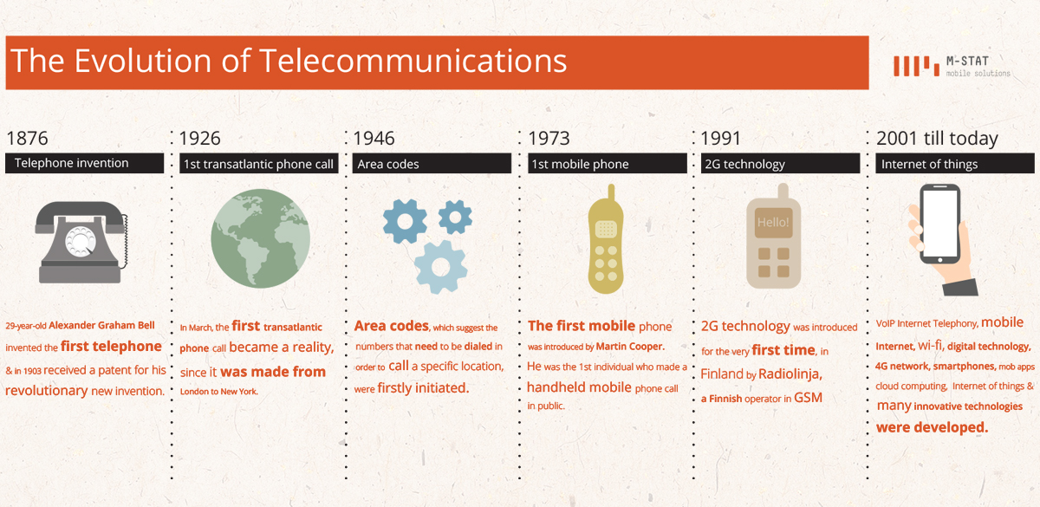

[Image source](https://callhippo.com/blog/telephony/how-telecommunication-innovations-have-revolutionized-the-way-we-work-today)

**Figure 1.1:** Visually represents the evolution of telecommunication technologies over the years. This could help create an understanding of the pace of change in the industry.

**Methods**

The methodology deployed in this report involved a comprehensive literature review, which encompassed the analysis of existing reports, scholarly articles, industry updates, and market trends relevant to the global telecommunication sector. I also gathered a meticulous SWOT (Strengths, Weaknesses, Opportunities, Threats) analysis of some of the leading global telecommunication companies. The intention was to glean insights into their strategic approaches, challenges, and innovative practices. The synthesis of these findings was instrumental in delivering informed conclusions and providing actionable recommendations to bolster the telecommunication sector's performance and competitiveness amidst dynamic market conditions.

**Results**

The research underlined that the telecommunication sector is currently in the throes of a radical digital transformation. This paradigm shift is spurred by cutting-edge technologies such as 5G, Artificial Intelligence (AI), cloud computing, and the Internet of Things (IoT), all of which are playing a decisive role in reshaping the industry's contours. The SWOT analysis below disclosed a varied landscape teeming with diverse strengths and weaknesses, depending on the specific company. Furthermore, it illuminated a horizon filled with compelling opportunities and formidable threats, as these companies navigate their paths in this rapidly evolving technological arena.

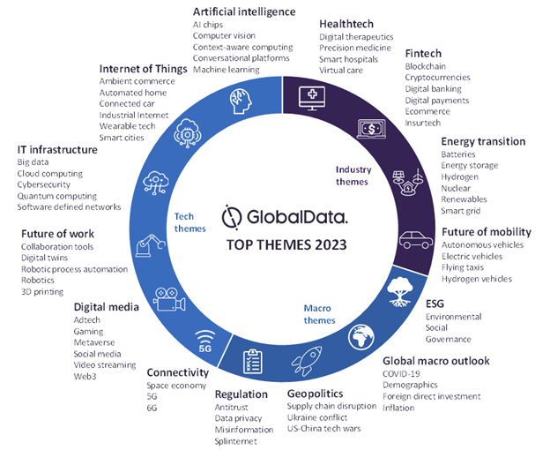

[Image source](https://www.globaldata.com/store/talk-to-us/?report=3069153)

**Figure 2.1:** highlights key technologies (5G, AI, cloud computing, IoT) and their impact on the industry. This helps provide a visual representation of the technologies driving change in the sector.

**Recommendations**

In light of the above results, we advocate for a set of recommendations to ensure the sustained competitiveness of telecommunication companies. Primarily, these companies must allocate significant resources to Research and Development (R&D) to stay abreast of technological advancements and drive innovation. Upgrading and maintaining a robust infrastructure is critical for reliable, high-speed, and secure data transmission, setting the stage for superior service delivery. Additionally, companies should strive to enhance their customer service departments. A focus on customer satisfaction can lead to increased loyalty, thereby fostering a consistent customer base. As a proactive measure, companies should cultivate relationships with customers through personalized experiences and prompt redressal of grievances, fortifying their standing in a competitive market.

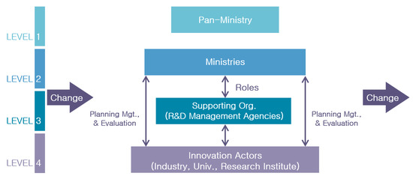

[Image source](https://www.mdpi.com/2199-8531/7/3/200)

**Figure 3.1:** Illustrates the recommended strategic process for these companies. It provides a visual guide to the steps companies take to stay competitive in R&D.

**Conclusions**

The telecommunication industry, a vital global connector, faces challenges from rapid technological shifts, regulatory demands, and competition, among others. Yet, these hurdles can be transformed into growth avenues through strategic integration of technologies like 5G, AI, cloud computing, and IoT, robust investment in R&D, and prioritizing infrastructure development. Prioritizing superior customer service and fostering strategic partnerships can further enhance competitiveness and customer retention. Despite the complex landscape, industry, armed with the right strategies and investments, has the potential to lead the digital revolution.

**Glossary**

* Artificial Intelligence (AI): The capability of a machine to mimic intelligent human behavior.
* Cloud Computing: The delivery of computing services over the internet.
* Internet of Things (IoT): The interconnection via the internet of computing devices embedded in everyday objects, enabling them to send and receive data.
* 5G: The fifth generation of cellular network technology, providing faster speed, reduced latency, and massive device connectivity.

**Work Cited**

Globaldata. (2022, July 23). Market Research Reports Consulting | GlobalData UK Ltd. <https://www.globaldata.com/store/talk-to-us/?report=3069153>

Khoshant Senior Digital Marketing Executive at CallHippo. Hippo’s SEO. (2023, January 10). How telecomm innovations have revolutionized the way we work today. CallHippo. <https://callhippo.com/blog/telephony/how-telecommunication-innovations-have-revolutionized-the-way-we-work-today>

Hwang, B.-Y., Park, S.-H., &amp; Kim, D.-C. (2021, September 9). Efficiency of public R&amp;D management agency and its improvement toward open innovation. MDPI. <https://www.mdpi.com/2199-8531/7/3/200>

Arizona Global Campus, (12th Edition). Macmillan Higher Education, 2017.

Gaibi, Z., Jones, G., Pont, P., &amp; Vaidya, M. (2021, April 28). A blueprint for telecom’s critical reinvention. McKinsey &amp; Company. <https://www.mckinsey.com/industries/technology-media-and-telecommunications/our-insights/a-blueprint-for-telecoms-critical-reinvention>

editorial team. (2021, November 20). SWOT analysis of the telecom industry. Bizfluent. <https://bizfluent.com/info-7986338-swot-analysis-telecom-industry.html>

Javaid, S. (n.d.). In-depth guide to Digital Transformation for Telecoms in 2023. AIMultiple. <https://research.aimultiple.com/telco-digital-transformation/>

Altadonna, N. (2023, January 7). Future of digital transformation in telecom: What to expect from 2023. Apty. <https://www.apty.io/blog/digital-transformation-in-telecom/>

Markel, Mike. Technical Communication. Available from: University of